January 1959

GUS RESCUES A ROOKIE

by Martin Bunn
When it came to nabbing a speeder,
Officer Newman might as well have traded his car for a bicycle.

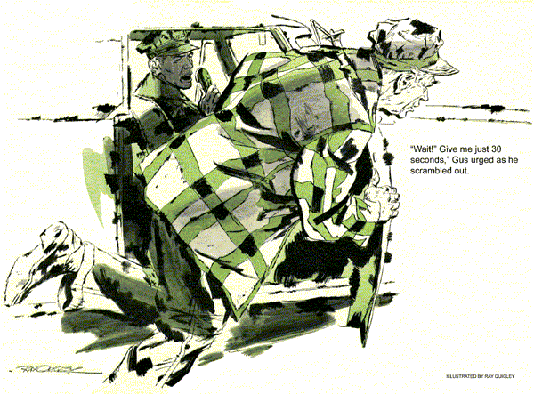
The rookie cop from Centerville floorboarded the gas, flipped on the red flasher, and kicked down the siren button with the cool efficiency of a veteran. The hopped up police car dug out fast - on the tail of a speeding red convertible.
"Seems to take off pretty good," observed Gus Wilson as he snugged up his seat belt and clamped down tighter on a cold pipe.
"Wait till we get going!" the young officer shouted above the mounting howl of the siren. "That's when it happens."
As he spoke the car was seized with a fit of knocking and bucking. The young cop gritted his teeth. "Guess we'll have to give up the chase," he said bitterly."
The unexpected engine behavior puzzled Gus, as did the desperate anxiety of the clean cut earnest young man at his side. He had come to the Model Garage, introduced himself as Ted Newman, and explained that he was now on the Centerville police force, still on probation - and that he was in trouble because of his car. That had been enough for Gus to leave his assistant, Stan Hicks, in charge of the shop and go trouble-shooting along the highways.
"See what I mean?" Newman said slowly now, bringing the car to a stop off the side of the road. "If I can't catch an ordinary speeder, where would I be in a real emergency?"
"Take it easy, son," Gus said, unfastening his seat belt and climbing out. "You may need colder spark plugs. I'll just take a look." After a quick inspection he looked up from under the hood and shook his head. "Nope," he said. "You're running on J-2s now, and that's about the coldest plugs you can get by with."
"I know, Mr. Wilson. The mechanics at our police garage put them in. And they checked the timing, carburetor, distributor, and even installed a new head manifold gasket. Now they think I'm pulling some trick to make monkeys of them."
Gus mentally ticked off the possible trouble-causers. "I don't get it," he said, climbing back into the seat. "This car looks brand new."
"It is brand new, Mr. Wilson, and that's just the trouble. In Centerville we have to buy our own cars - city policy. A certain politician I won't name thinks that all police cars should be bought from his brother-in-law. I'm stubborn, I guess, but I bought mine from another dealer."
"But isn't your dealer responsible?"
"Oh, sure, but I don't dare go to him," Newman explained. "We have to use the police garage; they're strict about that."
Gus nodded sympathetically. "Guess they keep pretty close tabs on you during the probation period."
"That's right. Already the chief thinks there's something fishy that I haven't nabbed any speeders, and the other day the car went into its bronco-bucking act right in the middle of a high-speed civil-defense exercise, with the mayor and all the big shots there. If I get any more black marks against me I'll be off the force even before I make regular."
"So you decided to risk an out-of-town garage," Gus said.
Ted nodded. "Jerry - that's State Trooper Jerry Corcoran - knew about the fix I'm in and said you were the best auto mechanic in the state. So I came over on my first off-duty day, but I have to report back at four o'clock."
"Let's get going then, Ted - back to the Model Garage, we're not licked yet.
And take what Jerry said with a grain of salt," he added.
Ted Newman's face brightened as he started the car and pulled back onto the highway. "Okay. Want me to try another speed run while I'm still in my own territory?"
"Good idea," Gus agreed. He watched the needle climb, edge past 80, his ears attuned for any warning sign of engine trouble. It came with shock suddenness - a hard, metallic ringing, and then a chassis-shaking buck even more violent than before. "Detonation," he muttered.
"What?" yelled Ted, slowing down.
"Detonation," Gus said. "It's like the knock or ping you get from low-octane gas, or excessive spark-plug advance, or the pre-ignition I thought you might have from too-hot spark plugs. Only this is different, and a lot worse."
"You're telling me," Ted said in disgust.
Back at the Model Garage Gus went through the motions of same routine checks while he mulled the problem over.
Then he had Ted start the motor, mostly to stop him from pacing nervously up and down. "If they'd just keep me to escorting funerals I'd be okay," Ted said gloomily. He glanced up at a wall clock. "Gosh, I'm almost due back on duty."
Gus got up, "I'm going to try a new distributor cap. Won't take a minute, and we'll be on our way."
As they arrived at a highway junction within Centerville city limits, Officer Newman checked his wrist watch, picked up the radiophone mike, and called his dispatcher at headquarters to check in for duty. A police-code reply came back over the loudspeaker.
"I got a standby signal," he told Gus excitedly. "Something's up."
Gus was listening to the engine, hoping his distributor cap change had done the trick, when the radio squawk box broke into a chatter of rapid-fire instructions. Ted acknowledged the message and swung the squad car around sharply.
"What's that about a holdup?" Gus asked as the car picked up speed.
Ted was all business. "State Police call for assistance....setting up a road-block...my post is at an intersection 15 miles out...bank stickup!"
"Gosh!" was all Gus could say.
"Just pray this wagon keeps going. And if we run into any trouble, better duck down to the floor so you won't get caught in a crossfire."
"Crossfire!" Gus repeated. "Why, Ted..." Just then the engine started to buck. "Stop her!"
"Can't now," snapped the panicky young officer, trumping down on the gas pedal.
Then, realizing the futility of trying to push the balky car any more, he eased the throttle and coasted to a halt, microphone in hand. "Got to call in for someone to cover the intersection for me."
"Wait! Give me just 30 seconds," Gus urged as he scrambled out and lifted the hood. Newman, mike still in hand was about to call in when Gus was back.
"Let's get going," he said.
This time the speedometer passed 80 without a quiver, left 90 going away, and rested at well over 100 for the rest five miles. Pulling up at the intersection, Ted radioed in his arrival. A jumble of police code answered him.
"Those crooks headed our way?" Gus asked excitedly.
"They've already been caught."
"Oh," Gus sounded disappointed.
Ted grinned. "Yeah," he said, "it would have been nice if I could have brought them in - but you saved my neck. If I hadn't been able to report in here on time, it really would have hung me."
He turned facing Gus. "Now, how did you manage to fix this thing in 30 seconds?"
"Crossfire," Gus said. "When you mentioned crossfire it flashed a light."
Newman shook his head. "Guess I'm thick."
Gus held up his two index fingers side by side. "Suppose those two were ignition wires. High voltage in one wire can induce a current in the other." He separated the fingers a bit. "Now, move them far enough apart or cross them at an angle and the induced current won't be hot enough to bother."
"But why all that noise under the hood?"
"Your firing order is 1-5-4-8-6-3-7-2," Gus explained. "Starting with the front right as 1, and going 1-2-3-4 on the right, 5-6-7-8 are on the left bank, again starting at the front."
Ted nodded. "The induced current was firing the wrong cylinders - cross-firing."
"It goes deeper than that. There are four throws on a V-8 shaft. In most cases the firing order jumps back and forth from back to back, but in the cases of 8 and 6, and 2 and 1, the next cylinder to fire is on the same bank and only 90 degrees behind the firing cylinder. Now, remember I said the wires had to be fairly close together and running parallel.
Well, it's easy for that to happen with ignition wires on the same bank. The tricky part that sets the stage is having the combustible charge in the cylinder that lags 90 degrees. When the crossfire touches them off., the piston is so far from top center it wants to kick back the other way."
Ted snapped his fingers. "I've got it. Two cylinders are fighting the rest of the engine. You moved the wires apart!"
"As easy as that," Gus said.
"Now, one more problem," Ted said.
"How am I going to explain this magic-fix to the guys at the police garage?"
"Tell you what," said Gus. "Put a few drops of water in the fuel-pump filter bowl. They'll be sure to spot it and think they've found your trouble."
Ted chuckled. "I've heard of oil on troubled waters, but that's a new twist."
"Well, Ted, if you're going in for bucking city politicians, you'd better learn a few tricks of your own."
END

