February 1959

GUS FACES A LAWSUIT

by Martin Bunn

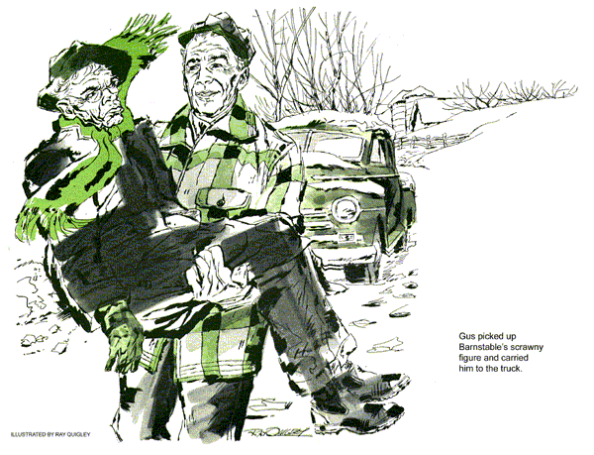
A blustery wind was swirling snow along the street in front of the Model Garage as Gus Wilson came back from a quick lunch at the diner. A good day for going over accounts, he mused.
"Telephone for you, Gus," called Stan Hicks, his assistant, from the office door. "It's Harvey Johnson - and sounds like trouble."
Gus picked up the phone. "What's wrong, Harvey?"
"Glad I caught you, Gus. Silas Barnstable's car is stalled just past my place. Says his feet are frozen solid, that it's all your fault, and that he's going to sue you for all you're worth."
"Sue me!" Gus exclaimed, "what for? Anyway, it isn't cold enough today to freeze a man's feet."
"Says his feet are tenderer than most and that he'll have your hide for something you did to his generator. You know Silas."
"Yeah, I know Silas," Gus said with a sigh. "Put the old goat on."
"Can't, Gus. Wouldn't leave his car. Says the longer he has to wait the more he's going to sue you for."
"Okay, thanks, Harvey. I'll be over," Gus put the phone down and went out to the tow truck, zipping up his leather jacket. He grinned at Stan. "Well, here I go for another Barnstable bout."
"Watch out for fouls," Stan called as his boss got in the truck and drove off.
As he drove, Gus tried to figure out what old Silas was up to. He wasn't seriously worried, but he knew that the penny-pinching Barnstable would sue anyone on the slightest pretext - if only to make trouble. He recalled the generator job.
"Just give it a quick clean-up, Gus," Barnstable had said.
What it had needed badly was a complete overhaul, and that was what it got, over the old man's protests that he was being cheated and robbed. Silas wasn't one to forget when money (his) was concerned. If the generator had failed..
"But frozen feet!" Gus muttered in disgust, watching the snow flicker down ahead. "The old faker."
The car had stalled at the far end of Harvey Johnson's property. Gus swung the tow truck around, backed up to the Barnstable sedan, honking his horn.
When there was no reaction, he climbed down and approached the car window on the driver's side. Silas sat hunched down behind the wheel, his coat collar turned up around his ears, his thin, irascible features set in sullen lines. Gus tapped on the glass.
"Open up, Barnstable!" he shouted.
Barnstable straightened up, rolled down the window, peered at Gus like a snapping turtle.
"Sabotage!" he shrieked. "I've always suspected you ran a racket at that Model Garage of yours, Gus Wilson, but this cinches it. Soak me for a generator overhaul I didn't need, and what happens?"
"Take it easy, Silas."
"Don't Silas me. You deliberately rigged that generator so this would happen and you'd get another expensive repair job. That's what I told Harvey Johnson and that's what I'll say in court."
"Never mind that now," Gus said. "Get into my truck; I'm towing you in."
"A man can't walk on frozen feet, or didn't Harvey tell you about that? I may be maimed for life and.. "
Gus opened the door, picked up the scrawny figure in his arms, carried him to the truck, plunked him down in the seat, still screaming.
"... before I'm through I'll own the Model Garage, lock, stock and barrel."
As he ranted, Gus climbed into the stalled car and tried to start it. Satisfied that the battery was dead, he hoisted the front end up with the tow-truck winch, took his seat in the truck beside Barnstable, and headed back toward town.
"Turn that heater off. Don't you know better than to thaw out frozen flesh too fast?"
Barnstable was silent for a few minutes, then stormed again. "Just wait till my lawyer hears about this."
"Maybe I did slip up somewhere," Gus admitted honestly. "But a lot of other things may have caused your trouble."
"Like the generator regulator, maybe?" Silas suggested.
"Could be."
"Got you there," Barnstable snapped.
"Forgot you insisted on putting in a new one, eh?"
"The old one was shot," Gus said patiently.
"So you said. Anything else?"
Gus looked back to see that the tow was secure. "Maybe your battery.. ."
Barnstable chuckled. "Got you there, too. When you harpooned me for the overhaul and the new regulator, you checked my battery and said it was good for at least another year. Now look at me, all crippled up with frozen feet."
"I doubt that," Gus said, "but we'll soon find out.
"Hey, there!" Barnstable sat up in alarm. "This isn't the way to the garage."
"I'm taking you to the hospital. If I'm going to be sued for frozen feet I want to be sure they're frozen."
"No you don't, I'll doctor my own feet.
You ain't going to stick me for expensive doctor bills atop of everything else."
Gus had a mind to drive on to the hospital, but as the old fellow seemed ready to jump out, he turned toward the Barnstable home.
Barnstable protested again. "You're not taking me home, either. I'm going right along to the garage to see you don't pull a fast one."
"What about your poor feet?"
"I told you. They have to be thawed out slow. They'll do that in your garage, at least until my lawyer gets there."
As Gus pulled into the garage, Barnstable lowered himself carefully, shuffled across the floor, grimacing and groaning, to the telephone and dialed.
"No monkey business, now," he yelled at Stan Hicks, who was lowering the crippled sedan. Then into the phone; "Dore?
This is Barnstable. Get down to the Model Garage right away. I'm suing Gus for my feet."
Stan whistled. "Tom Dore! That shyster will take you apart, Gus."
"Maybe," Gus said, taking off his jacket and reaching for a pair of coveralls.
Tom Dore was there in less than five minutes. He was tall, gaunt, long-legged, looking like a stork peering through thick-lensed spectacles.
"What's all this about your teeth, Silas?" Gus Wilson been knocking you around?" That's malicious assault. We'll get a dentist - expert testimony - and.. ."
"Feet - feet, not teeth." Barnstable corrected irritably, pointing a trembling finger at Gus.
"My feet got froze when the generator that scoundrel sabotaged conked out and stalled my car in this blizzard. And if that isn't enough.. "
"Watch your tongue, Silas," Dore admonished. "Frozen feet are good enough. We'll see."
"For $10,000," Barnstable added.
"Not so fast," Gus said, lifting the hood of the car. "First let's see what's wrong and who's to blame."
"Watch him, Dore, he's slippery."
Stan gave a derisive snort. "If Gus is to blame he'll admit it. Just try to get any jury from around here to believe otherwise."
"Hmm, maybe you're right," Dore admitted.
"Well, Gus, just what is wrong?"
"I'll have to look," Gus said.
He checked the battery terminals; they were tight and not corroded. A hydrometer test showed the battery very low. A voltmeter said that it would take and hold a charge. Pulling the cover off the generator frame he brought over a trouble light; no sign of thrown solder, burned wires or loose armature segments, no jumping brushes. He was replacing the frame cover when he paused, looked closer.
"Come, come," Dore urged. "What's the verdict?"
"Generator okay," Gus reported, "but I think I've spotted the trouble." He reached over to the firewall with a screwdriver and removed the cover of the generator regulator. "There's your trouble," he said, "the regulator. Look at those voltage contact points."
Barnstable beamed. "Make a note of that, Dore. Gus installed that regulator - " new one, too."
"That's right," Gus admitted. "But I didn't install that radio and it wasn't there when I did the generator job."
"Darn tootin' you didn't install it. Bought it at a cut-rate store and put it in myself. That's why it works - or did until my generator went out."
"Make a note of that, Dore," Gus said, "and take a look here." He held the light over the generator.
"See, this is a radio-suppression condenser. It's attached to the generator terminal here, which is the field terminal, not to the armature terminal where it belongs."
"So what?" Barnstable asked. "The radio worked."
"Sure, at the cost of damaging the voltage-regulator points. That's why your battery went. Any mechanic will back me up.
"You know, Mr. Dore," Gus continued, a twinkle in his eye. "Barnstable has made some pretty serious accusations - in front of witnesses - defamation of character, slander."
Dore rubbed his chin and peered at Barnstable through his thick glasses.
"Hmm, yes, I think you may have a case, Gus. With a sympathetic jury and good witnesses.. "
"There's Harvey Johnson, too," Stan said. "I'll bet Silas told Harvey plenty."
"Then," Gus said, "there's the towing fee, my time, a new regulator.. "
"Now wait a minute," Barnstable shouted. "Maybe I made a mistake. I'll admit it - put it in writing that you did a good job on that generator, Gus. You handle it, Dore, you're still my lawyer."
"What's the matter, Silas?" Gus inquired. "Getting cold feet?"
END

