December 1959

GUS KEEPS SANTA ON SCHEDULE

by Martin Bunn

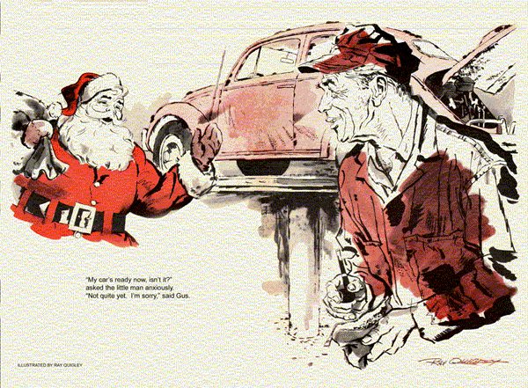
With a final tug on his thick white whiskers, Gus opened the door of the Model Garage office.
Surprise stopped him in mid-step, for framed in the doorway was a shorter duplicate of himself - Santa suit, stocking cap, and all. For a confused moment Gus thought he'd walked up to a mirror.
"Mr. Wilson?" asked the apparition.
"My name is Olford. I shall be in town two hours and 14 minutes. Can you repair my car in that time?"
Gus looked from the cherubic, bewhiskered face to the garage floor. A small, air-cooled, rear-engine car of popular German make stood there.
"I don't know," he said. "It's my day for playing Santa, too - at the grade school. I'll be out an hour or more. Maybe my helper can take care of it. Just what's wrong?"
"I am accountant for the trustees who operate the Anderson Home for Children in this community, and the Melville School 200 miles north. The man I hired as Saint Nicholas fell ill at the last moment. I'm taking his place."
"I see," said Gus. "But your car…"
"Oil failure, sir, oil failure. I've drafted a tight schedule that will allow me to appear at both institutions. Wearing this costume on the trip, for instance, nets me 20 minutes. But unless you can remedy the situation, I may have to abandon my visit to Melville."
"How does this oil failure show?" asked Stan, whom Gus had called over.
"The green low pressure warning light becomes luminous at any speed over 40," said Olford. "When it first happened weeks ago, the dealer installed a new pressure switch. But I have not driven fast since then, until today, when the same thing occurred. Unless I can hold 60 on the throughway, I shall arrive after the children's bedtime."
"We'll see what we can do, Mr. Olford," promised Gus, and the smaller Santa bustled off to call a taxi.
"I'll hop to it," said Stan. "Say, how about that favor I asked for? You going to wear that red suit for my nephews?"
"I'll lend you the suit," said Gus.
"I'm not cut out for Santa. I'd never fool those kids. Gus, look - will you take a bet?"
"A bet on what?" asked Gus warily.
"You know how things come in threes.
If three of these foreign jobs come in today, will you do my play-acting?"
Gus chuckled. "On Christmas Eve? Stan, you're on. And now I'm off."
The first thing Gus saw in the shop when he returned from the grade school was a little French rear-engine sedan. Donning shop clothes, he went back to the hoist on which Stan had raised Olford's car. The young helper was plainly puzzled.
"There's plenty of oil. The crankcase screen is clean. The wrench marks on the new switch are still fresh. If it were a leaky oil line, you'd have low pressure at low speeds more likely than at high."
"Check for a short in the warning circuit," suggested Gus. "The trouble may not be what it seems. And say - what's that French sedan doing here?"
"That? Oh, it's in for a check of the generator and voltage regulator."
"Doesn't it belong to the new high school teacher who boards near you?"
"Yeah. The standard battery didn't stay charged after he put in a radio and the weather turned cold. He drives a lot of stop-and-go. So he put in a new 115-amp battery. Now that falls off, too."
Looking at Stan's too-innocent face, Gus had a notion that he was being hood-winked. It stayed with him as he went back into the office. With year's end approaching, there was paperwork to get rid of. Gus sighed as his pencil bit into inventory figures.
"Fire!" Stan's voice managed to crescendo on the single word, "Fire!"
Gus ran out to find Stan tearing at the hood of the French car. As he flung it back, greasy white smoke boiled out.
Stan streaked for an extinguisher. Gus grabbed a bolt cutter, hooked its jaws over the battery ground cable, and bit through. A squirt of carbon dioxide quenched the flames.
"Just as well this is the luggage compartment," panted Stan, "and the engine is at the other end."
"A little paint and the grease on the battery terminal burned," said Gus. "The fire did your job for you."
"How's that?"
"Find out how it started, and maybe you won't have to check the generator and regulator at all. I'll look at Olford's car meanwhile."
But Gus soon felt he had taken on a brain buster. As Stan had said, the oil and screen were in good shape. There was no sign of a short in as much of the wiring as Gus traced before Stan came over.
"You were right," Stan reported. "The hot terminal of that oversized battery sat almost on top of the hold-down strap.
When corrosion formed current began to short across it from the terminal to the ground strap."
Gus nodded. "The battery was being drained just standing still."
"Uh-huh. More corrosion more leakage, until it got strong enough to start that fire. I cut a notch in the strap next to the terminal to give it room, and put on a new ground cable."
"Sounds okay," approved Gus. "But this job still stumps me."
"I guess, like you said, it just isn't what it seems," muttered Stan.
Gus looked up. "Could be," he said, "that it's not oil, but air."
"Air in the oil line?"
"No, cooling air. If this mill overheats the oil can get thin enough to trip the low-pressure warning. Now how could the air fail?" This belt drives the generator and blower, both on the same shaft. But it's tight."
"And if it were slipping," Stan pointed out, "you'd get a no-charge signal from the generator circuit."
Brooding over the problem, Gus began to fill his pipe. Outside, a taxi screeched to a stop. Olford entered, his cheeks as red as his suit.
"It went famously - famously. The children enjoyed it enormously. My car's ready now, is it not?"
"Not quite yet. I'm sorry," said Gus.
"Well, there is no point in arriving at Melville tardily; the children will have been sent to bed. I had best telephone and cancel my projected visit."
Visibly dejected, the little man walked away. Gus tried to remember all he knew about the German car's cooling system.
Wasn't there a thermostatic bellows linked to a hinged throat that controlled air intake? Suppose the bellows had collapsed or exploded?
Grabbing a drop light, Gus raised the car enough to peer into the right-hand heater duct. Well forward, he could just make out the bellows. It looked its normal shrunken, cool size. Clapping an exhaust hose over each of the twin tailpipes, Gus started the engine. After a short time he again peered into the air duct. The bellows was well expanded.
"Thermostat works," muttered Gus.
"Could be the linkage," With the engine off, he reached forward around the blower casing, feeling for the intake throat. Instead, his hand encountered a flappy substance that gave at his touch.
"Stan!" he roared. "Tell Mr. Olford to cancel that call."
From the workbench, Gus chose a couple of sheet-metal screws and washers. Humming softly, he drove the screws into the firewall forward of the engine, then shut the compartment.
"Have you conquered the trouble?" asked Olford as he came bustling up.
"Yes. You can drive fast now."
Olford mopped his face with a large handkerchief. "I'm delighted - delighted. I believe I would have been as disappointed as the children."
Stuffing away the handkerchief, he pulled out a watch.
"Yes, I can still make it."
Briskly the little accountant paid Gus's modest bill, hopped into his car, and drove away. Stan looked after him curiously. "You didn't road test his car, Boss. How come you're sure?"
"When I felt around to see whether the linkage was connected," explained Gus, "I found the insulation had fallen off the firewall. It was blocking the air intake. At high speeds, the engine didn't get enough air. It overheated and thinned out the oil. All I did was refasten the loose insulation."
Stan nodded absent-mindedly. Just as he was about to close the door, a small English sedan rolled in.
"Oh no," groaned Gus, "Mrs. Larkin!"
The woman looked coyly at Stan. "This young man told me for weeks that I should get new plugs before going on my Christmas trip. Today he even telephoned to remind me. "
Stan was taken with an uncontrollable coughing spell. He was nowhere in sight as Gus, after ushering Mrs. Larkin out, went back into his office. When Gus came out again 10 minutes later, Stan was just closing the hood of her car, with four old plugs in one hand and a troubled face that brightened suddenly.
"Gus! You're going to play Santa for my nephews after I.. "
Once more paunchy and bewhiskered, Gus grinned at his helper. "After you framed me by wangling two more jobs on foreign cars, right after Olford's"
"You - you're not mad then?"
Gus chuckled. "You'd have talked me into it anyway, Stan. Haven't you just proved twice over that you're an all-fired powerful salesman?"
END

