August 1959

GUS SALVAGES A VACATION

by Martin Bunn

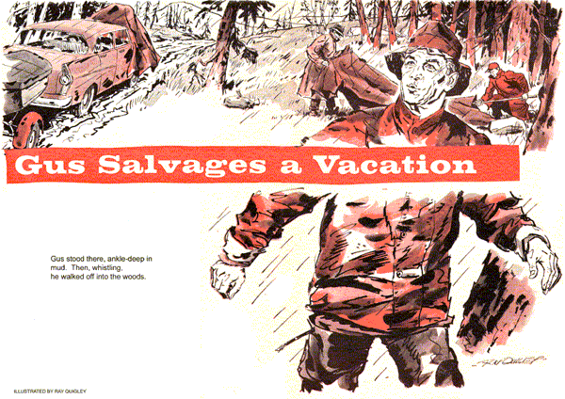
Gus Wilson, snuggled between sleeping bags in the back seat, was dreaming of fish - big, beautiful fish that leaped to take his bait.
A clap of thunder woke him. He yawned, and stretched humorously. In the front seat his buddies, Pete Vancourt, who was driving, and Elmer Stoddard, were reminiscing about previous fishing trips the trio had made to Wilderness Lake.
Gus thanked his lucky stars he had an able assistant in Stan Hicks to take care of the Model Garage at vacation time. He looked back and happily eyed the boat-loaded trailer bumping behind on the mountain road.
Stoddard turned around. "Sounds as though we might run into some bad weather, Gus."
"Make the fish bite better. Relax, Elmer - think of it, nothing to do for a week but fish and loaf."
"Then think again, Gus Wilson," Vancourt put in. "Since I'm furnishing the car, you'll do the chores. We'll have you so busy chopping wood, cooking, and washing dishes, you'll wish you were back in the Model Garage grinding valves."
"And since I'm supplying the boat," Stoddard added, "I'm counting on you to clean all the fish we catch."
"Naturally," Gus agreed, "since I'm the only one who can catch any."
"Whoa, there, Gus!" Stoddard protested. "Who caught the heavy-weight last year?"
"Sure, after you shoved a pound of sinkers down its craw. Why, my big walleye topped your skinny pike by a good pound."
They had been climbing steadily, and as the car topped the mountain summit, a bank of black clouds, shot with lightning, moved swiftly in from the north wind. Thunder rumbled along the forested ridges as the first drops of rain fell, then came the downpour. The winding dirt road turned to mud.
Suddenly the engine began to miss. Gus spoke up fast. "Keep pushing her," he warned. "We don't want a breakdown in this deluge."
"Listen to the back-seat driver," Pete said, down-shifting to second.
"I'm listening to that engine," Gus said. The missing became worse, developed into a series of backfires. Then the car shuddered to a stop.
The three men looked at each other, silently listening to the rain beating on the car road, the moan of wind through the swaying trees. "You," said Vancourt pointing at Gus, "are the mechanic."
"Not me. My job is cleaning fish. Remember?"
"Gus has a point there," Stoddard said. "Hop out and get us rolling, Pete."
Vancourt pulled out a cigarette and lit it. "If you characters are counting on me, the fish in Wilderness Lake will live to a ripe old age. I know even less about engines than Elmer here."
"Yeah, I forgot about that," Stoddard said. "It's up to you, Gus. Get out your tools and make like a mechanic."
"What tools?" Gus asked. "When I'm invited on a vacation by so-called friends, I expect them to furnish a car, not a backfiring teakettle. I'm sleepy." He yawned, settled back among the sleeping bags and closed his eyes.
"Aw, come off it," Vancourt said, grabbing Gus's arm and shaking him.
"We've still got 50 miles to go."
Gus sat up and peered out into the downpour, "I might get struck by lightening out there," He grinned. "Oh, all right, but it's just because I can't wait to get at those fish."
"That's our boy, Stoddard encouraged, as Gus struggled into boots and a slicker. Pulling a floppy rain hat down around his ears, he climbed out and dug a tool kit out of the trunk. Opening it he saw a pair of pliers, a screwdriver and a monkey wrench.
"With this I'm expected to put in new timing gears?" he asked Vancourt.
"Timing gears?"
"Sure," Gus said. "What did you think was causing all that backfiring?"
"He's kidding, Pete," Stoddard said.
"Okay," Gus admitted. "But you guys better get busy putting a canvas tarp over the hood or we'll drown out the engine for sure."
Working together, Vancourt and Stoddard draped a canvas over the raised hood. As each held up a corner, Gus ducked underneath and went to work.
Then he started looking for some trouble that could have been caused by water thrown up over the engine by the front wheels. The backfiring in the muffler indicated that raw gas was being shunted there, and that the cylinders were firing out of time.
"Hand me a flashlight, Elmer," Stoddard dropped his tarp corner and dug into the glove compartment.
With a better light, Gus noticed that the secondary wires to the spark plugs were held together by a fiber fixture attached to the block. The fixture was wet. Suspecting a spark leak, he removed the wires and wiped them dry with a bandanna. Next he checked ignition connections, removed the spark plug wires from the distributor cap, and dried out the contacts by twisting the corners of his bandanna inside.
"Try her now, Pete," he shouted.
When the engine caught, it backfired like a machine gun and ran so rough it threatened to shake loose from the hangers. Gus was puzzled. He hadn't really expected to find anything seriously wrong. Now he wasn't so sure.
"Okay, that's enough, Pete," he yelled, ducking back under the canvas. It had to be ignition trouble, but locating it under these conditions was something else.
He pulled the distributor cap, bridged the starter relay terminals with the handles of the pliers, and rocked the ignition points open on a cam lobe. The points seemed to have about the right gap, with no signs of pitting or burning. He turned the distributor cap over and played his flashlight inside.
There was the trouble - a jagged crack running from the center, high-tension rotor contact segment to one of the spark plug wire terminals at the distributor cap edge. High-tension spark impulses were being diverted along this shorting crack. Meanwhile spark impulses intended for other cylinders were so weakened that missing occurred.
Gus came out from under the canvas shelter. "We're in a jam, boys," he announced. "Let's get in out of the rain."
When the dripping trio was seated in the car, he explained the situation.
"Now isn't that just dandy," Vancourt said. "Elmer and I bring along a bull-necked, impossible-to-get-along-with mechanic on our vacation simply because he is supposed to be able to fix things. Then, the first thing goes wrong, he gives with explanations."
"Leaving us," Stoddard added, "stuck in the mud 50 miles from nowhere. Well, we might as well break out the tent and get settled here for the night."
"Suits me," Gus agreed.
"Elmer and I'll take care of the tent," Vancourt said. "You scrounge around for some wood, Gus. Maybe we can have a fire if the rain lets up a little."
Gus stood ankle-drop in mud, gazing off into the forest. "Aren't those spruces growing on a little rim over there?"
"What's the difference?" Stoddard asked. "We're not going to chop down any trees. A few loads of fallen deadwood is all we want."
Gus was whistling as he walked into the woods. In a few minutes he was back and stuck his head and shoulders under the open-hood shelter. His companions, wrestling with the tent, watched as he emerged, removed the canvas, shut the hood and got into the car. When he stepped on the starter, the engine sprung to life, running smoothly.
"Well, what are we waiting for?" he called out. "Hop in and let's go fishing."
Stoddard and Vancourt lost no time in getting into the car.
"And let it be understood," Gus said, "that I'm driving the car for the rest of our vacation.
You, Pete, have the fish-cleaning chore."
"For getting us out of that mess we'd serve you breakfast in bed."
"Don't overdo it," Stoddard said "But just how did you fix that crack in the distributor cap, Gus?"
"Nothing to it," Gus explained modestly. "I collected some gum oozing out of a big spruce, smeared it into the crack, and stuck a bit of paper on top."
"What kind of a fix is that?"
"It stopped the short," Vancourt said.
"We've got 50 miles to go and then 100 back home. We'll never make it."
"Maybe you can make a more permanent repair up at the lake," said Elmer.
"Nope," Gus said. "But I wouldn't be surprised if that spruce-gum job held up for a thousand miles."
"Have it your way," Stoddard said, "but for gosh sake take it easy so we don't jog that crack open again."
In reply Gus stepped on the gas. "Relax, you two. We'll make it all right."
They did.
END

