September 1958

GUS MAKES THE RIGHT CONTACT

by Martin Bunn

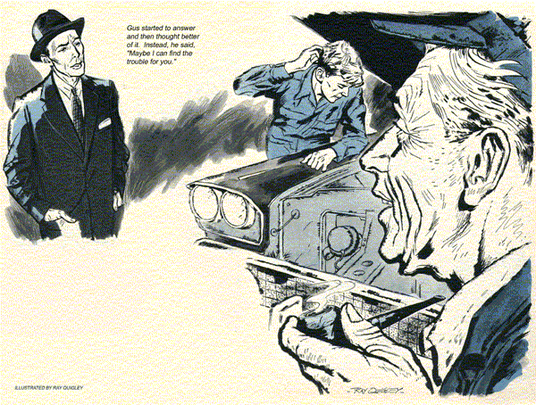
"The upper crust has arrived," said Stan Hicks as a long, sleek, black sedan pulled up in front of the Model Garage. A distinguished-looking man wearing a black Homburg was at the wheel. "Bet he's a Wall Street broker, Gus."
"What makes you think so?" asked Gus Wilson, who was putting away his tools.
"You can tell just by looking at him."
Gus wiped his hands on a piece of waste. "There's an old saying, Stan,
"Don't judge a book by its cover." He stepped out of his coveralls and hung them up.
"Take care of him. I have to see Red Ellis about the Legion dance."
"Thought you decided to call it off because you couldn't afford an orchestra."
Gus laughed. "That's what Red thought. But I have a surprise for Mr. Ellis. There's a deal cooking. Be back in half an hour, Stan."
Stan walked over to the big car. The driver uncoiled his lanky frame from behind the wheel and smiled ruefully.
"You'd think that a car with only a hundred miles on it could make the trip from Durgin to Centerville without acting as if it wanted to roll over and die."
He was tall, around 40, dressed in an obviously expensive suit and spotlessly shined shoes. As he talked, Stan noticed, he drummed nervously on the hood of the car with his manicured fingernails.
"What's the trouble?" Stan asked.
"Wish I knew. It runs all right for a while. Then all of a sudden it just stops.
I held up about 15 cars back on the East Endicott Bridge. Ran like a dream for the salesman I bought it from a couple of days ago. Burns me up to get hooked like that."
"I know what you mean," Stan said.
"Let me take it inside and have a look."
"Okay, pal, but make it as snappy as you can. Have to see a guy here in town and then I'm due over in Centerville tonight. Miller's the name."
Something in the way he introduced himself made Stan feel that he should recognize the name. Probably some big-shot financier, he mused, although that didn't tie in with the flip way he talked.
Inside the garage, Miller paced up and down as Stan went to work. First thing he looked for was a vapor lock. It wasn't that. Every few minutes the man poked his head under the hood, cutting off Stan's light, urging him to hurry.
"Where's Gus Wilson?" he asked as Stan examined the sediment bowl while checking the fuel system.
"I'm doing the best I can," Stan said, ignoring the question about his boss. He removed the porcelain strainer. The screen was clean and the bowl fresh.
"What's that you're doing now?" Miller asked impatiently. "All I want you to do is fix it. I don't want it rebuilt."
"I have to check the line from the sediment bowl to the fuel pump," Stan explained. "Might be clogged. It can happen even in a new car," He went over the fuel-pump screen.
The light was blocked out again as Miller's angular face appeared over the radiator. "Do you have to take that thing out?"
Stan was hurt. That "thing," he pointed out, was the carburetor, and it had to be removed for a dirt-check.
"Maybe I should call Mr. Wilson... ." Miller began.
"Hold your horses, mister," Stan broke in. "Some things you just can't hurry."
Stan could take a carburetor apart and put it together blindfolded. This one was as open and free as a newly cleaned pipe. He tightened it back in place.
The man again. "You are a mechanic, aren't you?" he asked.
Stan controlled his temper. "About all that's left is the electrical system.
"Say, how many systems does one of these buggies have? You've been poking around in there half an hour."
"This guy's been working too hard.
He's cracking up," Stan said to himself as he tackled the distributor. It was slick as a whistle.
Suddenly he struck pay dirt.
"I think I've found it," he exclaimed.
Miller came over, and this time Stan didn't mind the man watching.
"Notice when I pull the center wire out of the distributor. See," there's no spark against the block when I work the starter.
They must have given you a bum coil.
Anyhow, that's where your trouble is."
Stan wasted no time getting a new coil out of stock and into the car.
"Now," he said, "you've really got a spark there. Guess we're ready for a test run. I'd go along, only I've got to keep an eye on the garage. Just drive around a few blocks and try it at different speeds." Stan spoke with assurance.
Just as Miller's car turned the corner, Gus appeared from the other direction.
"Boy," said Stan, "I've sweated out almost an hour over that buggy. He's trying it out now. But I think I got it licked. Turned out to be the obvious thing after all - coil trouble."
"Hope you're right," Gus said. "Red Ellis and I got to going round and round about the dance. Sorry I took so long, but the guy I was expecting never showed."
A few minutes later Stan looked up and saw, to his dismay, the sleek car heading for the garage. It was being pushed by another car. At the wheel was the impeccable but frustrated Miller. Stan glanced at Gus, who had a wide grin on his face.
Miller slid out of his car and faced Stan. "You know man," he fretted, "I've wasted more than an hour while you fooled around with my engine and it still won't go. I missed a client here and now it looks as if I'll miss out on that contract in Centerville. You can say I've had it."
A deflated Stan turned to Gus. "This is Mr. Miller."
"Over from Durgin?" Gus asked.
"That's me. And you're... ?"
Gus started to answer and then thought better of it. Instead he said, "Maybe I can find the trouble for you."
Gus did a quick rundown on the plugs, checked the battery-cable terminals and the ground connections. "So far so good. Let's look at the distributor."
He removed the cap from the distributor and inspected the contact points.
"They're okay," he said, "No, wait a minute. Look here." He pointed to a nut on the side of the distributor that held the small wire leading to the coil. "By golly, that's where the trouble is." He bent to get a better look at the nut.
"You know, someone - maybe at the factory - put that nut on askew. There was nothing wrong with the coil, but when it was attached, the nut - here - that holds the wire leading from the coil wasn't threaded in properly. It jammed and the guy who installed it probably thought it was tight. But it wasn't.
There's just a fraction of an inch for the connection to jump around in. That's why it goes for a while then stops."
Stan scratched his head. "Now why didn't I see that?"
"I guess you didn't get that far when you found coil trouble. You were right as far as you went - just too ready to accept the obvious. In more ways than one," he added significantly. "Now, Mr. Miller, I think a twist of the pliers will do the trick." He removed the nut and reset it so it fitted snugly. "Stan, if you'll put back the original coil, I think Mr. Miller will be all set."
When Stan had the coil back, Gus adjusted the distributor and got behind the wheel. He started the engine, changing speeds.
"Now that's mighty sweet," Miller said.
He took out his wallet.
"No charge," Gus said. "This one is on the house because we held you up."
"Well, thanks very much," Miller said.
He took out a card and handed it to Gus.
"Maybe you know a Gus Wilson around here. I was supposed to see him about playing at a Legion dance."
Stan's eyes bugged. "You're not Stick Miller, the band leader?" He gulped.
"Yup, I'm on my way to Centerville to bid on State's senior prom. Got word to stop off here to see this Wilson about the Legion dance." He glanced at his watch.
But it's so late now I won't have time to look him up. Anyway, the price he offered was too low. If you see him, tell him for me, will you?"
"B-but this is - "
"And thanks again," Miller continued speaking to Gus. "If there's ever a favor I can do for you, let me know. You know your stuff, man."
"I'm Gus Wilson," said Gus, smiling.
"Well, I'll be... "
He turned on Stan.
"Why didn't you tell me? Why did you think I was asking for him?"
"Stan sometimes pays too much attention to the obvious," Gus explained.
"Well, no harm done," Miller conceded expansively. "And about that dance, no reason why I can't shave my price."
Gus stretched out his hand. "The Legion appreciates your generosity."
"Don't mention it. Get in touch with my agent, and he'll tell you what dates I have open." He started up the engine.
"Well, all right! That sounds more like it!
So long," With a screech of rubber he was gone.
"Guess I made a fool of myself," Stan said. "When he asked for you, I thought he wanted you to take over on the job. Well, I've learned a good lesson."
"What's that?" asked Gus.
"Never judge a book by its cover - or maybe I should say, 'Dig that crazy broker!"
END

