May 1958

GUS MEETS A MASTER MECHANIC

by Martin Bunn 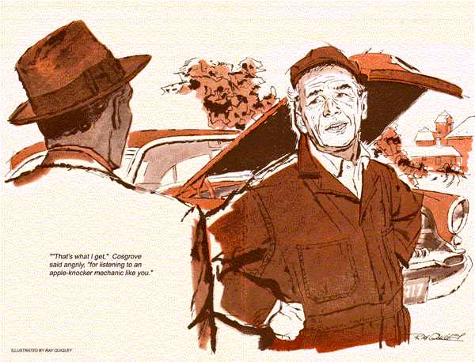
When a passing motorist notified Gus Wilson that a man 10 miles down the highway needed a rental battery, the burly proprietor of the Model Garage immediately went to the rescue. Pulling up before the stalled car, Gus swung down from the cab with a 12-bolt battery swinging on a carrying strap. The motorist, a youngster of about 20, greeted him cheerily.
"About time, Pop," he said, reaching for the battery. "Here, let me take that. It's a bit on the heavy side for you."
Gus was so astonished that he relinquished his grasp on the battery. "The name," he said, "is Gus Wilson. Model Garage."
"Never heard of the joint, Pop," the young fellow said as he raised the hood of his sedan, whipped a wrench and battery pliers from his pocket, and began making the battery exchange.
Gus leaned over his shoulder to glance at the date-of-sale stampings on the lead cell connectors of the car's battery.
"This battery shouldn't have failed after only a year," he said. "There must be a short in your wiring or a defective generator."
"You just leave that to me, Pop," the young man said briskly. "After my motor went dead I ran the battery down trying to start it. I knew what was wrong, of course, but hoped to get it going long enough to pull over the next rise, so that maybe I could coast down nearer a service station or telephone."
"I see," Gus said. "What is wrong?"
"Blown condenser. Any mechanic could tell that, and I've had four years' experience in big-time garages in the city. It would be hard to explain to the layman, but the action of the condenser is very important. If you have a blown condenser the spark is too weak to jump across the spark-plug electrodes against compression. Say, I hope the Model Garage sent out a condenser for this model car. If not, you'd better rustle your bones back to town after one. I'm due to report on the job right away."
"What job?" Gus asked.
"Oh, didn't I tell you? I'm Fred Cosgrove - sent out from the city to take charge of the mechanical work for the Henderson Construction Company. They're a big outfit that's building homes in a new subdivision in the town. I'm to take care of their equipment, sort of a master mechanic's job. An outfit like Henderson's couldn't have apple-knocker mechanics fooling with their expensive machinery."
"Yeah," Gus said, as Cosgrove finished the battery exchange. "I know Matt Henderson. Pretty big outfit."
"That's what I hear," Cosgrove said. "By the way, what's your job with this Model Garage outfit, Pop?"
"Oh," Gus said, "I do just about anything that comes to hand."
"I see," Cosgrove said. "Sort of handyman about the joint Now how about a condenser for this rig?"
A flicker of amusement came to Gus's eyes as he said, "the Model Garage only sent a battery out with me. But I just happen to have a condenser, too. Now, where did I see it last?"
He rummaged around in the service truck and brought out a condenser.
"That one won't do," Cosgrove snapped. "It's too big. You couldn't fit that thing inside my distributor with a hammer. You'd better hustle back to town and get one made for this car."
"No use in that," Gus said. "I can tow you in as I go."
"Oh, no you won't!" Cosgrove exclaimed. "Wouldn't it look pretty for the new master mechanic for the Hendersen Construction Company to be towed into town because he couldn't fix his own car on the road!"
"I never thought of that," Gus admitted. "A fellow like you does have to watch out for his reputation. Say, couldn't you just sort of stick this condenser to the side of the distributor, or maybe hang it on the coil, and tie the wires to it? t doesn't have to be inside the distributor, does it?"
"Well, now," Cosgrove said, "come to think of it, it might work that way long enough to pull me into town."
"Let's go try it," Gus said.
Cosgrove managed to attach the condenser to the side of the distributor by using one of the screws that fastened the breaker plate and connected the condenser lead to the primary wire terminal. The motor started instantly and ran smoothly.
"I'd better get this battery of yours on the line," Gus said as he climbed into his service truck. "You can follow me in and have the right condenser installed. The Model Garage is on West Main Street."
"I'll find it," Cosgrove said, glancing at his watch. "I'll be stopping on the way in for lunch. I'm hungrier than a dog."
Gus drove away with a frown on his face. "Pop!" he repeated to himself. "Give me that battery, he says, it's too heavy for you, Pop!"
Gus had been at the Model Garage for about an hour when Fred Cosgrove phoned.
"Model Garage?" he said. "This is Cosgrove, the man you sent that battery out to a while back. Get Pop out here again, and this time see that he brings the right condenser to fit my car. The one he brought last time went out. I had to walk a mile to a farm to telephone."
"Be right with you, Mr. Cosgrove."
Gus found young Cosgrove parked on the highway shoulder with the hood raised.
"That's what I get," he declared angrily, "for listening to an apple-knocker mechanic like you. That phony condenser blew out within two miles. I haven't got enough spark in this rig to see in a coal mine."
"No spark at all?" Gus asked. He turned the ignition on, leaned over the motor, pulled the high-tension wire from the distributor and removed the distributor cap. Holding the secondary ignition wire close to the engine block, he snapped the exposed ignition points with his thumb. Nothing happened.
"Even with a blown condenser," Gus said, "I should at least see a weak spark, reddish instead of blue, with no snap or jump to it. I'd say you've got a bad coil, not a blown condenser."
"Is that so?" Cosgrove said. "And how do you account for the fact that my coil was all right just a couple of miles back?"
"Well," Gus said slowly, "such things do happen. Sometimes when you put a fully charged battery and a new condenser on an old coil, the coil goes blooey. Like when you put a new set of batteries in a flashlight. A light bulb that might last a long time with weak batteries blows out under the load of the new."
"Flashlights aren't automobiles, Pop," Cosgrove said. "Here, give me that new condenser." Swiftly Cosgrove installed the new condenser, buckled down the hood, got into the car. "See you in town, Pop," he said as he turned on the ignition, engaged the starter.
When the motor failed to start, he kept engaging the starter, a baffled expression on his face.
"Better cut that out," Gus cautioned as he raised the hood, "or you'll run the battery down. Leave the ignition on."
Once again Gus pulled the high-tension wire from the distributor, removed the distributor top, held the secondary wire close to the engine block, snapped the ignition points with his thumb.
"You haven't got any more spark here than a dead buzzard," he declared. "You need a new coil. I'd better tow you in."
"You aren't going to tow me anywhere," Cosgrove said. "And why haven't you got a new coil with you? What kind of a screwball outfit is this Model Garage?"
"Usually they send everything I might need," Gus said. "But you telephoned that all you needed was a condenser. Naturally, knowing that you were a master mechanic…"
"Knock it off, Pop," Cosgrove interrupted, "and get into town after a coil. I'm in a hurry."
"Not so fast," Gus replied. "It doesn't seem to me that this coil is old enough to have gone out completely. Now, this 12-volt coil of yours is basically a six-volt coil with a replacement resistor in the bottom to cut the voltage in half. I'll bet you the best dinner in town that all that's wrong with the coil is that the resistor is burned out. Often such coils are thrown into the trash can by mechanics who don't know that they do contain an easily replaced resistor. We could pull the cover from the bottom of the coil, which covers the resistor, remove it, if it's burned out, and put the primary-circuit wires together. You'd run then, but you'd soon burn up your ignition points. As it is, I just happen to have a new resistor for this coil with me."
"Just happen, eh," Cosgrove said, his eyes suddenly wise with wry humor. "Maybe I'm not as far out in the sticks as I thought. Fix it, Pop. And I hope you're not as hungry as I am, because I've got a hunch I'm buying your dinner."
"The best dinner in town, mind you," Gus chuckled. He removed the burned-out coil resistor, installed the new one and started the car.
"You know, Cosgrove, us apple-knocker mechanics are always hungry."
END

