March 1958

GUS DOES IT BY THE NUMBERS

by Martin Bunn
With a gun in his back, the chips were down for Gus -
but an old poker player never forgets how to bluff.

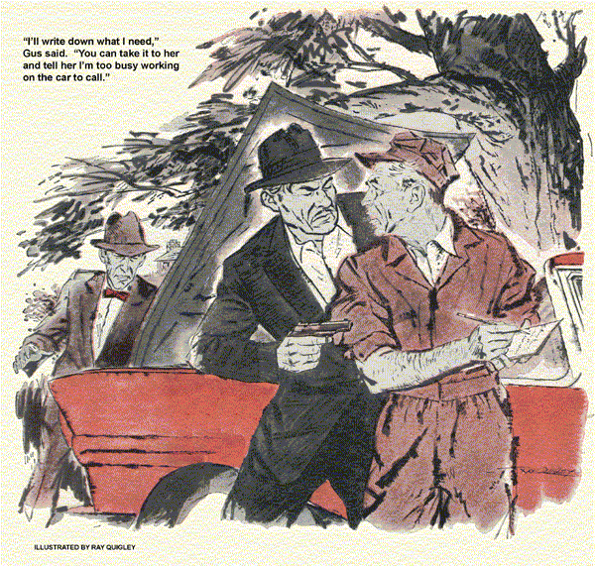
Reluctantly, Gus Wilson's weary eyes focused on a silhouetted figure waving its arms in the road ahead. "Trouble," muttered the Model Garageman as he peered through the windshield of the service truck into the fast-setting sun. The road was a lonely one, five miles off the main highway. Gus had been out on a farm all afternoon lending a hand with a balky tractor engine.
Pulling closer to the waving figure, he saw a late-model car, hood raised, stalled in the driveway of the old Lakeside Motel. Gus slowed down and resigned himself to a late supper. A thought twitched in his mind that the Lakeside was ordinarily deserted at this time of year. The elderly widow of the former owner lived there now and rented the somewhat rundown cabins occasionally to fishermen or hunters.
Gus eased to a stop and grinned down from the truck. "What's the matter, friend, no rooms available?"
The arm waver turned out to be a burly character who evidently didn't appreciate Gus's genial approach. "Me and my partner were just leavin'." He explained, "and this crummy car won't start. Then we get it started but it kept dyin.' We just made it in here last night."
Gus was about to offer his services when a smaller man got out of the ailing car and came over. "Come on, Mike," he said unpleasantly, "don't mess with this blacksmith. You can smell the horse on his truck," Gus hadn't noticed it, but the truck did bear a faint memory of its visit to the farm.
"Sorry," Gus grunted, and dropped the idling truck into gear.
"Hey, hold it!" The big man's voice cut into the roar of the engine. Gus's jaw tightened but he stopped again. Big Mike waved the little guy back and spoke to Gus more persuasively. "Look, Mac, fix us up, will ya?" We'll pay overtime and your boss won't even need to know."
"Skip it," Gus said. With a feeling that he was acting against his better judgment, he slid down from the truck with his tool kit.
He noted the make, year and model of the car, then casually opened the gas cap and flicked the beam of his flash-light down the filler neck. This brought an outburst from the smaller man. "Hey, do we look stupid? There's a full tank there." Gus nodded and said nothing.
Slipping into the driver's seat, he started the engine, with difficulty, listened briefly to its shaking and throbbing, and walked around to wiggle under the up-raised hood. Reaching for his screwdriver, he quickly twisted the latches that held the distributor cap, lifted the cap, and shot his light at the exposed breaker points.
Mike leaned over the fender, his massive shoulders cutting off the little remaining light. "Look here," Gus said, as he probed between the points, "you've got to have a new breaker assembly. These points are burned blue."
"Yeah," the big man's jaw was hard, "and I suppose you just happen to have a set on that truck?"
"No, I don't," Gus said mildly, "but I can phone my partner to run them out in about 15 minutes." He thought a moment. "Better see what made them burn so bad before I call. Might be something else we'll need."
A quick check under the hood showed the wiring to be in order. Gus then poked and prodded briefly under the dash panel, and a low whistle slipped past the stem of his cold and battered pipe. He knew suddenly that he was in very real trouble. He tried to conceal his discovery, but the two men seemed instantly aware that something was up.
"Fix it up, and no monkey business!" Mike was now pointing a large automatic pistol dead center at Gus.
Gus shrugged helplessly. "I'll still have to call for the new points."
"You ain't callin' nobody! Just fix it," Mike demanded.
Gus's heart started to pound. Now he had to bluff. "All right, fix it with that gun, if you can." He took a deep breath. "If you don't want me to call for parts, ask the lady who runs this court to do it for you."
The little man swore. "How could the old dame call? She don't know from nothin' about cars."
Gus explained it carefully, as though talking to a child. "Look, I'll write down what I need. You can read it, take it to her, and tell her I'm too busy working on the car to call." Gus Wilson, was an old poker player; he pushed another chip into the pot. "You afraid of an old woman?"
Mike's lip curled, "Gimme the dope. It better not be a trick."
Gus scribbled a few words on an envelope he'd used for the day's book-keeping, resolved that he'd forget all accounts involved if he lived through this mess. He'd scarcely finished writing when the ham-like fist grabbed the envelope.
"What's all this junk?" Mike exploded.
"Bring new points for '57 Ford V-8 to Lakeside Motel. Is 2 hot on 184349?"
He shook his head. "Sounds fishy to me!"
Gus gestured impatiently with his flash-light. "It's near closing time. My partner will be gone in a few minutes. All the message tells him is that I need points and I want him to check the shop manual on the ignition circuit. That's the part number of the coil. Do you think I remember all that stuff on these cars?"
Reluctantly, the big man nodded at Gus. "Keep the rod on him," he said to the little guy, and strode rapidly toward the motel office. Gus tapped out his pipe, looked away from the baleful eye of the automatic and tried to think.
Mike was back too quickly. "This deal's no good. The old girl calls and right away this guy asks a lot of questions. Didn't sound like he knew about no part numbers or nothin'."
Gus knew his life probably depended on Stan Hick's being on the ball. "Stan said he'd come out, didn't he?"
"Sure," Mike said. "He's comin', but Buster, we ain't gonna be here. Either you're gonna get this car going, fast, or we're takin' your truck. It's slow, but it's better than walkin',"
Gus searched in his tool kit, finally came up with a point file. Working as slowly as he dared he filed and set the points. The contact metal was almost gone. "I'll have to time it by ear," he said.
He started the engine and made a few adjustments on the distributor. As he straightened up, something exploded behind his ear.
A flashing red light brought Gus back to consciousness. The police spot flashed, painfully in his eyes, and then flicked off as Jerry Corcoran's patrol car with Stan Hicks in the right-hand seat pulled to a stop. "You all right, Gus? Which way did they go?"
Gus grinned weakly. "I'm still kicking. I think you'll find them about a mile down the road with car trouble. Watch 'em - they're armed." His warning was drowned in the roar of the Interceptor engine as Jerry took out.
Minutes later he was back. "State boys got your friends, Gus - I'd radioed ahead."
Later, with a small white patch behind his ear and a sandwich in his hand, Gus Wilson gave his story at headquarters: "When I couldn't figure out why the points were burned so badly, I started checking the current supply to the coil.
Like most 12-volt systems, this one has a resistance in the primary lead so the coil gets only six volts for normal running. When you turn the ignition key a start, you cut out the resistance by means of a second lead at the back of the switch and give full voltage to the coil for good starting.
"On this," Gus continued, "I could see some tool marks on the back of the switch, and the wires were connected to the wrong terminals so the coil and points got double voltage all the time. I figured these fellows probably stole the car by jumping the ignition."
"That's right," Jerry cut in. "They're the prison escapees we've been after… What then?"
"Afterwards, while they were holed up," Gus said, "they either jimmied the switch up to work with a key, or installed a stolen one."
"Right, again, probably," Jerry said. "The little guy is a lock expert."
"Anyway," Gus said, "they knew I was on to them. And I had to figure some way to get help."
Stan Hicks laughed. "You sure had me going. I finally decided that phony part number might be an engine number two meant two persons, which was all it took to piece the puzzle together. I'm glad you're on our side, Gus."
Gus yawned. "I'm on your side all the way, Jerry, but if you'll excuse me I'd like to be on my back in bed for the next few hours. It's been a long day."
"One more thing, Gus," said the state trooper. "How'd you know that car would stop within a mile or so? They coasted right up to our road block."
Gus laughed. "I just pulled the coil lead around the exhaust manifold and reconnected it. As soon as the manifold got hot, the insulation burned through and grounded out the ignition.
END

