June 1958

GUS BLOWS AWAY A TRAFFIC JAM

by Martin Bunn

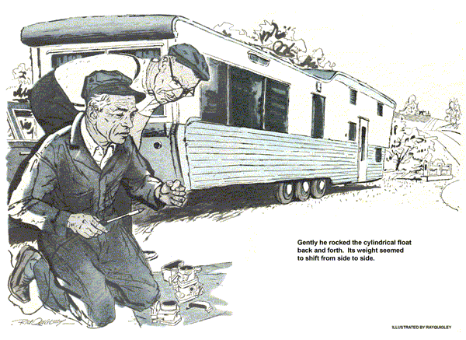
Gus Wilson was installing a new clutch in the Model Garage service truck when his helper took a phone call in the office.
"A man by the name of Prouty," Stan reported. "In a hurry. Headed this way - but says his car won't pull the Birch Mountain grade."
"Won't pull the grade, eh?" Gus said. "Probably nothing much wrong. I'll run out there in my car…"
Topping Birch Mountain some 10 miles out from town, Gus came down the steep grade on the far side. As he neared the bottom he saw a heavy sedan parked on the shoulder. Hitched to it was a massive house trailer - it seemed to Gus nearly 40 feet long He stopped.
A short, stoutish individual bustled over.
"Gus Wilson?" he inquired, seizing Gus's hand and pumping it vigorously. He peered into Gus's face through thick-lensed glasses that gave him the appearance of a genial barn owl. "My name's Ebenezer Prouty, Grand Exalted Wagon Master of the Friends of the Open Road."
"Grand exalted what?" Gus asked, gazing at the monstrous trailer.
"Wagon Master," Prouty said. "I'm the man who goes ahead to arrange for the rendezvous of the Friends - but no matter. Fix my car so I can get under way. I'm due in an hour."
"I see," Gus said, although he didn't. "That's a pretty big trailer to pull with a car, isn't it?"
"I've got a state permit to pull it," Prouty said. "Never had a bit of trouble when the car is running up to form."
"You don't say," Gus said.
"That's right. But right now this car wouldn't pull the hat off your head."
Gus got behind the wheel, started the motor. He gunned it, listening to the engine stagger, falter, lope, shake in its hangers. The symptoms were as familiar to him as the ringing of a phone.
"She's loaded up on gas," Gus said.
"Now that is what I call efficient mechanical detection , Wilson," said Prouty. "As Wagon Master for the Friends, I have to make efficiency my byword. No doubt you have the remedy, Wilson?"
"It isn't that simple," Gus said. "Loading up could be caused by a number of conditions - faulty fuel pump, clogged air cleaner, clogged air-mixture passages or jets, a faulty float needle seat in the carburetor, or a faulty automatic choke. I'll have to run it down."
"Well, let's get on with it," Prouty said, glancing at his watch. "I simply must get into town immediately."
Being accustomed to clients in a hurry, Gus went to work in his usual systematic manner. He disconnected the fuel-pump line at the carburetor, turned the motor over with the starter. A satisfactory flow of gas resulted, but having no pressure-analyzing gauge, Gus couldn't be sure that pump pressure wasn't too high.
He removed the air cleaner, washed out its element with gas from a can in his car. Next, he checked the hot-air screen of the automatic choke and saw that the parts worked freely. He checked and set the carburetor float level, and with a tire pump from his car, blew out the carburetor jets, paying close attention to the air-mixture passages.
With the parts back in place, he tried out the engine. Again it loaded up, loped, shook in its hangers.
"Really, Wilson," Prouty said worriedly, "this can't go on. I simply must get to this rendezvous."
"Figuring this one out," Gus said, "may take a little time, and I certainly can't tow your heavy rig in, even if I had a trailer towing hitch.
Excuse me, but just what is your hurry, Mr. Prouty?"
"As Wagon Master for the Friends of the Road, I have considerable responsibility," Prouty said. "If this trailer of mine isn't parked where it is supposed to be by noon, in plain sight of the main highway, the Friends will be running around in circles. Two hundred of them."
"Two hundred!" Gus echoed.
"At least," Prouty said. "The Friends are an organization of folks who own house trailers. Several times a year we pick a central point for a rendezvous."
"I see," Gus said. "And what does this trailer have to do with it all?"
"As Wagon Master," Prouty explained, "I am advance man for the rendezvous. I have made arrangements with a contractor in your town, Mr. Matt Henderson, to rendezvous on some vacant land where he starting a new subdivision. None of the Friends knows exactly where this spot is. Each has been informed by mail that my house trailer, which is well-known to all, will be parked on this tract, in sight of the main highway as they drive through town.
"Not only must I act as decoy, Wilson, but I must direct each trailer into a spot in a huge circle, using the loudspeaker system on my trailer. If I am not there by noon, the Friends are going to be very annoyed at me."
"Not half as annoyed," Gus said solemnly, "as a policeman named Jerry Corcoran is going to be with me, if I let 200 house trailers come into town to circle around in traffic, not knowing where they're going. It would be a madhouse."
"Precisely," Prouty said. "Perhaps we had better fix my car."
"Perhaps we had," Gus agreed as he dove back under the hood.
He knew that if the fuel pump was delivering too much pressure, it could be overloading the engine with gas. The trouble might also be in faulty-seating of the carburetor float needle. Another possibility, and the easiest to check, was the automatic choke. Gus removed the air cleaner, started the engine, and held open the butterfly of the automatic choke while he gunned the engine. While it loaded up and loped, the carburetor becoming wet outside with gas, he knew that the choke was not responsible. His suspicions fixed on the carburetor.
This time Gus pulled the offending unit apart, searching for clogged passages, loose or worn jets, a jammed float needle or float.
Removing the latter to inspect the needle seat, he reached over to set it in a safe place on the fender. In midair his arm froze.
Gently he rocked the cylindrical float back and forth in his fingers. Its weight seemed to shift from side to side.
"Ah!" he breathed. "We've got it."
"Got what?" Prouty snapped.
"There's some gasoline inside this float," Gus said. "That makes it float low and logy. Instead of shutting off the gas, it lets the level rise in the bowl, so your motor loads up and stalls."
Gus shook the float hard, searching for the place where the gas had entered.
"Can't seem to locate the leak," he said. "It's probably so small that this gas has taken weeks to seep inside."
"How are you going to get it out?"
"There's only one way."
Reaching into his kit for a push drill, Gus fitted on a 1/16-inch bit. He drilled a hole in one end of the float, put his lips to it, and blew mightily. On the surface of the float now he was able to detect a hair-like crack, revealed by a seepage of gasoline forced out by the air pressure.
Gus drained the gas out of the float through the hole he had drilled, then with his six-volt soldering iron laid a film of solder over the drilled hole and the crack. After reassembling the carburetor and installing it, he buckled down the hood. "Try her now," he said.
The engine surged to life, buckled down to a smooth purr.
"That does it!" called Prouty. "I must be off!"
"Right behind you," answered Gus.
Roaring in low gear, the big sedan buckled into the grade, hauling the huge trailer easily behind. Gus followed it to Matt Henderson's newly cleared subdivision property south of town, then drove back to the Model Garage.
Getting out of his car he saw a long trailer disappearing around the corner. As he was washing up, it appeared again. The man driving the car that hauled it had a stunned expression. Gus stepped outside.
"Hey, friend," the driver called to Gus. "Where can I find the Wagon Master's rig?"
"Turn south at the next corner, friend," Gus called back. "Go half a mile beyond the city limits, and you'll see the rig you're looking for parked on a knoll. It wasn't there a few minutes ago, or you'd have spotted it coming into town."
"Thanks, friend." The man drove on.
"What's this 'friend' business?" asked Stan. "That guy's a stranger, isn't he?"
"Not to the right people," retorted Gus. "Whom you and I will meet tonight at the big dinner. We're going by special invitation of the Rendezvous of the Friends of the Open Road. I'm betting it will be a fine feed."
It was. Sitting within the circle of trailers that evening, before a glowing cookfire, Gus listened with well-fed contentment to 300 voices raised in song. Then, looking around at the great bulks of the 200-odd trailers, he let out a slow whistle.
"Huh? Anything wrong?" asked Stan.
Gus grinned. "I was just thinking what could have happened in town today - if I'd run out of wind there on the Birch Mountain grade."
END

