July 1958

GUS FACES A LOW-DOWN CHARGE

by Martin Bunn

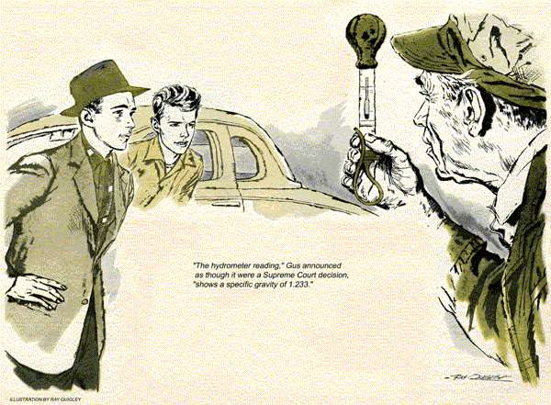
When Verle Graham and Don Holt drove Don's middle-aged coupe into the Model Garage, their conversation wasn't intended for the ears of its proprietor, Gus Wilson. But, working quietly behind a car, Gus couldn't help hearing every word they said. A wry grin moved over his face.
"What kind of a sucker do you take me for, Verle?" Don Holt asked heatedly.
"The service-station man said you owed me a new battery. You've known this old character, Gus Wilson, all your life. I don't know him from Adam's off ox. A fine break I'll get here."
"Just because Gus Wilson is a friend of mine won't make any difference," Verle retorted. "He'll be square with us both."
Gus slipped quietly from the far side of the car, moved around a couple of other vehicles, and stepped into view.
"Hello, boys," he said. "What's your trouble this morning?"
"Hi, Gus," Verle said. "We want you to decide whether I owe Don, here, a new battery, or if he has to fix his generator. You see, when I sold Don this car last month, I guaranteed that the battery would hold up for at least six months. Now he claims the battery's no good, and I claim it's the generator that's bad."
"It's already settled," Don Holt said.
"My service-station man tested this battery and he said it needed charging. Now if it was any good, it wouldn't need charging - I run it enough to keep it up. I'll bet my hat that this battery is no good."
"It's not that simple," Gus said. "It depends on several factors."
"All we want is an honest battery test," Don said. "I can't tell how much my generator is charging, because my ammeter only shows red on discharge, and green on charge. Since it shows green whenever the engine is running, I know that it's charging. If the battery was any good it would stay up."
"He's trying to take me for a new battery, Gus," Verle Graham warned. "His pal at the service station said that a battery should have a specific gravity of at least 1.235. He claims this one tests only 1,233. Imagine trying to stick a guy over two measly points."
"It isn't just a matter of two points low." Don Holt protested. "It's the fact that 1,235 is the lowest a good battery should get."
"You're getting me confused with this point business," Gus said cheerfully.
"Let's get this straight. Your service-station man claims that your battery should have a specific gravity of at least 1.235 with a sound generator. Since it tests two points lower than this, you want Verle to back up his six-month guarantee with a new battery."
"Right," Don declared.
"I guess that's it," Verle said slowly.
"If the battery is bad, I'll buy a new one - but Gus, you'll have to give me two or three months' credit on it. Right now I'm flat."
Gus winked at Stan Hicks as he got a hydrometer from the bench, thrust it into the battery, filled it, held it up in take a reading. He repeated this action in the other two battery cells.
"The hydrometer reading," Gus announced as though it were a Supreme Court decision, "shows a specific gravity of 1.233."
"There," Don said triumphantly. "With your own mechanic backing me up, Verle, you'll have to come to terms now."
"Not so fast," Gus said. "Since you two have put me on the spot as to who is going to pay for what, let's not jump to any hasty conclusions. This is a hot day, I'd say near a hundred in the shade. I'll bet the electrolyte in this battery is about that hot. You can't go by what a hydrometer tells you, unless the electrolyte stands at a true testing temperature of 80 degrees Fahrenheit. For every five degrees below 80, the hydrometer reading is false by two thousandths high. For every five degrees above 80 the hydrometer reading is off by two thousandths low, or as we call it, two points low."
"What!" Don's youthful features were indignant. "What kind of double-talk is this?"
Gus got a long, thin thermometer, thrust it into the battery, left it there a long minute and took a reading.
"The temperature of this battery's electrolyte," he announced, "is 90 degrees Fahrenheit. Since this is 10 degrees, or two fives, above a true, testing temperature of 80 degrees, our hydrometer reading in four thousandths low. Therefore, the true specific gravity of this battery is 1.237."
"Holy cow," Verle Graham exclaimed.
"That lets me out, Gus."
"So that's why you insisted on bringing the car here," Don Holt said bitterly.
"Nice deal, juggling figures and temperatures to beat me out of my battery guarantee. Wait till I tell the fellows out where I live about this. I'll bet my hat this garage won't get any more of their repair business."
"That's twice you've bet your hat on this job, Don," Gus said quietly.
"I'm willing to give your battery a voltage and a breakdown test to prove my point. This battery is probably all right."
"Maybe I'm wrong," Gus said calmly, "but I don't recall your mentioning any such troubles when you came in. Suppose you show me."
The youth slipped behind the wheel, stepped on the starter. The engine turned sluggishly, didn't start until the starter switch had been held closed for more than half a minute. "I suppose you call that a good battery," Don said.
"I'd call that a badly worn bushing in the rear housing of your starter assembly," Gus replied.
"Starter assembly," Verle crowed! "Do you mean to tell me that the trouble isn't in the generator at all?"
"And why not," Gus asked. "Don said that the ammeter showed green when the engine was running. When I took the caps from the battery cells I could see bubbles rising in the electrolyte, which indicated that the generator was throwing a good charge into it when you drove in here. From the sound of things I'd say that the starter is running in a bind from a bad bushing, letting the armature strike the field coils with every turn. This robs the primary ignition circuit of juice producing hard starting. With this engine taking so long to start, it would take a pretty good battery to hold up to even where this one is, with the kind of stop-and-go driving most of you young fellows do.
Here, I'll show you."
Swiftly Gus removed and disassembled the starter. He removed the rear casting, drove out its armature-shaft bushing, installed a new one, ran a reamer through it, reassembled and installed the unit.
"Try it now," he said.
This time when Don stepped on the starter, the engine fired instantly.
"Well, I'll be darned!" Verle exclaimed.
Gus dug out his pipe, filled it and lit up. "You boys sort of put the cart before the horse when you came in here," he said. "You didn't ask me to tell you what was wrong - you told me. You asked me to judge between a bad battery and a bad generator. Next time, tell the mechanic your troubles and let him do his own thinking."
The way it turns out." Don Holt said slowly, "is that I have to pay for fixing the starter. How much do I owe you, Mr. Wilson?"
"Well," Gus said, "there's just about enough rubbish piled behind the garage to fill the rear deck of this coupe. Tell you what I'll do. If you'll haul that rubbish to the city dump on your way home, I'll call it square. Does that sound fair?"
"It sure does," Don said enthusiastically. "I guess I was wrong about you, Mr. Wilson, just like Verle said I was when I got to shooting off my mouth."
"After all," Gus, said, and his eyes twinkled, "you didn't know me from Adam's off ox."
Don Holt's face reddened. "I'll bet he heard every word we said when we first came in."
"Who, me?" Gus said. "Why, an old character like me can't hear anything."
"What I keep asking myself," Stan said, after the boys had left, "is what condition you would have said that battery was in if this had been a zero-weather day, with the electrolyte standing at, say, 35 degrees and the battery showing a hydrometer test of 1.233, as this one did."
"In that case," Gus commented, "I'd have had Verle Graham on my credit books for a new battery. Even though I was sort of kidding the lads along, this temperature business in a battery test is really the straight goods. A battery with a specific gravity of 1.233, on a normal hydrometer reading, with the electrolyte standing at 35 degrees, would have an actual, corrected reading of 1.233 - which would really be a dead one in the eyes of those youngsters."
"Those kids had you in a bind," Stan said. "I was wondering how you were going to squirm out of it without getting one or the other sore at you. I never saw you use a thermometer on a battery test before."
"I never found myself arguing two points of specific gravity before," Gus said. "With the decision hanging on such a tricky technicality, I felt that I'd better get just a little bit technical myself, that's all."
"Well, you sure did, Professor Wilson." Stan chuckled. "You sure did."
END

