January 1958

GUS FINDS THE SCENT

by Martin Bunn
When a new tire blew up,
Gus smelled a rat - or was it the old fox who sold it?

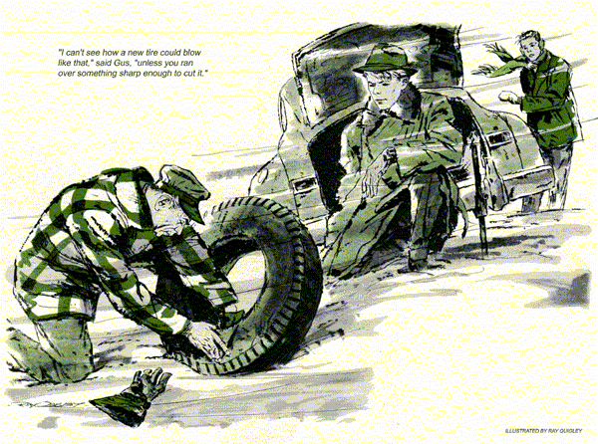
Gus was surprised when Harold Strom phoned from up country to say that one of his tires had blown out. For only a few weeks before, Gus's helper, Stan Hicks, had reported indignantly that Strom had bought a full new set somewhere else.
"Don't fret about it," Gus had said. "Harold probably had to arrange for time payments and didn't want to ask me. He's a good kid even if he is a bit high-spirited when he's behind the wheel. I'm glad he has new rubber, wherever he got it."
And now, with almost brand-new tires, Strom was phoning about a blowout.
"It's the right rear," he complained. "It simply blew apart, and I've got no spare.
"I'm stuck unless you can help, Gus."
"Let's see now," said Gus, thinking fast. He knew Harold was doing odd jobs and saving every cent to get to college.
"I've got a fair used tire in your size. I'll bring it myself."
It must have been sheer curiosity, Gus thought as he drove over roads made dangerous by a recent ice storm, that impelled him to do this nuisance chore instead of sending Stan Hicks. But he found reward in the grateful smile that greeted him as he drove up. Harold, a gawky, wide-shouldered kid with a cow-lick, had already removed the damaged tire. With him was Bert Vickers, a squirrelly young driver whose own jalopy stood ahead of Harold's.
"Look at this, Gus," said Harold, the grin fading. "Spanking new from Pop Binford's emporium of high prices and low down payments. Half paid for - and all shot."
"That's tough," Gus remarked sympathetically. He squatted down to examine the tubeless carcass. Its bead was broken and a long rip extended into the tread. Repair was impossible.
"I can't see how a new tire could blow like that," said Gus, "unless you ran over something sharp enough to cut it."
His eyes followed the car's tracks back through the icy snow. They turned out, as though Harold had been passing another car when the blowout occurred, and a scuffed streak in the right track indicated that the blown tire had been slipping under acceleration. Gus looked sharply at Bert Vickers.
"Were you and Harold racing?"
"No!" It was Harold who answered.
"Bert tried to crowd me over. I stepped on it to clear him. That's nothing to blow a tire, is it?"
"No, it isn't," Gus said soberly, taking a used tire off his truck. "This one will do as a spare, Harold, but don't use it for regular service."
Harold answered angrily, "I'll use it just long enough to drive to Binford's service station and make him come across with a new one."
"Fat chance," Vickers hooted from his souped-up jalopy, and took off in a roar of dual exhausts.
As Gus mounted and inflated the used tire, he was inclined to agree with Vickers about getting a replacement out of Pop Binford. Pop was a wily dealer who preyed upon those always hard up for cash, particularly high-school and college students. He charged outrageous prices for his often inferior merchandise, and got away with it by selling on very low down payments and weekly installments.
If not exactly crooked, Pop was at least razor-sharp.
While Harold let the car down, Gus picked up the blown tire to put it into the trunk. Suddenly he paused, nostrils twitching. After a brief hesitation, he slammed the lid, then stood watching Harold drive away.
Back at the Model Garage, that afternoon, Gus was installing a rebuilt engine when Harold pulled in.
"Of all the lousy deals," he declared angrily. "Binford wouldn't replace that tire, Gus."
Gus turned from his work, dug out and lit his pipe. "Tell me about it."
"Binford said he'd ordinarily replace such a tire, but that in this case it had been abused, that my driving was -"
"Squirrelly," Gus interrupted.
"But it isn't," Harold protested.
"No," Gus agreed, "but you couldn't quite resist that challenge from Vickers, who is squirrelly. Nevertheless, that tire shouldn't have blown, and Binford knows it. I'd like to turn the tables on the old fox just this once. Let's take another look, or rather smell, at that tire."
"Smell?" Harold asked, surprised.
Gus didn't answer, but lifted the tire out of Harold's car and sniffed at it.
"Hah!" he grunted, and strolled back into the office. Shuffling through papers on his battered desk, he selected one, turned to the telephone, and dialed.
"Binford?" he said. "Gus Wilson.
How's business...? Same here. This cold wave has us hopping."
"Bawl him out, Gus," Harold hissed.
"Say," Gus asked, "have you had trouble with air hoses gathering moisture and forming ice? You have? What did you do about it? Alcohol, eh? Well, thanks for the tip, Binford."
Gus hung up, a look of triumph in his eyes.
"You didn't tell him off," Harold complained. "All you talked about was the weather. I thought you were - "Going to talk about your tire? "My hearing's gone sour! I didn't hear tires mentioned - just the weather." "Why not?" Gus chuckled. "In a way, the weather caused your tire to blow out."
"Come again?" the youngster asked.
"You see," Gus explained. "I know how Binford operates. To get any credit from him, you have to buy your gas there. I'll bet the air in your tires came out of his hoses - am I right?"
"Right," Harold said. "What of it?"
"When Bert Vickers crowded you, you stepped on it, even though the streets were icy. That could be a quick way to commit suicide, incidentally. In this case your left rear tire took hold, but the right spun, and developed a lot of static electricity."
"But I don't see..."
"In dampish, freezing weather, such as we've been having." Gus went on, "air hoses sometimes gather moisture and form ice inside. Some service station operators put antifreeze in their hoses to prevent this. Ethylene glycol is all right, but with an alcohol base antifreeze there's a possibility of getting alcohol fumes into the tires. Now spark a charge of static electricity in them and - boom!"
Harold scratched his head. "You mean to tell me that you could blow a tire to pieces this way?"
"Yes," Gus declared. "When I noticed a smell of alcohol around that blown tire I remembered a bulletin sent to me by a well-known tire firm. It warned dealers not to use alcohol in their air hoses to prevent icing, and told of several tires blown apart just that way."
"How could they be sure that's what did it?" Harold asked.
"They proved it," Gus said. "Welded a spark plug into a wheel rim, injected a little alcohol into the tire, then furnished a spark. The test tires blew the way yours did, with the bead torn."
Harold's eyes lit up. "Gus, can I hang this on Binford?"
"It was his alcoholic air that did the damage, wasn't it?" Gus asked dryly.
"Here, take this bulletin to him. Tell him Gus Wilson said when they send free information, it pays a man to read it." "That won't pry a new tire out of him."
"I wouldn't suggest that you blackmail him," Gus said. "But you might say what a good story this alcohol business would make. If that doesn't work, then get him to phone me."
Gus didn't expect Binford to phone. Nor did he, but about five o'clock Harold Strom drove slowly by the Model garage, tooting his horn and holding up two fingers in the victory sign.
Stan looked up to catch a gleam of satisfaction in Gus's eyes. "Enjoyed that little ruckus with Binford, hey, Boss?"
"Yep," answered Gus. "That was some blowout Harold had. You might say we both got a bang out of it."
END

