April 1958

GUS TREATS A CASE OF SPRING FEVER

by Martin Bunn
When the pretty schoolmarm's car wouldn't back up,
Stan was sure he could fix it.
It was lucky he had Gus to back him up.

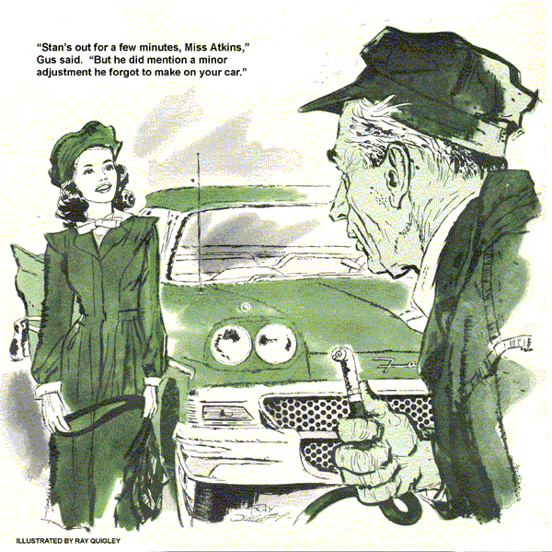
Gus Wilson slammed down the phone in the Model Garage. Why, that old coot Silas Barnstable, asking him to pull his old clunker out of the mud, then having the nerve to add: "And don't send that young whipper-snapper, Stan Hicks!" Stan had turned into a darn good mechanic, even if it did seem like only yesterday that he was hardly old enough to shave.
Gus sighed at the passage of time and headed for the tow truck.
"Watch the store, Stan," he called back. "Have to give old Silas a tow."
A heavy overnight rain had left huge puddles everywhere this morning. Spring was in the air...
A horn blared in the doorway. Stan got up from his work abruptly and whacked his head on a car hood.
Stunned, he motioned frantically to the driver of the 1957 Ford lunging down the center of the shop, and stepped aside just as the car dipped to a stop.
"Hey, lady, what are you trying to do, kill me? Drive it into a stall!"
A pretty young face framed with glistening black hair popped out the window. "No sir! I'm parking so I can drive out the back door if necessary!"
Before Stan could utter another word, the young lady stepped out of the car. We-l-l, thought Stan, I'm glad Gus didn't send me to rescue Barnstable.
"Where's Mr. Wilson?"
"He's out on a call. I'm Stan Hicks, his assistant."
"Oh...I'm Mary Atkins, I teach kindergarten at the elementary school."
"You're a schoolteacher?" Stan blurted. "Why, you don't look old enough to -"
Her impudent little nose lifted. "Mr. Hicks," she snapped, her eyes flashing, "I came here to get my car repaired. I can go elsewhere!"
Stan smiled sheepishly. "Don't get riled up, Miss.
I'm sorry. It's just that - well - doesn't seem like we had teachers like you when I was in school."
The fire left her eyes and she gave Stan a quick smile. "I'm sorry, too. And I'm sorry I made you bump your head. I was mad. You see, I just had a spring tune-up last week. Now the car won't go in reverse and the radio makes a funny noise. I tried to parallel-park in front of the department store downtown and the car wouldn't back up!"
Eager to prove to his pretty customer that Gus Wilson was not the only mechanic in the Model Garage, Stan quickly lifted the hood and examined the gearshift linkage. It seemed okay. Then he recalled the tune-up she had mentioned.
If the emergency-brake cable had been adjusted too tightly, the car might move ahead freely, yet hesitate to back up because rear-wheel brake shoes have a tendency to self-energize if maladjusted.
Sliding a jack under the axle, Stan slid under, checked the emergency-cable tension and then slowly rotated the rear wheels. "The wheels turned backward."
"Well, perhaps the wheels move, but the gearshift lever won't go into reverse!"
Stan slipped into the seat and tried the shift lever. With the clutch depressed, it slipped into reverse easily.
"But it wouldn't work for me!" the girl insisted.
Stan reached for the ignition switch.
Let's drive it back and forth and see."
As he turned the switch, a loud "clack" came from the vicinity of the radio.
A shapely arm flashed past Stan's nose and an accusing finger pointed at the radio. "There, that's what I meant was wrong with the radio!"
"It doesn't sound like the radio, Mary - er - Miss Atkins."
Turning the switch off and on, he added, "Sounds like a relay to me."
Glancing across the dash, his eyes spotted the overdrive-lockout control. "Sure." He grinned. "The overdrive relay. It's mounted in the engine compartment right in front of the radio. It could sound like the radio to anybody who didn't know."
"But what about the reverse?"
"You have a ground between the relay and the overdrive governor switch," Stan announced, reaching for a creeper. "That's why your car won't back up."
He slid beneath the car and checked the wire leading to the tiny governor projecting from the overdrive housing. The wire looked sound. Remembering Gus's counsel about faulty switches, he removed the wire and rubber boot covering the switch.
From above trim ankles came a plaintive voice: "But what have this 'ground' and 'governor' got to do with the reverse gear?"
"Just wait - I'm going to tell you."
Stan slid out, governor switch in hand.
"This little gadget should be the troublemaker," he said, inverting the switch and clamping it in the vise. Removing the screws from the cap, he explained that the unit is a centrifugal switch.
"See, here's the trouble." Stan pointed to a tiny drop of dirty water on the switch points inside the cap. "You had continuity across the points all the time because of this drop of condensation."
He wiped the cap dry, polished the points, and replaced the cap.
"Is that all that's wrong?" she asked.
"Probably. You see, the condensation made the relay energize every time the ignition switch was turned. Then that energized the overdrive solenoid. The solenoid kept the lockout rail from letting the low-reverse sliding gear engage with the reverse idler. Understand?"
"Good heavens, no!"
Stan chuckled. "Okay - let's try this.
With overdrive when you reach about 28 miles an hour, centrifugal force shoves the flyweight segments in the governor switch-out to close the switch points.
When the governor switch closes, the car can go into overdrive. At the same time, the transmission is locked in such a way that you can't shift into reverse when in overdrive. Your switch was closed all the time, so you couldn't possibly shift to reverse. That better?"
"A little," she answered uncertainly.
"My, you certainly know a lot about cars."
It was a while before Miss Atkins left the shop. In fact, she'd barely departed when Gus Wilson returned.
"That old tightwad," Gus said as he stepped from the tow truck. "Bald tires, no chains. Any business while I was away?" He lit his pipe and walked over to the shop order pad.
"Not much," Stan replied from under the hood of a car. "Just an old schoolmarm, a Miss Atkins or something. Car wouldn't back up. Overdrive. Took off the governor switch, put it in the vise, found a bead of condensation across the switch points. I cleaned the points and put it back on."
After a long thoughtful silence, Gus said, "I'll bet Miss Atkins comes back inside half an hour."
"You're pulling my leg, Gus. Bottle of soda says she won't come back. Okay?"
"That's a bet, Stan. Thirty minutes."
"Right," Stan agreed. "Say, Gus, I've got an errand at the drug store. Okay if I take off for a few minutes?"
Gus, bent intently over a running engine, didn't hear the Ford come in, or see a pretty, dark-haired girl get out.
"Stan! Stan!"
Gus turned.
"Oh," she said breathlessly, "you're Mr. Wilson."
"And you're Mary Atkins."
"Stan - uh - Mr. Hicks repaired my car. Now it won't back up - again!"
"I see," Gus said. His eyes twinkled.
"Stan's out for a few minutes, Miss Atkins. But he did mention a minor adjustment he forgot to make on your car."
Reaching for the air hose, he slid under the car, then reappeared. He smiled. "There - everything is fine now."
Miss Atkins was just driving off when Stan came sauntering across the street.
Spotting the familiar car, he broke step and dashed toward Gus.
"Guess the sodas are on you, Stan," Gus announced.
"Was she in here?" Stan demanded.
"Yep, and I fixed her car."
"Okay," Stan groaned. He walked to the vending machine and came back with two bottles. "Tell me what I did wrong."
"Well," Gus began sipping his free drink, "when you're at the ball game with her tomorrow you can tell her - "
"Ball game with her? How'd you -"
"Well, first off, I knew she wasn't an 'old schoolmarm.' Remember, I'm on the school board. In the second place, Stan, you don't usually write down the phone number, the landlady's name, and the color of the customer's hair and eyes on the shop order. Or circle the phrase 'two o'clock, Randall Field,' - which, in case you didn't know, is the time and place of the opening game for the high-school baseball team tomorrow. And lastly, if that package you brought from the drug store isn't candy, I'll eat it."
Stan smiled weakly.
"Gus, you've got me.
How'd I lose the bet?"
"You mentioned condensation. That was the tip-off. The switches hardly ever collect condensation, but once in awhile they get water inside when driven through hubcap-high water. Like today--.
"On this model ford, the governor switch points almost downward. You said you put it in the vise to take the cap off - upward, I figured - and just cleaned the points. So I guessed, since you couldn't see inside the governor because of the circular fly-weights on this model, that there might be more water inside.
"Now a slight knowledge of the workings of the female mind told me Miss Atkins would return to the store, because today is Bargain Day. Any bump on the way might shake down the water, shorting the switch again.
"You tell her tomorrow, when you buy her a soda at the game, that the way to get liquid out of a container is to tip it upside down. Which is just what I did. I blew the water out of the governor, right on the car."
Gus chuckled, then added, "Here's a couple of tickets for the game. Red Plummer gave them to me."
Stan handed one ticket back: "Thanks, Gus, but you go, too. I'm doing a little thinking today - teachers go free."
END

