September 1957

GUS REFEREES A BULL FIGHT

by Martin Bunn
In the livestock show at the county fair no holds were barred -
but Gus hoped to keep the mayhem down.

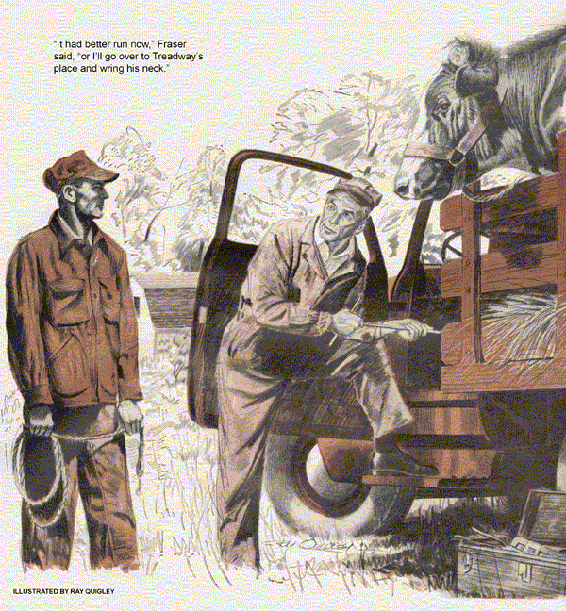
The opening day of the annual county fair was always a hectic one for Gus Wilson and Stan Hicks in the Model Garage. The town's merchants were busy arranging booths to display their products. Farmers and ranchers brought in their prize livestock and produce, their wives and daughters entering their choicest cookery. Competition was keen for the various blue ribbons and other awards of merit. On this day the county really hummed.
The day started off badly for the Model Garage.
The telephone was ringing when Gus opened for business at eight o'clock. A customer had wrecked his car 20 miles up the highway and needed a tow truck. Not wanting to leave the garage for any length of time, Gus sent his helper, Stan Hicks, to bring in the wreck. Stan had just pulled out when Barney Overboltz, the newspaper route boy, drove up to the pumps.
"George Fraser wants you to come out on the Big Hill road right away," Barney told Gus. "He thinks that Mike Treadway has jammed his truck in some way, so that he can't enter his prize bull in the livestock show. He seemed awfully excited about it."
Gus chuckled. "Treadway and Fraser are always excited on opening day of the county fair. Since Stan's away with the tow truck, I can't leave the garage - that is unless you'd be willing to handle the pumps while I'm gone."
"Sure thing," Barney said. "My newspapers are all delivered."
With Barney taking care of the Model Garage, Gus tossed his tool kit into his light service car and headed out on the Big Hill. It was considerably overloaded with the largest shiniest-coated Holstein bull that Gus had ever seen, together with a Poland China boar and now, some enormous pumpkins and squashes, and other products of the field. George, his comely wife and their pretty, teen-age daughter, Sally, were peering anxiously beneath the truck, to the accompaniment of assorted bull bellows and pig protest.
"Morning, folks," Gus greeted them as he pulled up and got out his heavy tool kit. "What seems to be the trouble?"
"The motor runs," Fraser said worriedly, glancing at his watch, "but the rig won't turn a wheel. It's eight thirty now and the deadline for entering stock in the livestock show at the county fair is 10 o'clock sharp. This bull of mine is going to take the blue ribbon this year, for sure, if I can get him there in time."
"And," Mrs. Fraser declared, "my upside-down cake has a mighty good chance of winning first place in the cake baking contest."
Sally Fraser turned her big eyes on Gus. "Just wait until Freddy Treadway sees me walk off with blue ribbon for homemade bread. He'll sit up and take notice then."
"With those eyes, Sally," Gus said, "you don't need to know how to cook. Start her up, Fraser. We'll see how she acts."
Fraser started the motor and put the truck in gear, but the vehicle didn't move.
"Probably a broken axle," Gus said, "but it could be anywhere in the drive line. Shut off the motor and I'll see."
With the motor stopped, but the truck left in gear, Gus jacked up one rear wheel. He turned it by hand, let it down and jacked up the other. Finding that he could rotate both wheels without turning over the motor, and doubting that the vehicle would have two broken axles, he dismissed broken axles from his mind to turn his attention elsewhere.
"It just might be a stripped differential," he said. "Start her up and try it in gear again, Fraser, while I check underneath."
Fraser was running the motor in gear with Gus underneath with his hand on the torque tube containing the drive shaft, when Mike Treadway pulled alongside in a three-quarter-ton pickup truck. It contained, as far as Gus could make out, a bull that was a mate to Fraser's. Treadway, a long, lean, cadaverous man, thrust his craggy features out the pickup window and spat in the road.
"Having trouble, George?" he inquired.
"Trouble!" Fraser exclaimed. He shut off the motor to get down and move over to Treadway with his thumbs hooked belligerently in the bib of his overalls.
"It seems to me, Treadway, that I hired your sprout, Freddy, to grease this truck only yesterday. The rig was in good shape then. You don't suppose, Treadway, that the fact that my bull is due to beat yours at the fair has anything to do with my truck's rear end being ripped out now?"
"Your bull beat mine!" Treadway cried, peering at Fraser's animal curiously, as though he'd never won it before.' Now, you wouldn't be planning to enter an animal like that in the fair, would you, George?"
"You know I am," Fraser retorted. "In fact, you've been leaning over my fence, ogling the critter all summer, Treadway, trying to figure out some way to beat him.
If Gus finds a handful of your old bolts and nuts in my differential, I'll come looking for you."
Looking up at young Freddy Treadway, who sat beside his father, Sally Fraser protested. "Pa, Freddy wouldn't do that. He wouldn't do anything to hurt me."
"Hurt you?" Fraser grumbled. "It's my bull that's hurt, not you. With my truck shot, how am I going to get the bull to the fair in time?"
"And then," Mrs. Fraser said, "there's my upside-down cake."
"Upside-down cake!" Mrs. Treadway exclaimed. "My goodness, Sarah, are you going to enter an upside-down cake too?"
"Since Mrs. Treadway could hardly have put bolts in my differential," Fraser said dryly, "let's forget the cakes, shall we?"
"I didn't put anything in your differential but grease," Freddy Treadway protested.
"Maybe your grease isn't any better than your bull, George," Treadway said, grinning.
"Well, we'll be getting on. I wouldn't want to be too late to enter the best bull in the county."
Treadway drove off, leaving Fraser standing in a cloud of dust, muttering threats.
Gus thrust his head out from beneath the truck. "The rear end isn't torn out, Fraser. I had my hand on the drive shaft torque tube when you ran the rig in gear. If the drive shaft had been turning inside the torque tube I'd have felt the vibration. It wasn't turning, so I know that your trouble is ahead of the drive shaft, either in the universal joint, transmission or clutch. Run it in gear again and I'm pretty sure I can locate it."
With the motor turning over in gear, Gus had one hand on the drive-shaft torque tube, feeling for inner vibration, his ear cocked for any sound that might indicate a stripped universal joint, stripped gears in the transmission, or a broken clutch spine shaft. Suddenly a familiar odor smote his nostrils.
"Shut it off, Fraser!" he yelled above the around of the motor.
Gus came out from beneath the truck, took up the floorboards and removed the clutch inspection plate. Peering into the interior with his flashlight, he saw that the uppermost stud bolt, which held the clutch pressure plate to the flywheel, was backed off and loose. He touched the starter button off and on, to turn the motor one complete revolution. It showed him that all the stud bolts, which held the vital clutch pressure plate to the flywheel, were very loose. Using an extension spin wrench, he carefully tightened each bolt, replaced the floorboards, checked the clutch pedal threw for floorboard clearance.
"Try it now, Fraser," Gus said. "That loose pressure plate had your clutch slipping so much that I could smell hot clutch lining. Maybe it won't pull this hill now with this load. The clutch facings may be too glazed and worn from slippage to do the job."
"It had better," Fraser said grimly, "Or I'll go over to Treadway's place and wring his neck. You can bet your bottom dollar that he had Freddy back those bolts off."
Gus shook his head. "I'll admit that the loosening of the stud bolts holding a clutch pressure plate is something that doesn't happen very often, but I'm sure that Freddy didn't loosen these. The dirt on the bolt heads showed that they hadn't had a wrench on them in a long time. Probably the fault lies with the mechanic who installed the clutch. When tightening those bolts against clutch spring pressure a man can be fooled into thinking that they're tight when they're not. Try it and see if it will pull the hill. If you drive as fast as the law allows you'll have time to enter your bull at the fair. It's just a little after nine."
When the truck lunged into the pull, Fraser didn't even look back. He went barreling up Big Hill, while the magnificent bull in the back bellowed tremendously at a comely cow it had spotted in a nearby pasture, no doubt wishing that Gus Wilson had kept his grease-smeared nose out of George Fraser's faulty truck transmission.
Strolling through the county fair with Stan Hicks a couple of evenings later, Gus smiled to himself when he saw the Treadways and the Frasers standing together in the livestock show admiring the blue ribbon that decorated Fraser's bull. They were talking amiably. Freddy Treadway was laughing and Sally was using her big eyes on him.
"If you hadn't proved Treadway's innocence," Stan Hicks said, "those folks would have been enemies from here on out."
"I doubt it," Gus replied, grinning.
"For them, the county fair comes but once a year. Within a month they'd have been leaning over the fence, laughing about it, each one figuring how he could beat the other at the next livestock show."
END

