March 1957

GUS FIXES A TRAFFIC TICKET

by Martin Bunn
Could Gus cop-proof a car
that acted up only over 50 miles an hour -
and then did a snake dance in the middle of the highway?

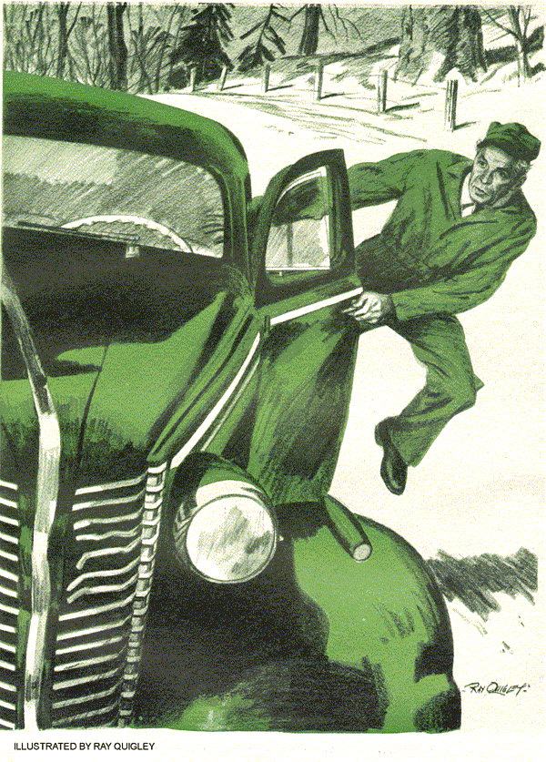
The Model Garage had just opened for business when a call from Judge Morley Walker brought Gus Wilson to the phone.
"Gus," the judge said, "I've a case of traffic violation coming before me later this morning that I'm pretty sure will involve you before it's cleared up. I suggest that you get in touch with Officer Corcoran and discuss the case of the People versus Pearson."
"How's that?" Gus queried. But the judge had hung up.
"Now what have I done?" the bewildered proprietor of the Model Garage demanded of his helper, Stan Hicks.
Stan chuckled, when told the circumstances. "If I were you, I'd call Jerry Corcoran and plead guilty," he advised.
"You're in bad, Gus."
Gus, puzzled, put in a call to Corcoran.
"Pearson?" Corcoran said over the phone. "Why sure, I know all about that case. We're beginning to think this guy is nuts. His record shows that he's been driving for years without a traffic violation. But within the past month he's been arrested three times for reckless driving. I wouldn't be at all surprised this morning if Judge Walker suspends his license for a couple of months."
"That sounds bad, Jerry," Gus said.
"But where do I come in on all this?"
"I wouldn't know." Corcoran said.
"But if Judge Walker called you on it, I've a hunch you'll find out before the day's up."
Gus discovered that Corcoran was right when a long-hooded car pulled up before the Model Garage. Its driver whipped open the door, popped around to lift the hood and peer suspiciously at the motor.
The man was considerably over six feet tall, lean as a plasterer's lath, with a cadaverous face holding an expression of permanent exasperation.
"What can I do for you?" Gus inquired.
"I'm Gus Wilson."
"Listen to the motor run," the man begged. "Do you hear anything wrong with it?"
"Can't say that I do," Gus said, cocking an ear to the idling straight eight motor.
"Sounds pretty to me."
A wild look came into the driver's eyes.
"That's what the cops say. But I claim that this rattletrap misses, turns hand springs under the hood and runs backward half the time."
"Cops?" Gus said. "You wouldn't be Mr. Pearson, by any chance?"
"The same," Pearson retorted. "I'm supposed to be a reckless driver."
"Are you?" Gus asked.
"No!" Pearson cried. "For years I've driven back and forth to my job in Stanfield, 80 miles a day, without a traffic ticket. Then I buy this jalopy and every time I turn around someone blows a siren down the back of my neck. I tell you, it's driving me daffy."
"Tell me about it," Gus said.
"I'm a careful driver," Pearson said, staring around, as if to challenge somebody to dispute his claim. "But when a man drives 40 miles to work he has to move right along."
"Of course," Gus said soothingly.
"Okay," Pearson said. "Now I'm moving along. Everything is fine. The car is running sweet. Then I step on her a bit.
And then - brother!"
"Misses, huh," Gus said. "But why should you be arrested for that?"
"Why should I?" Pearson jabbed a finger angrily into Gus's middle. "Now get this, Wilson. I'm in heavy traffic, and trying to get to work on time. There's one of those crawling characters up ahead.
We're all anxious to get by. Then there's an opening and the guy in front of me zooms around this slow-moving guy.
There's plenty of room for me to get around, too, and maybe some of the cars behind me. So I step on it, and whish!"
"Whish!" Gus echoed. "So you go around. I get it."
"You don't get it," Pearson declared.
"I only go halfway around. Then this belly-flapping, bent-on-the-middle car of mine begins to miss bad. Now, Wilson, what would you do?"
"Flare my stop lights and ease back into line. That's the only thing to do when you start to pass and can't make it."
"Hah!" Pearson snorted in disgust.
"You don't ease back slowly with a motor that's practically running backward. You ease back fast, and the cars behind whomp on their brakes. Tires screech and everybody sticks his head out and makes faces at you and calls you names, and then a cop comes along and you find yourself talking to the judge."
"I see," Gus said. "Why haven't you had the car fixed?"
"Fixed! I've had the dang thing in every garage in Stanfield. How can you fix a car that won't act up unless you're driving 50 miles and hour?" Pearson scratched his head. "Let's get back to my story....
"After easing back into traffic, I pull off on the shoulder and stop fast. I whip out the door, leap to the front and throw up the hood. There she is, just chuckling at me. I keep thinking that if I'm fast enough sometime I'll catch her at it."
"And," Gus said, "you try to be so fast that a police officer calls it reckless driving."
"Exactly!" Pearson exclaimed. "And don't think one of those characters will believe it's motor trouble. They just listen to that sweet-running motor, look up and sort of sneer. That's what I tried to tell the judge this morning. I said, "Now get this, Your Honor..."
"What did the judge tell you today?"
"He pointed his finger at me," Pearson explained, "and said, "You either prove to me that there's something wrong with your car and get it fixed, or I'm going to suspend your driver's license for 90 days, and recommend that you be sent to the county hospital for observation. You can take your car anywhere you like, but I suggest that you see Gus Wilson. This court will accept the decision."
"Hospital observation - good Lord!" Gus exclaimed. "We'd better get busy and see what's wrong with this car."
Gus's first guess was that the car needed a new set of spark plugs - weak plugs would short cut under rapid acceleration. But he was pretty sure that, since other mechanics had worked on the car, he was up against a tougher nut than this to crack. With the uneasy feeling that Judge Morley Walker was breathing on his neck. Gus went to work.
He cleaned and tested the plugs, finding them all right. He checked the ignition points, and the distributor shaft bearing for a loose bushing. He took care to see that the spring tension on the distributor breaker point was not too great, causing bounce and missing at high speeds. He removed the distributor breaker plate and checked the centrifugal wrights of the automatic advance for friction - a slow spark on acceleration would cause a loss of power. He checked the coil and condenser connections.
Turning to the fuel system, he checked the accelerating jet and pump in the carburetor. Next, suspecting stalling due to a low gas level in the carburetor bowl, he checked the float level, cleaned the carburetor, checked the gas line, gas tank cap vent and gasoline pump. He made sure that the intake-manifold studs were tight, with no air leaks.
"Let's road-test her now," he said.
"Better take a road where there's no cops," Pearson warned. "They seem to get hot under the collar every time they see this rig."
Down the highway toward Stanfield, with Gus driving, the car ran smoothly. When Gus found himself clear of traffic he speeded up, then fed throttle as he would if he had been trying a fast pass.
The car picked up speed - then began to miss badly and fall away in power. Gus eased over onto the shoulder, leaped out and popped open the hood. The motor now idled smoothly. After trying this maneuver several times he began to understand the look of exasperation riding in Pearson's eyes.
"Now it's got you doing it," Pearson declared. "First thing you know a cop will come along and slap you with a ticket. You should try this during the rush hours, when folks are trying to get to or from work."
"I see what you mean," Gus told him, a puzzled expression in his eyes. "If I could only get it to miss when it's standing still."
"That," said Pearson, "is just what I've been trying ever since I got the car."
The problem still seemed simple to Gus. The car acted all right when standing still, or when running steadily along the highway, but missed badly on rapid acceleration when the motor would naturally be doing considerable shaking in its rubber-cushioned hangers. There must be a raw or broken wire, or a loose connection affected by the motor shake.
Gus began a thorough search for such wiring trouble. It got him nowhere. He tried the car again anyway - and got the same overall missing and sudden loss of power. It was baffling.
Gus hated, as do all good mechanics, to open a motor wide when not under load, but he felt justified this time. He reached beneath the hood and removed the throttle wide open. The motor leaped from idle to full power without a sign of a miss.
"Peculiar," Gus said, straightening his back. Then a wary look came into his eyes. He twisted the sleeve of his coveralls around.
"That's funny, my elbow's wet. Does this car use much water?"
"No," Pearson said, "but I suppose the service station operator adds some water every time I buy gas."
Reaching under the hood again, Gus gunned the motor to full, his eye on the radiator. As the motor shook in its rubber-cushioned mountings under full acceleration, Gus saw a thin jet of water shoot from the gooseneck of the upper hose connection.
"Ah!" he breathed examining the point minutely. "We've got it whipped. Let's hustle back to the garage."
"What was it?" Pearson asked.
"A tricky combination," Gus told him as they drove. "There's a tiny crack in the pipe where the upper radiator hose attaches and a very stiff upper radiator hose. This crack doesn't leak except under rapid acceleration, when water pressure is suddenly increased and the motor shakes in its hangers. Then the tiny crack opens up and throws a thin spray. It's picked up and atomized by the fan blast, and thrown on the plugs - that's when they short out. By the time you pull over, get out and raise the hood, the heat of the motor has dried off this thin film of water. We'll solder that crack, put on a more flexible upper radiator hose, and your trouble is over."
Pearson said doubtfully, "Can you make the judge believe that, Wilson?"
"He will," Gus assured him. "Don't forget, he took the trouble to look up your past clean driving record, and decided that something here needed looking into before he suspended your license."
"I never thought of it in that way." Pearson said - and, for the first time, Gus saw him grin.
END

