July 1957

GUS BETS ON A SURE THING

by Martin Bunn
The little old man in the station wagon
was dead sure all garagemen were crooks.
That was a challenge Gus couldn't resist.

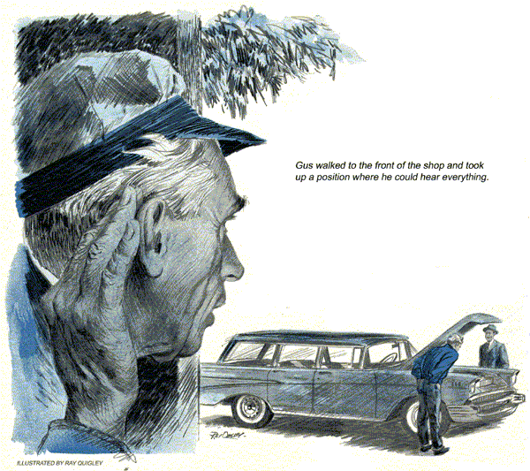
A new station wagon coughed and sputtered and came to a stop at the curb in front of Gus Wilson's Model Garage.
Gus removed his pipe from between his teeth, knocked ashes into the palm of his hand, and walked out to the street.
"Go away!" shouted the driver. "I didn't stop here because I wanted to."
Gus was taken aback. "What seems to be the trouble?"
"Troubles enough! And now I have to stall in front of your place. It's fate.
You're all out to get me!"
"We are?" Gus couldn't suppress a twinkle in his eye. The old gentleman seemed about to pop with indignation, Gus continued; "Something wrong with your engine?"
"You're ding dang well right something is wrong with my engine. It stops for no gol-darned blankety-blank reason. Halfway up a hill. Right in the middle of traffic. Anywhere. Just stops. And now it has to stop in front of your place."
"Let's have a look at it," Gus said, taking a step toward the hood.
The old gentleman flung open the door and pulled himself up to his full height - not much over five feet. "You keep your hands off my car!" he shouted. "You're just like all the others. You want to get at my engine, tinker with something talk me into replacing an expensive part, and then send me on to the next crooked mechanic."
Gus looked at the angry motorist. Here was a job, he realized for a public relation expert.
"Mister," he said soothingly, "I won't touch your car until you ask me to. In the meantime, you just park here as long as you want to." He turned on his heel and went into the shop.
The old gentleman watched him go, his eyes suspicious.
Gus walked to the back of the shop, out of the old fellow's sight, where he found Stan Hicks, his young assistant ready to go home. Gus told him about the apoplectic little man out front.
"Send him on his way," Stan said angrily. "If he thinks we're pirates let him go somewhere else. We don't need him."
"It's not that simple," Gus explained.
"He's stalled out there and even if we don't need him, he needs help. Besides, we can't let him go around telling everybody that all garagemen are crooks. This little old guy is a challenge."
"But how are we going to help him if he doesn't want help?"
"Look," Gus said, "he doesn't know you. Go out the back way, stroll around in the front as if you were just passing by, and get him talking. I'll listen in. Maybe I can tell what's wrong."
Gus walked in the front of the shop and took up a position out of sight, where he could hear everything.
"Hello, friend," he heard Stan say casually.
"Hello, hello," The little old man pulled his head out from under the hood.
"Know anything about cars?"
Stan allowed that he knew a little hit. "But why don't you let Gus Wilson look at it?" he suggested hopefully.
"Who's Gus Wilson?"
Stan pointed to the sign over the garage.
"No, sir!" snapped the man. "I don't mind being stuck once, or maybe twice, but I'm not going to be a sucker for every garageman from here to Florida."
Stan peered at the engine, trying not to act like a professional mechanic. "What seems to be the trouble?"
The old gentleman sighed. "It all started this morning. I was going up the hill just the other side of Riverton on Route 101 when the car went dead on me.
I pulled off to the side of the road and turned the key in the starter switch and she started right up again.
I went along for a mile or so, and she stopped again.
Again, as soon as I turned the key hard over, she started up. Right in the middle of downtown Riverton she stopped again. 'Caused a whole of a traffic jam before I could get going again. People were honking and swearing at me. I took it into a garage there and they looked it over and told me I needed new points. So I said. Go ahead put 'em in," and they did. I paid 'em, drove about a mile and the same thing happened."
"You mean the engine stopped dead," Stan probed.
"I mean dead," snapped the man. "This time I was going downhill. When I turned the key, it started up right away but backfired and blew out my muffler."
"It can happen," said Stan.
"So I went into another garage. This time they said I needed a new carburetor.
So I said,' Go ahead and put it on,' and they did and a new muffler, besides. I paid 'em and drove out of the place and halfway up the next hill, the same thing.
Stopped dead. Just like before. So I drove into the next garage. What do you think they told me?"
"What," asked Stan.
"They told me I needed a new coil and a timing job. So I let them have the car for a couple of hours and went to lunch.
When I got back, they handed me a bill that nearly bowled me over. But I paid 'em and drove off. I got this far and she stopped again. I'm fed up."
"I don't blame you," said Stan. At this point he needed a conference with Gus so he added. "I'll go and borrow a screw-driver from Mr. Wilson. Maybe I can find the trouble."
Inside the shop, Gus was waiting for him. "Quite a tale of woe," he remarked, shaking his head.
"I don't wonder he's sore," Stan said.
"What do we do now?"
"I want to hear the engine. Get him to start it up. If possible, run it up and down, back and forth."
"Know what I think the trouble is?"
Stan offered. "I think he's got some dirt or water in his fuel line."
"Could be," Gus agreed thoughtfully, but let's get the engine started."
Stan picked up a screwdriver and returned to the man and his car. "Mind starting the engine?" he suggested.
The man got in and turned the key.
The engine hummed. Stan listened and looked.
He could detect nothing. Above the sound of the engine, the car radio was merrily blaring full tilt.
"Drive it down the street a way," Stan requested.
The little man had to shout, "how's that?"
"Drive it down the street a little way," Stan repeated above the din.
"Okay," The man put it in gear and the car moved forward. Nothing happened.
Stan waved him to back up. The man put it in reverse and the car moved backward.
About halfway it stopped. There was dead silence. The man's face appeared out the window.
"See what I mean?" he snapped.
"Yes, I see." Stan walked to the car. "Start it up again."
The key was turned, the motor roared and radio blared. Stan was just about to look under the hood again, when the motor went dead.
In the silence that caused, Gus ambled out of the shop. The man in the car regarded him with angry-eyed suspicion.
"What do you want?" he demanded.
"My friend," Gus said easily, "I'm a gambling man. Are you?"
Stan Hick's jaw dropped. He had never known Gus to gamble on anything.
"Maybe I am and maybe I'm not." The old goat replied testily. "So what?"
"Just this," said Gus. I'll bet you I can tell you what's wrong with your car.
And furthermore, I can fix it."
"No sir. You aren't going to touch -"
"Just a minute, friend. Let's put it in the form of a little wager. I'll tell you what's wrong with your car if you'll let me fix it.
After I fix it, you drive on your way. Don't pay me a cent. Drive as long as you want to. When you are convinced that I have taken care of the trouble, you can send me a check."
Curiosity was replacing anger, and the man said, "Well, I don't know."
"What have you got to lose?" Gus asked. "If it doesn't work, you don't pay me."
Suppose it does work and I'm 200 miles away. How do you know I'll pay?"
Gus smiled. "I'm a fair judge of people.
I don't think you'd welch on a bet."
The man put out his hand. "You're on.
Now, what's the trouble?"
"Sounds like dirt or water in the gas line to me," Stan Hicks put in.
"Nope," said Gus. "It's your ignition switch. Stan - er, young man, take my car and run down to the McDonald Agency and pick up a starter switch."
"Now a new starter switch," the old fellow taunted. "You fellows are just parts salesman. Okay, put it in,
But I think it's dirt in the gas line, like he says." He pointed at the departing Stan.
"It's my gamble," said Gus pleasantly.
Help me push it in here and we'll put in the new switch for you."
When the job was done, the little man pocketed Gus's bill and got behind the wheel. He started the engine, raced it a couple of times, and put the car in gear.
Above the noise of the car radio, he shouted.
"Where's the next garage down the line?"
I'll be looking for it in a few minutes."
Gus just laughed.
When the car was out of sight, Stan turned to Gus.
"How could you be so sure of yourself?
It could have been any number of things. It could have been dirt in the fuel line.
You never even looked."
"Didn't need to," Gus said. "I just listened."
"So did I," Stan protested. "But there wasn't anything to hear. First the engine went and then it didn't."
"I didn't listen to the engine," Gus said with a grin.
Stan gasped. "What did you listen to?"
"I listened to the radio," said Gus.
"But what--?"
"Didn't you notice that when the engine stopped, the radio stopped?" Gus said.
"Dirt in the gas line wouldn't have affected the radio. Since he had new points and a new coil, the chances were that the trouble was in the primary ignition circuit, probably in the switch itself. I checked when I installed the switch. I'm not much of a gambler," he concluded. "I just keep my ears open."
Three days later when the check arrived, Gus showed it to Stan. "Take my advice," he said. "Only bet on a sure thing."
END

