December 1957

GUS BAILS OUT A TEEN-AGER

by Martin Bunn
With Christmas coming
and just enough cash to buy his girl a gift,
the kid was stuck in more ways than one.

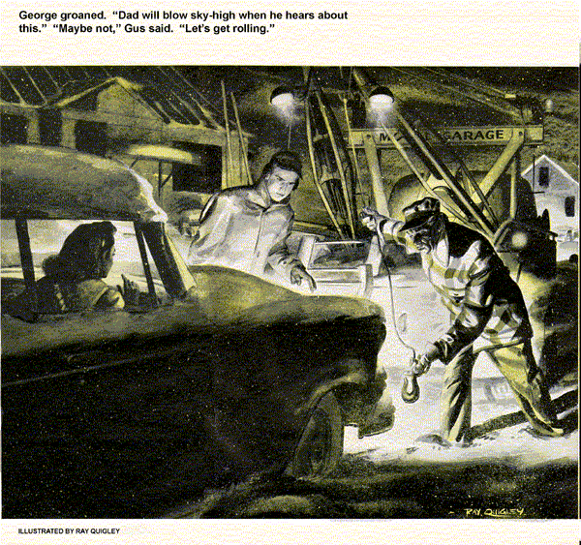
A heavy December snowstorm was in progress when the call from Cynthia Andrews came to Gus Wilson's Model Garage.
"Mr. Wilson," Cynthia Andrews said, relief in her voice, "thank goodness you haven't closed for the night."
"What's your trouble?" Gus asked hoping that he wasn't going to be called out into a storm like this at seven o'clock in the evening.
"My son George just telephoned me that the car is broken down in the snow. I can't think what might be wrong with it. I used it only yesterday, when I went out into the country to buy a Christmas turkey from a farm."
"Things like that happen," Gus said.
"Maybe I shouldn't have given George permission to use the car," Mrs. Andrews continued. "He's only 17, you know. But it wasn't snowing when he left, and it's only two days to Christmas. George wanted to take his girl friend, Lydia Turner, for a ride, hoping to find out what she would like for a Christmas present."
"Well, Mrs. Andrews," Gus interrupted, "if you'll give me the address I'll get going."
"Address? I don't know exactly. It's somewhere on North 128th Street. Do you know where that is?"
"I'll find it," Gus said grimly and hung up, picturing what it would be like now out on 128th Street, which had been newly bulldozed out of weed-ridden lots, at the very edge of the Meadowville housing development.
"Kids can get themselves into the darnedest jams," Gus said to his helper, Stan Hicks, as he climbed into his service truck. "Sorry, Stan, but I guess you'd better stick around until I get back. I may need your help."
Gus drove slowly through the swirling snow. As his windshield wipers labored to keep the glass clear, the long rows of newly built houses in Meadowville passed in ghostly procession.
Snow whipped at Gus's face as he stopped to play his spotlight beam on a street corner sign - 120th Street. He counted the streets as he progressed, finally arriving at 128th, then turned north, hoping that he wasn't already north of the stalled car. He proceeded slowly, sweeping his spotlight back and forth across the thinly graveled thoroughfare, along which houses in various stages of construction stood like rows of snow-clad-skeletons.
When he finally spotted the Andrews car it was so snow blown that at first he took it to be a snowdrift. At his approach, lights snapped on and George Andrews leapt out, waving his arms.
Gus wasted no time. He swung the truck around, backed close, got out and cranked down the winch chain.
"Mr. Wilson!" George exclaimed. "Am I glad to see you!"
"You don't seem to be in deep enough to be stuck," Gus said. "Couldn't you pull out?"
"Sure," George said, "if there wasn't something wrong with the car. It won't pull and there's a grating noise in the rear end."
"Sounds like a stripped differential gear or a broken axle," Gus said. "How come you're way out here on a night like this?"
"I was taking Lydia home. We couldn't see the street signs for snow and drove too far out. When we tried to turn around something went wrong," George groaned. "Dad will blow sky-high when he hears about this."
"Maybe not," Gus said, "Let's get rolling." He stared thoughtfully at the car for a moment. "With rear-end trouble, maybe we'd better play it safe and hook on to the back instead of the front." He moved the service truck around to the rear, attached the winch chain and hoisted the rear end up.
"Okay," he told George, "Here we go."
As soon as he got into the Model Garage, Gus telephoned the Andrews. John Andrews, George's father, answered.
"I've pulled your car in, John," Gus told him. "There's something wrong, but I haven't had time to trace it yet."
"Whatever it is, fix it," Andrews said irritably. "But mind you, don't charge it to me. Make the boy pay for it. It's his responsibility. I'll call a taxi and come down there and drive the car home myself."
"Better give me an hour or so first." Gus said, and hung up.
As he raised the rear end of the car on a floor jack, Gus found himself under the scrutiny of two very worried teen-agers.
"What did George's father say?" Lydia asked. "Was he very angry?"
"Well - not very," Gus said with a smile. "He'll be down later to drive you home."
"Treating me like a kid again," George declared moodily. "I could drive home just as well as he could."
"Sure," said Gus agreeably. "Now let's see what's wrong."
With Stan Hicks easing the car into gear, Gus listened underneath. There was a definite grinding noise, which seemed to come from the differential. The wheels ran jerkily. Gus lowered the wheels to the floor and found that both stopped with the car in gear, motor turning. But now the grinding noise increased in volume. Gus asked himself; a broken axle? or a stripped ring and pinion?
He jacked the rear end up again. When tests showed that the axles were sound, he settled on the differential gears and pulled the differential housing cover for inspection. What he saw astonished him.
The gears were in perfect condition.
"Strange," he mused, "Start the motor, Stan, and turn her over again. Slowly now. That's right. Now put on the brakes."
With the motor turning in gear, the rear wheels locked with the brakes, Gus checked to see if the pinion gear was turning against the ring gear of the differential. It wasn't. The grating noise continued. He ducked under the car, sure now that the grinding sound had been merely telegraphing down the torque tube to the differential housing. He ran his ear along the torque tube.
"Aha!" he exclaimed. "It's in the universal joint."
Taking the universal down, Gus saw at last what had happened. The splined yoke, where it fitted over the drive shaft, had split open, causing the splines to jump over each other so that they failed to drive the rear wheels under load.
Gus installed a new universal joint, and the Andrews car was ready to roll.
Young Andrew was at his heels when Gus went into the office.
"I hope this isn't going to cost too much, Mr. Wilson," he said nervously, "so Dad won't hit the roof when he sees the bill."
"Your father won't see it, George," said Gus. "He said you must pay it."
"He did!" George grinned again. "Gee, Mr. Wilson, I've been socking away part of my allowance for months now, and I've only enough to buy Lydia's Christmas present."
"I'm sorry," Gus said.
"How much money do you have?"
"Ten dollars."
"That," declared Gus, "is just the amount you owe me."
"Gee," the boy exclaimed, handing Gus some crumpled bills, "now I'm completely broke and Christmas is only two days off."
Just then the senior Andrews entered the office. "Did you get the car fixed, Gus?" he asked.
"Yes, and George paid the bill."
"Fine," Andrews said. "Well, get in the car, George, and we'll take Lydia home."
"Aren't you interested in knowing what was wrong with your car?" Gus said to the parent's retreating figure.
"Sure," said Andrews pausing. "What did George manage to break this time?
And how much did it cost him?"
Gus picked up the broken universal joint. "It cost him a Christmas present for Lydia. Ten dollars, to be exact - which was all he had."
"I see," Andrews said. "What were you saying he did to the car?"
"This universal joint split open at the splines, but only because there was an old crack in it that had been there so long it had rusted. It might have gone at any time, John - yesterday, for instance, when your wife was out buying that Christmas turkey."
Andrews bent over to examine the broken part. "You're sure of this, Gus?"
"I'm positive John," Gus said.
"In that case," Andrews said slowly, "I made the boy pay for something that wasn't his fault at all."
"Looks that way to me."
John Andrews stood silent a moment.
"I'll slip the 10 dollars in his wallet after he's asleep tonight. Tomorrow I'll explain about the universal joint."
"That will almost do it, John," Gus aid. Then seeing the new question on Andrews' face, he continued, "the storm is about over, maybe you could ride in the back seat on the way home. When a boy takes a girl out for a drive, he wants her to feel that he's competent to drive her home again."
Andrews looked intently at Gus, "Say, how come a bachelor like yourself knows so much about kids?"
"I'm an important observer," Gus said, smiling slowly. "If I had a son, I'd probably be tougher on him than you are."
"Maybe so," Andrews said. "But I'll take your advice this time, anyway. And, Gus... a Merry Christmas to you."
END

