August 1957

GUS GETS HIS SIGNALS SWITCHED

by Martin Bunn
Did Tony Coskey's negligence cause the crash?
or Had the brakes of Fenton Smith's limousine failed?
Paging Gus Wilson!

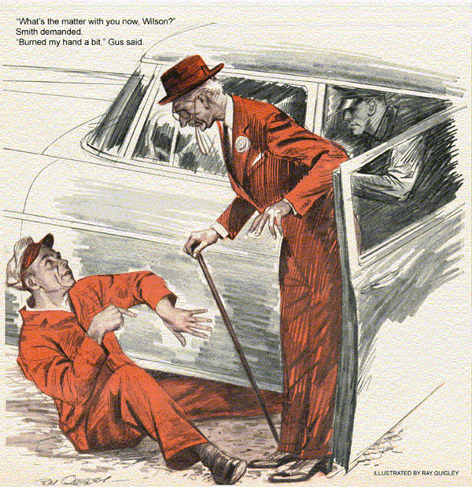
When Gus Wilson and his helper in the Model Garage, Stan Hicks, heard the crash, they rushed out into the street. An amazing sight met their eyes. The long-snouted limousine of Fenton Smith, a wealthy and somewhat irritable financier, had rammed into the rear of Tony Coskey's pickup truck. The impact had caused an assortment of fruits and vegetables to erupt from Tony's vehicle. Melons, tomatoes, grapefruit, oranges and cabbages rolled about under the feet of gathering spectators.
Smith's chauffeur, Bill Sullivan, a burly ex-Army sergeant, sat behind the wheel of the limousine with a stunned expression on his face. Fenton Smith, a thin lath of a man with the predatory features of an eagle, had his head out the window, engaging in heated discussion with Tony. Officer Jerry Corcoran was just arriving on the scene.
"You clumsy ox!" Smith said. "A man isn't safe with you driving that junk pile about. You didn't signal your stop. I'll sue you for damages."
Tony, a squat little man who supported his family by peddling vegetables, looked up at Smith in astonishment.
"But, Mr. Smith," he protested, "you can't sue me. I didn't run into you. You ran into me."
Gus ran his expert eye over the points of impact between the two vehicles, noting that the only damage to Tony's truck was a broken tail light, while the Smith limousine had its very expensive radiator grille smashed beyond repair.
"That grille," Smith declared, getting down to look at it, "will cost a pretty penny to replace. Officer Corcoran, since this fellow stopped abruptly without signaling, he's at fault. He should be arrested for reckless driving."
At first glance it seemed ridiculous that the testy financier should blame Tony for the crash, since his car had struck the truck. It was entirely possible that Tony's stop light hadn't been functioning. If so, and if Tony had failed to signal his stop with his hand, Smith might be able to make his charges stick. Since Tony's stop light was now smashed, the answer to the question of fault seemed to be with Bill Sullivan. Jerry Corcoran's eyes turned questioningly to the chauffeur.
"It wasn't Tony's fault, Officer," Sullivan said, breaking the stunned silence. "His stop light flashed. I wouldn't have hit him if my brakes hadn't failed."
"Brakes failed!" Smith roared glaring suspiciously at Sullivan. "Rubbish, I don't believe it."
Jerry Corcoran inquired softly, "And why would you think your own chauffeur would lie about the accident?"
Bystanders glared knowingly at one another, for there wasn't a person present who didn't know that Tony Coskey had served in the Army under Bill Sullivan, and the two were fast friends. It could well be that Sullivan was taking the blame for the crash on his own square shoulders to spare his friend.
"You'll do well to remember who pays your salary, Sullivan," Smith said angrily. "Covering up for this fellow will only get you fired."
"Sorry, sir," Sullivan said firmly. "The brakes failed."
"Check these brakes, Wilson," Smith ordered.
Gus got in the limousine drove it back and forth, supplying the brakes. The firm resistance of the brake pedal, the instant response, told Gus that, at the moment anyway, there was nothing wrong with the brakes.
"They seem to be all right now," Gus said, "but -"
"Don't give me any buts, Wilson," Smith interrupted. "Check the brakes thoroughly. If there's nothing wrong with them I'll get a new chauffeur and Tony Coskey can pay the bill for the repairs on my car."
Sullivan said, "But I tell you, sir -"
"We've heard enough from you, Sullivan, for one day," Smith said, "Get on with it, Wilson."
As Gus drove the car into the Model Garage he could see Tony Coskey bustling about, gathering up his fruits and vegetables. From the miserable expression on his face, Gus knew that the little man realized a new grille for Smith's limousine would cost him more than he could hope to make in a month.
Gus had never liked working on Fenton Smith's car while the owner was around. The eccentric bachelor was inclined to look over his shoulder, complaining, issuing orders. Now Gus found, Smith was even more suspicious than usual, undoubtedly feeling that all hands were against him to get Tony Coskey off the hook. Smith watched every move Gus made as he worked on the brakes.
Perhaps, Gus thought, the hydraulic fluid was low in the master cylinder, admitting air into the system to cause brake failure. The air might escape to restore brake action when the brake pedal was pumped. He checked the master cylinder fluid level through the inspection hole in the floorboard.
Finding plenty of fluid, he thought of a cocked and frozen wheel cylinder piston, then dropped the idea. This would lock only one brake. Ample hydraulic fluid seemed to rule out hydraulic fluid leaks, but to make sure Gus inspected the system for leaks. There were none. The brake pedal lacked that springy, spongy feel that would indicate weak hydraulic hoses.
Under pressure, bad hoses could swell to increase the fluid capacity of the system, and so delay the brake action. Gus inspected the hoses themselves as a double check. Everything seemed to be in good working order.
"Drive the car back and forth while I watch it, Stan," Gus told his helper.
"Step on it hard, so I can see if brake action is even."
Stan drove the big car back and forth on the garage floor.
"Enough of this, Wilson," Smith said impatiently. "Any man can see that those brakes are all right. Sullivan lied."
"Your brakes seem to be all right," Gus said thoughtfully, "but your stop lights aren't working. They didn't flash on when Stan used the brakes."
"Not working!" Smith exclaimed. "Fix them then - I'm in a hurry."
"Just a moment," Gus said. He dropped onto a creeper to slide under the car, emerging almost at once, to remove the red lenses from the stop lights. Inspection proved that the bulbs were sound.
"We'll road-test her," Gus said.
"With the stop lights out?" Smith protested. "Fix them first."
Gus smiled disarmingly. "A road test may show why they don't burn. I'll signal my stops by hand."
Smith got in the back seat. His eyes came to rest on his chauffeur, up front with Gus, and a look of suspicion came over his face. "You come back here with me, Sullivan," he ordered. "I'll have no conniving between you two."
Gus drove slowly through traffic. At the first stop he signaled with his hand, but his eyes moved to the ammeter. From the rear, Sullivan noticed this and a puzzled expression came into his eyes.
Gus drove out to a country road at the edge of town, speeded up, began to apply the brakes intermittently.
"Is this necessary when testing stop lights, Wilson?" Smith demanded. "Anyway, you can't see them from where you sit."
"I can tell if they go on by a watching the ammeter," Gus explained. "I'm testing the brakes now."
"Brakes!" Smith rose in his seat like a hooked salmon. 'You said the brakes were all right, Wilson."
"I said that they seemed to be all right," Gus reminded him. "Now my theory is that - whoops!"
As Gus hit the brake pedal it plunked suddenly to the floor without effect. The big car careened on without hindrance. Gus brought it to a stop with the emergency brake, leaped out to wriggle beneath it. He came out immediately, shaking one hand with a pained expression.
"What's the matter with you now, Wilson?" Smith demanded.
"Burned my hand a bit," Gus said. "I found that stop-light switch a bit warm when I checked it in the garage, but it sure is sizzling now. No wonder your brakes failed, Sullivan."
"What has a stop-light switch to do with my brakes?" Smith asked sarcastically.
"Plenty, in this case," Gus explained.
"This stop light switch is located on the end of the master brake cylinder, and is operated by hydraulic fluid pressure. It's shorted out. When Sullivan drove in heavy traffic, using his brakes often, the shorted switch got so hot that it caused the fluid to boil. Boiling fluid will create gas I the brake lines, which has the same effect as air in the lines, bringing about brake failure.
"When I found the switch warm in the shop and then saw that the stop lights weren't burning, even though the bulbs were sound, I figured a dead-shorted switch. Some inferior grades of brake fluid have low boiling points - in fact some states have passed laws setting up minimum specifications for the fluid. I'd better check and see what kind of brake fluid Sullivan has been using."
"But you said that the brakes were working when you tested them in the street," Smith said.
"Brake fluid gas will condense again as it cools," Gus said, "and the brakes will work normally again. I didn't check your brakes, Mr. Smith, until quite some time after the accident occurred. I'll install a new stop light switch to correct your trouble. Now about Tony Coskey's tail light, I'm sure -"
"Mr. Wilson," Smith interrupted, and for the first time since Gus had known the testy old codger, there was a twinkle of humor in his eyes. "What a pity you're not a lawyer. I could have used you in one of my corporations. What a beating I'd give Hastings and Company in that lawsuit - er, of course. I'll repair Mr. Coskey's car. Now, since I'm a very busy man, shall we get along?"
END

