October 1956

GUS SAVES THE LIVESTOCK

by Martin Bunn
The local critters wouldn't stay alive long unless...
Gus solved the mystery of Pete Blinstock's crazy driving
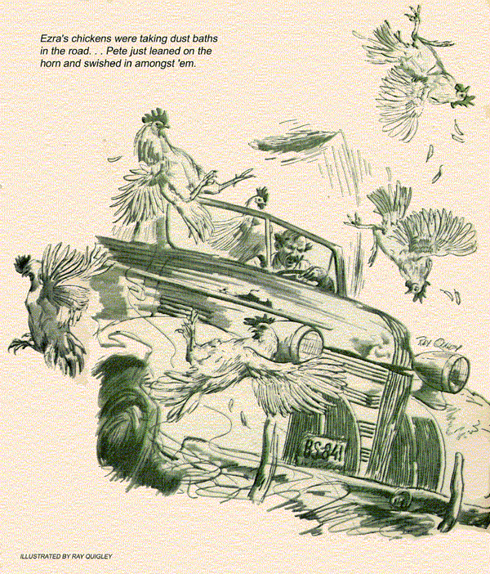
When Gus Wilson heard the rumor that Pete Blinstock was getting so old that he was entertaining his second childhood he got a chuckle out of it. The rumor originated with Pete's rather excitable neighbors, Ezra Hendricks and Tom Hanratty. These three old codgers, who owned adjoining farms at the edge of town, were really the best of friends. But they took great delight in needling each other unmercifully.
"I tell you, Gus," Ezra Hendricks confided, his gray beard fairly crackling with indignation, "Pete's getting so old that he's beginning to slip his cable - acts like a Plymouth Rock pullet with her first egg."
"That's right, Gus," Tom Hanratty declared. "Only yesterday he scooped up my bull and plastered it against a rail fence."
"Scooped up your bull!" Gus breathed. "Now wait a minute, boys . . ."
"It's a fact," Hanratty insisted. "I was leading my bull across the road when here he came, around the corner and down the hill on two wheels in his old rattletrap, foxtail waving in the breeze, scooped up my bull on his front bumper and slewed it into the fence."
"Foxtail!" Gus ejaculated. "Do you mean to tell me that Pete Blinstock is running around with a foxtail on his car?"
"Right," Ezra declared. "And, if you ask me, with scrambled brains."
"Can you picture Pete Blinstock," Stan Hicks, Gus's helper, said, mirthfully, after the two men had left the Model Garage, "dashing around with a foxtail flying from his radio antenna?"
"Yes," Gus chuckled, "I can. Since Ezra and Tom are always making fun of Pete's car, it would be just like him to wave that foxtail in their faces just to get back at them. And it would be just like Tom Hanratty to lead his bull slowly across the road just as Pete Blinstock came along, to get a rise out of him."
Gus didn't see any of the three for a few days. Then, one afternoon, they drove into the Model Garage in Pete Blinstock's car, buzzing like a trio of angry hornets.
"This has gone far enough!" Ezra Hendricks yelled, shaking his finger under Pete Blinstock's nose.
"We've got the evidence on him this time, Gus," Tom Hanratty declared, holding up three very lively White Leghorn pullets with their legs tied together.
Gus could hardly hear himself think with the yelling and the cackling of the outraged chickens.
"If you weren't too dang tight to feed your chickens, Ezra Hendricks," Pete roared, "they wouldn't be pecking around in the county road where they could get scooped up--"
"Easy now," Gus stepped into the mix-up with a broad grin. "What's this really about?"
"My chickens," Ezra said indignantly, "were taking dust baths in the road, but did Pete slow down? Not on your life. He just leaned on the horn and swished in amongst 'em."
"So," Hanratty said grimly, "me and Ezra got together for a showdown."
"Showdown my eye!" Blinstock retorted. "If they'd keep their stock out of the county road, Gus, everything would be all right. If there was another way around, besides down that hill in front of their places, I'd take it. But there isn't. Now and then my car slips out of gear on the downgrade, and before I can clap on the brakes, away we go. And here's their stock all over the road…"
"Hold it." Gus held up his hand. "Let's forget the livestock for a minute. Did you say that your car slipped out of gear on the hill, Pete?"
"That's right," said Pete, "and that's what I'm here about. I wouldn't put it past these two characters to have had a hand in this gear-jumping business. Mighty peculiar, ain't it, Gus, that the hill in front of their places is the only hill where my car slips out of gear?"
"I wouldn't know about that," Gus said grimly, "but if your car is slipping out of gear, Pete, you'd better have it fixed, and quickly."
"Pay him no mind, Gus," Ezra said. "That's just one of his slippery alibis. There's nothing wrong with his car that hasn't been wrong since it came over on the Mayflower. And it's only been the past few days that he's taken to cutting up didoes with it, like a teen-ager."
"Maybe," Gus commented, rolling out his tool bench, "but I think we'd better take a look anyway."
Gus's first thought was to check and see if the studs which held the transmission to the bell housing were tight. When he found that they were, he checked the drive-shaft universal joint for wear and looseness. Finding nothing seriously wrong here, he then checked the U bolts at the rear springs, thinking that looseness might have caused them to shear the centering pin on one spring or the other, causing it to move about and throw the drive shaft out of line.
Gus found his mind occupied with Pete's statement that the car only flew out of gear on the particular hill in front of the farms of his two neighbors.
"Let's go for a drive," Gus said.
"We'll go along, Gus," Ezra announced firmly. "We want to be on hand when you get the goods on him."
With the trio in the car with him, Gus drove around town, putting the car down the Pine Street hill. Everything seemed to perform perfectly, except the brakes, which certainly did need attention. In fact, Gus was vaguely disturbed because things functioned too perfectly. It seemed to Gus that the last time he had driven Pete's car the clutch had been grabby, and that he had recommended that it be worked over. It occurred to Gus that the hill before Ezra's and Tom's places broke over a rocky ridge and that it made driving pretty rough.
Accordingly, he drove Pete's car out to a hill that was similar and started down it, putting the car against compression. He was halfway down when it suddenly jumped out of gear. The sudden release of the holding power of compression caused the car to shoot away like a rocket. Gus slammed on the brakes and managed to come to a shrieking halt that caused the chickens to cackle loudly in protest.
"There," Pete crowed. "You see, it does slip out of gear."
"Probably," Ezra said sourly, "pulled out of line by that foxtail waving around in the breeze."
"I didn't put that thing up there," Pete protested, "and I wouldn't have left it up there if you fellows hadn't got your wind up over it so much."
"You didn't put it up there?" Gus queried.
"No," Blinstock said. "Tony Triesta hung it there - you know Tony, Gus."
Gus did know Tony, a lad who lived down the road from Pete a couple of miles, who had a shine on a girl over in Stanfield, and a great yen to become a mechanic like Gus.
"How," Gus queried, "did Tony happen to do that?"
"Well," Pete said, sort of shamefaced at being caught in a kindly deed, "you see, Tony hasn't a car of his own and he was in a lather to take that girl friend of his out in Stanfield. So I let him use my car over a weekend. He tied the foxtail on the thing. He's a nice boy, Gus, and proud. He didn't want to be beholden to me for the use of the car, so he paid me back by putting in a new clutch plate."
"He put in a new clutch plate!" Gus breathed. "I see."
Gus did see. Tony, in his zeal to become a mechanic, had rigged up a workshop in his father's machine shed, where he tinkered on his friends' cars, and worked on the farm machinery.
"Maybe," Gus said thoughtfully, "we'd better have a look at your transmission. Let's go back to the garage…
When Gus pulled the four studs that held the transmission to the bell housing, slid the transmission back and shone a light on the two milled faces, he found a small bit of gravel, crushed by the pressure when the stud had been tightened. He cleaned the milled faces and bolted the transmission tight against the bell housing. "That shop of Tony's--" he asked Pete, "it has a gravel floor, doesn't it?"
Pete nodded.
"Well," said Gus, "when Tony put on your new clutch plate he picked up a bit of gravel - just enough to tip the transmission over out of line with the clutch. That threw the car out of gear when going downhill against compression."
"But it's all fixed now, eh, Gus?" Pete wanted to know.
"No," Gus said flatly, "it's not. It won't jump out of gear any more, but you have no business, Pete, running around with such poor brakes, and you know it."
"You might as well talk to a post, Gus," Ezra Hendricks cackled. "Pete's so tight that he wouldn't dig up the money for a brake job unless you hog-tied him and pried it out of him with a crowbar."
"Is that so!" Pete shoved his nose practically into Ezra's bushy whiskers. "Well, I'll show you a thing or two. Gus, put on the best brake lining you've got. Ezra Hendricks, get your whiskers out of my face or I'll…
Gus winked broadly at Stan Hicks as he prepared to do the brake job. The three old codgers watched him for a few minutes, and then went down to the drugstore together for an ice cream soda.
"Human nature," Stan Hicks remarked, "is sure peculiar. Isn't it though?" Gus chuckled as he pulled a rear wheel.
END

