June 1956

GUS BAITS A TRAP

by Martin Bunn
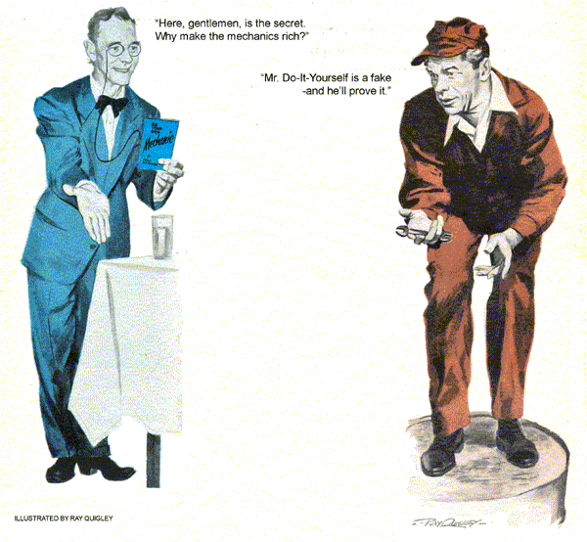
"I want to give my car a pill," said the seedy little man, adjusting his pince-nez glasses and fixing Gus with a glittering, if watery, eye. "Be so good as to let me have a pint of gasoline to wash it down with."
Gus took in the customer and his small '49 car at one glance. - One was as pompous as the other was ordinary.
"I don't know much about giving pills," he said easily. "What are they for?"
"They improve the gasoline mileage by 200 percent." He showed Gus a bottle containing small red pills. On the outside was printed "GAS-O-MORE - ADDS MILES TO YOUR MILEAGE."
"Take my advice, mister, and don't use them." Gus told him. "If you aren't getting good mileage, you probably need a tune-up."
The man took off his glasses and let them hang by the long black ribbon around his neck. "I figured you'd say something like that. You mechanics are all the same. Want to get your hands on a man's car. Expensive tune-ups. Not me, I do all my own work. I'll put you fellows out of business one of these days."
Gus couldn't help being amused. "How?"
The little man returned the pills carefully to a suitcase on the front seat. Then he handed Gus a business card which read: "Philo Dittington, Mr. Do-It-Yourself, Author, Lecturer."
"Why, sure!" Gus exclaimed. "You're going to talk at the Business and Professional Men's Luncheon Club this noon." He extended his hand. "Let me be the first to welcome you to our town."
Mr. Dittington put a small, paper-bound book into Gus's outstretched hand.
"This is my book on servicing your own car. It's called: Be Your Own Mechanic. Only a dollar. Might give you some pointers."
Gus laughed. "I'll wait until after the lecture to do my homework. I'll see you this noon." Philo Dittington got into his car and stepped on the starter. The engine ground over and over with a tired whine before finally catching.
"Wouldn't be surprised if your car needed a little attention." Gus said. "Maybe the plugs or points."
"I know," retorted Dittington. "It's the points. I happen to have a new set in the glove compartment. But you're not going to get the job. Right after my lecture, the president of your club is going to put them in for me."
"Fred Pettigrew?" Gus exclaimed.
"He's a dentist. What he knows about engines wouldn't fill the reverse side of a postage stamp. I take care of all the work on his car."
Philo Dittington smiled smugly.
"Don't worry my good man. Each of my lectures ends with just such a demonstration. With the aid of my principles of self help, Dr. Pettigrew will successfully install a set of points in my car. Come and see for yourself."
"The points in the car now," Gus inquired. "Did you put them in yourself?"
"No, sir. Just bought this car, Second hand. No sense to buying new cars when with my book I can fix anything that goes wrong. Good day, sir."
Gus arrived at the Community House at a quarter of twelve. Most of the membership of the Business and Professional Men's Luncheon Club was on hand. And already word had gotten around that their president, Fred Pettigrew was going to install a new set of points in the speaker's car.
Jack Bishop took Gus aside. "Is this guy nuts?" he demanded. "Imagine letting Fred Pettigrew get under the hood of a car! Shouldn't we warn Dittington?"
Gus stroked his chin thoughtfully. "I'm more inclined to think we ought to warn Fred. I have a hunch that this Mr. Philo Dittington is an outright fake."
Bishop stared. "How come?"
"Just suppose Fred does succeed in installing those points, don't you suppose that most of the people here will buy a copy of Dittington's book? And that this Dittington will tell the whole town that the club's endorsed him? He's carrying some pills that are supposed to extend gas mileage. I figure he'll try to sell those at a fancy price, too. They're strictly n.g."
"Shouldn't we blow the whistle on him?" Bishop said indignantly. "I'm going to speak to Fred right now."
Gus held out a restraining hand. "Not now. It wouldn't do any good. I have no proof of any kind. We have to let the guy expose himself. Otherwise he'll say I'm persecuting him just because I'm scared that he'll hurt my garage business."
"But how can we get him to expose himself?"
Gus chuckled. "My hunch is that he's already set his own trap. I'll bait it, and I think we can watch him spring it himself. Just don't be surprised at anything I say or do in the next hour or so." He winked at Jack and moved off to the dining room.
When the meal was over, Fred Pettigrew gave Philo Dittington a splendid introduction, which he read from a sheet of paper that Dittington had been thoughtful enough to supply.. Dittington then arose and launched into a smooth, flowery dissertation on the merits of Do-It-Yourself as exemplified in the Ten Dittington Commandments of Self-Help. There was something reminiscent to Gus of the pitch of the old-time snake-oil salesmen, Dittington laced his talk with references to his handbook.
"Here, gentlemen," he told them dramatically, "is the secret of Do-It-Yourself. Why make the mechanics rich?"
Just to show them how simple it all was, he went on, he had prevailed upon Dr. Pettigrew, a distinguished member of the dental profession to give them all a demonstration. When the applause had died down and the meeting was about to move outside, Gus got to his feet.
"Can I have your attention for a moment?" The room quieted down. "I want you all to know that the Model Garage stands behind this demonstration 100 percent."
Cries of "Good for you, Gus!" and "You're a real sport, Gus!"
Gus continued, "You all know I make a living servicing other people's cars.
Just the same, I think the more people know about how to take care of their own cars the better. If Mr. Dittington's book does what he says it does, you will all be better off for buying it. If it doesn't, you can get your money back at the Model Garage."
Again there was applause, and the membership moved out to watch Fred Pettigrew install a set of points.
Gus did not stay for the demonstration. He returned to the Model Garage, put on his work clothes and continued about his business.
Pretty soon Jack Bishop pulled in. His face was red. He was waving a copy of Philo Dittington's book.
"It's jus as you said, Gus. This is a collection of nothing. The only chapter that tells anything at all is the one on installing points. The rest is just a lot of stuff about the Dittington principles."
"Good thing I didn't buy a copy, "Gus said. "I'd be out a buck, too."
"But, Gus, you guaranteed them! You said they could get their money back at the Model Garage. What re you going to do?"
"Sit tight."
Jack exploded. "You should have seen the guy. While Fred was installing the points - and I suppose it was impressive to see him read the directions like a cook book and then do what it said and have it come out right - while Fred was working, the little Dittington guy moved around selling his book. I never saw anything so smooth. And what a line of chatter. Of course a big crowd gathered. He must have sold a hundred books. And plenty of those bottles of pills at two bucks apiece. When Fred had finished and he'd sold his last book, he stepped on the starter and the engine started as smooth as could be. Then he was off. That's when us suckers began looking at our merchandise."
- Gus pointed down the road that came from the center of town. The first two or three of what soon developed into an avalanche of unhappy customers were bearing down upon the Model Garage.
When the dust had cleared, Gus climbed up on an oil drum.
"Gentlemen and members of the fraternity of Do-It-Yourself," he began. The faces turned toward him were friendly because everybody in town trusted Gus.
"How are you going to get out of this pickle?" someone shouted. Gus joined in the laughter.
"You want your money back?"
"You bet we do! You said you'd give it to us!"
- Gus held up his hand. "No, I didn't," he corrected. "I said you could get your money back at the Model Garage."
"What's the difference?"
"The difference is this: You'll get your money back at the Model Garage, but Dittington will give it to you. Mr. Do-It-Yourself is a fake - and he'll prove-it-himself"
"How do you know? We'll never see him again."
"I think you will," Gus assured them.
"I figure it this way. When he left you, he did what any one of you would have done under the circumstances. He went around the corner to count his money.
According to the crowd gathered here, that could take a long time."
"The crowd laughed. "About five minutes ago, he started his car once more, listened appreciatively to the sound of Fred's skillful work. In about two minutes or so, he will come chugging and spitting up the highway, and unless I miss my guess, will stall completely somewhere around the Model Garage."
Exclamations of disbelief greeted this last statement, but just then Jack Bishop called out: "Look what's coming!"
Coughing and sputtering, the car containing Mr. Do-It-Yourself lurched along the street. With a final wheeze it stopped out front.
"Get your money back at the Model Garage!" shouted Gus. The crowd turned as one and swarmed over Dittington.
They soon had their dollars back and were looking to Gus for an explanation.
Gus spoke severely to Mr. Dittington.
"Mister, you got just what you deserved. You're out to cheat the public. Most especially, you discourage people who would like to do things themselves. It takes more than a book of directions - especially yours. Now, do you want me to fix your car, or don't you?"
Dittington cleared his throat. "How much?" he croaked.
"Not a cent. But while I'm working, you stay in your car. This lesson in Do-It-Yourself is for these gentlemen only." He lifted the hood of Dittington's car and removed the breaker arm from the distributor. He took it to the back of his shop, out of hearing of the deflated little promoter.
"Normally this sort of thing doesn't happen." "Gus explained. "But this particular year on this car always gave trouble. Usually the breaker arm fits easily over the pin - not too loose, not too snug. But on this car, a new set of points always has a tendency to be too tight. Being too tight, the friction of its movement on the pin causes heat. The heat causes it to bind. It almost always happens just about a half-mile away, if you put in new points as you got them. I'll take this reamer and make this hole a little bigger. Now it will run free."
"What I don't understand," said Jack Bishop, "is why this never happened to Dittington before."
"He just bought this car a short while ago," Gus explained. "Hadn't had this make before. The ones he'd had didn't have this trouble. Now let's speed the little faker on his way."
In a jiffy the job was done the hood lowered and engine purring. Philo Dittington leaned out the window.
"Sir," he said, his weak eyes moist, "I owe you a debt of gratitude."
As he drove out of sight. Stan Hicks, Gus's helper murmured, "Boy that was close, Gus. Suppose that car had gone more or less than a half-mile? Or that he had taken a different road out of town?"
Gus smiled. "That's easy. We would have gone into the book business."
END

