July 1956

GUS FOLLOWS A FALSE TRAIL

by Martin Bunn
The Model Garageman never expected to see the day
when an old hound dog
would give him a trouble-shooting lesson.
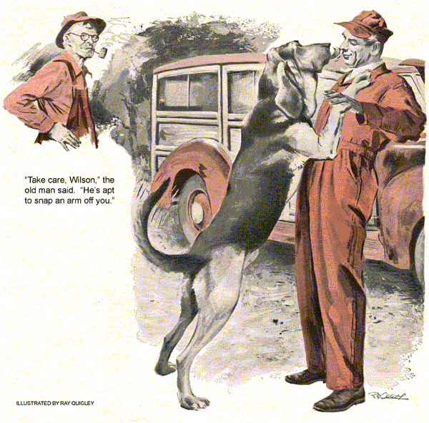
When the aging, mud-spattered station wagon drove up to Gus Wilson's gas pumps, the genial proprietor of the Model Garage moved to attend it. Beside the driver, and oldster in dire need of a haircut and shave, sat the largest, most flop-eared and sad-eyed hound dog Gus had ever seen.
"Are you Gus Wilson?" the old fellow inquired, peering at the Model Garageman with eyes as clear and blue as a mountain lake.
"I'm Wilson," Gus told him. "What can I do for you?"
"If you're as smart as I've been told," the old man countered, "you'll know without me telling you."
Gus chuckled as he cocked an ear to the motor, which was running in a series of staggering gallops.
"Any mechanic who didn't suspect that you had carburetor trouble wouldn't be worth his salt, mister," he declared.
"My name's Smoot - Hank Smoot," the driver said. "I've got a farm up on Peavine Mountain a way. Came to town yesterday to shop and figured on being home last night. I've got 30 miles to cover before dark. If I'm not home tonight, Pete and Patty'll be put out with me - Patty has rheumatiz. I imagine Jasmine will get along - sleeps most of the time, anyway." This is the first time I've been away from home overnight since Ma died. Should have been home last night, but the car got to bucking on me. You know, Wilson, sometimes I think a man's a fool to monkey with automobiles. I recall, back in the old days, when I drove a pair of mules, I was always certain of getting back, I got along fine."
"If you'll drive into the garage up to the workbench," Gus cut in, "I'll get to work on your car."
"Right you are," Smoot declared, shifting into gear, continuing to talk above the roar of the motor.
"Carburetor trouble, eh?" he yelled.
"It's about time I found a mechanic who had something besides bone above his ears."
In the garage, he turned off the motor and got out of the car, the hound dog following him. Gus couldn't resist stroking the dog's head. The hound responded by rearing up to place huge forepaws on Gus's chest.
"Take care, Wilson," the old man warned. "He's apt to snap an arm right off you." The hound lapped at Gus's face with a sandpaper tongue. "Vicious, isn't he?" Gus said dryly. He pulled away, gave the dog another pat and then turned to the station wagon. His ear had told him that here was a car with a badly fouled up carburetor, perhaps caused by leaky intake gaskets. His hunch seemed well founded when he discovered that the nuts holding the intake manifold to the block were loose. Tightening these, however, brought no results. Gus attached his vacuum gauge to the motor, and finding an extremely low vacuum reading, removed the carburetor. "Ah!" said Smoot, who was watching every move. "You put your finger on it first clatter. Well, now, I always say it's what's above a man's ears, rather than the heft of his shoulders, that makes the difference. What's wrong here, Wilson?" My guess, Gus told him, is a faulty gas mixture, caused by an air leak somewhere in the intake system." Gus took the carburetor down, blew out the jets, set the float level, checked the butterfly cross-arm shaft for side play that might admit air, then checked all gaskets carefully, including the air-horn gasket. He put the carburetor back and started the motor. It ran as raggedly as ever. "Guessed wrong, eh," Smoot said, and real worry came to his eyes. "Well, a man's entitled to a wrong guess or two, I reckon. But let's not guess wrong too often, Wilson. I got to get home tonight. My stock will get along, being on pasture, but Pete and Jasmine and Patty are locked up in the shed." "Locked in the shed!" Gus exclaimed. "That's right," Smoot said. "You wouldn't think a cat and dog and a pet skunk would get along together, would you? But they do. Pete, the cat, takes care of the rats. Jasmine handles the mice when she ain't asleep. Patty's the mother of old Blue here, though you wouldn't think it to look at her. How she ever managed to whelp a pup like Blue, I don't know-Blue's the best trail hound in the state." Gus coughed. Patty and Jasmine and Pete - he'd thought they were Smoot's motherless kids. He'd been breaking his neck hurrying for a herd of animals. Now what was wrong with this rig, anyway? Leaky intake gaskets, he'd bet; while these manifold nuts were loose they might have burned. It could be burned intake valves, of course, but there was something about the way she sounded when she came in... Gus broke out a new set of intake gaskets, pulled the intake manifold and installed them. When he started the engine it still ran with that peculiar galloping action.
Gus abandoned the idea of making a rush job out of the wagon. He went to work systematically, realizing that he had been fooled by a strong first hunch into hasty action. He removed, cleaned, set and tested the spark plugs checked timing and cleaned and act ignition points, pulled the valve cover and set the valve tappets, thinking that intakes might possibly be riding open. When he started the motor he found that the vacuum still read the same on the gauge. If he hadn't set tappet clearance, he'd have sworn that the valves were riding open, with badly worn rings and cylinders tapered like ice-cream cones. The thought brought a wary look to Gus's eyes. No, it wasn't worn rings and tapered cylinder bores. The carbon on the spark plugs had been dry, indicating little oil eating, and there had been no excess fumes issuing from the crankcase breather pipe to indicate badly worn cylinders. Hank Smoot, Gus told himself, wouldn't get home tonight. It was going to take a valve grind to fix this one. Gus was so sure this time that when he pulled the spark plugs again and ran a compression test, he could hardly believe his eyes. The gauge showed that compression was about equal on all cylinders and only a few pounds below normal. What have we here, he asked himself, as he dug out and lit his pipe.
"Right smart gadget," Smoot said, looking at Gus's compression gauge.
"But gadgets don't get me on my way. Tell me, Wilson, do you really know what's wrong with my car?"
"No," Gus admitted honestly. "I don't. I thought I did when you first drove in, but when the intake gaskets and the carburetor check didn't do the trick I sort of got off."
"I see," Smoot said soberly. "Just like old Blue here. I recall the time Mose Wallgreen's little tot got lost on the mountain with night and a storm coming down. Cute as a picture she was, four years old, with a pink ribbon to her hair. Folks came racking up to my place after me and Blue, like they always do when anybody's lost or hurt in the hills. Blue got on the girl's trail right away, nose to the ground, tail wagging, like a hound does when he's sure of himself. Then, way up there beyond the ridge, Blue began to act uncertain, back-trailing, sniffing with his head high ..." The old man's eyes became bright with memory, and his wrinkled hands stroked the great hound's head.
"You know, Wilson," he said, "I thought for sure then that Mose Wallgren's daughter was a goner with night coming down and the clouds spitting snow. But Blue turned back and picked up the trail where he'd lost it. We found Mose Wallgren's daughter cuddled up in a pile of leaves, scared but safe."
Gus's mind went back several years to newspaper headlines he'd read, and a sense of shame came to him. He'd been laughing at this bewhiskered old man and his hound, he thought, yet together they had done something that put anything he'd ever done to shame.
"Yes," Smoot declared, "it's the feller who can get off the trail then turn around and admit it, and get on it again, who sets off the powder under the stump."
He'd been so sure, Gus thought, that his first guess was right. Then he'd tried everything, and come up with burned valves. When the compression gauge proved him wrong again, he hadn't known where to turn. Maybe he'd better do some backtracking himself.
Convinced more than ever that his original hunch had been right, Gus began a systematic check of everything that could affect carburetion. Finally he pulled the intake manifold again and inspected it minutely with a pencil light.
Suddenly Gus paused, "Aha, what's this?" he murmured, steadying the light on a pea-sized hole that had been burned through the stack that led down through the exhaust stove to the intake. The gas mixture drawn into the carburetor had been sucking exhaust fumes through the hole, effectively killing the vacuum. Gus sent his helper, Stan Hicks, for a new manifold. When this was installed the engine purred like a kitten.
"Some trails," Hank Smoot declared as he got behind the wheel, "are a mite hard to follow, Wilson, even for old and wise heads. Well, I reckon I'd best be getting on home. Hop in, Blue." Watching the venerable station wagon go down the street, Gus was thoughtful.
"Queer duck, wasn't he," Stan Hicks commented.
"Queer, perhaps," Gus said, "but wise, and the salt of the earth." He chuckled. "Anyway, I never thought I'd see the day when I could learn a lesson in trouble shooting from a hound dog."
END

