February 1956

GUS AND THE NINETY DAY WONDER

by Martin Bunn
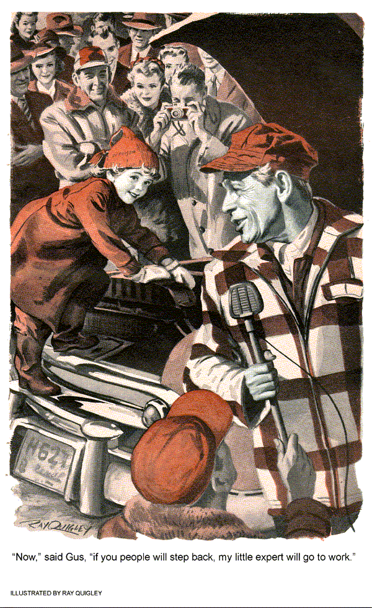
"I just can't figure it out. Gus," Johnny Carter said mournfully.
"This was one of my A-1 cars. 'Had a new-car guarantee. In fact, it was as good as new when it left my lot. But he's claiming all over Capitol City that I cheated him - sold him a lemon."
Gus looked thoughtfully at the young car dealer. "Did you give him free service for 90 days?"
"I would have, but he didn't bring it in until the ninetieth day, and then he just wanted it winterized. I put in winter-grade oil, tuned it, and put in antifreeze. I even wired a little tag to his radiator hose showing how much antifreeze I had put in and that it was good for 30 below - that's one of my little service courtesies."
"What's the matter with his car now?" Gus asked.
"It skips. It went for about 10 miles after I serviced it and then it began to miss. There's a short in it somewhere, and neither my mechanic nor I can find a thing."
Gus said consolingly. "There are cars like that, Johnny. Maybe it is a lemon. It's not your fault."
"Gus you don't understand," Johnny Carter ran his fingers through his rumpled hair.
"When I got out of the service, my one ambition was to have an automobile agency of my own. I took every cent I had and put it into this used-car lot, hoping to make enough money and a good enough reputation so that I could have the new auto agency everybody said was due to be started in Capitol City." He stopped for breath.
"But selling one lemon isn't going to ruin your whole career, son," Gus said.
"Oh, isn't it? The guy I sold it to is the brother-in-law of the man who allots franchises in this part of the state. He can make me or break me."
"Why not buy the car back from him for just what he paid for it?"
"That's what Gruntzman wants me to do. In fact, he's insisting. He says I had it rigged so that it would run for 90 days and then, blooey! He calls the car the Ninety-Day Wonder."
"Gruntzman," Gus mused. "Where have I heard that name before?"
"Only every other hour on station WCAP," moaned Johnny. "He's Grunny Gruntzman of Platter Parade, the disc-jockey show. That's him now!" Johnny indicated the music that was coming from the back of the Model Garage.
The music stopped and a voice came through the loudspeaker.
"Do I seem a little out of breath, guys and chicks?" The voice made Gus think of maple syrup that had been carbonated. "I've been running," the voice went on. "I started for work, like I always do, in my Ninety-Day Wonder, and like always it began skipping and coughing. So I had to push it all the way to the studio." In the background there was a peal of laughter from some studio guest. "It tried to turn in at the lot where I bought it, but I won't let it go home until the jerk that sold it to me gives me my money back. I wonder who he'll sell it to next?"
Johnny ground his fist into the palm of his hand.
"It won't be long before everybody in Capitol City knows who he's talking about. I'll be ruined."
Gus put his hand on Johnny's shoulder. "Son, we've got to prove he's wrong and make him eat his words. You tell him to bring his Ninety-Day Wonder in here."
"I'll do it, Gus. Thanks a lot!" Johnny waved from his car window and was off down the road toward Capitol City.
Gus looked at his watch. It was six-thirty. He walked to the washroom at the back of the shop. As he passed Stan Hicks, he said, "Can you hold the fort until closing time? I'm going to the inter-city basketball tournament with Red Plummer," Red was sports editor of the Capitol City Times.
Stan whistled. "Free seats again, Gus? Boy, it sure pays to have friends in the newspaper business."
The next afternoon Johnny Carter was back again. His face was long. "He won't come," he told Gus. "He just wants his money back."
Gus filled his pipe thoughtfully. "Let me get a couple of things straight, Johnny. Gruntzman had no complaints about the car during the 90-day guarantee period."
"Right."
"He brought it in to have it winterized on the day the guarantee ran out. Was that just a coincidence?"
"I think so," Johnny said. "He liked the car up to that time."
"You tuned the car, changed the oil and put in antifreeze.
Right?"
Johnny nodded. "And you tied a card saying how much antifreeze you had put in and what temperature it was good for on the radiator-hose connection."
"Most service stations don't do that," Johnny admitted, "but I thought people might like it."
"Good. Now you run along. I've got a couple of phone calls to make."
The result of Gus's first call appeared in the Capitol City Times the following morning. It was a small advertisement. "I specialize in fixing Ninety-Day Wonders." It was signed, "The Model Garage, Gus Wilson, Prop."
The result of another phone call appeared as the first paragraph in the column, "Red Plummer Looks At Sports."
As readers of this column know, our motto is: "If you can't be an athlete, be a good sport."
A certain radio disc jockey has been making jokes about his Ninety-Day Wonder, a car he bought from a local second- hand-car dealer. That may be fun for the disc jockey, but it's pretty hard on the man who sold him the car. There is an advertisement elsewhere in this paper by a man who specializes in fixing Ninety- Day Wonders. Do you suppose this certain disc jockey will accept his invitation? Do you think he really wants his car fixed?
Gus turned to Stan, who had been reading over his shoulder.
"Let's hear what the opposition has to say," They walked to the back of the shop and turned on the radio.
A voice faded in. It was Grunny." - but your friend Grunny isn't going to take this lying down. No, sir! I'm going out to this Model Garage this afternoon -"
Stan looked at Gus, eyes widened.
"-and furthermore, since Mad Man Jerk wants publicity in the newspapers for his Ninety Day Wonder. I'm inviting the Capitol City Times to send a reporter and photographer to cover the story.
"Up to now, I've been polite. I've never mentioned the name of the lot that sold me the lemon. But unless this Gus Wilson proves that the Ninety Day Wonder isn't an A-1 lemon, I'm going to run the jerk who sold it to me out of business. If Wilson can fix it and prove to me that the car was all right when I bought it - are you listening, Red Plummer? - I'll give the owner of the lot free plugs for a full year!"
Gus snapped the radio off. In front of the shop there was a screech of rubber as a car pulled up, Johnny Carter came running in.
"Did you hear that!" he cried. "If you can't fix his car, we're both ruined!"
"But I think I can fix his car," Gus said quietly. "And furthermore, I think I can prove that his trouble was entirely of his own making."
"You can?"
"One of his sponsors is Bill's Auto Accessories. He plugs one of their gadgets every week." Gus smiled. "One in particular sticks in my mind.
When I heard him advertise it I thought to myself that it made more sense than a lot of them." Gus stopped to get out his tobacco pouch. "But I had a notion at the time that this gadget might, under certain circumstances cause just the kind of trouble that Gruntzman is having."
Stan said very patiently, "Gus, remember us? What trouble?"
"A short circuit," said Gus. He started to walk to Johnny Carter's car. "Come on, Johnny. You're going to drive me to Bill's Auto Accessories in Capitol City. We'll be back in plenty of time for the broadcast."
AT FOUR-THIRTY that afternoon, there was such a crowd in front of the Model Garage that Jerry Corcoran and two other state policemen were kept busy directing the parade of radio people, photographers, reporters and curiosity seekers.
Gus was the picture of confidence as the Ninety Day Wonder sputtered up to him.
Grunny Gruntzman got out briskly.
He shook hands with Gus, not unpleasantly, Gus noted that, for all his dapper appearance and cocksure demeanor, he had a pleasant rather sincere face. Gus got the distinct impression that Gruntzman honestly believed that he was crusading against the evils of the second-hand-car racket.
A man with earphones on made a signal to Gruntzman. The disc jockey took the microphone. He spoke briefly, outlining what was going on.
"And now," he concluded, "I'm going to turn the proceedings over to Gus Wilson of the Model Garage." Gruntzman handed the microphone to an announcer, who held it before Gus.
Gus said quietly, "Start the car." Stan Hicks jumped in and the motor turned over and then idled. The uneven rhythm was immediately evident. The announcer held the microphone close to it.
"And now," Gus said, as all eyes turned in his direction. "I am going to call upon my Ninety Day Wonder expert to handle this problem." He looked into the crowd and his eye fell on four - year-old Molly Sturgess.
"Will you come over here, Molly?" he called. There was a stir in the crowd. Grunny Gruntzman's face began to get very red. Johnny Carter's eyes nearly popped from their sockets.
"Turn off the motor, Stan," directed Gus. "And then come out and lift the hood." While this was being done, observed, photographed and noted down. Gus bent down and whispered into Molly's ear. So interested was everybody in what was being done to the Ninety-Day Wonder that they didn't notice Gus's brief conference.
"Now," said Gus, "if you people will step back from the engine my little expert will go to work." Molly climbed quickly up on the front bumper, leaned over under the hood, busied herself for a brief moment with her two little hands, withdrew her head and ran back to Gus. It was done so quickly that even the announcer didn't get over to see it.
"Start the engine again," Gus said.
This time the motor sounded smooth, even, regular. A burst of spontaneous applause went up from the crowd. The announcer rushed up to Molly.
"What did you do, honey?"
Gus interposed. "Trade secret," he said. "Isn't it, Molly?"
"Yes, Uncle Gus."
At this point Gunny Grantzman proved himself not only a good sport but a good showman as well. He grabbed the microphone from the announcer.
"Folks," he said, "that gnawing sound you hear is your old friend Grunny Gruntzman eating his words. I guess I owe a year's free plugs to a certain second-hand-car dealer and I might as well give him the first one right now. Come over here, Johnny. Guys and chicks, I want you to meet an honest dealer. His name is Johnny Carter. And if I have anything to say about it, he'll be manager and owner of a new car agency in Capitol City before long. Johnny, I'm sorry for all the trouble I've caused you."
Johnny's face was red. He muttered awkwardly. "It's okay, Grunny. Thanks a lot."
Gruntzman beckoned to Gus. "Folks, I want to introduce the proprietor of the Model Garage. Gus, tell us now, what did you - I mean your expert - do?"
"You've been a good sport, Mr. Gruntzman," Gus said, "so I'll be one, too. When you got your car winterized, Johnny Carter tied a card with a piece of wire to your radiator hose. The card told how much antifreeze you had. After he had done that, and before you left his shop, you had one of his mechanics install a metal support to the underside of the radiator hose. It was a gadget known as a Hosupport."
"That's right. But I don't see -"
"You undid the wire on the card so that the Hosupport could be installed, and then you tied it back on. Right?"
"Yes, but -"
"That's when your troubles began. Shortly after you started your engine, the fan blew the card and wire back until they were right beside the generator. Being attached to the metal Hosupport, it caused a constant short circuit.
"All my expert did was to take off the card and the wire."
One of the radio engineers was making signals to Gruntzman. The disc jockey nodded. "Guys and chicks, this concludes the Grunny Gruntzman show for today. I hope some of you will have learned as good a lesson as old Grunny has. Don't jump to conclusions. So long!"
The radio men began gathering up their equipment. The crowd drifted away. Gruntzman was talking with Johnny Carter about the free plugs he was going to give him. Suddenly the Ninety-Day Wonder began to choke and sputter, and then it died altogether. Stan Hicks looked at Gus. Gus looked at Gruntzman. Gruntzman, his face becoming crimson with anger, looked at Johnny Carter.
"For crying out loud! There it goes again! I've been swindled again! I -"
"Hold on, Gruntzman," Gus said sternly. "remember your advice to your listeners. Don't jump to conclusions. I suggest that you look at your gasoline gauge."
The disc jockey did so. He looked up, his face sheepish. "I'll be darned," he said. "Out of gas, which," he added, "just about describes me!"
END

