December 1956

GUS FIXES AN EGGBEATER

by Martin Bunn
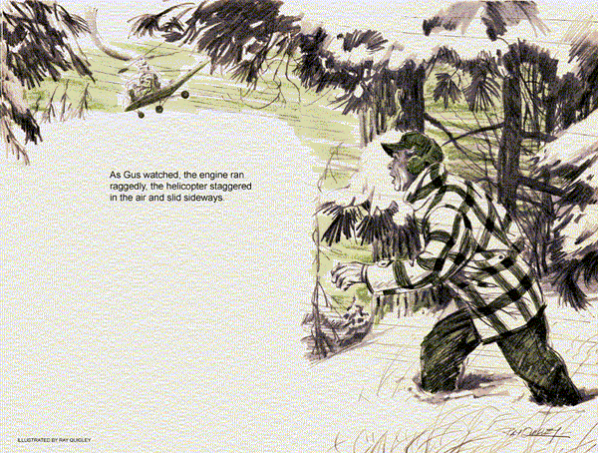
Gus Wilson's service truck was having heavy going of it over the mountain road to Highland.
Snowplows had opened the road after an early winter storm, but now - a week before Christmas - a new fall of snow was coming down thickly. The weather was bitter cold.
The burly proprietor of the Model Garage had pulled up and stepped from the truck to remove a large branch from the road, when he heard the sputtering of an airborne motor.
Wiping the snow from his face, Gus caught a glimpse of a helicopter flying low over the trees across a deep ravine to his right. The awkward-looking machine seemed to be in trouble. As Gus watched, the engine ran raggedly and the rotor blades slowed. The helicopter staggered in the air, slid sideways and dropped into the forest. An exclamation of horror escaped Gus's lips as he dashed down into the ravine.
Gus found himself floundering in deep snow. By the time he had reached the bottom of the ravine and started to climb the other side, he was gasping for breath. Gaining the top, he found that there was still no sign of the downed helicopter.
Then, suddenly, the silence was broken by the outraged bellowing of a voice that Gus knew well.
"By yimminy, this thing goes, or through the snow I walk to Highland."
"Knute Hansen!" Gus exclaimed.
"What in time is that old coot doing up here in a helicopter?"
Gus moved toward the voice and came to a little clearing, where the stricken ship squatted in the snow. Ralph Erickson, a Helicopter Incorporated pilot, and Knute Hansen were walking about, apparently uninjured.
"Hello there," Gus called out. "Is anybody hurt?"
Erickson spun about. "Well, I'll be darned if it isn't Gus Wilson. What are you doing here?"
"I was on a service call to Highland," Gus told him, "when I saw you go down. My truck's over there on the road."
Knute Hansen's pale blue eyes lit up with relief. "I don't worry no more now.
Gus Vilson fix this whirlybird so she flies to Highland to fetch out my Frieda's kiddie."
"Frieda's kiddie!" Gus breathed. "You mean that one of your daughter's children is . . ."
"It's little Inga," Knute said. "She's - "
"She's got appendicitis," Erickson interrupted. "We got a call to evacuate her to the hospital in a hurry. Then this blasted rig began to cut out and we plunked down in the snow."
"Appendicitis!" Gus turned swiftly away and gestured toward the mountain road. "Come on - we'll go on to Highland in my truck."
"You can't get through," Erickson said flatly. "The state police told us that the road to Highland was closed by snow and fallen timber a little way above here. It'll take days to clear it."
"I didn't know," Gus said, and his glance went quickly to Knute Hansen.
Knute, a widower, lived in town, but his heart was never far from his daughter and her family in Highland. A picture flashed through Gus's mind of a Christmas Eve, when he had been a guest in Frieda's home, seeing six-year-old Inga cuddled in her grandfather's arms, the old fellow stroking her yellow hair, his eyes soft.
"We've got to get through," Gus declared grimly, "and fast. What's wrong with this rig, Erickson?"
"It'll take a copter mechanic," Erickson said harshly. "The average mechanic can't touch this thing. And all I know is how to fly them."
Gus walked over to the helicopter.
Looking at the complicated, unfamiliar pile of machinery, he felt a sinking in the pit of his stomach. Normally, he thought, an automobile mechanic would have no right to tamper with this thing, and then tell a man to get in and fly it. With tools produced by Erickson he removed the front cowling plate to expose the six-cylinder, vertically opposed engine.
"She was missing badly when you came down," Gus said. "Sounded like ignition trouble. Maybe you've got fouled breaker points or it could be a shorted ignition wire."
Locating the magnetos, Gus went to work to check them and trace the unfamiliar wiring, looking for loose connections or broken insulation.
Finding nothing wrong here, he began checking generally, not knowing exactly what it was that he was looking for. Perhaps an iced gas line.
"Plenty of gas?" he asked Erickson.
"Sure - I filled up before I left. I'm always careful about that. You see, this ship uses 91/96 aviation gas. Our other one uses 87/88."
"Then this ship uses gas with a lot more lead in it than the other one?"
"Eight times as much," Erickson said.
"We'd better check the plugs," Gus told him. "They might have developed lead fouling."
Gus removed the plugs, his fingers numb with cold. Some of them, the lower ones particularly, had a heavy gathering of lead fouling on the electrodes. A thorough cleaning would require a sand blaster, but he did the best he could with his knife.
"Try her now," he said, when the plugs were replaced.
Erickson turned her over. The engine caught. As it revved up, Gus detected a high-pitched, familiar whine. He brought his hand down sharply. "Cut!" he yelled.
Knute Hansen, who had sprung for the fuselage the moment the motor started, halted in mid-stride, swiveling about to look at Gus with an agonized expression.
"It's all right, Knute," Gus assured him. "The starter clutch didn't disengage - caused by the cold, probably. Try again, Erickson."
This time when Erickson engaged the starter switch the engine didn't budge. The starter seemed completely dead.
"What's wrong now?" Gus said anxiously. "Is there any way of starting this rig without the starter?"
"Not a chance," the pilot told him.
"It's the starter, or nothing."
Gus quickly checked the starter cable and switch, looking for loose connections.
Then he removed the starter, laid it down on the floor of the fuselage and started to take it apart.
Looking down at the damage, Gus stood there with the snowflakes whitening his shoulders, wondering how long it would take them to fight 20 miles through the snow to Highland afoot, and bring back a pain-racked child to his truck.
When the copter's starter had failed to disengage, the engine had spun the armature so fast that one of the windings had been thrown from the armature core slot by centrifugal force. The winding, a piece of copper about a sixteenth inch wide by an eighth of an inch in depth, had become locked between the armature laminations and the field-coil pole shoes. It had been broken in two, twisted around, flattened to knife-blade thinness.
"We're sunk," Erickson said woodenly.
"By yimminy, maybe I better start walking," Knute Hansen said. Looking into the old man's eyes Gus saw the rising panic there, and something else - a question.
"I don't know, Knute," Gus said slowly. "You see, I don't know just how much damage has been done here."
"Lay off it," Erickson said sharply.
"Tell him the truth. You know as well as I do that this starter is completely shot."
"Maybe," Gus said shortly, and with a pair of side cutters he neatly snipped off the broken ends of the armature winding, tapped the stub ends down into the armature core slot, so that they wouldn't strike the field coils. He assembled the starter, with the armature carefully set in a certain position in relation to the brushes.
"Try her now, Erickson," he said.
An expression of surprise came over the pilot's face as the engine turned over, and then caught. The long rotor blades over Gus's head turned slowly in negative pitch. Knute Hansen tumbled into his seat.
"If you manage to get off," Gus yelled, cupping his hands, "don't stop that engine in Highland. It won't start again if that starter happens to stop on the dead commutator bar."
The rotor began to revolve faster. The squat, ugly machine began to rock in the snow, and Erickson gave her full throttle. The helicopter lifted, rose above the trees, its down-wash temporarily blinding Gus with blown whiteness. When his sight cleared he could dimly see the machine in the storm, high in the wintry sky, lined out on a course for Highland.
Gus trudged back to his truck and headed back for town. This was one service call that would have to wait. Then he smiled to himself. If all went well, he was thinking, little Inga would be back home again in time for the Christmas holiday.
END

