August 1956

GUS SEIZES AT A STRAW

by Martin Bunn
The youngsters watched anxiously.
Could the Model Garageman put enough pressure
on a balky pickup to get it over the hill?
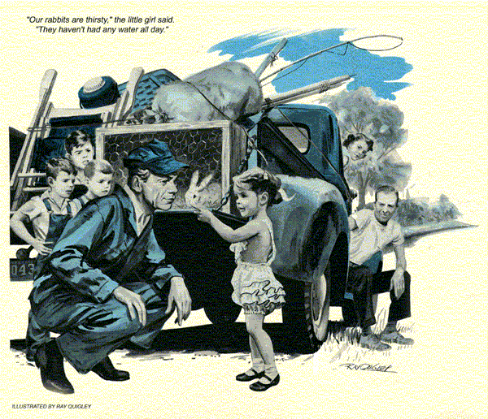
Gus Wilson, proprietor of the Model Garage, came across the stalled pickup on a steep grade on the Cedar Creek route. A blazing summer sun beat down on a startling variety of household goods. Gus, halting his truck behind the pickup, noted a hutch of white rabbits resting on the open tailgate and, inside, several baskets of what appeared to be food, a couple of rolled-up tents, fishing poles, folding chairs, a folding table, and odds and ends of camping gear.
A tall, spare man uncoiled from the shade of the truck to peer uncertainly at Gus.
"I'm Gus Wilson," the Model Garage owner announced. "A passing car told me that you needed a mechanic."
"She won't pull the grade," the man said, his voice holding a note of complete discouragement. "The kids have been looking forward to this camping trip out on Eagle Lake for weeks, but at this rate I don't know if we're ever going to get there. It seems like it takes a mechanic to get us over every stiff grade the last hundred miles."
"I see," Gus said.
"If that's the mechanic," a woman called from the cab, "don't you hold him up with jawing at him, Henry Morgan."
Deciding that he was up against a routine case of gas starvation, Gus blew out the gas line, checked the tank for fuel, inspected the fuel pump and carburetor-float setting. He cleaned the carburetor and filter screen, made sure that the gasket of the ceramic filter unit wasn't sucking air, blew out the carburetor jets, inspected the windshield-wiper vacuum line for leaks and tightened the intake manifold. Then, to make certain that he wasn't scouting the wrong track, he ran a routine ignition check. After that, he started the motor, moved around to look into the exhaust pipe. The whitish color of the inside of the pipe convinced him of good compression and clean firing.
Turning, Gus found himself looking into the eyes of a half-circle of children, ranging from about three to 10 years old. They stood there, silent and big-eyed, three overhauled and cow-licked boys and a tiny, honey-haired girl.
"Our rabbits are thirsty," the little girl said. "They haven't had any water all day."
"Don't bother the mechanic, children," Mrs. Morgan interrupted as she stepped from the cab, a buxom, motherly woman, the strain of worry and heat on her pleasant features.
"No bother, lady," Gus told her, his eyes moving to where the rabbits lay, sides heaving in tortured breathing.
"There's some shade trees over the hill," he told Morgan. "Let's try to pull over. I'll drive right behind you."
The pickup started off with a surge of power. It was about a mile to the top of the Cedar Creek grade and the pickup almost made it before it faltered to a stop and the engine died.
"Made quite a piece," Morgan remarked, avoiding Gus's eyes.
The children descended from the car to swarm around Gus.
"You didn't fix it," the little girl declared accusingly, her eyes straying to the rabbit hutch.
Gus smiled down at her, touched her hair with his hand.
"Why don't you kids get some water from that tank in my service car for your rabbits," he said. "There's a canvas there, too. Put it over the hutch for shade."
Their eyes lit up as they ran toward the service car.
"We're country people," Mrs. Morgan said quietly. "Our kids sort of take to animals."
"I know," Gus told her. He tightened all fuel-line connections, removed the ceramic filter unit and replaced it with a new one. Water and other foreign elements sometimes clogged these units.
"Let's try it again," he told Morgan.
When the motor started, Gus saw the pulsations of the pump instantly fill the glass bowl of the filter element. Then, with the children all aboard, the truck pulled to the top of the grade, where Morgan parked on the shoulder.
"Seems to be all right now," he said. "I'll pay you and we'll be on our way."
Gus cocked an ear to the nicely idling motor, eyes wary.
"Let's get this straight," he said. "You've been calling in mechanics every time you hit a steep grade for the last hundred miles. They always get you rolling over the grades but the trouble occurs again. That doesn't sound right to me - there's something screwy here."
"Seems that way," Morgan said. "You're the fifth man we've had work on this rig. They all seemed to think that they had us fixed up for good. We always hoped that they were right. They weren't."
"Any mechanic worth his salt," Gus said, "would spot this as gas trouble the minute he laid eyes on it. Any mechanic would undoubtedly do the same things I did, and someone has put on a new gas pump recently. What has me puzzled is why these fellows, including myself, got your load over a steep grade if they didn't fix whatever was wrong. Now if you'll pull down into the shade of those trees, I'll take another look."
It was hot, and as Gus walked back to his service car he found himself hungering for a cold, thick, malted milk, so thick that when you tried to suck it up with a straw, the straw flattened and you had to use a spoon. Gus smacked his lips and drove beneath the trees.
He approached the job now with an air of fresh determination. Under the watchful eyes of the children Gus cut the valve stem out of an old inner tube, together with a portion of the surrounding rubber. He removed the gas-tank cap, placed the opening of the bottom of the valve over the tank filler pipe and wound the balance of the rubber tightly about the pipe, tying it securely. He then attached a tire pump to the valve stem and had Morgan pump vigorously as he crawled about under the pickup. He traced the gas line from tank to carburetor for leaks but found none.
He crawled out, lifted the hood and looked at the motor, a baffled expression on his face. He shook the dirt from his graying hair, and with a stubborn look got a jack from the service car.
"Pump a bit more, will you, Morgan?" he said, as he jacked up the rear wheel and rammed his head under the fender.
Slowly, a barely perceptible spot of moisture appeared on the line. It was something that a person almost imagined he saw, disappearing in the heat of the day as fast as it showed.
"Ah!" Gus grunted, pulling his head from beneath the fender, moving to get a hacksaw and brass tubing connector from his kit. He released the air from the line, sawed it in two, coupled it together again.
"I have an idea that she'll take you now," he told Morgan.
"We'd admire to have you eat a bite with us," Morgan said, nodding to where Mrs. Morgan had spread a picnic lunch.
Gus was about to decline the invitation when the honey-haired little girl came to slip her hand in his.
"You're the nicest mechanic we ever had," she declared solemnly. "You saved our rabbits."
"Thank you," Gus told her, smiling. "It's been a long time since I picnicked with a pretty girl."
Sitting in the shade with a sandwich in hand, Gus explained to the Morgans what their trouble had been.
"Lack of gas on steep grades," he said, "is such a common occurrence in this business that we mechanics have pretty well adopted a routine trouble-shooting schedule for it. When I found that several mechanics had worked on your rig, and all muffed it, I knew that it had to be something out of the ordinary. Holes and leaks in gas lines are, of course, common - most mechanics would spot such a thing at once. But this hole was so small that it was practically nonexistent. It neither leaked gas nor sucked air, except when you got on a very steep, long grade with a load.
"You see," Gus went on, "a motor naturally requires more gas on a heavy pull. The gas pump takes a longer diaphragm stroke, creates more vacuum pull on the line. It is also pulling the gas uphill, against the pull of gravity. Only under these conditions did this pinhole in your line cause trouble. I first suspected it when I thought I saw tiny air bubbles in your glass filter bowl just as we topped the grade.
Such tiny bubbles, if the grade were long enough, would build up an air lock in the line and starve out the motor."
"Why didn't those other mechanics find it?" Morgan wanted to know. "They fixed us enough to pull the grades."
"Because," Gus told him, and he grimaced, "of routine procedure in a case like this. Each mechanic immediately uncoupled the gas line and spun the motor to see if the gas pump was working. In doing this they pumped out the air lock and fixed you up so you could pull the grade. Naturally, they did this and that also, and when you pulled the grade they took it for granted that they had corrected the trouble."
"How come you didn't?" Morgan asked.
"I didn't want to be just another mechanic who got the Morgans over a hill," Gus said. "And then I got to thinking about a nice, cold, thick, malted milk, so thick that the straw would flatten when you tried to suck it up and you had to use a spoon. Your gas line couldn't flatten under extra-heavy suction, Morgan, but it could suck air, even through a pinhole."
"I'd like a malted milk, right now - a real thick one," the honey-haired tot said. "Strawberry flavor."
"Stop at the Model Garage as you pass," Gus told her as he left, "and the malted milks will be on me. In fact, I think I'll even have one myself."
END

