September 1955

GUS TAKES TO WATER

by Martin Bunn
Gus's flash lanced out, revealing jagged cliffs.
"We'll be cut to bits." Peter breathed.
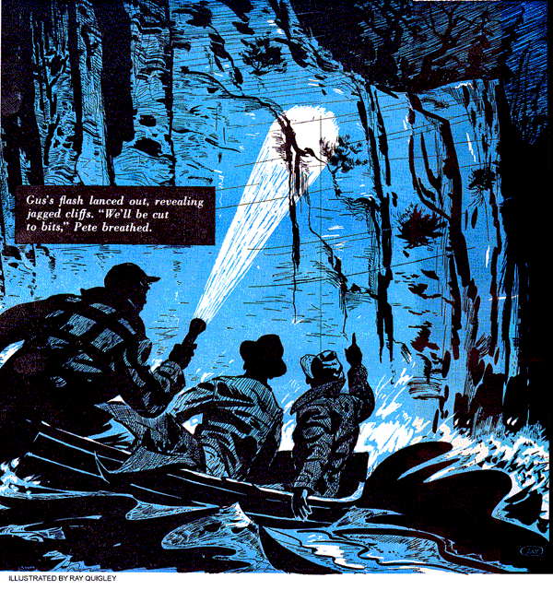
Gus Wilson, genial proprietor of the Model Garage and two fishing buddies were on their long-planned vacation at last. And they were having the time of their lives. On a sheltered cove of a lake in the rugged wilderness of the northeastern highlands of Minnesota, Gus had just hooked the biggest fish of the trip.
"Keep him out of the brush!" Pete Vancourt whooped.
Elmer Stoddard worked determinedly with the oars to keep the 14-foot, flat-bottomed skiff away from the shore. Gus, in mackinaw and tattered hat, leaned into his rod as a monster northern pike went into the air.
"Whee!" Gus yodeled, and his joyous shout was tossed back from the forested peaks surrounding the lake.
Gus finally brought the great pike in close.
"Got him!" yelled Elmer, as he batted the fish over the head with a wild swing of an oar.
"Man, what a fish!" Gus exulted, admiring the green, pale spotted prize. "This one alone makes the long trip up here worthwhile."
"Sure does," Pete agreed. "We'll fish this cove again tomorrow."
Gus looked up at the evening sky. "Right now, we'd better head for camp - we've got 10 miles of lake to cross."
"Let's go," said Pete. He pulled the starter cord on their three-horse Lauson motor. "We'll make camp by dark."
The motor sprang to life and the skiff swung around. As they came out of the sheltered cove they met a stiff headwind which was beginning to pick the lake up into curling whitecaps and a lashing of spray came over the bow.
"Hey," Elmer complained, "Quarter those rollers Pete - what are you trying to do, drown us?"
"Camp," Pete reminded him, "is straight across the lake. I'm not running in circles for a little blow like this. Water'll do you good, Elmer - you haven't washed up since we left home."
"We won't make camp by dark," Gus remarked after a while. "This wind is holding us back. We should have brought Elmer's six-horse motor along."
"Pete's three-horse is better for trolling," said Elmer, tossing a coin expertly in the air and catching it. "Heads, you do the cooking tonight, Gus - tails you wash dishes."
"I lose either way," Gus protested, grinning wiping the spray from his leathered features. "Hey, what's wrong with the motor?"
Even as Gus spoke the motor suddenly died.
"Can't be out of gas," Pete said. "I just filled it today."
"Didn't sound like gas to me," Gus said, whipping out a flashlight. "Keep her head into the wind with the oars, Elmer."
"How can I? I broke one oar on that fish of yours - all I've got now is the handle."
"Fine," Gus said ironically. "Light the gas lantern, will you, Pete? It's there under the forward seat."
Gus bent over the outboard and shut off the gas petcock and the air vent, unclamped the motor and swung it inboard. Spray lashed over the gunwales.
"This motor," said Pete, "is old perpetual motion itself. Never have had any trouble with it before."
"You've given it a lot of use," Gus grunted, taking out the single spark plug. "There's always a first time, even for the best."
"Nothing wrong with it now, I'll bet, but wet plug or wires - man, that wind is sure picking up to blow."
"Maybe it's just wet," Gus placed a big thumb over the spark-plug hole and pulled the starter cord. "Ah, so that's it."
"What's it?"
"No compression," Gus said. "Likely it's valve trouble."
Gus removed the motor skirts, took the cover from the valve compartment, and peered inside with his flashlight. Darkness had now come down in earnest.
"Broken valve spring," he announced.
"We're cooked."
"Cooked?" Elmer poised his lone ear.
"What'll we do now?"
"We'll drift with the wind," Pete said, "until we hit shore, and bail like our lives depend on it."
"Mine does," said Elmer hollowly. "I can't swim."
"Put on a life preserver," Gus told him, "just in case. But we won't have to swim. We'll bail and stay afloat until we reach shore."
"Sounds wonderful," Elmer chuckled, "if we make it."
We'll make shore all right, Gus thought grimly, but what shore will it be? The way I've got this wind drift figured out, we'll hit a mile or so of cliffs that come down sheer to the water, with boulders sticking up. We won't be able to tell which way to dodge until we're close in - then it will be too late. These waves would batter us against the cliffs, even with life belts on.
"Well," he said, "I might as well tinker with the motor - maybe I can fix it."
"Nice way to get out of bailing Gus," said Pete. "You can't fix a broken valve spring."
Gus couldn't open up the motor with spray coming aboard and into the works.
He took a square of canvas they had brought along for a luncheon ground cloth, and with this covered the motor. Down below the gunwales on his knees, he could feel the skiff rise on the waves, fall sickeningly into the trough with a thud. Cascades of spray spattered on the canvas above Gus's head, and above the howling of the wind came the clatter of frantically wielded bailing cans.
Gus pulled the carburetor and moved the exhaust stack, took out the studs and freed the cylinder. He pulled it from the broken-springed valve stem. As he pulled the valve up out of the guide, the spring rolled across the floorboards in two segments.
"I wonder," Elmer called out, the wind whipping his words away. "how far we are from shore? Get to bailing, Pete. Water's gaining on us."
Gus ducked under the canvas again, thinking about that mile of sheer cliffs, where they'd have no chance if they struck. Why, he asked himself, didn't we bring along our spare six-horse job is best for trolling. We're babes in these woods, I guess. How far from shore...how much time do we have left? Suddenly, Gus reached out and dragged his fishing-tackle box under the canvas.
"Hey," Pete yelled, a few minutes later, "we're close to shore. I can hear the wind in the pines."
Gus came out from under the canvas. His flashlight beam lanced out through the heaving blackness, revealing cliffs that stood straight up from the water, angry waves foaming at their base, exposing jagged rocks.
"Good heavens!" Pete breathed. "We'll be cut to bits."
Gus grunted as he swung the motor outboard and clamped it firmly in place, opened gas petcock and air vent.
"Try her, Pete," he said. "You know her better than I."
"Try her!" Pete echoed. "You didn't..."
"Maybe," Gus said. "Try it, man."
Pete shut the choke, cracked the throttle, pulled the starter cord, once, twice, three times. The motor coughed, staggered, cleared its throat and hit smoothly. Glancing at the rocks close aboard now, Pete opened the throttle wide. The motor didn't respond. It sputtered, loaded up, began to die. Gus shut the throttle to slow.
"Easy does it," he said. "That valve spring is too weak to take it fast - slow and steady now, to pull us away."
It was touch and go there for a few minutes, but slow and steady did pull them away, down to the end of the cliffs and to a sandy beach. With the boat propped three-quarters over on sticks to form a shelter, and a roaring fire reflecting heat, the battle of the lake seemed never to have been.
"This is the life," Pete commented, turning a slab of pike on a forked stick over the fire. "Now tell us, Gus how you managed to fix that broken valve spring. 'Seemed impossible to me."
"It was impossible," Gus admitted. "But you know those heavy piano-wire leaders we brought along for muskellunge? I wrapped one of those leaders around a screwdriver that had a shaft a bit larger than the bottom end of the valve guide. The spring I made was too weak to close the valve fast enough for my speed - that's why she died when you opened the throttle."
"But it was fast enough," Pete said fervently, "to claw us off those cliffs.
If we'd hit there we'd have had it."
"You can say that again," Elmer agreed. "I'm glad you didn't tell me about those cliffs, Gus, out there on the lake, I'd have been scared to death."
"I was," Gus said and he meant it.
END

