November 1955

GUS OBEYS ORDERS

by Martin Bunn
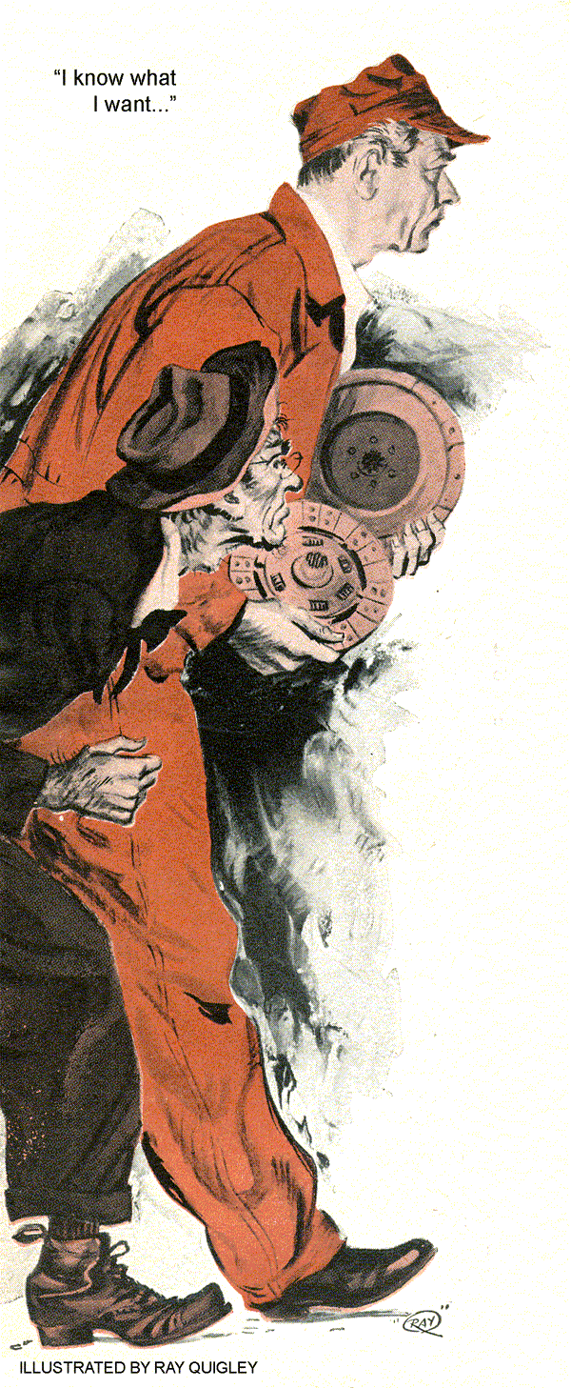
How much would you charge," Silas Barnstable inquired suspiciously of Gus Wilson, proprietor of the Model Garage, "to put a new clutch in my Ford?"
Gus, who was engaged in putting the usual two gallons of gas in Barnstable's dilapidated Ford, could hardly believe his ears. Silas, well known as the town tightwad usually scrounged worn parts from a junkyard, and tried to fix his car himself or hired some kid to do it for him.
"It's about time," Gus said, hanging up the hose, "that you did something about that chatter when you shift gears. Every time you shift, you're in danger of being thrown out of the rig."
"None of your sarcastic remarks," Silas snapped, peering angrily over the tops of his glasses. "What'll you charge put in a clutch?"
"Depends," Gus told him, "on what's required. I can't give you a flat price until I check over the job."
"Oh, no you don't," Silas said warily. "I'm on to how you garage fellers work. You poke around and hem and haw and make believe a lot of things need fixing that don't.
Time you get done, you've chalked up a bill that's worth more than the car."
Gus was tempted to tell the stingy old coot that it wouldn't take much of a bill to be worth more than his third-hand Ford but he refrained from doing so. He made the mistake of trying to reason with Barnstable, making him more suspicious than ever.
"It's this way, Silas," he explained. "You think that you need a new clutch, and from the way your car acts, undoubtedly you do but I can't be sure until I check it out.
This Ford has gone over a hundred thousand miles - loose and worn universal joint, transmission bearings, drive bushings, and even loose truss rods could be causing your chatter when shifting. Even if you do need a clutch overhaul, the price would depend on how many parts I had to put into it."
"Quit beating around the bush," Silas demanded. "Nobody works on my car until I know what it will cost me. If you won't give me a straight answer, I'll take my business somewhere else."
"All right," Gus said wearily. "A clutch overhaul it is. I'll put in an exchange disk, facing and pressure plate, and it will cost you 28 dollars."
Barnstable rose up in his seat like a hooked salmon. "What- d'ya mean 28 dollars" he yelled.- "That's highway robbery."
The cantankerous old codger shifted into low, roared the motor with a clatter of pistons, and lifted his foot from the clutch.
The car leaped from the gas pumps with a shuddering and chattering that threatened to shake off its dilapidated, flapping fenders.
"Take his business somewhere else," Stan Hicks said, coming from the grease rack.
"I wish he would."
"It takes all kinds to make a world," Gus said amiably. "We might even miss the old man if he didn't come around at least once in awhile."
"Why?" Stan queried. "Occasionally he buys two gallons of gas. In the meantime, he fills his leaking radiator and tires with our water and air every day. When he needs oil, he dips it from our waste barrel for free. Most of the bolts and nuts in his old jalopy he filched from our junk box."
"Kind of ingenious character, isn't, he?" Gus chuckled. "I wonder who he'll find to put in a clutch for less than 28 dollars?"
Gus didn't have long to wonder. Barnstable made the rounds of the town's garages, and then showed back at the Model Garage as Cantankerous as he ever was.
"I've decided," he told Gus, "to let you fix my clutch. But mind you, I'll have my eye on you every minute. So don't try slippin' in any beat up parts"
"I won't", Gus promised. "But you'd better let me check the car over first. I might save you... "
Now," Barnstable warned, "don't start trying to hornswoggle me again. I know what I want - just see that you give it to me."
"You're the doctor," Gus said grimly." Back the car under the chain hoist Stan - I'II get right to work on it."
Gus hooked the back of the chassis to a split chain, and hoisted the rear end high. He got under on a creeper, and lay there awhile, looking up at the bottom of the old Ford. The clutch, he thought, would really have to work smooth on this baby when he was finished with it to make her take off without any chattering. "I'll bet every bearing, gear and bushing between clutch and rear wheels could stand replacing," he muttered half aloud. Gus' mind went back to depression days, when junk heaps in this condition had been common. He grunted as he began to unhook spring, universal joint and other connections. He backed the rear assembly out from under, put a jack under the rear of the engine, and removed the transmission. He removed the flywheel housing, prick-punched the flywheel and clutch cover, and eased the pressure-plate tension off carefully by backing off the studs all the way around. Then he removed them and took out the pressure plate and facing disk for closer inspection.
"Hmm," Gus grunted, wiping a slight bit of moisture from the edges of the parts and smelling it. "You've been squirting gas in here recently-"
"It's none o' your business," Barnstable said belligerently. "I'll do as I please with my car."
Gus had a mental picture of Barnstable running around trying to beat down his price, and failing. Then, as a last resort before coming back to Gus, he had squirted gasoline into the clutch in an attempt to wash out grease to stop his chatter. The humorous thing about this was that there was no grease on the clutch facings. Gus began to inspect the pressure plate and disk carefully for cracks, burns, warpage and adjustment of pressure-plate springs.
"Now look here, Gus,"
Barnstable protested. "I was to get new parts. I ain't going to stand for any tinkering around on these old... ."
"All right," Gus interrupted, and moved to draw out an exchange pressure plate and a lined disk from his store in the stock room.
Gus worked systematically to install the parts. In spite of the fact that Silas had insisted that his trouble was caused by a bad clutch, Gus kept his eye open for other easily visible defects, such as loose truss rods and transmission out of line. Gus intended to road test the completed car, but Barnstable got in it and drove out.
"I'll test it myself," he announced testily, as he left with a lurch.
"Brother!" Stan Hicks chortled, "I never expected to see the day when Silas Barnstable would pay for a first class repair job."
Gus poked thoughtfully at a gob of grease that had leaked onto the floor from the old Ford's transmission as it lay there. He got a scoop of sawdust to cover up the spot.
"Yeah" he said finally, "and neither did I. The trouble is, it wasn't a first-class repair job. Barnstable's clutch was bad enough for any normal driver to want to have it rebuilt. But it wasn't bad enough for Barnstable to have wanted it rebuilt. I'm not so sure the clutch was causing his shift shudder and chatter after all."
"You don't tell me" a beauteous expression of mirth came to Stan's face. "Is this good - the old coot paid for a job that, if he'd known it, he might have been happy to go without."
"Maybe," - Gus said thoughtfully. "That's just where the shoe may pinch. What's going to happen if his car shudders and chatters when it shifts the same as it did before? Sounded like it would when he drove out."
"Crimminy!" Stan breathed. "Sure as shooting, the ring-tailed character will come back in here like a mad dog with a tin can on its tail."
Gus shrugged helplessly. "I tried to tell him," he said grimly. 'I wanted to check the car out but he was so darned suspicious. Golly, here he comes now."
Barnstable drove into the Model Garage, brought the Ford to a shuddering halt, and leaped out like a spindle-shanked rooster.
"You gypped me" he yelled. "It's worse than it was."
"Not worse," Gus said placidly. "You got a new clutch-remember."
"I'll sue you," Barnstable threatened.
"What for?" Gus queried, leaning calmly against the bench and lighting his pipe. "You got what you insisted on having, didn't you?"
"That's right, Silas," Stan agreed.
Gus and Stan could see the awful truth now dawning on Barnstable's face - he had guessed wrong, forced Gus to follow his guess and, worse yet, put out money without curing his trouble.
"Do you mean to tell me," he began weakly. "that I... ?"
"No," Gus said, anticipating his words, "I don't. I shouldn't do it, but if you'll quit being so suspicious, and give me a free hand, I'll try to fix you up without any further charge... Where did you get that grease that you have in your transmission?"
"What business is that of yours?" Barnstable sputtered.
Stan Hicks cut in. "He got it," Stan said sharply, "from Robler, when he drained the summer grease from his trucks - Robler told me so himself."
"And," Barnstable said triumphantly, "Robler didn't charge me anything for it, either.
You can still get a bargain at some of the garages in this town."
"Ah" Gus grunted. "So that's it. That grease would be far too heavy for the transmission of your light car, Silas. It could be the thing that's causing your shift shudder and chatter."
"You knew it all the time," Barnstable I didn't," Gus told him, "and I don't know it for sure now. I only suspected it after you drove out when I noticed some of your transmission grease on the floor.
Ordinarily such heavy grease might not cause a car to chatter when being shifted, if the car was in good condition otherwise. But with a hundred thousand miles of wear on transmission gears, universal joint and drive bushings, it could be the cause of it."
"Let's see... Stan drain and flush Silas's transmission and fill it with the proper grease."
When this job was done, a much-chastened Barnstable permitted Gus to road test the Ford. The shift shudder and chatter were largely gone.
"Maybe," Stan Hicks told Gus later, "this will teach the old coot a lesson."
"I doubt it," Gus said. "Hang it all, if a man doesn't trust his mechanic, he'd best hunt up one he does trust."
END

