June 1955

GUS SPARKS A URANIUM HUNT

by Martin Bunn
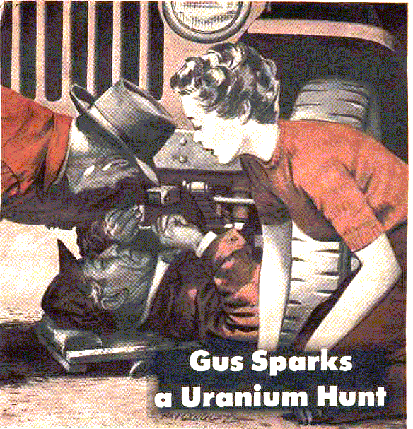
Gus Wilson was considerably surprised, early one morning, when Hank and Nancy Stoneman drove into his Model Garage in their Jeep, only an hour after they had started out on their uranium-hunting expedition. Nancy Stoneman was practically in tears.
"We've planned this trip for so long, Gus," she wailed, "and we've only got a weeks vacation - we can't waste a minute of it."
"Trouble?" Gus asked, not knowing what else to say.
"You said it, Gus," Hank Stoneman said. He heaved his lanky frame from the Jeep disgustedly. "This crate has been running like a watch ever since I got it a month back - uphill, downhill, empty and loaded. But now, when we start our trip, it throws a rod on the first hill."
"Is that all?" Gus spoke lightly, hoping to dispel their gloom. "You'll soon be on your way - won't take long to put in a rod bearing."
"I wouldn't have planned this trip if the fellow I bought the car from hadn't told me it was in fine condition," Stoneman said bitterly. "It seemed to be, too - didn't even have to add any oil during the time I drove it."
Silas Barnstable, who had idled over with Pete Vancourt, looked at the Stonemans and sniffed audibly.
"Maybe," he said sourly, "the automobile ain't one to put up with wild-goose chases all over creation."
"Wild-goose chase!" Stoneman exclaimed." We might get rich. The Government pays big for locating uranium. Besides this is a sort of delayed honeymoon for us - we didn't take one when we were married."
"Honeymoon!" Silas snorted. "Rubbish - chasing around with a tent and skillet like painted Indians."
"Why, you dried up old coot," Pete Vancourt retorted, "Gus and me and Elmer Stoddard plan to live in a tent on our vacation. Come on, Silas, let's get out of here and let Gus fix the Jeep."
"I don't care what he says." Nancy Stoneman's chin came up. "It's going to be fun. We planned to camp at Meeker Springs tonight, but it's getting late."
"You can still make it, Nancy," Gus said, lifting the hood. "We'll have you on the road in no time."
That was what Gus thought at the moment. But when he cocked his ear to the motor, a puzzled expression came to his face.
"Rod out, you say?" he asked. "This motor sounds just fine, if you ask me."
"Don't let it fool you, Gus," Stoneman said. "You should hear it on a hill."
"I'd like to," Gus said, "Jump in and we'll see."
The motor sounded sweet until they hit the first steep hill out of town. Then it developed a knock that did sound considerably like a rod bearing. Gus drove back to the garage silently, his mind searching the possibilities. One bum guess, he thought, and these kids lose a day of their vacation. To them that's a year out of their lives.
Back at the garage, Gus wiggled the throttle from idle to quick pickup, held it at medium cruising a moment. Very queer, he thought. A rod comes in sharpest from idle to pickup, a piston at sustained, unloaded revolutions. But there was no knock there. Could it be a main bearing?
But with the pan off, he could find nothing wrong with the mains. He didn't take any chances on the rods. He pulled the caps, inspected each one for snug fit. One of the center rods had a small piece broken out of the very center of the shell.
"Ah!" Gus grunted, as he pushed himself out to get a new bearing shell.
With this installed, Gus continued to probe for trouble, turning the shaft, watching the rods turn on their journals, looking for side play that would spell misalignment and a possible knock. Then he put the pan back on and poured in the drained oil, which appeared new.
"Just put in new oil, didn't you?" he remarked.
"Yeah," Hank Stoneman said. "Scott changed it last night."
"Fine," Gus said. "Hop in, and we'll try her out."
It seemed to Gus that he'd never heard a smoother-running Willys engine - until they hit the first steep hill out of town. Then the knock came back, as strongly as before. Gus said nothing as he turned back to the Model Garage, but his face was drawn and thoughtful. Nancy Stoneman was eagerly awaiting their return, all smiles.
Gus ran his hands nervously through his grizzled beard, his mind racing. Nothing wrong underneath - it had to be somewhere on top. He found himself taking a compression check, hoping that a sticking valve might be striking a tappet push rod. He checked valve setting, timing, ignition wiring - fiddling around. He looked at the clock - two hours gone.
"Can't you find the trouble, Gus? Nancy Stoneman asked anxiously. "We came to you because we were sure… "
"Thanks," Gus grunted, angry with himself. Was he a mechanic or a backyard tinkerer?
Again he reviewed the facts. Sure he'd found a cracked rod bearing, but the bearing was snug - he felt at the time that it wouldn't have caused that knock.
His ear had told him, right at the start, that the knock was timed to the revolutions of the main shaft.
The trouble was down there - why was he wasting time up here? He crawled under again and removed the pan.
Gus lay there, looking at the bottom of the motor, asking himself what he could have missed here - the mains and rods were right, there was proper alignment and side clearance. A drop of oil fell from the round, floating oil-suction assembly, with its protecting screen. Gus wiped the oil from his weathered cheek impatiently, began to probe the bottom of the motor with his shop light. The shop light was too bulky to be moved about among the rods, so he fumbled out his pencil light, began to play its beam along the shaft.
The brilliant beam of the pencil light was reflected from a tiny bright spot on one of the center crankshaft counterbalances. "Ah!" Gus breathed. "Now what caused that? Maybe the counterbalance has been striking the oil stick."
Gus grunted as he turned the shaft over slowly. No, the counterbalance hadn't been striking the oil stick. There was nothing near enough to strike the counterbalance. And what if there was? It would strike all the time, not just on hills.
Gus was inclined to disregard the bright spot on the counterbalance. Maybe, he thought, he'd scraped the power-bar handle across it when he was taking down the rods.
Another drop of oil fell from the oil float. It just missed Gus's left eye. He snorted as he wrung a greasy knuckle in the eye socket. Then he relaxed and just lay there, looking up at he offending oil-suction float, thinking of knocks that didn't come in for a month, even on hills, and then suddenly came in, and only on hills. He reached up to waggle the oil float up and down for the length of its travel on its movable arm. He crawled out to call Scott Service.
"Scott," he said, "this is Gus Wilson. You've been servicing Hank Stoneman's Jeep. How is she on oil?
"Fine," Scott replied. "That Jeep don't use hardly any oil. It was down a quart when Stonmeman bought it, but seeing that he was soon to start on this uranium-hunting expedition, we didn't add any. We changed the filter and filled her to the mark with new oil last night.
"Thanks, Scott." Gus hung up.
He was like a hound on a hot trail now. He slid under the Jeep and began taking off the oil-float assembly. As he had expected, there was a bright, dented spot on the top. He took the assembly to the bench and worked on it a moment, washed it out, crawled under and replaced it. He slapped up the pan, reached a brawny arm out to his tool kit for a speed wrench. Something in his movements seemed to communicate a sense of success to the Stoneman's. Nancy came to squat down and peer under at Gus. Hank hastened to join her.
"Please hurry, Gus," Nancy pleaded. She added wryly, "We're late for our honeymoon."
Gus smiled cheerfully. "I'll have you on your way in minutes." "What in tunket was it?" Hank asked.
"The oil float," Gus said out of the corner of his mouth as he worked to buckle up the pan. "It works on a moving arm, with a stop that lets it float only so high. This stop has been bent so that the float bypassed it, going so high that one of the crankshaft counterbalances struck it… that knock didn't sound quite like a rod to me."
Stoneman was puzzled. "But why did it strike only on hills - and why didn't it strike until we started our trip?
"That's what had me fooled," Gus chuckled. "It didn't strike before because you were a quart low on oil. It didn't strike even after Scott had filled the pan with new oil to the high mark, until you hit a steep hill. Then the oil ran to the back of the pan and raised the oil intake float high enough so that it did strike. I simply bent the stop back again so it couldn't be bypassed."
Gus chuckled again. "I couldn't find it until it almost spit in my eye. Things like this sure get me down."
"Stoneman laughed. "Don't kid us, Gus. You love it."
"Maybe," Gus said ruefully, "but I sure do get frazzled around the edges sometimes. There, the pan is on. In with the oil and you're on your way. Meeker Springs, here you come."
END

