February 1955

GUS ENCOUNTERS A STUBBORN MISS

by Martin Bunn
Had Miss Wilks lost her head over him? or was it just
a cylinder head that brought the lady to the Model Garage?
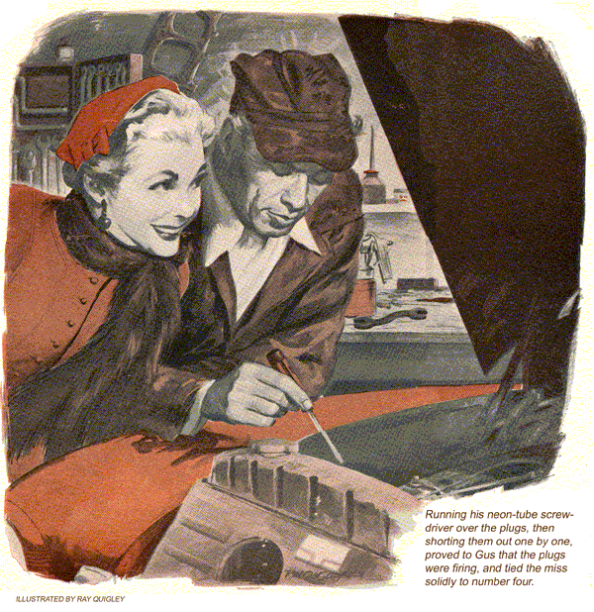
When Emma Wilks, the comely new schoolteacher, drove her badly missing 1948 sedan into the Model Garage, Gus Wilson anticipated nothing more complicated than a routine repair job.
"After all," Emma said, her blond hair tickling Gus's burly neck as they peered beneath the raised hood of the car, "it isn't dignified for a schoolteacher to drive around with a bucking, missing car, is it, Mr. Wilson?"
"No, it isn't," Gus told her, carefully avoiding Emma's big, blue eyes.
Knowing that Emma had but recently bought the used car from a reliable dealer in the city, who had completely overhauled it, Gus at first suspected loose gaskets.
"My, what strong hands you have," Emma remarked as Gus tightened cylinder and head gaskets.
Cylinder Compression Is High
With the motor still missing, Gus ran a compression check and found all cylinders high in readings. Running his neon-tube screwdriver over the plugs, then shorting them out one by one proved that the plugs were firing, and tied the miss solidly to number four.
Full compression on a compression check, with the motor turning slowly with the starter, and a miss while running, with good ignition, suggested a gummed and slowly closing valve. Since the new valve grind made this extremely doubtful, Gus's thoughts turned to a weak or broken valve spring, or too close a valve setting. Removing the valve cover to check this, he was astonished to see one of the half-moon valve keepers of number-four intake valve lying on the cylinder head.
The remaining half of the keeper held the valve, but caused the spring to cock to one side, binding the stem.
"Here's your trouble, Miss Wilks," Gus said.
"I just knew you'd find it," Emma gushed. "You're wonderful."
Red-faced, Gus removed the metal cap that rode the top of the valve stem, to prevent excessive oil from running down the stem, held the valve pried up against the inside of the head with a crooked bar thrust through the spark-plug hole while he compressed the spring and replaced the valve-keeper half. The engine now ran smoothly.
"I just knew I could depend on you, Mr. Wilson," the schoolteacher exclaimed admiringly.
"And you're a bachelor, too, remember, Gus," Stan Hicks chuckled as Emma drove out. Stan hummed the Wedding March as he worked.
Ever since Gus had unwittingly bid on the new teacher's lunch basket at the church box social a couple of weeks earlier, folks had been eager to build a romance between Emma and the town's most eligible bachelor. Leaders in this were Gus's pals, the irrepressible Elmer Stoddard and Pete Vancourt.
"You'll be all wrapped up in matrimony before you know it, Gus," they had told him.
"Emma just bought that car so she could drive it in here for you to repair while she whispers sweet nothings."
"Go soak your heads," Gus had told them angrily. "She hasn't brought the car in to me yet."
"Give her time," Pete Vancourt had grinned. "I'll bet her car develops more mysterious complaints than a 1908 Model T."
And now, Gus thought, smoking at the bench, she had brought it in. But it wasn't a mysterious complaint. Whoever had ground those valves just didn't put the valve keeper in all the way.
But the next day Emma again brought the car in - and Gus found the same valve keeper lying on the cylinder head.
"Now, isn't that strange?" Emma said as she stood at Gus's shoulder.
More than strange, Gus thought to himself as he replaced the keeper, bade Emma farewell and watched her drive out.
"Hah!" Stan Hicks chortled as she pulled away. "What did Elmer and Pete tell you?"
"Now look here," Gus bellowed. "If you mean to intimate that the lady took that valve keeper out herself, just so she would have an excuse to come in here and--"
Gus halted in midspeech, while a wary look came to his eyes.
"But," he demanded of no one in particular, "how in tunket did it get out? Do you suppose that Pete and Elmer sneaked over at night and did it? They could, you know, with Miss Wilks car parked behind the boarding house."
"Now, Gus," Stan advised, "don't fight it. When a lady sets her cap for a man, he's--"
Gus didn't wait to hear the last of this remark. He tossed his cap on a bench and went down the street to the restaurant. By the time he had returned the worst thing had happened. Pete Vancourt and Elmer Stoddard had gotten together with Stan Hicks.
"Brother," Stoddard greeted Gus, "are you hooked! Like a gaffed bass."
"I wouldn't say that exactly," Vancourt put in. "After all, let's not give up so easily. Elmer, we must advance to the rescue of our pal.
Now let me see. How can we help him?"
"Help me!" Gus roared. "Why, you slinking coyotes. I'll bet that you two are at the bottom of this."
"Listen to the ungrateful cuss," Stoddard sorrowed.
"The thing to do," Pete Vancourt said, winking at Stan Hicks, "is to figure out the lady's next move. Then we can short-circuit it."
"If you two open your traps again," Gus growled, advancing with poised screwdriver, "I'll ram this right down--"
"I've got it," Pete Vancourt exploded, snapping his fingers. "The next time Emma's car breaks down, she'll arrange to have it happen way out on some lonely road, at night."
"How cozy," Stoddard cooed.
"Get out!" Gus bellowed as the pair went down the street grinning.
Gus Receives a Night Call
When Emma Wilks actually did call Gus from a lonely country road the next evening at dusk, Gus hung up the phone feeling as if he had been poked in the stomach with the handle of a screwdriver. He tossed his kit in the service car and drove out without telling Stan Hicks where he was going.
"I knew that everything would be all right when I got you on the phone," she said. "I called from the farmhouse over there, and here you are. How nice."
"Yeah," Gus said hollowly. Without hesitation he raised the hood and took off the valve cover. Seeing the keeper half of number four on the cylinder head in the light of his flash nevertheless jolted him. This would be the third time he'd put this keeper in. First thing he'd know the other half would fly out and there'd be a valve through a piston. Gus had the uncomfortable feeling that Pete Vancourt and Elmer Stoddard would leap from the brush at any moment.
Thinking about them as he replaced the keeper, it came to Gus that he might have let their kidding warp his usual calm judgment. With the keeper once more in place, he installed the curved disk of the oil cap on the top of the valve stem, and peered closely at the valve, using his flash. He grunted, brought a feeler gauge from his pocket, attempted to thrust it between the rim of the oil cap and the top of the spring.
Oil Cap Gets a Pounding
"Miss Wilks," he said disgustedly, "you have been bringing your car to a fool."
"Why, Mr. Wilson!"
Gus didn't hear her. He was busy taking off the oil cap, placing it on the flat of a fender dolly, pounding its rim with a hammer, replacing it, adjusting valve rocker-arm clearance and sending Emma on her way.
Back at the Model Garage a shame-faced Gus told Stan Hicks the sad story.
"When they ground the valves," he exclaimed, "they naturally trued up the ends of the stems on a grinder. But they ground number-four intake a little short, so that the oil cap, instead of resting on the top of the valve stem, rested its rim on top of the spring.
"So when the rocker arm came down to open the valve, the curved-down rim of the oil cap brought pressure to bear on the spring before pressure was brought to bear on the valve stem. This released pressure on the keepers, allowing one half to pop out. With the spring cocked over, the other half fortunately stayed in. All I had to do was to flatten the rim of the oil cap, so it would rest again on the valve-stem top and clear the spring."
Stan Hicks grinned disbelievingly. As he moved off to close up for the night, he hummed the Wedding March.
END

