December 1955

GUS PLAYS A DOUBLE ROLE

by Martin Bunn
The master mechanic works under wraps
to rescue young faith in Christmas miracles.
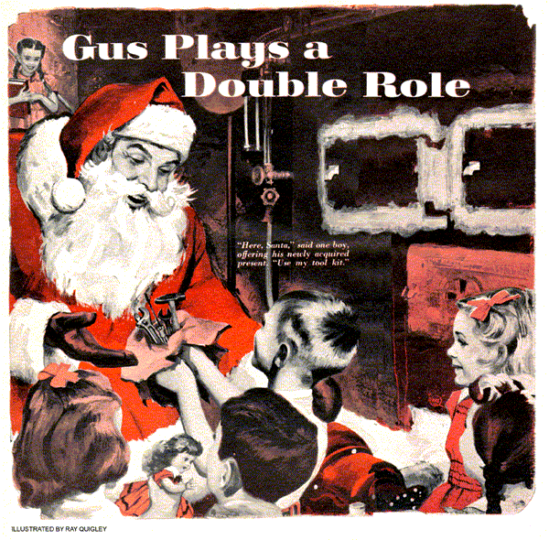
Gus Wilson, genial proprietor of the Model Garage, was having the time of his life. He was playing his usual role of Santa Claus for the Christmas festivities at the elementary school. Gus made an imposing figure as he moved among the happy, excited children, distributing gifts from the bulging pack on his back, red stocking cap worn at a jaunty angle, white beard flowing down upon his pillow-stuffed front.
Gus was getting along famously with the kids when Miss Davidson, the principal, approached him with such an expression of panic on her face that Gus feared she was about to speak his name and give him away.
"The heating plant won't run, Santa," she told Gus, "and we can't reach a furnace repairman. They all seem to be away for the holiday.
It's getting awfully cold in here. What can we do?"
Glancing through the open doors of Miss Davidson's office, Gus could see Matt Bergstrom, who was a member of the school board, frantically jiggling the phone hook as he tried to get a number. Sam Howard, the school's janitor, stood beside Matt, wringing his hands helplessly. Gus, heavily padded, had not noticed the cold.
This was a big evening for adults and kids alike. The walls of the school were gay with decorations. A huge tree sparkled with lights, and from its tip shone the silver star of Bethlehem. The school stage, where every year for over a quarter of a century the town's youngsters had presented a Biblical play, was decorated with star-studded evergreen wreaths.
Gus tousled Tommy Willard's mop of hair as he thought about the problem.
"Here you are, my lad," he boomed, handing the boy a present.
Turning to tiny Ann Trotter, Gus permitted a worried expression to come into his eyes. The child, her arms outstretched to take the gift Gus was offering, saw it. Her blue eyes opened wide in dismay and astonishment. This will never do, Gus thought.
"And now for you, my little lady," Gus said in his best Santa Claus voice, boosting the tiny tot to his shoulder, "I have this doll with real hair and eyes that close."
"I'm getting awfully cold, Santa Claus, and my baby is, too," she said as she cuddled the doll in her arms.
Matt Bergstrom stepped from Miss Davidson's office, and his eyes met Gus's in mute appeal.
"A nice state of affairs," someone in the audience grumbled aloud. "It's freezing cold in here."
The eyes of the adults strayed to Gus. Here was a man to whom they had been accustomed to turn in times of emergency.
Gus sighed. What could he do? He couldn't step off the stage with his presents still undistributed. Neither could the Santa Claus these kids had known for years suddenly turn into Gus Wilson of the Model Garage - the man who fixed daddy's car.
Besides, he knew little about automatically controlled oil-conversion units like the one that had been put in here. And yet, he did know something. He had been on the committee that had selected it. He had gone over its specifications rather thoroughly with the salesman.
At any rate, he had to make a decision now, and he made it.
"So," Gus roared jovially, chucking little Ann Trotter under her pretty chin, "my little one is cold. Perhaps old St. Nick can fix the furnace."
"Could you, Santa?" Tommy Willard asked.
"Ho, ho, ho," Gus cried out. "And why not? In my shop at the North Pole I fix many things."
Gus put Ann Trotter down and moved toward the basement door.
"I'll need tools," he said loudly, and his eyes sought out in the audience his helper at the garage, Stan Hicks.
Gus had fully expected that the parents and teachers would move to prevent the children from following him. Alone in the basement he could revert to Gus Wilson and work on the heating plant. But nobody made a move to prevent the shouting children from trooping along at Gus's heels.
Stan Hicks sidled out the door behind them. "I dunno what you folks are going to do," he said. "But me, I'm going after Gus's tools so Santa can do the job."
Sam Howard accompanied Gus into the basement. "I don't know anything about this gadget," he remarked sourly, "except how to turn it off and on."
Gus surveyed the ancient furnace with its gleaming conversion oil unit, feeling rising panic. On the way down he had glanced at the wall thermostat and noted that it was turned above the 70-degree mark. Yet the oil burner was silent and cold Looking at the circle of youthful, eager faces about him, the awful realization came to him that every child in the basement was expecting Santa Claus to work wonders.
"Here, Santa," said one boy, offering his newly acquired present to Gus. "Use my tool kit - it's a dinger."
"Just the thing, just the thing, my lad," Gus boomed.
Gus located the fuse panel, inspected the fuses. He traced the copper fuel line from the burner to where it split into two lines leading through the cement wall to buried fuel tanks. Each line had its shutoff valve and individual sediment bowl. The right tank, Gus noted, was shut off, the valve on the left tank wide open.
"I brought your tools from your sleigh, Santa Claus," Stan Hicks kidded Gus as he approached with Gus's small emergency tool kit.
"Ho, ho, ho," Gus roared jovially, slapping Stan so enthusiastically on the back that he staggered. "And how are my reindeer, my good lad?"
With tools in hand, Gus racked his memory for the details of the heating unit as he had gone over them at the time of purchase. He checked the high-tension ignition points, took out the tiny, high-pressure oil-spray nozzle and cleaned it, the children gleefully following his every move. He experimentally turned the heat-limit control switch from "automatic" setting to "manual." The hot-air fan started.
"Santa's fixed it," the children cried in unison.
Gus beamed on them, even though he knew that by starting the fan manually he had merely sent a current of air upstairs from a cold and flameless burner. He turned the switch back to automatic control. He now inspected the primary control switch, which was mounted in the furnace stack. This, he recalled, was primarily a safety device, with a heat-controlled bimetallic coil. It was so constructed that it would turn off the burner within a minute or so after it started to run if the burner didn't ignite in that time to bring the heat to the stack.
Gus noted that the re-set button on this switch was out. A crafty look came into his eyes as he pressed the re-set button.
The burner whirred, but without flame. It ran a minute or more and stopped.
Aha, Gus thought, he had either ignition trouble or no oil at the burner. Now at least he knew where to start. The ignition points seemed all right - he'd bet this rig was out of fuel.
"You, there," he bellowed, pointing a finger at Sam Howard. "Have you got fuel in your tanks?"
"Of course I have," Sam said. "In fact, the left-handed tank is full."
There went another theory, Gus thought grimly.
"I know the left-hand tank's full," Sam went on, "because I turned off the right-hand tank a couple of hours ago when it ran dry, and turned off the left, which ain't had a drop used out of it since it was filled. It holds nigh on to 600 gallons."
"So," Gus breathed, forgetting for the first time to use his Santa Claus voice, "the right-hand tank ran dry, did it, and you turned on the left."
"Maybe Santa can't fix our fire," a small voice - Ann Trotter's - said.
"He can, too," Tommy Willard said stoutly. "Santa can fix anything. Can't you, Santa?"
"Well," Gus said thoughtfully, stroking his beard, a twinkle in his eyes. "I haven't got all my magic tools from the North Pole. But if I had a plain, ordinary tin can, I just might do the trick that I have in mind."
"Tin can!" sputtered Matt Bergstrom, who had just come into the basement. "Tin can! Find him one, Sam."
Sam found a tin can that had once held liquid soap. Gus put it beneath the burner-regulating valve and backed off the bleeder plug. He pressed the re-set button on the primary switch. As the burner ran, it pumped out some oil - and along with the oil, the air lock that had been created when the right-hand fuel tank ran dry, and the left-hand fuel was forced in upon it.
Gus shutoff the bleeder plug before the burner stopped. He waited a couple of minutes and then pressed the re-set switch again. This time when the burner started Gus heard the roar of flame in the furnace pot, felt the swelling of heat.
"Santa fixed it! Santa fixed it!" the children cried, dancing around Gus.
Standing there, Gus lifted his eyes and sent up his own private, Christmas Eve prayer of thanks that as an automobile mechanic he had known all about air locks in fuel lines.
END

