September 1954

GUS CLOSES A STICKY CASE

by Martin Bunn
Deep inside the door of Fenton Well's limousine,
Gus found the key to unlock that arrogant banker's heart.
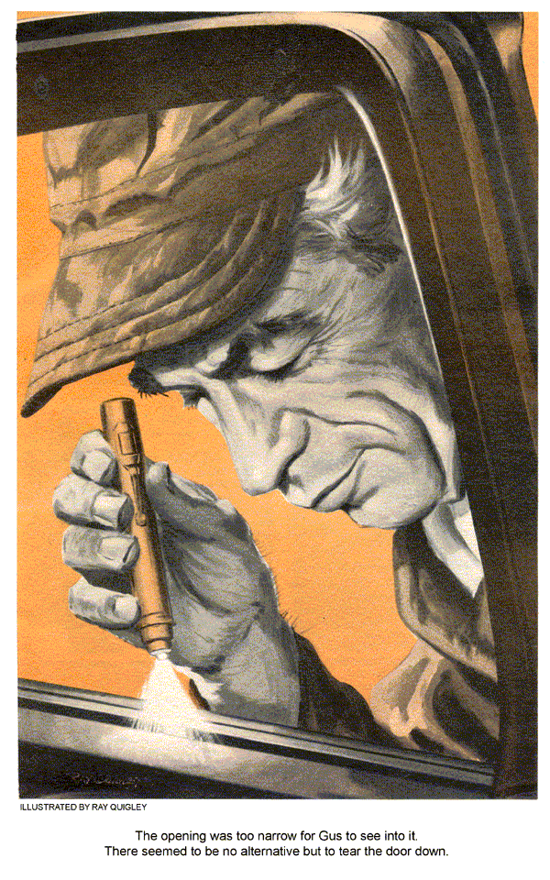
When Fenton Wells, wealthy and testy financier, drove his big limousine into the Model Garage with Pete Sullivan, his chauffeur, at the wheel, Gus Wilson winced. Wells had a habit of looking over Gus's shoulder while he worked, showing his interest by issuing orders.
Stan Hicks, Gus's helper, winked as he sidled away to the grease rack, where he suddenly became very busy.
Wells was a thin lath of a man, with the predatory features of an eagle. He was a widower who lived in a big house on the hill, apart from the town, with his servants and a six-year-old, orphaned granddaughter, whom it was said he idolized. As the financier stepped briskly from the car while Pete Sullivan held the door open, he caught his foot in the folds of a luxurious robe and nearly fell.
Sullivan Gets a Tongue Lashing
"Careful, sir," Pete said, steadying the man with a hand.
"You clumsy ox!" Wells roared. "Pick up that robe, and be careful with it, if you can."
Sullivan, who had been a sergeant in Korea, turned red to his ears as he bent to pick up the robe.
"It's a wonder," Wells declared angrily to Gus, "that I've a car at all, with this man driving it. The engine misses, the windows won't work, and last night Sullivan smashed a fender."
"I was parked," Sullivan protested, "when a fellow backed into me. I didn't smash the fender, Mr. Wells."
"Didn't smash it?" Wells's voice was caustic. "You could have backed away. You didn't have to sit there, half asleep."
"I couldn't back away," Sullivan said. "There was a car parked tight behind me. I blew my horn--"
"Don't talk back to me, you idiot," Wells warned, "or I'll--"
The Worm Turns
That was as far as Wells got. Pete's control snapped. He grasped the financier by his nose and twisted it.
"By gosh," he said, "I've taken enough from you, you razor-faced old goat."
Gus Wilson moved with amazing agility, to grasp Pete's wrist.
"Drop it, Pete," he pleaded. "Let him go."
"Help!" Wells screamed. "Help me, Wilson!"
"What's going on here?" demanded Officer Jerry Corcoran, dashing into the Model Garage from the street.
"Arrest this maniac, Officer," Wells gasped. "He tried to kill me."
Corcoran's eyes moved to Gus questioningly.
Gus shrugged. "Sullivan only pulled his nose."
"Only pulled my nose!" Wells shouted, dabbing at the rapidly swelling member with a handkerchief. "He tried to kill me."
"You'll have to come with me, Pete," Corcoran said, moving over to Sullivan's side. "And you, too, Wells, to sign the complaint."
"Brother!" Stan Hicks breathed. "Pete's sure in for it now."
"Assault and battery," Gus said grimly. "But why did Pete fly off that way? I've known him since he was a sprout. He's too level-headed and sensible to do such a thing."
Gus thought about it as he went to work on Wells's car. The action hadn't been at all like the Sullivan Gus had known, from knee pants to sergeant's stripes. Still, Gus told himself, Wells was enough to drive a man nuts. He couldn't even keep any help. He either got mad and fired them or they quit. Only the week before, he had fired Marie Lisbeth, the 18-year-old governess for his young grandchild. Not only that, but he tried to have her jailed. He would have, too, if he'd had enough proof.
Quickly Gus removed the miss from the engine, by installing a new set of spark plugs. He hammered out the small dent in the fender, sanded it smooth, sprayed it with undercoat. While this was drying, he turned his attention to the windows that Wells had complained about.
Window-Control System is Intricate
The car had an automatic system, operated by electrical energy and hydraulic pressure, furnished by a pump. A master switch by the driver's seat, plus individual switches on each door, controlled the windows.
Gus flipped the toggle switches for the windows and found that only the right front failed to work smoothly. As a routine starter, he checked the fluid in the reservoir, finding it in order. It occurred to him, since only one window failed to work, that this particular switch was faulty. He laid his ear close to the right front door panel and flipped the individual switch. He could distinctly hear the sharp click that indicated the switch was activating the solenoid.
This was going to be rugged, Gus told himself. He'd have to tear the entire door down to get at that hydraulic cylinder and the electrical circuit beyond the solenoid. Puzzled, Gus went over to the master switch. He worked the toggles alternately, running the three windows up and down, trying to start the right one. Suddenly, all three windows refused to budge. Good grief, Gus thought, if Wells came hotfooting back here and found that instead of fixing one window, Gus had stalled them all, he'd go through the roof.
"If he calls me an idiot," Gus muttered, "I'll - whoops, there I go. As bad as Sulllivan." Gus chuckled to himself as he pawed out his pipe, lit it and leaned on the bench.
"You stuck, Gus?" Stan Hicks called.
"Just taking a breather, Stan," Gus assured him.
Now what had stalled those other windows? The answer came to Gus with the thought. A blown fuse, no doubt. In the office he ran a stubby forefinger over the wiring circuit of this particular model, as shown in his shop manual. No, he hadn't blown a fuse. The model was equipped with a circuit breaker. In that case it perhaps had become hot and opened. If so, it should close as it cooled. Gus went back to the car, and when he flipped the switches the three windows again worked.
A gleam of satisfaction came into Gus's eyes. Now, he thought, if he wasn't a fool, this should tell him something. If that right front hydraulic cylinder was working, as the click of the solenoid indicated that it might be, it was delivering around 25 pounds of pressure to that window. The window would have to move up - unless it was tightly jammed. In that case a load might be thrown on the entire system that could cause the circuit breaker to throw open.
Gus tried to peer down into the window with his pencil light, but the opening was too narrow. There seemed to be no alternative but to tear the door down. He washed his hands carefully, broke out special tools and went at it. Shortly he had loosened the door panel enough so that it moved out a bit. Gus distinctly heard something fall inside the door. On a hunch he threw the toggle switch. Instantly the window moved up, so fast that it almost caught Gus's face.
Scratches Are the Tip Off
With the window working smoothly, Gus was tempted to refasten the door panel and let it go at that. Whatever had been jammed inside had evidently fallen to the bottom of the door, where it would cause no trouble in the future. Wells would soon return, impatient as usual, demanding his car.
Thinking about it, Gus's glance fastened on several long scratches on the window glass. Whatever had been jammed inside, had evidently been awfully hard. A calculating gleam came into his eyes. He began tearing the door down.
"My car ready?" Fenton Wells demanded, coming into the garage an hour later, accompanied by Henry Olds, his handy man. "Just about," Gus told him, shutting off the paint from his spray gun, and spraying the fender repair with air to dry the final coat of finish paint. "I put in new plugs. The windows--"
"Never mind the details, Wilson," Wells snapped. "Send me a bill. Get in, Olds. Get in, man. I'm in a hurry."
As Wells got in the car, Gus leaned against the open door.
"About Pete Sullivan," he inquired. "Going to prosecute?"
"Of course. The man's a maniac. I'll have him jailed."
"I agree," Gus said amiably, "that Pete shouldn't have done what he did. But sometimes we must consider extenuating circumstances."
"Extenuating circumstances, my eye," snapped Wells.
Gus extended his hand, in which lay an object that glittered with blue fire.
"Buying an expensive bauble like this for a birthday present for a six-year-old kid is news in this town," he said. "We all heard about it when it disappeared from your granddaughter's hand. I found it jammed in a window of your car, where undoubtedly the kid had dropped it."
Wells snatched the badly bent ring from Gus's hand.
"My granddaughter's ring," he gasped. "It was quite expensive, you know. A small stone - but blue-white and perfect."
"Blue-white or black," Gus said softly, "you accused Marie Lisbeth of stealing it, and fired her - remember?"
Looking into Gus's eyes, Wells did remember - and quite suddenly. The color drained from his face. For a moment, he looked small and shriveled, and somehow pitiful.
"So I did, Wilson," he mumbled. "So I did."
Gus Makes a Suggestion
"Perhaps," Gus said slowly, "you owe Marie an apology. Maybe it would be a nice gesture on your part to overlook Sullivan's action."
Wells was regaining his composure. "What has all this got to do with Pete Sullivan, may I ask?"
Gus set a match to his pipe before replying. "Did it ever occur to you," he asked, "that Pete Sullivan might be pretty fond of Marie Lisbeth?"
Wells took a deep breath. "I see what you mean, Wilson," he said, softening his tone. "I'm wondering if it wouldn't be better if I saw clearly more often."
END

