October 1954

GUS TRICKS A TRUCK

by Martin Bunn
A man's life hung in the balance.
Could Gus save him by double-crossing a stubborn truck?
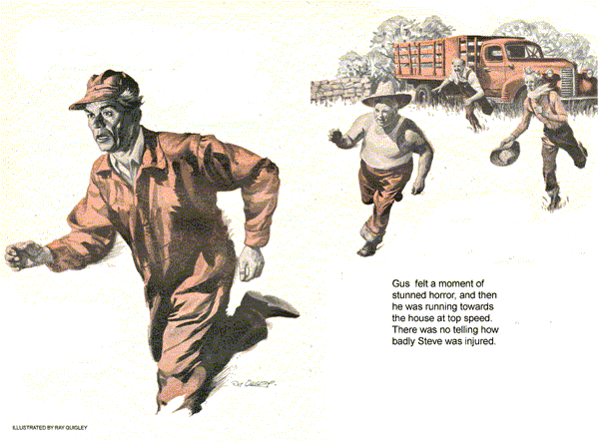
It was one of those windy, early-fall days. As Gus Wilson and his helper, Stan Hicks, drove out into the country-side. Gus gratefully inhaled gusts of tangy autumn air.
"On this call," he told Stan, "we'll kill two birds with one stone. You drop me off at Ezra Hendricks' place, and then go up to the Big Hill and pick up that motor for repair. That'll take you a couple of hours. I'll be ready to go by the time you get back."
"Fine!" Stan exclaimed. "This is one trip I'll enjoy."
A few minutes previously, Mrs. Ezra Hendricks had driven into the Model Garage to tell Gus that her husband was hauling corn in to fill his silo, and that their truck was stalled. Ezra had been trying to phone Gus, she said, but the rural telephone was out of order.
"What seemed to be the trouble with the truck?" Gus had asked.
"I don't know," Mrs. Hendricks had told him, "but Ezra told me that Pete Blinstock was raising so much dust that he couldn't even see the truck."
Idle Hands Cost Money
Driving into Ezra's yard, Gus waved to Will Shepard and Steve Overhart, working with a small tractor and a silage cutter on a fast-disappearing pile of corn.
"No wonder Ezra is frothing at the mouth," Gus told Stan. "Shepard and Overhart charge by the hour. If Ezra doesn't keep the corn coming to them, it will cost him while they stand idle."
The stalled truck, half loaded with corn shocks, stood at the edge of a field near the house. Beside it stood Tom Hanratty, another close neighbor of Ezra's pitchfork in hand. Ezra himself was leaning over the line fence, his gray beard trembling with indignation as he shook his fist at Pete Blinstock. Blinstock was preparing his field for the planting of winter wheat, just across the fence line, pulling a four-section drag with a crawler tractor. A curtain of dust rose behind him.
"Quit it, you lump jawed old gopher," Ezra yelled at Blinstock as Gus pulled up, swung out his tool kit and sent Stan on to Big Hill to pick up the motor.
The insults that passed between the two old gents might have fooled a stranger. But Gus knew they were warm friends who enjoyed needling each other unmercifully. Blinstock would not stop throwing dust as long as he got a rise out of Ezra.
"Some day," Ezra declared, coming over to the truck, "I'll grab Blinstock's nose and twist his head until he looks over his back."
"That," Tom Hanratty chuckled, "I would like to see."
Gus climbed into the truck, turned on the switch, pumped the throttle vigorously and stepped on the starter. The motor came to life, ran smoothly and then began to lose power with a hollow sound. Gus guessed that it had gas trouble, but he leaped out of the truck again to run a neon-tubed screwdriver over the spark plugs before the motor could die completely.
Air Cleaner Is Missing
Brilliant flashes in the screwdriver handle told him that there was little chance of ignition trouble. Carburetor or pump, he decided, unless Ezra was out of gas.
Even as this occurred to Gus, he noticed that the air cleaner was missing from the top of the carburetor. Gus frowned. It would be just like Ezra to throw the cleaner away in a fit of anger.
Gus peered into the throat of the carburetor, flashing his pencil light, working the throttle rapidly. He saw a tiny, thin jet of gas squirt from the injector nozzle. The stream angled off to the side, as though passing through a partly blocked nozzle. That carburetor had more dirt and sand and corn-husk shred in it than gas, Gus thought. He'd have to take it down and clean it out.
At that moment Will Shepard came tearing through the cornfield on a dead run, his features twisted with panic.
"Quick!" he yelled.
"Steve got slammed by the tractor belt. He's out cold." Gus felt a moment of stunned horror, and then he was running towards the house at top speed. Arriving on the scene, he found Steve Overhart unconscious on the ground. Shepard was dashing cold water in his face with no effect. There was no telling how badly he was injured - likely, Gus figured, concussion.
"Quick, Ezra!" he gasped. "Get out your car."
"My car!" Ezra echoed. "Ma still has it in town."
"Get any car!" Gus snapped. "Hanratty - Shepard - your cars?"
"We rode the tractor over," Shepard choked out. "There is no car."
Gus's mind chewed on the problem. Telephone out and no car on the premises. Blinstock's old car was seldom used, often had a dead battery or flat tire or both. Steve lay back now, in a state of shock. The man might die if he didn't get medical care quickly.
"Stay with him, Hanratty," Gus said, and ran toward the truck.
Gus jumped into the cab, pumped the throttle, stepped on the starter. The motor came to life as before, then died.
"That's the way she's been acting," Ezra chattered, coming up. "What are we going to do, Gus?"
Gus said nothing. He swung down, scooped up a fistful of tools. He'd have to jerk the carburetor and tear it apart for cleaning.
So Little Time - So Much to Do
His mind ran over the necessary steps; throttle rod to unhook, choke wire, gas line, vacuum line, two 5/16 nuts on two studs, lift the carburetor. Disconnect linkage between throttle and accelerating pump arm, remove machine screws between throat casting and bowl casting. Pull the two apart, remove and clean jets, clear float needle and don't drop it.
Gus reached out with a pair of side cutters to pull the cotter pin off the throttle rod. A gust of wind whipped dust from Blinstock's field, and for a moment Gus was blinded.
He backed out from the hood, straightened up. The swirling dust had stirred an old memory, of a little man who had once driven into his pumps broke and discouraged, heading east to look for work. He had come from where the dust blew much worse than this, where men fled before it for their very lives. Gus had given that man a tank of gas, because he needed it, and the man had told Gus something about fighting dust.
Thoughtfully Gus moved under the hood again. Swiftly he stripped number three and four wires from the spark plugs, reversed them. He jumped into the truck cab, pumped the throttle to gain that tiny jet of injector gas, stepped on the starter. The motor roared raggedly, backfired. Gus leaped out replaced the two wires on their proper plugs, climbed back into the cab, and the truck began to roll toward the house. Gus pulled up beside the injured man, leaped to the load of corn, kicking it around to form a bed. "Lift Steve up to me," he said, "Easy does it." They lifted the injured man, laid him gently down.
"Stay with him, Hanratty," Gus said. "You too Shepard. Ezra, you drive. I'll ride the fender with the hood up. When I yell once, you kick her out of gear and pump the throttle fast. When I yell again, put her in gear and get going."
That was the way it was. Several times on the way into town, the truck lost power, showed, threatened to quit. Each time, Gus yelled to Ezra as he reached in to twitch the wires from plugs three and four, and reverse them. Ezra threw the truck out of gear, pumped the throttle. The motor, freed of load, roared and backfired, Gus switched the wires back to the proper plugs and yelled to Ezra again. Ezra pulled the truck into gear, and they went on. In the hospital in town, prompt care brought Steve around and probably saved his life.
Although Ezra will always swear that it was Blinstock's dust that filled his carburetor with dirt, Gus reckoned that this had been a gradual accumulation over a period of time, cause by Ezra's foolish discarding of the air cleaner, thinking to gain power. Back in the Model Garage, Gus found Hendricks and Hanratty looking at him, with admiration.
"I don't know what you did to that truck, Gus," Ezra declared, "but you did it. You're one smart feller."
"Smart?" Gus leaned against the bench and lit his pipe. "I wouldn't say that. Matter of fact, I ridiculed the idea when the fellow told me about it."
"What feller?" demanded Ezra.
"This farmer from out West," Gus said. "He told me how to clear carburetor jets in an emergency, by switching wires and causing backfiring through the jets." Gus grinned.
"Sure glad I listened."
END

