November 1954

GUS GOES DOWSING FOR WATER

by Martin Bunn
Gus's sleepy eyes focused on the bedside clock
as his hand reached out to silence the telephone.
It was five o'clock in the morning.
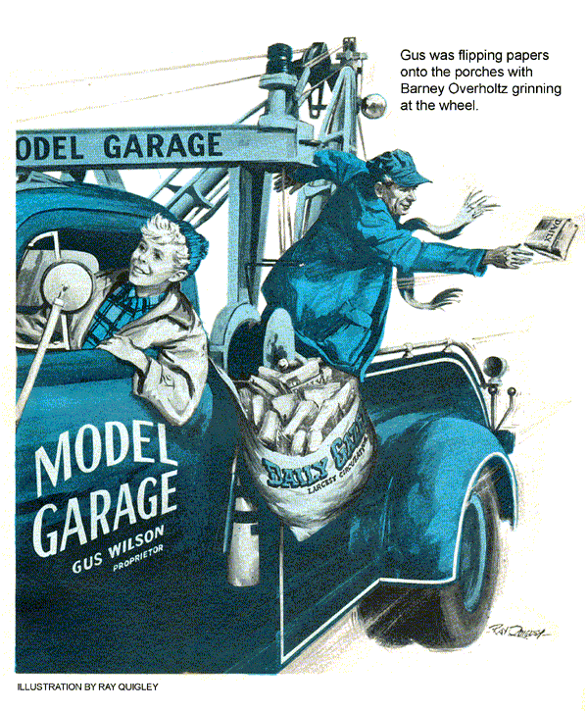
"Is this Mr. Wilson?" an eager voice inquired over the phone. "I'm Barry Overholtz. The crankcase of my car is full of water, and I've got to deliver my newspapers."
Gus was of a mind to hang up and go back to sleep. Then a mental picture came to the Model Garageman of Barney's thin young features, and he didn't have the heart to do it. Barney was 17 and as freckle-spattered as a brook trout. He had the trustful brown eyes of a cocker spaniel.
"Hold your horses, kid," Gus told him. "I'll be right over."
At Barney's house, Gus checked the oil stick of the kid's 1941 Ford. Then he did the only thing possible at the moment - for Gus. He loaded Barney's papers in his tow truck and started delivering them over Barney's rural route. Folks who were up this early were startled at the strange dawn vision of the burly owner of the Model Garage. Gus was flipping papers onto the porches, with Barney grinning at the wheel.
Gus Takes a Car Case History
"Now about this car of yours," Gus said. "You've had it about a month, haven't you? Have you ever let it run out of water and get hot? It's not been cold enough to freeze and crack the block."
"It's never been hot," Barney assured Gus.
"In that case," Gus declared, "since you bought it over in the city, you should contact your dealer there. He should fix it."
"Gosh!" Barney exclaimed. "Do you think he would?"
At that moment, Gus was inclined to think that he wouldn't. Most used-car dealers in the city were honest, but it was an old trick of unscrupulous dealers to put a temporary repair on a cracked block, and foist the car off on some unsuspecting character like this kid. The car would run all right for a few days but then the crack would open up and fill the crankcase with water.
"I'll have to have it fixed right away," Barney said, his eyes anxious, "or Mr. Thompson will take away my paper route."
A Ribbing For the Model Garageman
As soon as the newspapers were delivered Gus took Barney home and towed the water-logged Ford into the Model Garage. He got a quick breakfast at the café, where Officer Corcoran kidded him.
"My paper was late this morning, Gus," Corcoran declared. "It had greasy fingerprints all over it. The next time this occurs, I'll have to report you to Mr. Thompson."
"If it occurs again," Gus chuckled, "I'll be going to bed at dusk, so I can get up at five. Barney jangles a mean telephone." Back at the garage, Gus put in a long-distance call to Stevens and Bartlett, the used-car dealers where Barney had bought the car. Their attitude in the matter was about what Gus had expected.
"The car was all right when the kid took it out," Stevens told Gus. "I couldn't be expected to repair a water leak on an old car like this, after it's been driven 30 days on a paper route. Kids do things to cars, you know."
"I know," Gus said wearily, "and so do some dealers."
Gus hung up, wondering about what kind of an outfit Stevens and Bartlett were. He began working on the car. He drained water and oil, pulled the heads, began scraping carbon, inspecting gaskets for imperfections, block faces and valve ports for cracks. Stan Hicks, Gus's helper, strolled from the grease rack, grinned widely at Gus.
"You always were a sucker for kids, Gus," he said.
"It isn't that," Gus protested. "I'm just curious to see if this used-car outfit is trying to gyp Barney Overholtz."
The carbon on the heads and block faces was dry, indicating rings in good shape. There were no signs of water having been in the cylinders. There were no cracks, even at those danger points between valve ports and cylinders. Gus was puzzled. There had to be a crack some place. It must be inside the valve compartment.
Cylinder Walls Are Undistorted
A crack in the cylinder water jacket, inside the valve compartment, Gus told himself, seldom occurs unless a car has been badly frozen. He ran his inside micrometer around in the cylinders. Its reading showed that the car had been rebored to 60 thousandths oversize, yet there was no distortion of cylinder walls, such as would have been the case if the car had been badly frozen. Really, except for the mysterious crack, the old heap was in exceptional shape.
Gus pulled the generator and then the manifold, which on a Ford V-8 also acts as the valve-compartment cover. At once he saw water mixed with oil. This meant nothing, since water would have been pumped up here from the crankcase with the lubricating oil. It would be almost impossible, Gus knew, to locate a crack in here visually, without pulling valves, springs and guides, and cleaning the compartment with steam. Gus cleaned it the best he could, using a solvent spray and blowing out with compressed air. He could find no cracks, and being certain that there were none in the compression chambers, he replaced the engine head and filled the radiator with water.
Gus peered about in the valve compartment, seeing no water flow. Maybe the crack was way at the bottom of the block. This hardly seemed likely, but could not be overlooked. Gus pulled the pan, lay under the motor, looking up. He was there for perhaps five minutes, before he saw a single drop of water drip from the throw of the crankshaft, which was in the down position. Just at this moment the phone rang.
"This is Stevens," a voice said over the wire. "You understand, Wilson, that the 30-day guarantee on young Overholtz's cart has expired. Still, we'd like to know what's wrong with the car."
"At the moment," Gus said, "water is leaking out of the crankshaft."
"Out of the crankshaft!" Stevens repeated. "Never heard of such a thing."
"Neither have I," Gus told him as he hung up.
Getting under the car again, Gus found, by turning the crankshaft, that the water was very slowly issuing from the timing-gear case. If there was a crack up there, behind the timing gears, Gus told himself, they might as well junk this motor. He crawled out, back to the bench and lit his pipe.
There was something queer here, Gus thought. A crack caused by a freeze-up, in a car that had been rebored to 60 thousandths oversize, would surely come here, where the metal was thinnest. At least there would be cylinder-wall distortion. Or maybe, he thought, had been no freeze-up on this car. Where would that possibility leave him?
Gus looked grim, and then a slow smile formed at his mouth. How many times over the years has he leaned against this bench thinking that he was at the end of his rope? Yet, always, somehow, things had worked out. They would this time, too, he decided.
He had water and he had oil, he told himself, in passages. At what places that he hadn't thought of could these two possibly meet? Gus visualized the construction of the engine block. Nothing but a crack, he decided, could put water in the tuning-gear case, but the chances of its being there were so slim that the water must be running down there from the valve compartment. Gus moved forward, intent on pulling valve, springs and guides, for a closer inspection, when Barney Overholtz came into the garage.
"Hi, Mr. Wilson," he said, and then his eyes fell on his car. "Gosh!" he exclaimed. "You're working on it yourself."
"Yeah," Gus drawled. "Stevens and Bartlett tell me that your guarantee has expired. They won't do anything."
Gus Puts The Bill on the Cuff
Barney's trustful eyes rested on Gus's face. "Golly, Mr. Wilson, I won't be able to pay you for a while, because right now I'm broke. I had to pay Mr. Kleiber, over at Stanfield yesterday, for a new water pump. The left-hand one wobbled."
"Don't worry about it," Gus said. Then, thoughtfully: "You say you put on a new water pump yesterday?"
Gus found his mind chewing on a startling idea. The water pump had been put on just before water appeared in the crankcase. Was there any connection? Gus recalled that there was a small oil hole drilled from the valve compartment through the block, to meet a similar hole in each water pump. Oil flowed down these holes to lubricate the water pumps. But this was grabbing at straws, Gus told himself. No one had ever heard of water traveling along a pump shaft, up these oil holes into the valve compartment again, but could see nothing. He began to pull the new, left-hand water pump.
"What are you doing now?" Barney wanted to know.
"Grabbing at straws," Gus told him grimly.
With the pump off, Gus probed down the oil hole. It ran on a slant from a point within a half-inch of the pump rotor to the pump shaft. But this one had been inaccurately drilled. The side of the hole had broken out into the pump water jacket. Pressure from a filled radiator had forced water up the oil hole and into the front end of the valve compartment, where it ran down into the timing-gear case.
Trouble at Long Distance
"Out of a million water pumps," Gus said disgustedly, looking at it, "maybe one was badly drilled like this. And you had to get it, Barney. Goes to show that when a workman does a sloppy job, it can hurt someone a thousand miles away."
"I guess," Barney said thoughtfully, "a fellow should always do things real careful, Mr. Wilson, like you do."
"Me?" Gus chuckled. "Why, I'm not careful. I just bumble around, grabbing at straws. This one was awfully thin." The phone rang again.
"We've been thinking," Stevens said over the wire, "about that car we sold the newspaper boy. You can fix it up, Wilson, and bill us…"
"Goes to show, Barney," Gus grinned, "that folks are more honest than we sometimes give them credit for. Stevens won't have to pay, on account of the faulty pump, but that man has a conscience, after all."
END

