March 1954

GUS DOCTORS

A CASE OF THE JITTERS

by Martin Bunn
With an ex-GI's reputation at stake, the Model Garage uses
high-pressure methods on a car with the shakes.
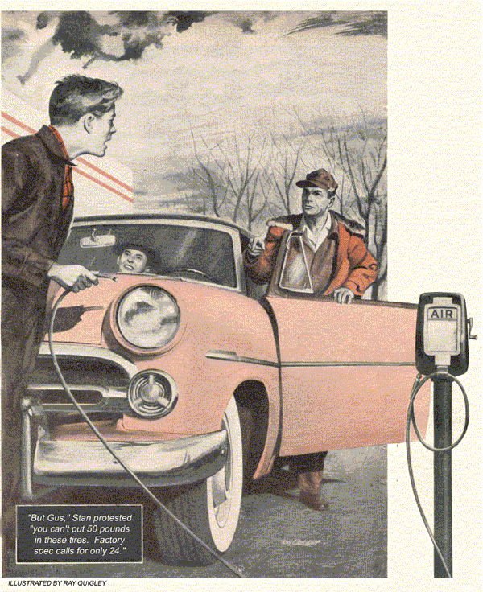
Alf Madsen's loose talk, soon after he returned from service in Korea, bothered Gus Wilson. Madsen drove that car of his around town as he had piloted his jet fighter overseas - fast and flashy.
And he complained. That was the nub of the problem. If he didn't button his lip, there was going to be trouble.
That is, there would be trouble for Big Bill Pederson. Pederson had sold Madsen the car. Pederson, too, had been in Korea. Now he ran a used-car lot a few blocks from Gus Wilson's Model Garage.
"The car's no good," Madison kept broadcasting around town. "It's got the shakes."
It was a cockeyed situation. Alf Madsen had been a lieutenant in the Air Force, Big Bill only a corporal in the Army Engineers. Alf was the son of one of the town's more prosperous citizens.
"If Madsen keeps shouting off his mouth, "Gus remarked to his helper, Stan Hicks, "the first thing you know, Big Bill Pederson will be out of business. That kind of talk gets around fast."
"If he won't back up his guarantee," Stan Hicks retorted, "maybe it would serve him right."
Maybe, thought Gus it wasn't that simple. Or maybe he was wasting his sympathy. Maybe Pederson didn't deserve the breaks. Funny, though both men were running true to form. He had known them as kids. Pederson was big of frame, slow, seemingly honest. Alf always had struck him as being an okay kid. He was just bumptious.
At lunchtime Gus went out of his way to drop in at Pederson's used-car lot. It was small and neat. Every car was shined and polished, with the price tag on the windshield. It didn't look like a gyp joint to Gus. Pederson came out of his small office-and-shop, a tall, wide-spanned young man, in slightly soiled coveralls.
"Gus Wilson!" he exclaimed, holding out his hand. "I haven't seen you since I got back. Every time I passed your shop your legs were sticking out from under a car. Didn't want to bother you."

A Man Has to Watch His Step
"Been pretty busy," Gus said shaking Pederson's hand heartily. "But lately things have dropped off. I came around to see if you might have some work you could shove my way."
"Golly, Gus," Pederson said. "I'm sorry, but you see I'm running here on a shoestring I couldn't get by unless I did my own work."
Gus eyed the neat lot. "You've got a nice little place," he said. "Should do well. The only trouble with the used-car business in this town is that a man has to watch his step. One sour deal can start folks to passing him by."
"How right you are," Pederson said with fervor. "That's why every sale I make has to be on the level."
"Well," Gus said. "I'll have to be moving on." He turned to go.
"Wait," said Pederson. He moved closer to Gus. "I've been away from home so long I'd almost forgotten a few things."
"Such as?" Gus asked.
"Among other things, that Gus Wilson doesn't go around the neighborhood drumming up trade, and that he doesn't talk just to hear the sound of his voice. Just what were you getting at a moment ago?"
Gus idly knocked the dottle from his pipe.
"Been some talk." He said bluntly, "About the Madsen deal."
Pederson scratched his jaw. "What would you do about it?"
"I'd fix it," Gus said softly, "or refund Madsen's money."
"But I can't refund his money," Pederson groaned. "I took the cash from the sale and bought two cheaper cars. Believe me, Gus, I'd refund to Madsen if I could."
"Well," Gus said, "what about fixing the car?"
"I can't fix it," Pederson said angrily, "and neither can anyone else - not to take the speed Madsen drives it. I've checked it from bumper to radiator cap. There's nothing wrong with the car. It's just one of those jobs that naturally vibrate a bit at high speeds. You've seen such cars, Gus."

Gus Makes an Offer
"Yes," Gus conceded. "How about tire and wheel balance?"
Pederson snorted. "Tires and wheels balance perfectly."
Gus scratched his head. "Why not let me look at Alf's car?" he asked. He added, to save Big Bill any embarrassment, "I just want to smell around a bit. Might save me taking a licking later, when I run into one like it."
Big Bill Pederson put his hand on Gus's shoulder, while a slow smile formed on his face.
"Years ago," he remarked, "I used to come around to the Model Garage to get my bicycle fixed. I guess things haven't changed much."
Pederson brought the car in at mid-afternoon. Gus left the garage in charge of Stan Hicks, and with Pederson beside him took the machine out on the highway leading to Stanfield. The sleek coupe purred like a kitten. It should have. It had less than 10,000 miles on the speedometer. Gus watched the speedometer needle climb - 50-60-65-70.
At 60 the car's smoothness began to fade. This wasn't something a man could tack squarely down. Gus had never heard anything quite like it, yet, yet he realized that it was vibration.
It could be anywhere - a loose flywheel, slightly out of line, loose transmission to the bell-housing studs, worn or dry universal joints, wheel bearings, out-of-balance main, or the drive shaft. A line of worry began to form about Gus's eyes.
"What did I tell you?" Pederson said.
Gus took the car back to the garage. He raised the hood, backed off the motor forward mounts, tightened them so that they were snug, but not to flatten the rubber cushioning. He put the car on the hoist, removed the flywheel cover and checked the flywheel for looseness with a bar. He tightened the studs that held transmission to bell housing, loosened the rear transmission support, wiggled it to make sure the transmission fell in line and retightened it. He greased and checked the universal joints and ran the car in gear studying the drive shaft.
Then he and Pederson took another run. The vibration was still there. Gus began to sweat.
Back at the garage once again, he checked the grease pack of the front wheel bearings, and proper bearing adjustment. He checked camber, caster, front suspension.
"Sometimes," he said to Pederson, "the manufacturers fail to pack front wheel bearings - not often, but it does happen. Now how about front-wheel and tire balance?"
"You check 'em," Pederson said. "I have."
Gus did check them. Wheels and tires balanced perfectly. Gus noted that Pederson had attached lead balancing weights here and there. He scratched his graying hair thoughtfully.
"Let's try her again," he said.
Gus pulled up at the pumps, beckoning to Stan Hicks.
"But, Gus," Stan protested, "you can't put 50 pounds in these tires. Factory spec calls for only 24."
"Sure," Gus nodded, "but let's ride on 50 this trip."
The Tires Balance
Once more on the open road, Gus watched the speedometer needle climb - 50-60-70-75.
"No vibration," he commented.
"But I can't ask Madsen to scoot around the country on 50 pounds of air," said Pederson.
"Right," Gus's eyes twinkled. "We've tacked this vibration down squarely to the tires. The rest is easy."
"Easy!" echoed Pederson, "I can't buy that. Tires balance - remember?"
"Sometimes," Gus said, "manufacturers fail to build a tire right - not often, but it happens. It happens so seldom that I'd bet my hat there's just one guilty tire on this bus."
Gus pulled an air gauge out of his pocked. "We'll just let the air out of one tire at a time, down to 24 pounds, until the vibration comes back."
The Vibration Goes Away
Gus knew that one tire in 10,000 or more may have its ply laps laid together, instead of being separated. When this occurs it is a mechanic's vibration nightmare. The tire can be made to balance, but there is a hard spot that pounds the road at high speeds. When the tire is inflated, rock hard, the hard spot is no different from the balance of the tread and the vibration goes away.
Out on the road again, the ghost vibration came back as soon as Gus, after two tries, reduced pressure on the third tire to normal. Gus smiled triumphantly.
Back of the Model Garage, he replaced the tire, after cutting into it to prove his point to Pederson.
"You won't even be out the cost of a tire," he told the used-car dealer. "I handle this brand, and I'm sure the factory will be happy to replace this one."
That evening Alf Madsen drove in.
"I hear," he told Gus, "that you fixed this bus, after that knucklehead, Pederson had monkeyed with a few weeks."
"Don't let the corporal kid you, Lieutenant," he said softly. "Pederson merely brought the car in here for an exchange on that faulty tire that was causing your trouble. Smart boy, that Big Bill."
Too Much Talk, Says Gus
Madsen's eyes carried suspicion. Then a slow smile formed around his lips.
"I've known you a long time, Gus," he said. "I think that you can lie slicker'n anybody I know, when you want to."
"And I," Gus told him, a twinkle in his eye, "used to hold your little pink nose so you could blow it, Lieutenant, I think that you've been talking too much and too loud lately."
"Maybe I have, at that," Alf Madsen said thoughtfully, as he drove out.
"Thanks a million, Gus."
END

