June 1954

GUS LENDS LUCK A HAND

by Martin Bunn
The tired old car and the tired old couple in it ...
somehow the Model Garageman
had to put new life into both of them.
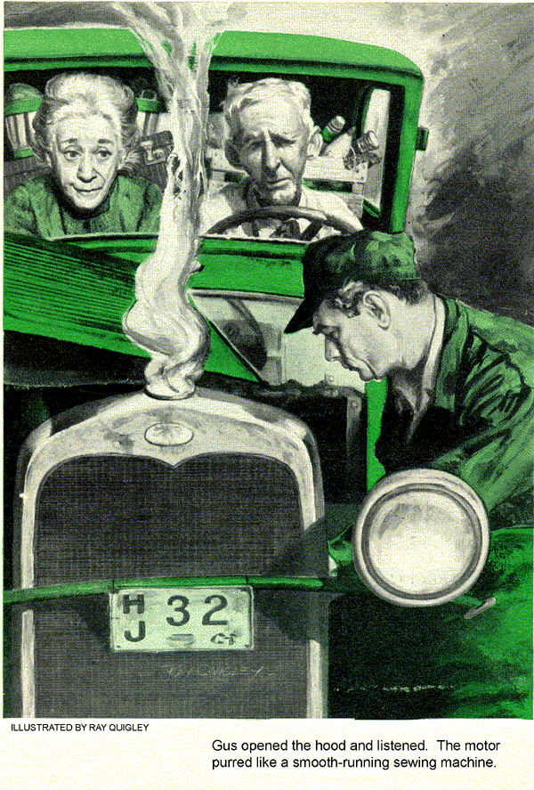
Gus Wilson was under a car in the Model Garage, installing new bearings, when he saw Stan Hicks go out into the warm spring sunshine to wait on a customer at the pumps. Stan filled the gas tank and then cautiously removed the radiator cap, leaping back from a gush of steam that arose.
What an outfit, Gus thought - an old sedan, loaded to the windows with luggage that sagged the springs. It was a heavy load, but still the car wouldn't boil if it was in any sort of shape. Maybe he'd better go out and take a look.
About to Give Up
There was an old, gray-haired couple in the car. Gus leaned on the window ledge beside the driver and gave them a slow, welcoming smile.
"Nice day," he said. "Going far?"
"Going far!" the old man retorted. "We was. Clean to Colorado. Now we're turning back. Don't mind particularly myself, but hate to, because of Ma."
Gus looked at the thin, weary-faced woman beside the man, and his expression became concerned.
"That's too bad," he said. "How come you're turning back?"
"Well, it's this way," the old fellow said. "Name's Hodge - Sam Hodge. This is my wife, Mary. Me and Ma been running a farm downstate a way for forty years. It wasn't much of a place, but we ate regular. Then Ma here got sick, and Dr. Shumway reckoned we'd best go west so Ma could get well. We didn't have no money to start over in a new country, so we just set and figgered a while. Something will turn up, Ma tell me, and sure enough it does."
"You don't say," Gus said.
"That's right," the woman cut in. "I told Pa it would and it did. And I've been telling him that we don't have to turn back now. If our good luck got us started, and helped us to meet Mr. Clark and be offered that caretaking job, right where Dr. Shumway said we should go, it'll help us get there."
"Women," the old man said, getting out of the car and stretching his small, wiry frame, "are uncommon inclined to argue. We put the farm up for sale, had the car all fixed up, loaded our rigging and started out. Car's been a-b'ling ever since we started, and that's only a few hours back. What'll happen when we get into the mountains? Cost us over a hundred dollars to have the car fixed. We ain't got the money for no more of that kind of fixin', so I says we'd better turn back before we get stranded too fur to turn back."
Overhaul Didn’t Work Out
"You had the car all fixed up," Gus said. "Then why should it boil? Radiator must be clogged."
"Thought of that," the old man said wearily. "If it was only that we'd go on. Had it flushed and a new water pump put in, a piece back. “Tain't that. Feller that did my work back home just didn't do a job. Charged us for fixin' up the shaft, reboring the cylinders, putting in new rings and bearings, grinding the valves and such. He charged, but guess he didn't do the work."
"That's a shame," Gus told him.
While Stan Hicks was collecting for the gas, Gus walked around to the rear of the car, stooped to peer into the exhaust pipe. The inside surface had that whitish, clean look that means good compression and clean firing. The motor started then, and as Gus moved up beside the driver he saw the old man twist the wheel as he shifted into gear, in preparation to turn around and head back the way he had come. The woman raised a protesting hand, then dropped it into her lap in resignation.
"Hold it, Mr. Hodge," Gus said quickly. "Mind if I listen to this motor a minute?"
"Go ahead and listen," the driver said. "Listen' sure can't do no harm."
Gus opened the hood and listened. The motor purred like a smooth-running sewing machine. He leaned in through the open window and his eyes moved over the instrument panel. The speedometer showed 82,000 miles. He opened the door, reached in to depress the throttle, revving up the motor.
Gus Spots the Trouble
"Watch out," the old man said dryly. "Some of the boxin'll fly out of her."
Gus's eyes halted on the oil-pressure gauge. The car, newly overhauled, with a reground shaft and new bearings should have held at 40 pounds of oil pressure at the speed the motor was turning over. It held at less than 10. Gus eased up on the throttle, and when the motor died to idle the pressure dropped until the oil-gauge needle was almost resting on the pin.
"This motor," he said flatly, "is in good shape, except that it doesn't have any oil pressure. Any motor will boil under load without oil pressure. Probably needs a new oil pump, or the screen's clogged. It's a quick job. I'll put in a rebuilt pump and check the screen for 10 dollars."
"Fellers all along the road been tellin' me things like that," Hodge said wearily. "A couple more quick jobs and we won't have the gas money to get home. I ain't strandin' Ma way off some place."
"You're the doctor," Gus said, shrugging his shoulders and turning away. He moved toward the garage, but he found that he couldn't so easily shake the look he had seen in the woman's eyes. The car turned from the pumps, halted at the curb to wait for passing traffic. Gus moved back.
"I'll gamble on it, mister," he said to the old man. "I'll fix it or it won't cost you a penny."
A stubborn set came to Hodge's jaw. He shifted into gear, as if to move forward. Then, suddenly, his resistance crumbled.
"All right," he said. "I'll take you up on that. Your offer seems to be fair enough."
Gus put the car on the hoist, took off the oil pan with a spin wrench. It occurred to him that he was a fool. A clean exhaust pipe only indicated good valves and rings, clean firing. He hadn't heard knocking rods, but the mechanic who had overhauled the car could have put in new rod bearings and neglected the mains. Or he could have put in new mains on an out-of-round main shaft. Oil would spurt here as if from a leaky kettle.
The oil-pump screen looked clear enough, but Gus wasn't taking any chances. He cleaned the screen and installed a rebuilt oil pump, poured the oil back in. He started the motor, eyes on the pressure gauge. It climbed to 20 pounds on the cooled oil.
"Well," the old man inquired anxiously. "Did that fix it?"
"We'll let her warm up," Gus told him. "We can't tell when it's cool."
Oil Pressure Still Falls
Gus could feel the woman's eyes on his face as he sat there, running the motor, watching the oil-gauge needle go down. Slowly it fell, until on the idle it again laid almost against the pin. Gus hated to look in the direction of the woman.
"No," he said honestly. "That didn't fix it."
He was twice a fool, he told himself. He should have looked over the oil-pressure check valve first. It might be gummed up or have something holding it open. He knew one once that had a chip of wood under it. Sweat beaded Gus's weathered features as he raised the hood and removed the spring and ball check from the side of the block, washed them in gas, and blew out the seat with the air hose. He replaced the check valve and again started the motor. The oil pressure remained the same. Hodge looked at the gauge and his face seemed to sag, to grow more wrinkled and tired.
"Well," he said, "thanks for trying, mister. We'll be on our way."
Gus backed to the bench, leaning on it, wiping his hands, fumbling his pipe out of his pocket.
"I'm not through yet," he remarked quietly.
Gus Goes in for More Tools
Stan Hicks jumped into the heavy silence, moving briskly forward to begin sweeping dust from the front floor mat with a whisk broom. The woman coughed thinly.
"Sure is dusty these days, isn't it?" Stan remarked brightly.
Gus straightened from the bench and moved into the stock room. He came out with four long, thin pipes in his hands, selected tools from his kit, ducked under the hood, his burly shoulders blocking all view of what he was doing. A few minutes later he straightened up and wiped his hands on a piece of waste. Then he reached to turn the ignition switch and depress the starter. He remained there a few moments, revving up the motor and letting it idle. Then he turned and his smile crinkled the crow's feet at his eyes.
"I reckon, Mr. Hodge," he said, "that you can be on your way now - west."
The old man stepped forward quickly, his eyes holding disbelief, seeing the oil-pressure-gauge indicator standing at 20 pounds at idle.
"I declare," he said. "You've gone and fixed it."
"Some mechanics," Gus told him, "forget that main and rod bearings aren't the only bearings in the oil-pressure line. This car has gone over 80,000 miles. You're losing your oil pressure through badly worn camshaft bearings. This car will take you now."
Gus Sets a Price
Hodge fumbled in his pocket and drew out a worn purse.
"How much do I owe you?"
"The oil pump," Gus told him, "isn't any better than the one you had when you drove in - you're welcome to the one I put in. I'll charge you four dollars for four camshaft oil regulators. I don't use them often, but I do keep them on hand for emergencies like this, when the oil flow to the camshaft has to be metered down to hold up pressure. When you get to Colorado and get the money, you'd better have new camshaft bearings installed."
"I told you, Sam," the woman said, and her face lit up with renewed faith.
END

