February 1954

GUS AIDS A HOT-ROD JOCKEY

by Martin Bunn
Young Howard was in a truckload of trouble,
and losing his bearings fast - if he lost any more,
his job was gone for good.
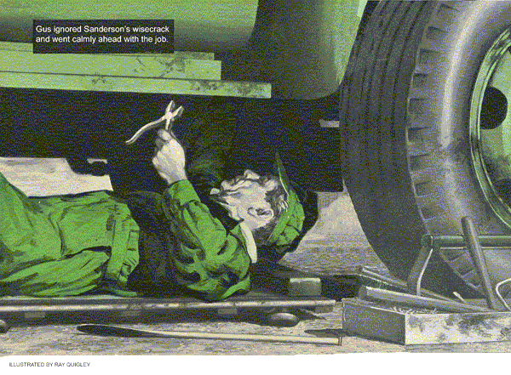
The customers of Gus Wilson's Model Garage like to stand around and chew the fat while getting repairs or a thankful of gas. They kept Gus well informed on the case of the burned-out connecting rods in one of the Sanderson brothers' trucks.
Considering the fact that Sam and Bill Sanderson did their own repair work on their several trucks, and were rather proud of their abilities as mechanics, Gus didn't think it his place to shoot off his mouth on the matter. Whenever one of the customers would drop in and inform Gus that another rod bearing had gone out on the truck that Joel Howard was driving for the Sandersons, he would puff his pipe and say, "You don't tell me!" But when Joel Howard got fired, Gus began to get curious.
"What can Bill and Sam Sanderson expect anyhow?" Silas Barnstable inquired of Gus as he helped himself to free air at the Model Garage. "Hiring a harum-scarum kid like Joel Howard!"
"I figured," Gus said cautiously, "that Joel had sort of calmed down."
"Hah!" Silas snorted. "Those kind never calm down. Been scaring folks witless ever since he was old enough to build a hot rod."
The town had its share of youngsters who were a mite heavy-footed on the throttle, but they usually came out of it when they grew old enough to get dry behind the ears. Joel Howard had followed the usual routine, it seemed to Gus, only he'd done it earlier than most.
He'd married before he was 21, became the father of a baby the first year, made a down payment on a home, and settled down to a steady job driving one of the Sandersons' trucks. That is, it was a steady job until three connecting rod bearings went out on the truck, one after the other. The truck wasn't a new model, but Sam Sanderson had completely rebuilt it.
"He'll have a hard time finding another job around here," Silas was saying now.
"And it'll just about serve him right."
"Oh, I wouldn't say that," Gus said placidly. "The boy's young and he's got a wife and kid to care for. I'd like to take a look at that truck."
"Eh?" Silas exclaimed. "Well, why don't you?"
Gus thoughtfully tamped tobacco in his pipe. "Don't think they'd like it - the Sanderson boys. But I wonder if anyone's put a bug in their ear about how they'd feel if rods kept flying out of that truck with other drivers? Feel peculiar, wouldn't they, after firing Joel?"
"Hah!" Silas grunted. "Never thought of that."
As the old miser drove away, Stan Hicks exploded from the grease rack.
"The old sourpuss!" he raved. "Always glad to see someone have hard luck."
Gus couldn't get the deal off his mind as he worked. When it got noised around town that Joel had been fired, no one else would hire him to drive. And driving was all the kid knew.

Sam Brings in the Truck
When Sam Sanderson drove the truck that had been causing all the trouble up to the pumps at the Model Garage that afternoon. Gus headed off Stan.
"Fill 'er up," Sanderson said. He had a grumpy look on his face.
After he'd paid for the gas and started the truck, he nodded toward the motor.
"Sounds sweet, don't she Gus?"
"Like a kitten," Gus told him. "A pity she throws rods."
"She don't' - " Sanderson snapped, "not when she's driven halfway right. But a hot-rod jockey would ruin any truck."
"How right you are," Gus said placatingly. "Still, I've known trucks that threw rods, no matter how you drove them."
"Look here, Gus, "Sanderson burst out.
"I overhauled this truck from stem to stern. I put in new rods and mains, and I put in the rods Joel burned out; number six twice, and number five once. And if you think the shaft is flat on those two throws, you've got another guess coming. I miked 'em."
"That so?" Gus asked. "Sounds like you fellows did a pretty careful job."
He shook his head solemnly. "No sir, I guess there isn't much I could do then, seeing as how you fellows could hardly have missed anything, if you were as careful as all that."
Sanderson's features held a look of exasperation, and then a faint grin crinkled the corners of his mouth.
"All right, all right, Gus," he said.
"I'll drive the old heap inside. If you don't find anything wrong you buy the coffee."
"Sold," Gus grinned.
Gus didn't waste any time after the truck was in the garage. He put a tray of tools and a clean drain pan within easy reach, slid under the truck on a creeper, drained the oil. Before the oil had stopped dripping Gus had the drain plug back in and the pan dropped. He reached out for a pair of side cutters and a power bar. He snapped on a three-quarter socket, and put heft to the bar.
"Hey," Sanderson protested. "What are you doin' with that three-quarter socket? The rods take nine-sixteenths.
There's nothing wrong with those mains. We put in new ones top and bottom halves."
"Just curious, Sam," Gus said.
Gus loosened the four husky main bearings, being careful not to let the main shaft down so far that the gears of the timing gear would disengage from the main sprocket. He took the front main cap off entirely, punched out the top half of the bearing with a soft brass driver. He looked into the crankcase.
"Curiosity," Sanderson remarked dryly, "often kills more than cats."
Gus ignored the wisecrack, and went calmly ahead with the job. He tightened up on the mains, then reached out for a handful of cotter keys, inserted them in the mains. He slid out with the oil pan.
"The gasket," he said to Sanderson, "Looks all right, wouldn't you say?"
"It's all right," Sanderson told him impatiently. "put the pan on, and if you're through I'll get rolling. Being shorthanded has put us way behind."
Gus put the pan on and the oil in.
"You don't need to be shorthanded," he said.
"Joel Howard needs a job."

Sanderson Plays It Safe
"Joel Howard!" Sanderson growled. "I wouldn't rehire that..."
Sanderson cut himself short. He peered at Gus with wary eyes. But Gus walked away and sat on the bench.
"I reckon," he said placidly, "that you'll go far to get a better man."
"You're crazy, Gus!" Sanderson yelled.
"Three rods in less than a week. I'd be a durn fool..."
"I'm not buying you any coffee, Sam." Gus told him. "Not today."
Sanderson's face was a picture of perplexity. He wanted to know just what Gus had found but he dare ask. He got the sudden and sure feeling that the best thing he could do was to drive out of the Model Garage and go ask Joel Howard to come back to work. He'd best drive out and forget that he ever came in, as he knew that if Gus had found anything amiss while under the truck, the town would never know about it - not if Joel Howard was back to work.'
"Maybe you're right," Sanderson said, as he climbed in and drove out.
"You aren't the only one around here that's curious, Gus," said Stan Hicks, who had kept any eye on the proceedings in between trips to the pumps. "Did you find something or were you just tossing a bluff?"

Stan Gets the Story Straight
"No bluff," Gus told him. "I ran into the same deal once before. The oil lead from the pump to the main shaft up that truck comes down through the block into the top half of the front main. When I heard that Sanderson had put in new mains, and that rods five and six were going out, I got suspicious.
"The oil hole in the top half of the front main on this model truck is slightly off-center, front to rear, and it's easy to put in the case backward. When this is done, the oil hole in the bearing meets the oil holes in the block and main shaft less than halfway. You got oil pressure, but you got it in the wrong place.
The oil flow to the shaft is cut down so much that although the forward rods got by, the back rods starve on a heavy pull.
"All I did was to turn the top half of the front main. The way it was, Sam would have burned out a rod himself."
"Then it wasn't Joel's fault at all!"
Stan said.
"And the best part of it was that Sam knew it when he left there. He'll puzzle it out for himself after awhile."
"And," Stan said angrily, "Silas Barnstable was around here tearing Joel down. He'd like to see Joel stay fired."
"Oh I wouldn't say that, Stan," Gus grinned. "Who do you think took my tip, and went up to prod Sanderson into coming down here? Silas really wanted Joel to get a break."
"Just for that," Stan vowed, "I'll go out and put air in his tires every day for a week, and smile."
END

