August 1954

GUS RIDES OUT A STORM

by Martin Bunn
Two scared kids in a jam take the Model Garageman out
into one storm to quell another - between irate parents!
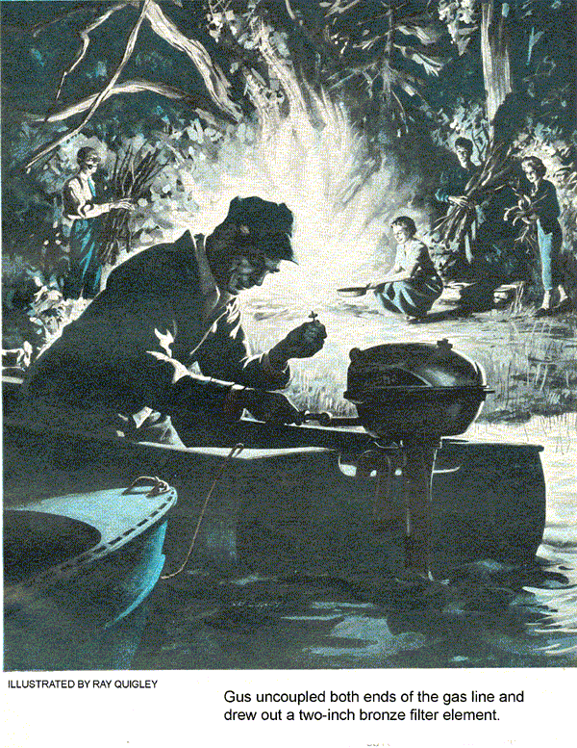
As darkness came down, clouds piled up in the west and a sharp thunderstorm took the edge off the midsummer heat. Glad at the chance to catch up, Gus Wilson was working late at a top overhaul. The Model Garage lights were the only ones on in the dark business section of the town.
The clatter of running footsteps outside the open shop door brought Gus from under the hood. Matt Bergstrom and Mrs. Adams, both winded, passed the pumps and made for him.
"Gus!" Matt puffed. "Haven't you got a boat up at the lake? May be trouble there - kids got caught out in the storm - should've been back hours ago. I thought they were at the Adamses and she thought--"
"Tell me on the way," Gus cut in. He bustled them into his car, strode over to pull the main switch of the garage and took out fast.
Panic Sets In
By the time they neared the lake, Gus had the story. Bergstrom's taffy-haired daughter Sally had gone for a swim and picnic with 16-year-old Guy Adams. They'd taken the Bergstrom outboard, heading for the beach on the far side of Thatcher's Island. When Sally didn't show up for supper, Matt assumed they'd waited out the thunderstorm at Lora Adams' home. When, at nine, Lora had called him, a kind of panic had begun to lick at both parents.
"Neither youngster is a strong swimmer," said Lora. "I just hope that storm didn't catch them out in--"
"Probably waited for the storm to blow over," Gus said quickly, "and then discovered the rain had drow-soaked the ignition." It occurred to him that Matt and Lora had infected each other with a highly contagious anxiety. "We'll be there in a couple of minutes now. If the lake's not too rough, we might take a run out to the island. Probably find them soaked and sheepish. Will you dig my flashlight out of the glove compartment, Matt?"
The Party Sets Out
Fair-sized waves were tossing Gus's 12-footer at its pole mooring, and rain water sloshed the floorboards. "Doesn't look so bad," Gus told them briskly. "Lora, you get in the bow and hang onto the flashlight. Matt, will you do some bailing from the middle seat?" He stripped off the cover, checked the gas and spun the kicker.
The wind was behind them as they headed out onto the lake. A past-full moon showed occasionally through scudding clouds, dimly picking out the ridge behind Thatcher's Island.
"Don't stand a prayer of finding anything in all this blackness," said Matt grimly. "I think we ought to go back to a telephone. Call the state police and get them to start a real search going."
The same idea had been in Gus's mind for minutes. "Maybe you're right," he conceded. "But let's take a fast look at the beach first - we're almost there."
At first they rounded the point of the island, the hearts of all three in the boat gave a flip-flop - there was a campfire in the cove. The distant reddish light glinted off the aluminum hull of the beached Bergstrom boat, and two small figures danced like Indians in thefirelight. Both Matt and Lora were calling as the boat slowed to coast in.
During the first moments of greeting, Gus busied himself with tilting the engine and pulling the hull up on the beach. Then he sauntered up to the group by the fire.
Storm Over the Lake
"…The silliest thing," Sally was saying. "Robinson Crusoe all over again - my name's Friday. I guess we were a little late in starting home. Anyhow, the clouds were awfully black, and we were just coming out of the cove when it began to rain like anything and I made Guy go back because I just knew we'd get struck by lightning. He said we could take off the motor and turn the boat over for shelter - it was just drenching - but I knew that metal boat would attract lightning and--"
"So we just waited out the storm in the woods," Guy finished. "I tried to tell Sal that trees were no protection against lightning, but you know how it is with women."
Guy's good spirits evidently grated on Bergstrom. "That's all very well, young man. But the storm blew over hours ago. Why didn't you come home right afterward? Your mother and I were both extremely worried."
"Daddy, we tried to three times, but the motor kept sputtering out," Sally interjected. "The wind was against us and we didn't have any oars and that old motor kept stopping. So Guy built a fire in the cleverest way and we just waited until--"
"That's enough," Matt cut in. "I'll talk to you later. Evidently you've never heard of smart alecks who manage to run out of gas when it suits them. Well, young man, what's your story?" "Look," said Lora Adams, "must we stand around here while you put witnesses on the stand? These children are wearing wet clothes and I think it's important to get them home instead of letting you sound off."
"I'm not sounding off. But I don't propose to let my daughter go out with a kid who can't even tell a straight story."
"You mean he can't get a word in. f you'd stop bullying him long enough - "
"Bullying - that's a laugh! The important thing is why a young girl was kept out for hours when there isn't a shred of justif--"
"Motor kept conking out, Guy?" Gus tossed a piece of wood into the fire. "Sounds like the rain got into it." He realized that the flare-up, even though it was just a reaction to anxiety, ought to be headed off if possible.
"Well, I thought so too, Mr. Wilson, but it doesn't make any sense. Because each time it'd start right up and run fine at low speed with the prop in neutral. And then she'd quit as soon as we'd start out for home."
"That's very plausible, young man - especially the part about not making any sense. That motor runs like a clock - hasn't missed a beat all season. What were you really doing - shutting off the gas line?" Matt's voice was icy.
"No, sir, I was not."
"Or did you just close the air valve on the cap so the gas wouldn't feed down?"
The Feud Begins
"I've had just about enough of this," said Mrs. Adams shrilly. "More than enough. I'm not going to stand around all night listening to somebody who's crazy as a hoot owl. Gus, will you take me home? You come with us, son - you've seen enough of the Bergstroms."
"Sure, Lora," Gus said. "Matt, what say we adjourn this until we get back? If you'll get the bailing can, Guy, we can wet these embers down. The woods are wet and the fire's on sand, but there's no point in taking any chances." Grabbing two sticks by their unburnt ends, Gus tossed them into the water. In the dark he could now barely make out Bergstrom's face. "If you'll hold the light for me, Matt, I'd like to take a look at that kicker of yours."
Gus climbed into the boat, found the gas tank half full, and noted that the prop was clear of the bottom. He checked the air valve, set the choke and shoved over the spark. Handing the flash to Matt, he yanked the starter handle. The motor sprang instantly to life, idling throatily as he eased off the choke. It sounded fine, Gus thought, wondering if Matt would boil over again. He cut the engine, edged past Bergstrom and stepped ashore.
"Doesn't seem bad now," he said decisively, "but I think you ought to lead the way home, Matt. We'll be along as soon as that fire is wetted down."
Bergstrom was silent for a moment. "Get in the bow, Sally," he said abruptly. "But don't think you've heard the last of this - any of you."
Flickering Farewell
Matt's engine caught again quickly. The boat turned out into the darkness and picked up speed. As it rounded the point of the cove, Sally winked the flash twice in mute farewell.
"I hope they get along all right," said Guy doubtfully. "Or do I?"
After Guy shoved off they could still faintly hear the high pitched beat of the other outboard in the dark. Then Gus fired up his own motor and they shot out of the sheltered cove. Around the point waves slapped solidly against the hull and spray blew back over Gus until he eased off the throttle.
"Look!" Guy saw it first - the yellowing beam of a flashlight out on the lake. They headed toward it. In a few moments the dim moonlight revealed the Bergstrom boat, broadside to the waves and rolling deeply. Matt was on his knees flailing at the starter; Sally flickered the tiring flash in merry greeting.
"Can't tow - painters aren't long enough," Gus called above his throttled-down motor. "Grab my gunwale, Matt, and hang on! I'll head back to the cove - too tough into the wind. Guy, take care of it at the bows. Don't get your hands pinched, either of you." He circled and came up alongside with bare steerage-way, then fed more power cautiously once the boats were lashed together by two pairs of arms. They headed back precariously, the strain easing as they turned downwind.
Bergstrom Picks Up the Battle
With both boats beached once more, Matt lost no time in regaining the initiative. “I don’t know what you did to that motor,” he told Guy, “but you sure bollixed it.”
“Gus Wilson, I asked you to take me home,” snapped Mrs. Adams. “I don’t see why you can’t leave him here- let him stew in his own childish juices. I suppose we could find room for Sally.”
Gus felt an amused irritation. “Nobody’s going to get marooned, Lora. I think five people are a bit too much of a load to take across in one haul tonight, but if necessary, I can make two trips.”
“That mightn’t be easy, Mr. Wilson,” giggled Sally. Remember the problem of the farmer who had to row a wolf and a lamb over a stream?”
“Before we do that, I’ll take a crack at your father’s motor,” Gus said. “Worth spending a little time if it saves four trips across the lake. That flash is getting feeble-hold it in close, Guy”
Using the tool kit in the boat. Gus pulled and checked the plugs and examined the wires for raw places. He laid the reconnected plugs on the motor, spun the flywheel. Blue voltage snapped across the points. He turned to the carburetor, squinting in the dim light.
Sure wish we hadn’t doused that fire,” he said. “This is mean to see.”
“I can get another one going right there on the beach,” Guy volunteered. “Anyone got any matches?”
Gus felt his pockets, shook his head. “I don’t smoke,” rasped Matt.
Clever Fireman
“It doesn’t matter-show them what you did before,” Sally called from the shore. “Toss me that old flash and I’ll get some branches from the dead pine.
The two youngsters pitched in, glad of the chance to show off before their elders. In a moment Sally dumped an armload of pine boughs just above the water’s edge, handed the almost worthless light back to Guy, and went back for more. Guy uncoupled the fuel line, drew a cupful of gas into the bailing can and handed it over to Sally, who poured it on the wood. Guy tore a narrow strip from his handkerchief and wet it lightly with gas. He folded it into a pad, checked that the tank was capped and the fuel valve was off.
“All set?”
“You bet.”
Using pliers to hold the pad by the end of one plug, Guy hauled on the starter handle. Nothing happened. The second time he tried, snapping sparks ignited the cotton. Carefully holding the flaming little torch with the pliers, Guy stepped ashore and tossed it on the fuel-soaked pine. At once the fire flared.
Treasure Trove-Two Hot Dogs
“Hey, that’s pretty slick,” Matt said. The warm, dancing light seemed to cheer everyone up. Lora Adams, investigating the picnic hamper, held up two hot dogs she’d found.
"With a frying pan, we could cook up a little snack," said Mrs. Adams.
"I'll get you a couple of green sticks," Matt told her suddenly. "Wait a second." He trotted up to the edge of the woods.
Gus smiled as he worked over the carburetor. The float needle moved freely and there was no grit or sediment inside. He uncoupled both ends of the gas line and drew out a two-inch bronze filter element. The line was clear. Taking up the metal filter element, he shook it, blew through it until his cheeks bulged, and stared at it for a moment.
Then he did a strange thing. Laying the filter element on the seat, he drove the point of his knife right through it. He blew through it again, and then carefully assembled the parts.
"Now," he said with conviction, "we can go home."
"Darnedest thing I ever saw," said Matt, "the way you drove a knife through that thing like butter."
Motor Starved by Clogged Filter
"It's not hard. The filter is a kind of spongy bronze - it works fine, stops dirt or water dead in its tracks. Like any filter, it clogs up if it has too much work to do. When its almost saturated with water, it will starve a motor but let enough gas through for idling. Let the motor sit a while, and enough gas will dribble through into the carburetor to run at full throttle for a few minutes.
"In the shop you can blow out the trapped water with compressed air, but I put a slit through just in case. May be a little water-spitting from the motor, but I doubt it."
"If you great brains have that problem licked," said Mrs. Adams with amiable tartness, "maybe you'll tell me how to divide up two hot dogs between five people."
"Three people," corrected Guy, who was sitting by the fire with his girl. "Sal and I can't eat and harmonize at the same time." They sang a chorus of "Show Me the Way to Go Home" and it seemed to Gus, whose ear was better tuned to knocking than flatting, that it was darned nice music.
END

