September 1953

GUS SAVES THE OLD HOMESTEAD

by Martin Bunn
A jangling phone cuts into Gus's peaceful dreams
with a real nightmare out at the Gantner place.
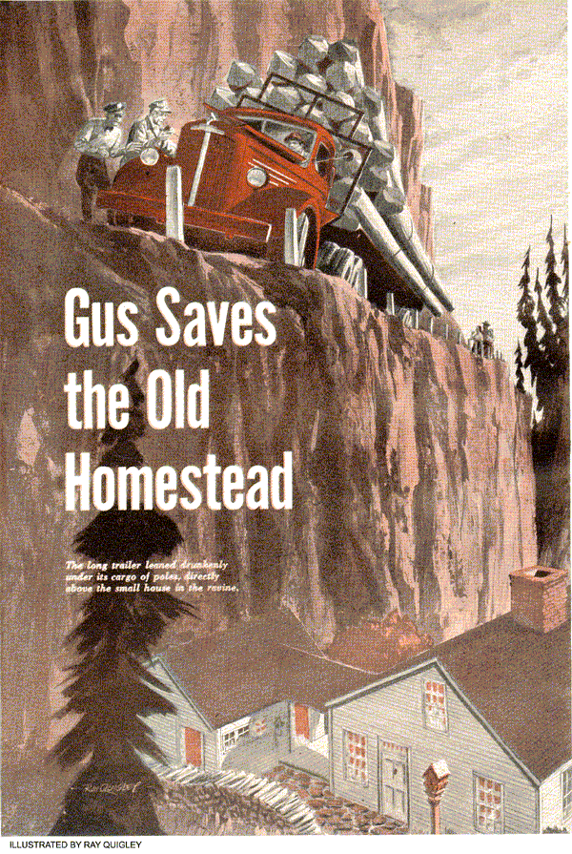
Morning was still a smoky gray, pierced only by the ticking of a clock and the sounds of heavy sleep. Sunday, at that hour, was never disturbed by the rattle of milk bottles, or the usual shriek of hot shave water through old plumbing. Maybe that was what made the sudden jangle of the telephone so grating.
Gus Wilson groaned and tried to shut out the sound. But it chased him around the edge of his pillow. Blindly he reached for the receiver.
"Gus? This is Billy Ryan. I hate to bust up your dreams, but we need your help."
"Help! Listen, Billy. This is no time to be playing cops and robbers. Why don't you climb into your patrol car and drive out to East Mountain? They say the sunrise there is real pretty."
"That's where I am now. There's a truck stalled here on the grade with a conked out engine and a load of telephone poles. The way those logs are shifting it won't be long before the cables snap. When they do there's a little house right below the road - the old Gantner place, you know - that's going to look like Home 1 after the Yucca Flats atomic-bomb test."
By now Gus was coming to.
"You pick me up in front here," he said.

Billy's Patrol Car Skids to a Stop
Gus put his hand on the door handle as Billy Ryan's patrol car squeaked to a stop.
"Okay, Billy," he said. "You can fill me in on the way."
"There isn't much to tell." Ryan began as they sped away. "The truck driver called the station from this house that's practically under the load. Said he was hauling the poles for a replacement job when the engine died halfway up the hill. It was too dark to back down, and he didn't want to trust his brakes to hold him. So he backed onto the shoulder, figuring to pull out as soon as he located the trouble."
"Only the engine wouldn't start," Gus interrupted, "and the outward slant of the road kept pulling on the load until the cargo started slipping."
"You're right about the poles," Ryan said, "but not about the engine. She'll start easy enough. But that place of theirs is going to be leveled if those poles let go. Be a shame, too, old Julius Gantner built it himself, back in the '60's - the first house up in that neck of the woods - and it's been home, now, to four generations of Gantners."
Gus scratched his head.
"How about my tow truck?"
"Not a chance. The slope above the road is bare, nothing to wind a cable around."
"What happens if I get the engine fixed?"
"Then he's going to take off up the hill as fast as he can. If he can push his luck as much as 50 yards, the house will be safe."

The Trailer Leans Drunkenly
The sun was just tipping the pines when the road broke through a slash in East Mountain, and they saw the truck high on the shoulder of the bald ridge beyond. Its long flat-bed trailer leaned drunkenly under the cargo of poles, directly above a splash of earth that fell off sharply toward a small house plastered against the side of the ravine. Four small figures standing at the side of the road added a final touch to the cheerless scene. Three of them would be the Gantners - Tom Gantner, old Juluis' grandson, his wife, Mary and their teen-age daughter, Susan - the other, the driver of the truck.
Billy Ryan eased to a stop a hundred feet behind the trailer.
"It's your move, Gus," he said.
Gus trotted ahead, nodded to the stocky driver who came forward to meet him, and noted with approval that the hood was already up, the engine running, and the tools laid out on the fender.
"Sure glad to see you, Mr. Wilson," the driver said. "I'm Bill Berry. Guess you know the rest of the story."
"Ryan's been briefing me," Gus said.
"Engine idles okay, but dies out when you pour on the power. Anything else?"
"Not much. There was a little sputtering the last few weeks, so I had the fuel line blown out yesterday, and a new fuel pump put in. She ran fine after that."
He was interrupted by a faint but ominous creaking.
"Hear that? Those poles are still shifting. Cables can't take that strain forever."
Tom Gantner had moved up quietly on the other side. His face was tense.
"I've heard you are a good mechanic… "
His voice trailed off.
Gus turned from a quick inspection of the ignition system and smiled.
"I'll do my best, Mr. Gantner."
Plenty of juice danced against his screwdriver at the plugs. The points in the distributor were good and there was no sign of a short.
There seemed to be plenty of output in the coil and the condenser looked okay.
With ignition crossed off the list, it was plain the engine was starved for gas. Gus began twisting the regulator screw of the carburetor. When he was sure that any richer mixture would drown out the plugs he pulled the accelerator arm. The motor coughed and died.
At a word from Gus, Berry climbed gingerly into the cab and stepped on the starter. The engine ran for a minute or two at idle, then died again. Gus puzzled a moment, then leaned the mixture down to its original strength. Berry started the engine again. This time it didn't die - not until Berry tried to increase its speed.
He had been listening for a thin hiss at the intake manifold. The fact that he couldn't hear it didn't mean anything; a bad leak might lower the pitch and make it harder to detect among the other noises.
"Have you some light oil handy?"
Berry dug a can of household oil out of the running board toolbox and Gus dropped a little around the manifold gasket. None of it was sucked in at the seal.
"That's out," Gus scowled. "I thought maybe your manifold facing might be warped from overheating, or that the gasket was shot."
Whatever it is, he told himself, it's right under my nose. Some small simple… Wait a minute!
Gus was looking at the filter unit, the small glass cup with the ceramic filter.
"Shut her off," he called to Berry.
Disconnecting the cup he mopped it out with a chunk of waste, wiped off the filter and put the unit back in place. There had been at least a spoonful of red silt at the bottom of the bowl.
"Now start her up again and gun her."
Berry cranked the engine back to life and hit the gas. This time the engine roared for a moment before conking out.
Gus took the cap off again and studied the intake and outlet tubes. They looked all right. He put the cup back, minus the filter. That would let him watch the flow of gas into the unit.
When Berry bore down on the starter the fuel jetted in with healthy bursts that quickly climbed to the level of the outlet tube. An instant later the engine caught. Gus shouted to Berry; "Gun her!"
The engine burst into a full-throated roar and stayed there, bellowing sweetly.

The Ponderous Cargo Testers
Berry didn't wait to ask questions. He put the truck in gear and inched forward letting the engine take the strain gradually.
Five feet. Ten feet. The ponderous cargo of poles teetered perceptibly. But somehow the cables held.
Tom Gantner grabbed his wife and daughter and shouted with relief.
"He's made it! By jingles, that boy has made it. Sounds silly to say it, maybe, but Gus Wilson's saved the old homestead!"
Billy Ryan ran for his patrol car, pulled up beside Gus and waved him in.
Well follow him up the grade," he said 'and stand by 'til that load breaks free."
For a quarter of a mile they trailed at a safe distance. Then the road was leveling.
Just ahead was a broad, clear space where Berry could pull off to the side. Even if the poles let go, now, they wouldn't tumble down the mountain. Another 100 feet - 50 - 20 - 10.
The truck ground to a stop.

Cables Lash Out in Arcs of Fury
Berry climbed out of the cab, grinning.
That grin stayed with him even when the cables gave a sudden hitch, twanged, and lashed out in twin arcs of fury. With a deafening roar, the poles rumbled to the ground.
Billy Ryan whistled.
"That," he said, "was luck."
Berry shook his head.
"Aren't you forgetting Mr. Wilson? Say, what was causing all the trouble, anyhow?"
Gus handed him the ceramic filter.
"You're kidding!"
"No. That little gadget was blocking the flow of gas. When you gunned the engine and it didn't quit, it suddenly came to me. That filter is so old that all of the impurities it had trapped finally plugged up most of its microscopic holes. What little fuel did get through to the carburetor was only enough to let the engine idle."
Berry was still incredulous.
"I've never heard the like. Say, would you fellows do me one more favor? I'd like to get a call through to the company, so they'll send some equipment up to put those poles back on the truck."
"Will do," Billy promised. "Are you ready to go Gus?"
As the patrol car spiraled smoothly down East Mountain, Ryan cocked an eye at his nodding companion.
"Sure was a pretty sunrise!"
END

