November 1953

GUS GOES HUNTING…FOR TROUBLE

by Martin Bunn
The tall Texan had bagged the biggest buck Gus had ever seen,
but his tongue was just as sharp as his shooting.
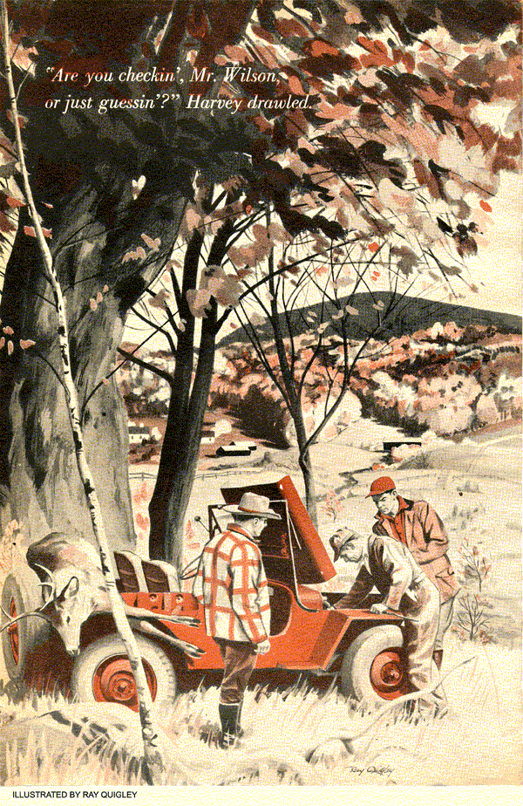
Gus had a car up on the rack, and he was working with the swift efficiency of long practice, but his thoughts roamed elsewhere. Tomorrow was Thanksgiving Day. And though Stan Hicks, his helper, had kidded him unmercifully about it, Gus just had a crazy hunch that he was going to win that turkey raffle down at Schutzheimer's meat market.
If he did, Sam over at the lunch wagon had promised to cook him a big turkey dinner with all the fixin's - which would help a little to make up for Gus's disappointment about something more important. This year, for the first time since he could remember, he had not been able to get away from the Model Garage during the deer-hunting season. And what Gus really craved was a couple of days' hunting - and a nice big juicy venison steak.
The phone rang. Ah-hah, thought Gus, maybe that was Karl Schutzheimer now - to tell him that he was the lucky winner of a plump gobbler.
It wasn't. Instead of Karl's familiar explosive accents, the voice on the phone came over as a lazy drawl.
"Howdy… Gus Wilson?" It rolled out slow and easy. "This here is Bill Harvey of San Angelo, Texas. I'm a few miles out of town at a farmhouse on… let's see, I got it written down here… it's Eye-thacka Road. Need a tow truck to haul that lizzie of mine in. She won't run for hoot nor holler!"
"All right, Mr. Harvey. Whose farm is it?"
"Folks named Peeble - they told me to call you. I'll be standing by their mailbox."
"Okay. I'm on my way," Gus said as he hung up. "Stan, take over while I go out on a call. And when Karl phones about my bird, tell him I'll be back."
"You better go buy me one, boss," Stan chortled. "Somebody may give you the bird - but I bet it won't be a turkey!"
Gus glared good-naturedly and backed the truck out.
Ithaca Road, or "Eye-thacka" as the Texan called it, ran north from town. It was more or less in the farm country at the edges of the heavily wooded hills bordering the area. The road was clear - there had been only a couple of snow flurries up to now - and Gus knew where the Peebles lived, so it only took a few minutes to get there.
He found Bill Harvey standing, long and lean and looking like a piece of sunburned leather, near the Peeble mailbox. Harvey was spattered with blood from shoulders to knees.
Gus squealed to a halt and jumped out.
"You didn't tell me you'd been hurt!"
"Shucks, Mr. Wilson, I ain't hurt. This here's deer blood. Reckon I got it all over me haulin' that buck down the mountain to our car."
"You had me worried! Where's the car?"
"Up this side road a couple of miles. Had to walk down here. Lost a lot of time doin' it. And I gotta get that buck into town by five this evenin' or we won't win the contest!"
"What contest?"
"That one the Chamber of Commerce over at Parsonville is runnin' for the biggest buck killed in the county durin' the day. And I'll roll a frijole from here to Texas if we don't have the biggest doggone buck you ever laid eyes on! Besides, that prize is a hundred bucks. Pretty good odds, eh? A hundred bucks for just one buck." Harver grinned expansively at his own joke.
Gus recalled Stan's bewildered gag about the turkey - this seemed to be a day for corny humor.
"We've got plenty of time to tow her in. Not quite three yet."
He climbed behind the wheel, Bill Harvey got in and they drove on up the road.
"Came up here from Texas to spend the holidays with my boy Pete and do some huntin'. He lives over in Parsonville with his wife and two kids. Well, we sure got us a king-size deer anyhow!"
Gus nodded, and kept an eye on the clock until two miles had ticked off. Shortly after that Bill Harvey told him to stop. "Right here'll do. This here truck's too big to squeeze through where my jeep went."
"You mean she's off the road?"
"Yep. She's another half-mile or so up the hill."
"Nothing to do but go up and look at it, I guess. Unless you want to carry that deer down and take it to the contest in my truck."
"No, don't think that'd work. Luggin' it through the brush would take from now until Texas recognized the United States! That buck is the granddaddy of 'em all!"
"Well, let me grab my tool kit. You lead the way."
Harvey set off at a long-legged pace and in a half-hour, after pushing their way through brush up a steep slope, they reached the jeep. Harvey's son, Pete, the spitting image of his old man, stood by a front wheel. In the back of the jeep, its head and rear legs extending over each side, was the biggest buck Gus had ever seen.
"We got a mechanic now, Pete. This here's Gus Wilson."
Gus shook hands with Pete, and when he caught his breath, began looking under the jeep's hood.
"She died and wouldn't start again. We had it up farther and around the hill, maybe another half-mile. She got warm running up and down over this rough ground. I thought maybe she got a vapor lock, but changed my mind when coolin' the carburetor with water didn't do any good. We got her to run again for a short time, after she sat a while, just before I started lookin' for a phone. But she quit for sure then."
"I see. We'll have you out of here soon, with any luck at all."
"Mister, I hope so. Winnin' that contest means a lot to my boy and me. And we're mighty anxious to tote this buck home and show the folks. Maybe you're a hunter yourself and know what I mean."
Gus knew what he meant. He gave the jeep a quick once-over. The engine was dirty with the oil and grime of thousands of miles. But on that first examination, Gus found nothing that would cause the engine to fail.
There might have been a vapor lock, and Gus hit the starter to make sure before going any further. The engine caught immediately.
Young Harvey shoved his hat back on his head. "I'll be dogged! It wouldn't do that a few minutes ago!"
"You might have had a vapor lock, although if Pete here wasn't able to start it up in all that time you were hiking for a phone, it would be a pretty stubborn one…"
Before he could finish, the engine sputtered and died. Gus hit the starter, but it only coughed, and refused to catch again.
"Just like before," Bill Harvey drawled.
Gus rolled up his sleeves and frowned. He dismantled the fuel pump and made a check. It was another part that should be replaced, but even with a well-worn diaphragm, it was still in operating condition. Replacing it carefully, he went on to examine the carburetor.
The carburetor was loaded with silt, when he got down inside. He had Harvey pour gasoline in a tin can to rinse it out with.
"Now try," Gus said after putting it back.
Harvey stepped on the starter, but the engine only cranked.
"That's tough luck! I'd better check your ignition."
"Ain't much time left. Can't you get on your horse a little, Mr. Wilson?" There was irritation in the Texan's drawl now.
"I'm going as fast as I can."
Gus checked the ignition wires all the way from the switch to the coil and the distributor, and to each of the plugs. That took another precious 15 minutes.
"That wasn't it, either. I'll be darned if--"
"Are you checkin', Mr. Wilson, or just guessin'?" Bill Harvey asked.
Gus controlled his temper and went about his work. The last item he checked was the fuel line. From tank to pump, he checked carefully. There were no breaks in the line, and no kinks from the rough going. The flex line by the pump was clear, though it did seem harder to blow through than it should have. "Try it now, Mr. Harvey."
The engine caught after a minute or so. But as before, it ran only long enough to get warm before the engine died.
Gus had a glimmer of an idea then. The flex tube had offered a little resistance to his lungs. It lay close to the hot engine, but it had been only warm when he had blown through it. Now that the engine had run again for a short time, the flex line was warmer. What if - it was just a hunch - but Gus detached the line again and tried to blow through it. This time, it was completely blocked!
"Well, there it is."
"That flex line? Why was that so hard to find?"
"I'll tell you why. This line has that long-lasting metal weave on the outside. But the inside is just lined with synthetic rubber. You know how rubber gets brittle and cracked when it's old. It finally gave out on you, and every time the engine gets warm now that section expands and twists enough to block your fuel. When you let it cool, it settles back and lets fuel pass through. Luckily, I've made the habit of carrying a couple of spare flex lines in my kit. You'll be on your way in a minute."
Gus connected a new line to the pump and started the engine. It kept going.
The Harveys and Gus piled in, and began a jolting, tree-dodging rampage down the hillside. But it looked as if their wild ride would be in vain. By the time they got back to the road, it was only 12 minutes before the contest deadline, and Gus figured it was at least seven or eight miles to Parsonville.
Nevertheless, Gus hurried as he climbed into his truck and wrote out a bill.
When Gus arrived back at the garage, and looked questioningly at Stan Hicks, the boy shook his head. "I told you, boss, you'd better buy a turkey!"
"I guess I'll have to settle for Sam's hamburger," Gus grunted, starting for the back shop to close up.
He was hardly out of the office door when the phone rang. Stan answered it.
"For you, boss."
"Hello, Gus Wilson speaking."
Bill Harvey's unmistakable drawl drifted through the receiver.
"I reckon you're pretty disgusted with Texans at this point, Mr. Wilson. I'm afraid I wasn't a very good example of that particular nationality today. I was pretty sore at my car, and when I thought we were going to miss that contest… Well, I want to apologize for takin' that out on you."
"Thought you were going to miss it . . . Did you get there in time after all?"
"Sure did, and with at least half a minute to spare, and our luck won hands down. We're home now - over at my boy's place - and we've got more deer meat here than we could get away with in a month o' Sundays. We were wonderin' if maybe you'd give us the pleasure of your company at Thanksgiving dinner tomorrow… We're havin' venison steaks."
END

