May 1953

GUS TAKES A GAMBLE

by Martin Bunn
Tracing that engine trouble was a tough job even for Gus -
and a kibitzing kid with a pistol didn't make it any easier.
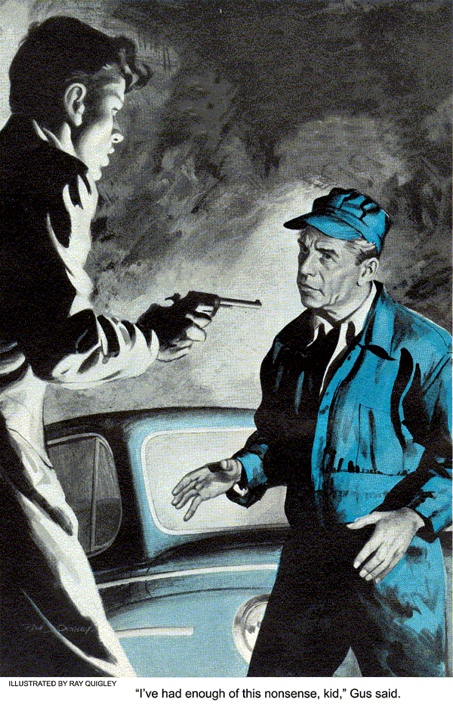
The kid came after sundown and stood in the shadows just inside the Model Garage. He was much too young for the grim look around his eyes and mouth. It reminds you of the concrete jungles of the city, but he was a local boy - Gus had seen him around - and the violent trembling of the gun in his hand shattered the illusion of toughness.
"Don't argue, mister. You're Gus Wilson, and you're going to fix my car quick. I ain't got anything against you personally, but get busy or you may get hurt."
"Suppose a customer comes in. Got that figured out too?"
"Close the door and use your trouble light."
Gus rolled down the door and snapped on the small caged light. It cast a glow on the kid's sweat-shined face. He couldn't be more than 17.
"And you expect me to work on this car with that gun twitching in your hand?"
The kid looked down at the gun, then shoved it in his pocket.
"Okay, but don't get any ideas. I could shoot you before you took two steps."
"All right, suppose you tell me what's wrong with the car."
"She misses, especially when you step on the gas all of a sudden, like when you're getting away from a light. Sometimes she runs perfect. Had her up to 75 easy just last night."

Gus Recalls Rainstorm
That stopped Gus. "You were driving 75, miles an hour in that downpour?" He recalled the heavy rainstorm that had kept him home all evening.
"Sure, why not?" the kid said with a touch of bravado. "I can handle her in a skid."
"Uh-huh," said Gus. He lifted the hood, reached down and removed the distributor cap. The rotor, points and condenser seemed to be all right.
"I've had enough of this nonsense, kid," Gus said.
"What are you running away from?" He didn't expect an answer, but talking might calm the boy a little.
"You'll read it in the paper tomorrow, I guess. Dill's Feed Store is missing 700 bucks. I worked for old man Dill up to tonight. Sure, front page and pictures, so there's no harm in telling you. Johnny Wentz missing, cash register robbed. But by the time the cops find out, I'll be too far away...and you're coming with me."
"Where do you figure is 'too far away' for the police?"
"Get to work and cut the gab!"
Gus said nothing. He cleaned and gapped the V-8's plugs, and put them back. When he started the engine it idled fast and a little rough, stalling when he set the idling speed adjustment down a bit. Gus backed out the idling mixture screws slightly and restarted the engine. The idle seemed better but she still bucked a little when he pulled open the throttle rod.

Kid Tells Why He Took the Money
"Why did you do it? Old man Dill paid you a salary."
"Chicken feed! Look, I've been on my own since I was 12. I never had anything of my own until I saved up for this car and these duds I got on. And I've been living in a cheap boarding home. I want better clothes and a decent place to live!"
"And you think stealing is going to make that dream come true? "Tell me, how are you going to enjoy these things when you're constantly on the run?"
Johnny pointed to the engine, but Gus knew his words had cut deep.
Gus looked over the carburetor for anything that would plug the air or fuel supply or cause it to be temporarily cut off during the surge of acceleration.
The carburetor was clean enough, and Gus moved down a mental check list to the next suspect, the fuel pump. While he dismantled the pump, he was aware of the kid fidgeting with growing impatience.
"What's taking so long?"
Gus ignored the question and looked at the pump mechanism. The intake and outlet valves were not gummed up with fuel deposits or tank additives. And the diaphragm edges weren't worn enough to cause trouble.
"Can't find anything wrong," he finally answered.
"Look, Wilson -" the kid's eyes narrowed, "You're just stalling!"
The gun was out again, and the kid's hand was no steadier than before.
"That pistol won't speed things up, sonny, I can only work so fast."
Gus tried to get his mind off the boy and concentrate on the car. He began looking for high voltage leaks tracing the plug leads again, looking for bare wires, loose connections, corrosion. He followed the line leading from the coil to the distributor.
Then he examined the ignition connections in back of the dash. By now, he was satisfied that the trouble was in the carburetion system. Something was starving the engine.
He crawled under the car with the trouble light and traced the fuel line from tank to engine. The leak he suspected was not there, and blowing the line failed to show any obstruction. He turned to the kid.

Gus Defies the Kid's Gun
"Okay, pull that trigger if you're going to, because I've gone as far as I can." Gus began walking deliberately toward him.
Johnny Wentz stepped back, and the gun he held wobbled in the dim light.
"Stay back..."
"No Johnny. I've had enough of this nonsense. You're not going to shoot, because you just aren't the type."
Gus covered the last three feet in one quick step and deftly removed the pistol from the boy's hand. Johnny Wentz stared unbelievingly at Gus for a moment, and then broke into a fit of sobbing. Gus led the boy to the car and made him sit down.
"Start driving," Gus said firmly. 'You're going to put that money back."
The boy moved the car into the street.
The engine did skip a little, Gus noted professionally, as they pulled away. He pocketed the gun - no need for that anymore.
"Suppose they catch me before I get a chance to turn myself in, "the kid was saying.
"It's always better to turn yourself in - I know that much. I guess you think I'm nothing but a stupid little punk. But you know, I was glad when you took the gun, I was scared to death."
"So was I," Gus said wryly, as Johnny pulled up in front of Dill's without cutting the ignition. "I'll wait here.
You're on your own, Johnny."
"You're going to trust me? I could run out on you."
"I don't think you will."
The boy walked slowly around to the back Gus hoped he was doing the right thing. It was a gamble.
The rain had started up again. To keep busy while he waited, Gus began tinkering with the windshield wiper. He had a peculiar notion....
A few minutes later, the boy came back.
"A cop was looking around back in the alley. I had to wait until he wasn't looking to crawl through the back window.
“The money's in the register."
“Okay. Drive me back to the garage, and then you go on home."
"What? I thought - Look I'm a -"
"Come on," said Gus, "let's go."
The kid wasn't a particularly good driver during those few blocks back to the garage.
Gus covered the painful interlude by telling him what he had found out about the car.
"Funny thing kid. It was your windshield wiper. Kind of a joke really when a guy goes searching all over creation for the answer and comes up with something like that! You see, the flexible control cable from your dashboard button to the valve was clamped a bit short. When you shoved in the button, it didn't shut the valve completely. The wiper didn't run, but enough air was admitted to the vacuum line to lean out your mixture. And since you already had it set on the lean side, the leak caused a skip on acceleration. That's all there was to it. I should have thought of it when you told me about the car running okay in that rainstorm."
Johnny stopped in front of the garage.
"Don't say anything kid. I know how you feel. Just go home and forget about it. Forget about trying to make all your dreams come true at once. It never happens that way. Take your time and you'll get there - the right way."

Cop Waits in Garage
Gus stepped out of the car and walked into the garage without turning around.
Inside he found a police car, and a visitor, Billy Ryan, sitting on the work bench. Gus stared at the officer worriedly.
"Hi Gus. "Thought I'd keep an eye on things until you got back."
"Busy night?" Gus asked.
"No, nothing special. Some female claims she saw someone forcing Dill's rear window.
But I didn't find anything."
"Billy...."
"Forget it Gus. I saw it all after the kid crawled back through that window. We'll give him another chance..."
"I don't think you'll regret it," Gus said.
"And here, you'd better take this gun."
Billy climbed into his patrol car and started up. He paused a minute to roll down the window. "You know, Gus you'd have made a pretty good cop, at that."
END

