January 1953

GUS FIXES THEIR WAGON

by Martin Bunn
Of course he could have refused to touch a getaway car -
but that was no grease gun in his back.
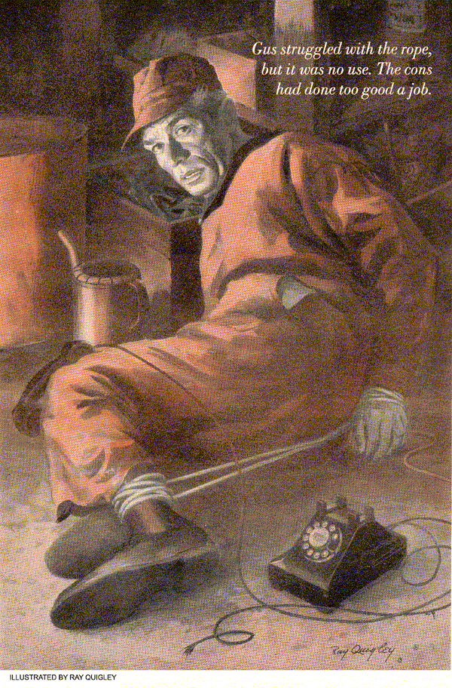
It was nearly closing time at the Model Garage and Gus was played out. It had been a raw, windy day, he'd had to go off on several emergency calls and now he was hurrying to finish up the last job before quitting time. But he was finding it a bit difficult to concentrate with his attention divided three ways
First, he was working on Doc Tandy's Model A. Second, the doc himself stood at Gus's elbow expounding an elaborate theory about how humans and automobiles were pretty much the same because they both broke down and had to be repaired. Third - and this was what Gus was really concerned about - an old but big, black sedan had been parked across the street for the last half-hour with two strangers in it who seemed to be keeping a mighty sharp eye on the doorway of the Model Garage.
Gus Gets the Jitters
It was just his imagination, Gus decided. Gloomy weather and fatigue had upset his nerves. He finished tightening the cylinder head on the Ford, twisted in a new set, of plugs and closed the hood.
"Okay, Doc, she's all yours."
Doc Tandy gave him a keen glance as he left. "Gus, you better go home and get some rest."
Gus peeled off his dungarees. He figured he'd leave the sweeping up to his helper, Stan Hicks, who had borrowed Gus's car and would return it to the garage later in the evening. Gus looked around at the next few days' work - two overhauls and a ring job. Then he flicked off the lights and reached to pull down the doors..
"We got a car for you to fix." The voice slammed across his shoulder. Gus jumped.
"I'm sorry, I'm closed for the night."
"Inside, grease ape!"
Two Customers In a Hurry
Gus drew back when a pistol barrel gouged his ribs. A sneer twisted the pasty face, and piggish eyes glittered back at him. The man made a motion with his other arm, and the black sedan rolled into the darkness of the garage.
"It's simple, buster. Fix our car fast and you'll be okay. Don't, and I separate you at the belt line."
"There's all-night garages in town, and you don't need a gun to get service. If you're after my day's receipts, they're in the bank already!"
The other man stepped from the car. He was younger, neater, but there was an odd slant to his face. He spoke quietly.
"Our apologies, dear sir, but sometimes a gun is necessary. Perhaps I should explain. In criminal nomenclature we are known as escaped cons. A good friend of ours provided this car, but it doesn't run well." He looked around at the three dismantled cars on the floor. "And really, with no other car here in running conditions, you offer us no choice but to insist that you fix ours. By the way, don't underestimate my associate's willingness to shoot. One more would make no difference. A prison guard suffered a slight case of trigger mortis last night!" The young man chuckled over his joke.
"I could call the police."
The convict's smile broadened.
"And shooting me won't get your car fixed!"
"No, but there are other places, and you don't want to die."
Gus looked from one man to the other. They weren't bluffing.
"Okay. You win."
"Now you're getting smart. Here's the pitch. This heap sputters every time you step on the gas in low gear, and in high over 35 or 40 it misses badly."
"That isn't so serious."
"It's serious if we have to play tag with a few patrol cars. Get busy."
Gus stepped away from the prod of the gun and opened the hood. It was a 1940 Lincoln Zephyr. He plugged in the trouble light and started the engine. It idled smoothly and sounded in good shape for its age. But when Gus pulled on the accelerator arm and revved the engine, it sputtered erratically and backfired.
Gus rolled up his sleeves. The pug still held the gun on him.
"I'm not going to try anything. Why don't you put that thing away?"
"Because I don't want to get belted with a wrench, that's why! Just do your work there."
Gus tackled the carburetor first, on the assumption that it was out of adjustment or clogged by dirt. But it was wasted motion.
"I guess it's your ignition system."
"You guess! Look, you find it quick! We ain't got all night!"
Gus tried the plugs next. It took time to inspect 12 on the testing machine. And while he checked, he heard them whispering rapidly in back of him. Only one word reached his ears - Chicago.
Gus put the plugs back in, and as he tightened up the last one on the forward end of the engine, he remembered something. There was a certain peculiarity to the '40 Zephyr that might. but there wasn't time for that yet. Gus wiped the clammy sweat off his face.
"Work!" The older man waved his gun toward the engine.
The distributor points were clean. They were pitted, but not enough to cause trouble, and though they were getting old, the contact metal wearing thin, they checked out all right when he tested the setting.
Gus didn't waste time putting an instrument on the coil. Instead, he got a new one and hooked it up. Looking hopefully at his captors, Gus slowly rolled up engine speed. Just at the instant he thought the danger point had been passed the spitting began again.
Gus leaned on the car and tried to stop trembling. His mind searched frantically for an answer, but it was hard to think with a gun pointed at him.
"Shake it up!"
"Look," Gus exploded, "you might as well get it into your pin-size brain that this may take a while!"
The older man edged forward menacingly, but the other stopped him.
"Let him think."
Gus remembered the condenser then.
There again, rather than take time to check it, he installed a new one. As a second thought he checked the insulation on the wiring, and still found nothing.
The end of the road had been reached now. He had checked everything he could without tearing the engine down.
"I've gone as far as I can. You better find another mechanic."
"He's pulling something! Let me slap him around! Let me slap - "
"Hold it! Try again, buster. This is your last chance."
Gus shrugged his shoulders and fiddled with the engine aimlessly. The gunman's threat rang a bell somewhere and as he puzzled over it, he reached down with a wrench, deep beyond the glow of the lamp, and loosened some bolts.
Slap - around .. slap .. something about the word was as familiar as a nursery rhyme, a missing ingredient, teasing at the edge of his mind.
New Points Turn the Trick
"Trying to think! Bouncing his skull on the concrete would help."
Bouncing .. it - happened - again.
Bouncing was a result of varying degrees of flexibility, a springiness.. a spring.. slap and bounce! That was it!"
"Okay, move that miserable friend of yours out of my way. I think I've found your trouble."
"It's about time!"
Gus went and got a new set of distributor points. The others had seemed all right, but actually they were what caused the car to sputter at high r.p.m. The constant flexing of the point spring over a long period of time had gradually sapped its strength until the spring failed to keep the contacts closed for the proper length of time. The spring was allowing them to slap and bounce at high r.p.m. The resultant charge of electricity reaching the plugs was too small to keep the engine running properly.
Gus Reaches the End of His Hope
It wasn't what Gus would call a common ailment. Being about the least expensive part of an engine, points were usually changed fairly regularly. But there were some home tinkerers who had the idea that clean points meant the distributor was in good order, no matter the age. Gus figured the Zephyrs owner was like that.
He installed the new set, adjusted them to the proper setting and raced the engine. It was smooth as fine oil.
"Okay. She's fixed. Now get out of here and leave me alone!"
"With pleasure, buster, but there's one thing more - just so you won't holler copper for a while."
The two men grabbed him and trussed him up with a length of rope Gus kept in a corner. Then the one with the gun ripped the telephone off the wall and dropped it near Gus.
"Something to amuse yourself with! So long, grease ape!"
The two convicts jumped in the car, backed out with a squeal of rubber and roared down the street.
Stan to the Rescue
Gus struggled with the rope, but the cons had done too good a job. He relaxed his muscles and waited. At least Stan hadn't gotten mixed up in it. Might have tried something rash he thought. These young squirts.. say, what's keeping that kid?
As if in answer to his thoughts, a car drove up on the concrete apron outside, and a cracked voice called out" "Hey Gus! You in there?"
"Hurry up, Stan! Get me out of these ropes. I've got to get to a phone. I'll explain later."
They drove to a drugstore a couple blocks away, and Gus ran inside. He dialed a number, and Officer Billy Ryan answered.
"This is Gus, Billy. You on the lookout for a couple of escaped cons?"
"Yeah, we been watching for 'em. Why?"
A Tip for the Cops
"Well, they've just left my garage - they're headed for Chicago. But I think you'll find them a short distance out of town on the westbound highway. Their car will break down, probably in the next 15 minutes or so. It's a black 1940 Lincoln Zephyr. You can't miss it!"
Gus could hear Ryan shouting at the dispatcher to send a car out and call the highway patrol for assistance.
"Hope you're right, Gus. But how do you know the car will break down?"
Gus told him how he had fixed the car, and of the other "adjustment" he had made.
"Nice going, Gus. You pulled a neat trick! So long."
Gus went back to the car and drove Stan home. He told him the whole story.
It was a neat trick. Only mechanics and a few owners of that model Zephyr would know about it. Once, a 1940 Zephyr had come in behind a tow truck with its radiator torn to pieces, and Gus had discovered that on that model the radiator was fastened only at the bottom. Sometimes, if the bolts loosened a little, and if the car was moving fast enough against a strong wind, the radiator just leaned into the fan blades. The result was a frightening noise, loss of coolant, and an overheated engine freezing up.
"Say, that's a pretty good stunt, boss!"
"Sure, if it works and they catch them." He stopped in front of Stan's house.
"You know, since I'm working for such a smart boss, my job is on a higher level than I thought. Don't you think I ought to have a raise?"
Gus took a playful swing at Stan as the young man jumped out of the car and said good night.
Gus Gets Some Good News
Gus had finished dinner and was settled down by the radio when the phone rang. It was Billy Ryan.
"I thought you'd be interested in how things turned out. We found the car abandoned at the edge of the road - "
"You didn't catch them, then?"
"Wait a minute! A little girl came running up to us. She was on the way to a neighbor's after sneaking out the back of her house to get help. Said there were a couple of bad men getting ready to shoot her folks. Well, we got there just in time. They're in our little cage right now. And tomorrow they'll be heading back for the big gray walls - thanks to you, Gus."
Gus grinned and glanced down at his wrists - they were still sore from the ropes the cons had tied him up with.
"Don't mention it, Billy," he said into the phone. "Always a pleasure to help out the law."
END

