May 1952

GUS DIAGNOSES

THE FLAT-TIRE CASE

by Martin Bunn
A mysterious epidemic of flats
had turned that old nickel nurser, Silas Barnstable,
into the Model Garage's best customer - for free air.
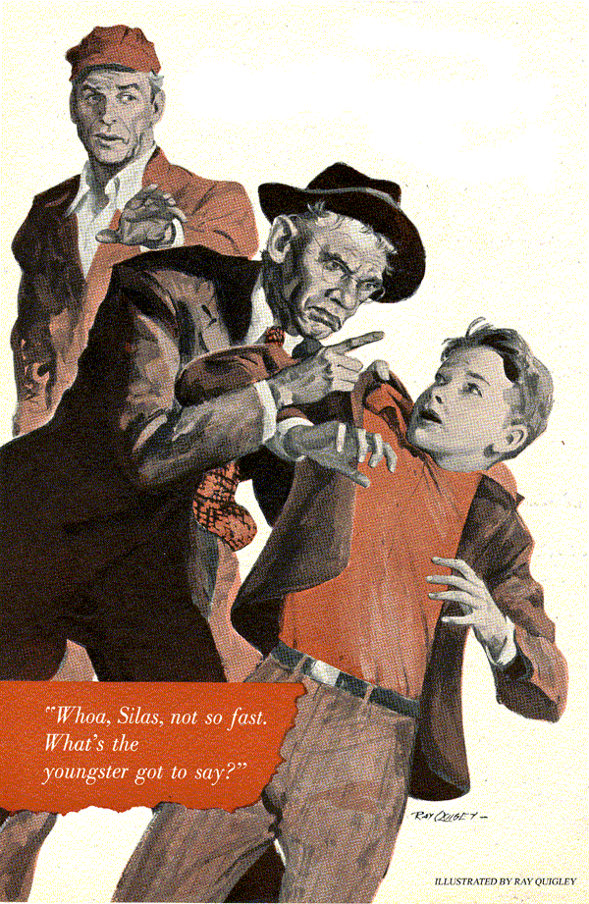
Gus Wilson was feeling pretty happy.
The first touch of spring was in the air and Gus was looking forward to all the things that warm weather brings - such as a chance to get in a little fishing now and then.
In this cheerful mood he chuckled good-naturedly at the sight of old Silas Barnstable, the town tightwad, helping himself industriously to the Model Garage's free air and water. Stan Hicks, Gus's helper, however, felt a little more strongly on the subject of Silas.
"Look at that old skinflint," he said disgustedly. "The only time he comes around here is when he can get something for free.
Gas and oil he buys at the cut-rate joints. Air and water he gets here. Why, he even stops by and uses our liquid spray to clean his windshield."
"Oh, don't be so tough on the old boy,"
Gus commented. "Thrift is still supposed to be a virtue, isn't it?"
"Yeah, but you know what I caught the old penny pincher doing the other day? He was pawing through our junk box picking out old discarded bolts and things."
"So what? If he wants to rummage around to save a nickel or a dime, let him."

Gus Greets a Steady Customer
Gus slammed down the hood of Doc Marvin's car and strolled out by the gas pumps.
"Getting your tires up to pressure?" he asked the wry-faced, bespectacled little man crouched down beside his old sedan.
"Had a flat," replied Barnstable, who was as frugal with words as he was with money.
By this time, Barnstable was treating the tire in the trunk to a helping of Gus's free air. From the amount it took, Gus gathered that this was the tire that had gone flat and that, after repairing it. Barnstable had switched it with his spare.
Gus thought no more about Barnstable and his flat tire until the next morning. He was replacing a carburetor when he looked out through the open repair shop doors.
There was Barnstable putting air on his spare again.

Another Good Tire Goes Wrong
"Another flat?" Gus called.
"Yup," grunted Barnstable. "Can't understand it."
"You probably used a bum patch."
"Didn't patch it. Couldn't find any hole in the tube. Then this morning when I went out to look at the car I had another flat."
"Could be a bad tube. That's the trouble with used stuff."
"Now, none of your sarcasm, Gus Wilson.
Besides, it wasn't the same tire, I put the one that went flat yesterday in the trunk as a spare. The one on this here wheel" Silas poked the right rear wheel with his toe - "was flat this morning."
"Find a nail this time?"
"Nope, same as yesterday. No nail, no cut, no nothin'. Just flat. So I switched it with the one in the trunk and drove over here to get some air."
Gus dipped his finger in the water can beside the gas pump and put a blob of water on the tip of the valve stem on the tire in the trunk.
"What you doin'?" Silas inquired suspiciously.
"Oh, just thought maybe you had a leaky valve, but it seems to be tight. No bubbles."
"Valve's all right. So's the tire." Barnstable waggled his finger at Gus. "I think I know what's goin' on. And I'm gonna find out."
The following morning, just as Gus drove up to the Model Garage, he saw old Barnstable's car pull out past the gas pumps and onto the road toward town. Immediately after, a large sedan drove up beside the first pump. Gus recognized Paul Rodgers at the wheel. He was tight-lipped with anger.
"Fill 'er up, "Rodgers said shortly, "Then he nodded toward the road. "Wasn't that Barnstable's car that just pulled out of here?"
"I think it was," Gus admitted. "Why?"
"What did he want?"
"Don't know, I wasn't here. Hey Stan! Come out here a minute."
Stan approached the car, wiping grease off his hands.
"What was ailing old Silas' car this morning?"
"Same thing. Needed air. Had a flat again this morning, and boy was he hopping mad.
Said something about' catching the culprit' tonight."
"Why, that miserable old tightwad," exploded Rodgers. "You know he lives near us out on Rolling Road. Keeps his car parked outside his house day and night because he's too cheap to use his own garage - rents it to someone else. Well, last night he came over to our place and accused my boy, Dick of deliberately letting the air out of his tires."
"Why did he pick on Dick?"
"I don't know. Probably because he's the only teenager on the block. Barnstable claims he saw Dick leaning up against his car the other evening. Said he was going to prefer charges if he kept having flat tires."
"Oh, he's probably just letting off steam," consoled Gus.
Early the next morning, Gus was wheeling his tow truck back to the Model Garage, after a rush call for a rental battery, when he suddenly realized he was on Rolling Road. As he was wondering how old Silas and his epidemic of flat tires were getting along, he suddenly spied Silas himself holding young Rodgers by the nape of the neck.
"Hey, what the dickens is going on?" Gus called braking the tow truck to a stop. As he got out he saw that Silas' car had another flat on the right rear tire.
"I caught him! I caught him!" Barnstable was shouting triumphantly. "He's the one who's been letting the air out of my tires. The police will take care of this."
"Whoa, Silas, not so fast. What's the youngster got to say?" protested Gus.
"Honest, Mr. Wilson, I didn't do it." Young Rodgers pleaded. "I was on my way to school and I dropped my baseball. It rolled under Mr. Barnstable's car so I reached down to pick it up. Next thing I knew he grabbed me."
Silas reluctantly loosened his hold on the youngster. "Tires don't just go flat of their own accord," he grumbled. "Somebody must be letting the air out of 'em."
"Not me," said Dick, with a little quaver in his voice. "And that's the truth."
"I believe you, Dick, "Gus said. "But you better run along to school now." He turned to Silas. "Tell you what I'm gonna do." He grinned. "I'll put your spare on for you and you follow me back to the garage. If I can't find out what's causing your tire trouble you can call in the cops."
"Well, I ain't gonna pay for the work. Just remember that this is all your idea."
Back at the Model Garage, Gus lifted the flat tire out of the trunk and began inspecting it. No nails or cuts showed on the outside of the sassing so he took it off the rim and examined the tube. Old Silas was right on one point at least - there wasn't a hole or a tear in it. Even a complete dunking in water failed to show any telltale bubbles.
Gus sighed and scratched his head.
"See, what did I tell you?" Barnstable chortled.
Gus said nothing. He dried the tube off, put it back in the casing and got the tire back on the rim.
"It's that young Rodgers, rascal," Silas persisted.
"Could be, but I still doubt it. By the way, where's the valve cap for this tire?"
"Don't use none on that one. No dust in there. Valve caps cost money."
Gus shook his head in bewilderment. Just how miserly could a guy get?
"Satisfied?" snapped Barnstable.
"Not yet," Gus replied calmly. "Now let's go over this flat tire business again. First of all, every flat has been on the right rear," Silas nodded.
"Second, only two tires have been involved - the right rear and your spare, which you've switched back and forth each time you've gotten a flat."
"That's right."
For a few minutes Gus just stood there sucking on his pipe.
"Well," Barnstable snorted impatiently, "if you've no more bright ideas I'll be on my way and you can bet that little Rodgers scamp will have to answer for his pranks."
"Hold it a minute, Silas. About these valve caps of yours. You've only got four?"
"Yep."
Gus reached down and unscrewed the cap on the right rear tire. "Where'd you buy this cap?"
"Well - uh - " Barnstable hesitated, embarrassed. "I didn't."
"What do you mean, you didn't?"
"Well, I just happened to see some old valve caps in that junk box of yours a few days ago and I borrowed a couple."
For the next few moments Gus couldn't talk, he was laughing so hard. "Well, you borrowed yourself three flat tires in the bargain," he came out finally, still chuckling.
"Take a look." There, wedged in the top of the valve cap was a small lock washer.

Silas Swallows His Pride
"You just happened to 'borrow' a valve cap that just happened to have a lock washer jammed up in it. Every time you put it on a tire valve, the washer pushed the valve stem down a bit and prevented you from screwing the cap down more than a couple of threads. The combination of a slow valve leak and a cap that wasn't screwed on tight added up to flat tires."
"Humph," grunted Barnstable, staring fixedly at the ground. "Guess maybe I owe you an apology and - "he swallowed audibly, "a little something for your time."
"Forget the apologies and the money," said Gus cheerfully, digging the lock washer out of the valve cap with his screwdriver and handing the cap back to Barnstable.
"But I think it might be a good idea if you stopped in town and bought young Dick Rodgers a new baseball. I noticed this morning that the one he has is kind of beat up... And Silas," Gus warned, "no bargains this time - get the boy a good one."
END

