March 1952

GUS GETS A HIGH PRESSURE JOB
by Martin Bunn
It was dark when Gus Wilson left the movie
and turned into the narrow alley that led to the parking lot.
Suddenly, from up ahead, he heard a shrill female voice.
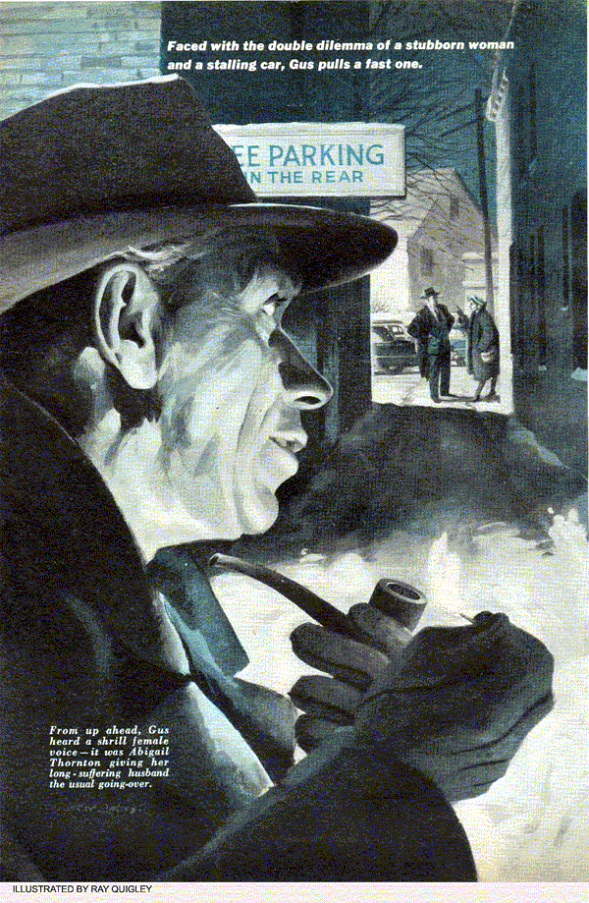
"I just can't understand you, Ned. You spend money like we were millionaires. The old one was perfectly good, but no, you had to go and squander hard-earned cash on a new one. And now look what you got. Tomorrow morning you're going to take it right in to those people and demand your money back..."
Gus didn't have to see the woman's face; he recognized the voice - it was Abigail Thorton giving her long-suffering husband, Ned, the usual oral going-over. In business, Ned Thorton was an aggressive go-getter - the town's top real-estate man - but when it came to Abigail he was just a timid soul. "Oh, I let her rant," he had once told Gus, rather sheepishly. "She seems to enjoy it."
As Gus got into his car, he could still hear Abigail's strident tones piercing the night.
Gus had just finished checking the gas tanks at the Model Garage the next morning when a shiny gray sedan rolled up to a stop. Gus didn't recognize the car, but he knew the driver. It was Ned Thorton.
"Hi, Ned," Gus greeted him, sympathetically recalling the previous night's incident. He walked around the car, admiringly. "I see the real-estate business is good."
"Sure, sure," Thorton replied glumly. "The fact is, Gus, I just had to get a new car. The old buggy was eating up gas, and besides, you can't drive prospects around in an old beat-up jalopy."
"Well, you sure got yourself a beauty. Get a good trade?"
"Thought so when I made it. But now I'm not so sure."
"Why? What's the matter?" Gus asked him.
"Plenty." Thorton grumbled. "Ever since the 500-mile check she's been using even more gas than the old bus, and she stalls just about every time I stop in traffic."
"Had it back to the dealer again?"
"At least a half-dozen times. They've tested and worked on it, and each time they've claimed there's nothing wrong." "But they should make good on it." "Oh, Gus, not you too," groaned Thorton. "Abigail's been needling me about that for days now. She - ah - objected to my spending money on a new car" - Gus thought that was putting it mildly - "but that's not the half of it. You know that big tract of undeveloped land that belongs to the hospital, out on the south road?"
Gus nodded.
"Well, one of the big steel companies is interested in it. Two of their top real-estate experts are due here on the 12:08 to look it over as a possible site for a new plant."
"Something big?" asked Gus.
"Big is right. They want at least a hundred acres. If I can put this deal over, it'll be a break for everyone - the hospital can use the money, and jobs for a couple of hundred people certainly wouldn't hurt this town."
"Plus a nice fat commission for Ned Thorton," Gus added with a grin.
"Right," Thorton agreed cheerfully, "and if I ever needed to make an impression and have things run smoothly, it's today. Fat chance, though, with that," he added, jerking his head toward the new car. "I won't even be able to get those men from the station to the country club for lunch without stalling a dozen times."
Gus climbed into the car and started the engine. It caught easily and ran smoothly.
"Oh, sure, she runs fine until she warms up." Thorton explained in answer to Gus's quizzical look. "Then the first time you slow down for traffic or stop for a light, she dies."
"What's the dealer's mechanic done on it?"
"Well, first off, he thought it was vapor lock, but he gave up on that. Then he checked the distributor and adjusted the points. Finally, he put on an entirely new carburetor - said the original one had a bad float."
"Make any difference?"
"Not one bit. That's why I've given up trying to get them to do anything about it. I'd rather pay you and get it done right."
Gus looked at his watch. "It's just 9:15 now," he said. "If you'll--"
"Holy smokes. Is it that late already? The Stevens boys are due at my office in 15 minutes. They want to look at the old Davis house."
"Well, hop in," said Gus. "I'll drive you down. It'll give me a chance to see how she runs. Then I'll bring it back here and try to find the bug."
The car performed beautifully on the way to town and Gus got Thorton to his office in plenty of time. "I'll do my best to have it for you by noon." Gus called after him.
The trip back to the Model Garage wasn't quite so uneventful, however. At the first traffic light, the engine died. Gus had a hard time coaxing it back into action again. A few blocks farther on, when Gus braked for a stop sign, it died again. Under load it seemed to run perfectly - but idling, it had a definite tendency to choke up and conk out.
"Acts as if the choke were pulled all the way out," thought Gus as he pulled into the garage.
"Hi, boss," young Stan Hicks called as Gus cut the engine. "Whose new buggy?"
"Ned Thorton's," replied Gus. "It stalls every time you stop and I've only got till noon to try and find out what's wrong."
Gus's hunch about the choke proved to be a dud. The carburetor seemed in top condition. A run-through of the ignition system failed to turn up anything either. And when Gus dollied his test rig up beside the car, Stan knew that the boss's hunches weren't paying off.
"Troubles?" he inquired.
"It's a funny thing, Stan, but I always hate to work on a brand-new car. With the old clunkers, you generally know what to look for because you know what's apt to wear out. But on a new job, you expect everything to be perfect, so where do you look?"
Just as Gus finished hooking up the test rig and was about to start up the engine, the office phone rang.
In a few seconds Stan was back. "It's Mrs. Thorton, Gus. She wants to know if their car is here and when it'll be ready."
"What'd you tell her?"
"I had to tell her it was here. She's still on the phone. Says she's got to have the car by 11 o'clock so she can drive to the city for a big bargain sale."
"Oh, blast that female!" Gus exploded, with unaccustomed severity. "Doesn't she know Ned needs this car if I can get it ready for him? Stall her off, tell her anything - tell her it won't be ready before late this afternoon."
It was quite a few minutes later when Stan finally came back into the shop. He gave a low whistle. "Boy - can that old gal beat her gums! I couldn't get a word in."
"Did you stall her?" asked Gus without taking his eyes off the test gauges.
"Sorry, boss, I couldn't," replied Stan apologetically. "The last thing she said before she hung up on me was that she was gonna call a cab and come over and sit right here until the car was ready."
"Brother, that's all I need. Here, you disconnect that fuel pump. I've got a phone call to make."
When Gus returned, he was grinning from ear to ear. "Well, that takes care of that."
"Takes care of what?"
"Abigail Thorton," Gus said as he picked up the fuel pump and began examining it. "I just called Jim Staid who runs the hack stand. He's gonna stall her as long as he can by taking his time with that cab. Now if I can only get this car to run."
Gus turned the fuel pump over and over with his hands. "Stan," he said thoughtfully at last, "want to get me another fuel-pump gasket just like this one?"
When Stan came back from the stock room, Gus took both gaskets, put them in place on the pump housing one on top of the other like a sandwich, and began bolting the assembly back onto the side of the crankcase. Then, when he had re-coupled the fuel lines, he pushed the starter button. After a dozen or so turns, the engine took off and settled into a smooth idle.
"I think that's got it," said Gus. "Close the hood, Stan, and I'll test-run her on the road. If she's okay, I can drop her off at Thorton's office in plenty of time for him to meet that train."
"Hey!" shouted Stan as Gus started the back the car out of the shop. "What do I do when that terrible-tempered Mrs. Thorton shows up?"
"That, Stan, is your problem."
Half an hour later, Gus was walking back to the garage. Ned Thorton's car had run perfectly - it hadn't balked at a single traffic light even after it had warmed up - and the real estate man had been jubilant when Gus handed the car over to him at exactly 11:40. Stan was sitting in the garage office, feet propped up on the desk, when Gus walked in.
"Mrs. Thorton been here yet?"
"Come and gone," Stan replied smugly, running his nails on his shirt front, then inspecting them critically.
"How'd you get rid of her?"
"Well, the poor woman seemed so upset about not having the car to drive her to that sale down in the city that I told her to take yours."
"You what!" bellowed Gus.
Stan's feet came down off the desk with a slam. "Hold it, boss, don't blow a valve." He grinned. "I was just kidding - your car's still out back where you left it. What I really told her was that the thyrostrat on the automatic sensigear wasn't synchrophased, and that you had to tow the car to the dealer's place to have it duo-timed. That seemed to satisfy her. She stomped off muttering something about how she'd told Ned that her car was a lemon and now she had proof." Gus chuckled. "For once, your double talk paid off."
"Say, what was really wrong with the car?" asked Stan. "You took off so fast I didn't get a chance to find out."
"High fuel pressure," explained Gus. "It was about double what it should've been. On cold starts, that didn't matter too much - the engine could take it - but after it got warmed up the extra gas would choke it out at idling speeds."
"How did an extra gasket on the fuel pump fix that?"
"It moved the pump housing out a bit and shortened the stroke of the pump arm. That cut down the pressure. I've a hunch that when Thorton took the car in for its 500-mile check, the mechanic discovered an oil leak around the flange of the pump and when he replaced the gasket he used one only about half as thick as it should've been. That lengthened the stroke of the pump arm and hiked up the pressure."
"Just like I told Mrs. Thorton," said Stan. "It was a simple case of crossed wires to the thyrostrat that caused a loss of power."
"Well, I don't know anything about thyrostats," grinned Gus, "but how about you applying your power to that grease job out on the rack - and keeping your fingers crossed that Ned Thorton clinches that real-estate deal for the hospital. And you might try crossing your toes, too. Maybe that'll help save Ned's skin when he shows up at home tonight and Abigail finds out he had the car all afternoon."
END

