July 1952

GUS GOES FISHING

AND GETS HOOKED

by Martin Bunn
All Gus wanted to do was fish
but he couldn't resist the temptation to show
the stiff-necked, mule-stubborn Dr. Angus
that it takes more than theories to fix a balky car.

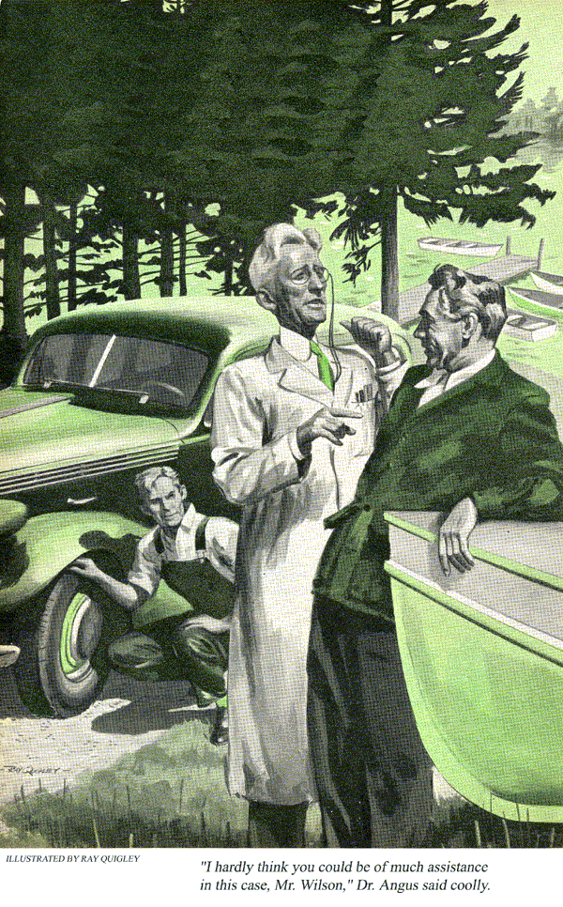
As he steered around a sharp bend in the narrow dirt road, Gus Wilson finally caught sight of what he had driven more than 200 miles to find.
It wasn't a big lake, but it looked like the answer to an angler's prayer. It had weed beds, sunken logs and a nook-and-cranny shore line. Everything about it spelled FISH. And that's just what Gus, with a few days off from his Model Garage, was after.
"Now to find that little hotel Jim Worden told me about," he muttered happily to himself, "and I'll be all set."
Driving on slowly he came to a winding lane that led down toward the lake. And sure enough, right there on the shore was a long, low one-story building.
Gus parked in front of the hotel. There were two other cars, and as he unloaded his gear he noticed that the front end of one was jacked up, with the front wheels and hub assemblies missing.
When he got no response to repeated knocking, he opened the door and walked in. No one seemed to be around so he settled himself in a big chair to wait. The only sound was a low humming noise that seemed to come from a hall leading off to the left.
Suddenly the humming stopped and Gus heard a door slam somewhere. The next thing he knew a tall, spare, bespectacled man in a long white coat was standing beside his chair peering down at him.
"I am Alvin Angus," the stranger said evenly. "And what can I do for you?"
Gus, a little taken aback by the man's sudden appearance, was annoyed to find himself stammering. "Why - er - I'm Gus Wilson, a friend of Jim Worden's. He suggested I come up here for a few days' fishing. This is a hotel, isn't it?"
"Yes, indeed. I have a vacant room right down the hall. Please follow me."
Feeling a bit nonplussed, Gus picked up his gear and followed.
Angus stopped in front of the second door along the hallway and swung it open to reveal a neatly furnished room.
"Here you are, Mr. Wilson. Dinner is at seven. If you need anything in the meantime, I'll be in my laboratory."
Gus was about to ask, "Where is that?" but before he could get the words out of his mouth the man was gone.
"Mighty odd character," thought Gus as he unpacked. With his white doctor's coat and "laboratory," Angus made the place seem like some sort of sanitarium instead of a fishermen's retreat. But if the fishing was as good as Jim had bragged it was Gus didn't care if Dracula himself ran the place.
A few minutes later, fishing rod in hand, he strolled contentedly down toward the lake. A pleasant-looking middle-aged man was just easing a skiff up to the dock.
"How's the fishing?" called Gus.
"Wonderful!" The man held up a couple of good-sized bass.
"I'm Gus Wilson," said Gus as the fisherman clambered up on the dock.
"Glad to know you. I'm Bill Plummer. Planning to spend a few days up here with the good doctor?"
"Doctor?"
"Yeah, Dr. Alvin Angus - the fellow who owns the hotel. Haven't you met him yet?"
"Well - yes. What is he - a physician?"
"Oh, no, he's a retired scientist. He runs the place, and he spends a lot of time in what he calls his laboratory - it's really more like a glorified workshop. Incidentally--" Plummer grinned - "don't get into an argument with Angus. He's the kind of guy who's always right about everything."
The fishing was wonderful. In a little over an hour, Gus reeled in a largemouth bass and a couple of nice lake trout.
That night he got a chance to talk to Dr. Angus. After a good dinner, served by a widow neighbor who cooked the meals, he, the doctor and Bill Plummer settled down on the back porch overlooking the lake.
Under Gus's friendly prodding, the doctor unbent a little and told how he'd spent many years as a research physicist and university professor. Then he had retired on the advice of his doctors and opened the fishing camp.
"After a lifetime of that sort of stuff," Gus put in sympathetically, "you must find it pretty dull catering to a bunch of guys who don't want to talk about anything but fishing. After all, scientific research is a pretty special kind of business. Most of us don't know much about it."
"But you should," snapped the doctor. "That's just the point. There is a scientific approach to every subject. I find, for example, that the practical problems I deal with in my laboratory yield to analysis exactly the same way that purely theoretical ones do."
Gus was getting interested. "That's certainly true up to a point." He was thinking of how he had licked many a tough problem at the Model Garage by just lighting his pipe and sitting down to think it over. "But of course you've got to have a lot of practical knowledge and experience before you can start analyzing."
"Can't agree with you on that. Fundamental principles apply to everything. No specific experience required."
Gus caught the sly grin on Plummer's face and suddenly remembered his warning about arguing with the doctor.
"Perhaps you're right, Doctor. I hadn't thought of it just that way. Well, I guess I'll turn in - want to get an early start on that fishing tomorrow."
Dr. Angus seemed somewhat mollified. "Come see my lab for a minute. Like to show you some of my equipment."
The doctor's "laboratory" was as neat as a laboratory should be, and elaborately outfitted. On one side of the room was a complete metal shop right down to a small shaper. On the other was a fully equipped woodworking shop.
Gus whistled admiringly. "This is really something. What sort of work do you do in here?"
"Oh, I've made some furniture for the hotel, and various odds and ends. And lately some of the local people have discovered that I have this shop and have been bringing me their repair problems. Only today, a chap who lives down the road brought his car in. He had bought a set of brake shoes by mail but when he started to install them he found his front-wheel drums badly scored. Asked me if I'd turn them down. I did so. And by the way, Mr. Wilson," Angus went on, waggling an emphatic finger, "that's a case in point. I know very little about automobiles but I predict that Clem Lamson's brakes will operate perfectly."
Gus recalled the jacked-up car out in front of the hotel. "Well, no doubt you're right," he said mildly. "See you tomorrow."
Up early as usual the next morning, Gus decided to take a walk before breakfast. As he opened the screen door, he heard voices raised in argument. The doctor and a man in overalls were crouched down beside the left front wheel of a car in the driveway.
"… impossible, Lamson," Dr. Angus was saying. "I did an excellent job on the drums. They must work all right."
"Well, they don't, all the same," the other man insisted. "Every time I put on the brakes I get that thumping sound, and all the talk in the world ain't going to fix it."
Gus fought a little battle with himself there on the doorstep. Here was his chance to show Angus that nothing took the place of know-how when it came to trouble-shooting in a mechanical problem. Still, this was his vacation and he'd sworn he wouldn't touch a car except to drive it.
He struggled - and lost. The doctor's cock-sure attitude the night before had got his dander up. And besides, he had a professional curiosity about the thumping brakes. The combination was too much for him. He was hooked as surely as one of those trout he'd taken out of the lake the afternoon before. With a sigh of happy resignation, he walked toward the car.
"I see you're an early bird, too, Doc."
Dr. Angus looked up with a frown and got to his feet. "Oh, it's you, Mr. Wilson. Yes, up early and starting the day with a problem. This is Clem Lamson - the chap who's having trouble with his brake drums."
Gus smiled and nodded a hello. "Something wrong?" he inquired. "Perhaps I can give you a hand."
"I hardly think you could be of much assistance in this case, Mr. Wilson," Dr. Angus said coolly. "The problem requires further analysis."
Clem Lamson looked at Gus and back to the doctor. "Let's tell him, anyhow."
Dr. Angus spread his hands. "No harm in that, I suppose. I finished the brake drums and we put them back on the car last evening before supper. But now Clem claims that his brakes make a thumping noise."
"Where does it seem to come from?"
"Can't tell rightly," said Clem, "but it sounds like the left front wheel."
"Mind if I try her out?" asked Gus.
"Nope. Reckon your guess is as good as anybody's. Let's take a little spin."
Gus drove, and the "little spin" proved that Clem was right. The thumping was there, all right, and Gus was sure it was coming from the left front wheel.
Back at the lodge again, the doctor looked on in stony silence as Gus went over the left front end of the car carefully. He checked the tie rods - nothing there. He examined the chassis and motor mounts.
"Got a jack handy, Clem?" Gus asked.
Clem opened the trunk and pulled one out.
"Swell, let's get this left front wheel off the ground. And Doc, could I borrow a wrench and some pliers?"
"You may," Angus replied. He turned toward the lodge.
By the time Clem and Gus had the wheel jacked up the doctor was back with a good-sized tool box.
After the wheel had been removed, Gus took off the grease cap, pulled the cotter pin and backed off the nut that held the hub and brake-drum assembly on the spindle. Then he slowly pulled the assembly off, turned it over and inspected the bearings.
"Nothing wrong there," he announced glumly. "Well, we'd better give the brake assembly a going over."
While Clem and the Doc watched, Gus checked the whole brake assembly - springs, wheel cylinder, hydraulic lines. He had just about made up his mind that he was on the wrong track when he happened to run his fingers over the lining on one of the brake shoes. Then he quickly picked up the drum and felt its inner surface.
Just at that point, the screen door to the lodge popped open. "Thought we had an early breakfast date before some fishing, Gus," Bill Plummer called.
"Be with you in a minute, Bill." Gus turned to Angus. "Look, Doc, I think if you'll chuck this drum assembly in your lathe and polish the inside of the drum with steel wool, Clem's troubles'll be over. I'll join after I've had some breakfast."
About a half-hour later, as he and Bill Plummer walked into the living room, they heard a car going off down the road. A moment later Dr. Angus walked in.
"Well, Mr. Wilson, I followed your suggestion and it worked. Clem has road-tested his car and there isn't a sign of a noise. Would you be good enough to explain it?"
Gus walked over to an old phonograph in the corner of the room and picked up a record. "Here, feel this." He ran his finger over the grooves. The doctor took the record and solemnly followed Gus's example.
"You see," Gus continued, "when you turned down Clem's brake drums your lathe tool left a groove similar to this on the surface of the drum. It was almost invisible, and on some brakes, it wouldn't have mattered, but on Clem's it did."
"And why was that?" "Because the brakes on Clem's car have the 'floating' type of brake shoes. They aren't anchored, but have play. As a result the grooves left by your lathe tool literally screwed the shoes out to a point where they'd suddenly snap out to a point where they'd suddenly snap back in again and thump against the inside of the hub."
The doctor thought for a moment. "Why didn't the same thing happen on the right wheel? I turned that drum down, too."
Gus held up his two hands. "One right and one left," he said. "The groove on the right wheel was reversed so it forced the brake shoes in rather than out, and in is their normal position. Result - no thump."
For the first time since they'd met, Gus saw the doctor smile. The smile grew until you could call it an honest-to-goodness grin.
"I want to thank you for teaching me a valuable lesson, Mr. Wilson," Dr. Angus said warmly. "You know, you possess rather remarkable analytical powers, but I suspect you also have a good deal of that 'practical knowledge and experience' you spoke of last night. So you win our little argument after all. Would you mind telling me what line of business you're in?"
"Not at all." Gus grinned. "Most of the year I run a garage. But right now I'm a full-time fisherman. How about joining Bill Plummer and me this morning?"
"Why, I believe I will. By the way, Mr. Wilson, I have a theory about angling--"
"Whoa - don't tell me," Gus broke in hurriedly. "Let's not analyze that. Might spoil the fun. Come on, Doc, let's go catch us a mess of trout."
END

