January 1952

GUS AND THE CAR

THAT WOULDN'T TURN LEFT
by Martin Bunn
Doc Evants diagnosed Gabriella's temperamental behavior
as some sort of warning -but Gus figured
all she needed was a little discipline
with the business end of a monkey wrench.
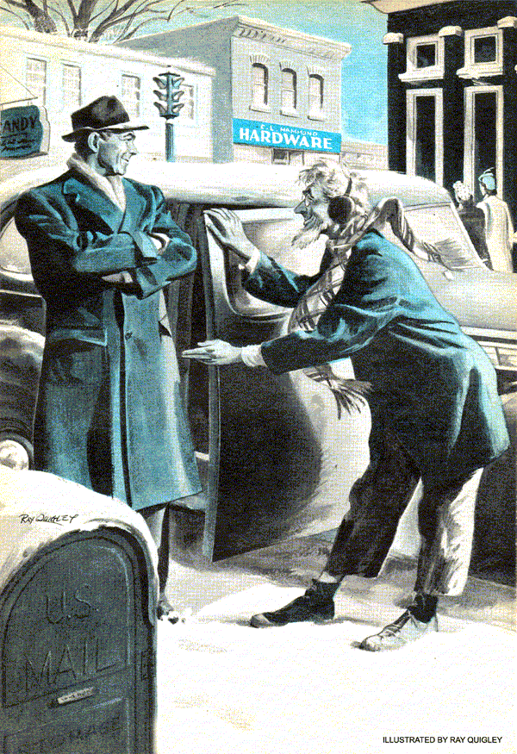
On a cold, brisk Sunday a few weeks ago, Gus Wilson was enjoying an afternoon off from his chores at the Model Garage by strolling through town. Suddenly a chorus of honking horns directed his attention toward the intersection ahead.
"Must be an accident," thought Gus as he hurried toward the commotion.
As he got closer, he saw two sedans had locked bumpers diagonally across the intersection and were blocking traffic in four directions. A stocky redhead was standing beside the first car shaking his fist at the driver.
"You lunkhead!" he shouted. "What was the idea of stopping so short? For two cents I'd--"
Just then Officer Pat Stanton strolled up. "Okay, you two. Break it up." He waved the redhead back to his own car. "Get these cars outta here or I'll give you both tickets."
As Gus reached the curb, the door of the first car popped open and out stepped a wiry, bespectacled little old man. In spite of the freezing weather, he wore neither overcoat nor hat. His odd costume consisted of well worn sneakers, a pair of baggy gray pants, a large corduroy jacket, and a plaid wool scarf looped twice around his neck with the ends dangling fore and aft.
Gus looked at the little man, then at the man's car, and did a double take. It was none other than "Doctor" Jason Evants, the town's best known eccentric and founder of the "Philosophy of Universal Sentiency" - a fad that interested some of the wealthier ladies in the community.
Gus had first run into Doc Evants when the buxom and affluent Mrs. Miller - who had been widowed a year or so ago and had since joined the little "doctor's" group of followers - sent Evants to the Model Garage with Gabriella. Gabriella was his car. Not only did the car bear a name, it could also think and feel - strictly in accordance with the rule of the Philosophy of Universal Sentiency which said that all inanimate things could. At least, that was Doc's story. He insisted "she" had frequently warned him of impending danger by suddenly stopping or refusing to run at all.
"Doctor Evants," called Gus as he walked over to the man. "Having trouble?"
"Ah, Mr. Wilson. Trouble you say." Evants waggled a finger at the redhead. "As you undoubtedly ascertain, this unpleasant individual collided with my car and has interlocked our bumpers."
"Maybe I can help," said Gus. Then he walked over to the second car and climbed up on the front bumper. "Okay," he called, motioning to the redhead. "Put your car in reverse and ease her back slowly."
On the fifth jump, Gus's weight finally jounced the bumper loose and the two cars gratingly parted company. Officer Stanton waved the redhead on his way and Doc Evants climbed back into his car. But instead of turning the corner he straightened out, drove into the through street ahead and parked.
Gus was curious enough to follow.
"Sorry to have been so curt, Mr. Wilson," said Doc Evants, "but I'm afraid that uncouth mental midget unnerved me a bit. Obviously the ebullient type suffering from introversions that can be salved only by expressions of superiority."
"In other words," said Gus with a smile, "a sorehead."
"It could be expressed that way."
"But what happened to Gabriella?" asked Gus, looking at the car parked at the curb. It was a '41 model in fair shape, while Gabriella, as Gus remembered her, had been a beat-up '35 sedan.
"Ah, Gabriella," sighed Doc Evants. "I finally had to retire her. Old age. She's spending her days out in the yard behind my house. I go out and sit in her every so often. We still understand each other perfectly."
Gus started to point to the car at the curb.
"This, Mr. Wilson, is Gabriella the Second. Thanks to dear Mrs. Miller and a few other friends of my Philosophy of Universal Sentiency I was able to invest in this more modern vehicle a short while ago."
"Does this one warn you the way your first Gabriella did?" asked Gus, suppressing a smile
"She's beginning to. It was a warning from her that helped cause that slight difficulty at that corner."
"Huh?"
Dr. Evants graciously opened the door to his car. "Let me give you a lift to your garage and I'll tell you about it."
Gus was about to say something about it being his day off, but his curiosity got the better of him and he climbed in with the little old fellow.
Dr. Evants started the car, going through the motions slowly and deliberately. "You see, Mr. Wilson, I was on my way over to see Mrs. Miller about a most important matter. As I was making that left turn from Bank into Main Street, Gabriella II began to sputter and buck as if she were reluctant to go in the direction of Mrs. Miller's house. As if she were trying to warn me."
The little man seemed very upset. At that point, he started to make a sharp left turn into Center Street. Sure enough, about halfway through the turn the engine began to miss and falter. The car had enough momentum to make the turn, but Dr. Evants would have none of it. He quickly straightened the car out and continued on ahead. When he did, Gabriella II's engine picked up and ran smoothly again.
"You see, she protested against making that turn."
Gus nodded, but said nothing.
At the next few corners, when Dr. Evants tried to make similar left turns, the same thing happened, and each time he wouldn't complete the turn. As a result, the trip to the garage turned out to be a circuitous tour of the town consisting of right turns only.
By the time they finally made the last right turn into the road that led past the garage, Gus had several ideas about Gabriella's hesitancy.
Stan Hicks, the helper at the Model Garage, was busy chipping away ice on the drive when Gus and the doc pulled up. "Hi. What are you doing here?"
"Meet Gabriella II," said Gus with appropriate flourish. "And she has a few of Gabriella I's - shall we say - peculiarities," he added, winking at Stan. "Doctor, why don't you let me check her to see whether she really is trying to warn you not to see Mrs. Miller today or whether it's something else?"
Doc Evants thought for a minute, tugging at his chin. "Are you suggesting that her protests might be the symptoms of some inherent mechanical difficulty?"
Gus nodded.
"I doubt it, but you have my permission to examine her. I'll stroll on down to Mrs. Bentley's and have a chat. I've got the first chapter on my new book, The Inconsistencies of Human Thought, that I'd like to show her. I'll drop back here later."
"What's the trouble with the old screwball's car?" Stan asked after they'd driven the sedan into the shop.
"Engine misfires on sharp left turns. I've a hunch it's either dirt in the gasoline line or a damaged carburetor float that gets stuck when centrifugal force throws it to the right on a sharp left-hand turn."
Before he checked either of these points, he got into the car, started the engine and proceeded to turn the steering wheel as far to the left as he could. He looked a little disappointed when the engine continued to purr along without so much as a missed beat. Finally, he shut off the ignition.
"What's the matter, boss? Think maybe the steering gear had something to do with it?"
"Just thought I'd check. But no luck."
And Gus had no better luck with his hunches about dirt in the gas lines or the gas tank or a faulty carburetor float.
"Boss, maybe the old doc's got something in this sent - sentiency stuff. You know - about car being like humans. They sure suffer from some of the same ailments - clogged up arteries, head troubles, breathing ailments, stiff joints, shorted nerves, and…"
"Son, I think you've got something there. Why the devil didn't I think of that before?" Gus all but dove in under the hood and began to check the wiring.
After about five minutes Gus straightened up and his face was all smiles.
"Take a look at this." He pointed down at the solenoid that operated the car's overdrive, and then hit it with his finger.
Stan saw that the unit was quite loose on its moorings and that the insulation on one of the heavy wires leading to it was badly frayed.
"Every time the car would swing to the left," explained Gus, "the solenoid would swing to the right and that bare spot on that wire - the one that leads to the ignition - would ground out against the car's frame. When the car was going straight or turning right it wouldn't touch the frame."
It didn't take Stan and Gus long to make the repair. Gus was just washing up when Evants walked in.
"Well, Mr. Wilson, has your stint of research convinced you that Gabriella II was warning me not to see Mrs. Miller today?"
"No, I'm convinced it was as you would say, 'a slight inherent electrical difficulty.' But she's all fixed now and ready to go."
"Splendid, splendid. I am truly grateful… I - ah - happen to be a bit short of funds at the moment." Evants went on, fumbling in his pockets without conviction, "but send me a bill, by all means. And now I must hurry along to Mrs. Miller's. "As a matter of fact," he confided, "I have a most important question to propound to that dear lady. Now that my fears have proven unfounded, I shall proceed with confidence." And with an airy whisk of his hand, he drove away briskly.
"Well, I'll be darned," said Gus, "if the little doctor hasn't got matrimony on his mind - and it'll be a pretty good catch for him if he makes it, which I suspect he will."
"Gee, boss, just think," mused Stan, "if you hadn't spotted the trouble, Doc Evants would've gone right on believing Gabriella was trying to warn him, and he might never have popped the question. Well, I wish him luck."
Gus, confirmed bachelor, grinned contentedly and reached for his pipe. "Me too," he said.
END

