February 1952

GUS HELPS TIE A KNOT
by Martin Bunn
It looked as if the happy couple
would have to spend their honeymoon in a roadside garage
unless Gus came to the rescue.

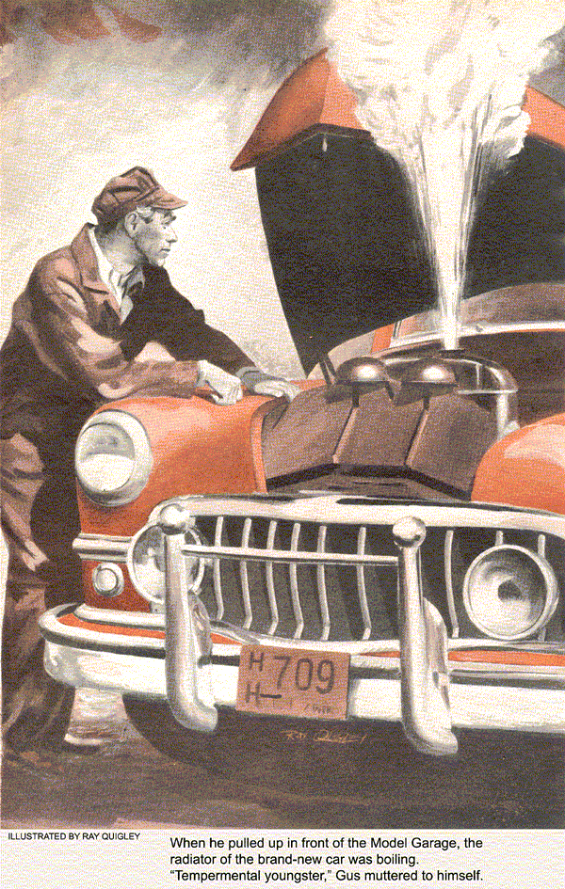
It was a sleety evening and Gus Wilson, his chin tucked well down into the upturned collar of his overcoat, was trudging toward Dan's Grill for some dinner. It had been one of those days at the Model Garage and he was glad it was over. He was looking forward to a sizzling steak with French fries and later an evening at home with a magazine.
Just then a pert voice interrupted his thoughts. "Hello, Mr. Wilson."
Gus looked down to find a very attractive young lady walking beside him. After a second look, he realized it was Peggy Anne Simpson, daughter of the vice-president of the local bank.
"Why, Peggy Simpson," said Gus, taking her arm to help her buck the cold wind. "What on earth are you doing out on a night like this? Thought you were getting married tomorrow afternoon."
Peggy laughed a nervous little laugh. "I hope I'm getting married tomorrow."
"What do you mean, hope?"
"Tom - my fiance', Tom Thorton - hasn't gotten here yet, darn it," explained Peggy, clamping her hat down more firmly on her pretty blond head. "He's driving up from Stanton - that's his home. I expected him early today, but he called tonight to say he's having trouble with the new car he bought me for a wedding present. He's stranded about halfway here."
"Trouble with a new car? What kind of trouble?"
"If I didn't love that man I'd be inclined to doubt his story. Here we're shivering with the cold and he claims our brand-new car is overheating."
By this time Gus and Peggy had reached the neon-lit door to Dan's place. "Join me?" asked Gus.
"I'd love to, Mr. Wilson, but I've got some last-minute arrangements to make for tomorrow - if Tom ever gets here. Gosh, I just happened to think, I guess our honeymoon will have to be postponed too. We'd planned a trip in the car."
"Well," Gus said sympathetically, "if I can be of any help, don't forget to call on me."
At about 2:15 the next afternoon a very tired and worried looking young man drove his car onto the concrete apron in front of the Model Garage. Gus had seen the car pull up and had the repair-shop door open.
"Mr. Wilson?" the driver inquired tensely as he slid out from under the wheel.
"That's right - and I guess you're Tom Thorton."
The young man managed a weak smile. "And how did you know that?"
"Saw that beautiful bride-to-be of yours last night, and she told me about your car trouble. She was pretty upset when you didn't get here yesterday."
"She was upset!" Tom ran his fingers through his hair and his voice sank dramatically. "To tell the truth, Mr. Wilson, I had my doubts more than once about getting here at all in time for the wedding."
"When did your troubles start?" Gus inquired gently as he ushered Tom into the shop.
"Almost as soon as I left home. I hadn't gone more than 30 miles when I noticed that the temperature gauge was up above normal. Naturally, I stopped to check the water. But the level was okay."
Gus nodded as he prodded some shreds of tobacco into the bowl of his pipe.
"When I got to the next town, I stopped at the first decent-looking garage I could find. The mechanic made some checks. Said the gauge was out of whack and that I shouldn't worry about it. I took his word for it and drove on. Oh brother, then my troubles really began."
Young Thorton's story of what happened during the next several hours even made Gus, with all his experience, wince.
After the first garage stop, Tom, believing what the mechanic had told him, rolled along. He ignored the temperature gauge. Then, suddenly he heard a boiling noise in his heater. He stopped and this time found the radiator almost bone dry. Miles from nowhere with no water in sight, he stuffed handful after handful of snow into the filler spout.
For the next 50 miles, the temperature gauge registered "normal" again. But after an overnight stop at a motel, the needle began climbing again in the morning.
He pulled into another roadside garage. This time the mechanic flushed the radiator and checked the entire cooling system. He found nothing, but said that "just to be on the safe side" he would remove the thermostats.
Tom had left that garage with a glimmer of hope that maybe his troubles were over. Even though he nearly froze because the heater wouldn't perk without the thermostat, he was happy to see that the temperature gauge stayed well below normal.
His peace of mind, however, did not last long. Soon the gauge began climbing again. Another stop at a garage proved nothing. But when he got on his way again the gauge stayed down on the cold side.
"How's it acting now?" asked Gus at the end of this grim tale.
"Right now, she's fine," Tom admitted, "but she blows hot and cold and I'd hate to start off on a honeymoon and spend the night in a roadside garage."
Gus grinned. "What time is the wedding?"
"Four-thirty, with a party afterward at Peg's house before we take off. We'd hoped to get away around six. I've got a hotel reservation down in the city for tonight."
Gus looked up at the small electric clock over his bench. It was just 2:45. He had only a little over three hours to find and fix the trouble if the newlywed Thortons were to start their honeymoon on schedule.
"Tell you what you do," said Gus, patting Tom's shoulder paternally. "You take my car for now - it's parked outside - and I'll see what I can do about yours. Now, don't worry - I'll try to have your car outside Peg's house by six o'clock."
Tom's expression brightened perceptibly. "If you do," he said, pumping Gus's hand vigorously, "you're my friend for life."
After Tom had gone, Gus wondered if he hadn't left himself out on a limb. His sympathy for the distraught young man must have affected his judgment. Of course, old cars that overheated in summer were run of the mill - a good flushing generally cured them - but a brand new car that ran both hot and cold in the wintertime was something else again.
Gus got to work. He started by going over the radiator core carefully. Nothing there. He checked the radiator hoses, thinking that perhaps in some way the inner lining of one of the two sets - it was a V-8 - might have come loose, forming a flap valve that cut off the circulation of water at certain speeds. Still no luck.
He started the engine and peered down the filler spout. Water circulation looked to be normal.
At that point, Gus decided to road-test the sedan. He had driven about 20 miles with the temperature gauge showing normal when he happened to look down at the dashboard clock. He suddenly realized that he'd already spent more than an hour and still hadn't a ghost of a clue to the trouble. He slowed the car to a stop, turned around on the narrow road, and headed back toward town. By the time he was halfway there, the engine gauge had climbed well up into the hot zone, and when he pulled up at the Model Garage the radiator was boiling.
"Temperamental youngster," Gus muttered to himself after he had parked the car inside. "Something must cut down the circulation every once in a while." He started the car up again, put more water in the radiator and began another systematic check.
Gus was standing at his bench wiping his hands on a piece of waste when the repair-shop door swung open. It was his helper, Stan Hicks, resplendent in blue suit, gray fedora and gray overcoat.
"I thought you were enjoying a day off," Gus said.
"I was, boss, until I went to Peggy Simpson's wedding and heard about her husband's car. Thought I'd come over and see if I could help."
"That was a nice idea, Stan. But I'm happy to report that she's all fixed and we've got just 15 minutes to get the car over to the Simpsons'. Hop in; I won't wait to change my clothes."
They found a place for Tom Thorton's car right at the Simpsons' driveway - a perfect spot for a quick getaway, thought Gus.
"Look, Stan, you take these keys in and give 'em to Tom. I'm not dressed up for a weddin' party. I'll go over and sit in my car and wait for you. I see it's parked just across the street."
Sitting relaxed in the driver's seat of his own car, Gus didn't see the two figures slip out the side door of the Simpsons' house. He didn't even notice when, hand-in-hand, they tiptoed around the back of his car. So he was understandably startled when the car door was jerked open and Peggy Thorton (nee Simpson) flung her arms around his neck and planted a very satisfactory kiss on the middle of his cheek.
"Mr. Wilson, you're a darling! You've made our wedding complete. Now we can leave on our honeymoon, just as we planned."
"Thanks a million, Mr. Wilson," Tom added fervently, poking his head inside the car.
"Okay, okay," said Gus, grinning from ear to ear. "Lots of luck to both of you. Now you two kids get back in there and give the folks the fun of peppering you with rice and confetti when you make your official exit."
"All right, boss," said Stan as he and Gus headed down into town for a cup of coffee. "How'd you mastermind this one?"
"Frankly, Stan, I was stumped. Then I just happened to be staring down at the engine when it was running and I saw it."
"Saw what?"
"One of the water pumps. That car has a V engine with two water pumps, one for each bank of cylinders, and they're driven by the fan belt. I noticed that the pulley on one wasn't turning. That belt was just slipping over it, so I pulled the pump down. What do you think I found?"
"What?"
"A lock washer. It had gotten into the cooling system somehow and every once in a while it got jammed under the impeller wheel and stopped the pump. That cut down the water circulation. Then when the car was stopped, or perhaps when it hit a bump, the washer would get loose and the pump would run. So I removed the washer."
Stan seemed to be thinking it over. "You know, boss," he said finally, "I don't think I'll ever be a good garageman. Just don't have the patience. Unless I'm tearing something down or putting it back together again, I don't feel like I'm doing anything. Take you, though. You can just sit back and watch and come up with the answer."
"Pure laziness," said Gus. "When you get to be my age, you'll be content to let that noggin of yours do more of the work too. It's easier than barking up your knuckles with a spanner or a pair of pliers . . . Besides, you can think sittin' down."
END

