October 1951

GUS AND THE

MISSING STRADDLE TRUCK
by Martin Bunn
When stolen bank money begins
to show up at the Model Garage, Gus turns detective –
without a single clue but a temperamental lumber truck.
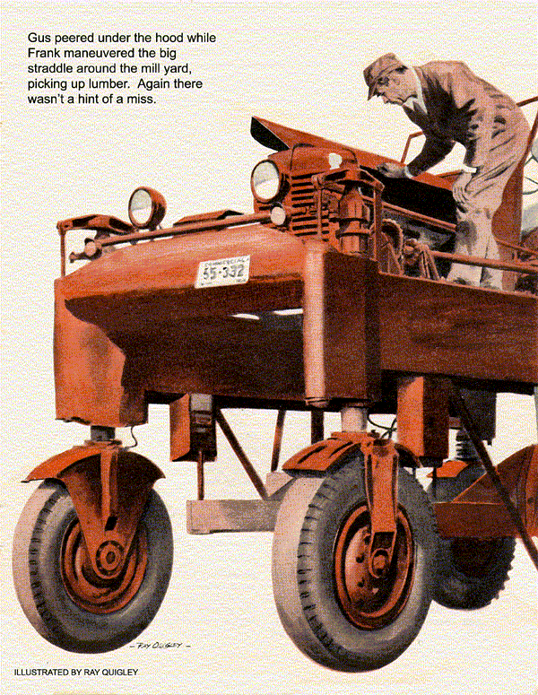
"Hiya, Gus."
Gus Wilson looked up from a car radiator he was working on to see the tall, trim figure of a state trooper standing in the Model Garage shop doorway.
"Sergeant Jerry Corcoran," said Gus. "You haven't been by in months. Where the devil you been keeping yourself?"
"Making the rounds as usual," replied the trooper. "Only now I have to cover more miles and more cases-I'm driving a radio car these days instead of a motorcycle."
"Well, glad you finally found some free time to stop by for a chat."
"Sorry, Gus, but this is strictly an official call," Jerry said, grimly.
Gus cocked his head quizzically as he held a match to his pipe. "Can't remember that I've jumped any red lights or knocked down any old ladies recently."
Jerry Corcoran laughed. "No, Gus, it's got nothing to do with you personally, but I think you and some of the other merchants in town can help me if you will."
"Sure thing. What's up?"
Stolen Money Traced to Garage
"Remember that big bank robbery down in the city early this summer?"
Gus nodded. He remembered it only too well. At the time, the papers had been full of the story, telling how three men had forced their way into the City National Bank one night, cracked open the safe and made off with close to $80,000.
"Well," explained Jerry, "the Feds think that job was masterminded by the same guy who's pulled at least four other big hauls-all of them safe-cracking jobs. And what's more, the Feds have a hunch he's hiding out around here."
"How come?" asked Gus.
"Some of the money has been turning up in the daily deposits here at the bank-they know the serial numbers of most of the stolen bills. As a matter of fact, Gus, several have turned up in the money you've deposited in the last few weeks."
"In my deposits?"
"Don't worry, Gus," Jerry grinned, "but it does mean that the guy we're looking for may be one of your customers. Been working on any strange cars lately?"
No Clues to Go On
"Now look, Jerry," said Gus, "you know as well as I do that all kinds of cars pull into a roadside garage.
People stop for gas, they want their oil changed, they have a flat they want fixed. Sure, most of our business comes from the townspeople, and we know most of them. But every day we service dozens of cars we've never seen before."
"Yeah, I know," replied Jerry," and the heck of it is that according to the flimsy descriptions we've got of this guy he looks just about like everybody else-no distinguishing features-just a Joe Doaks. All we're reasonably sure of is that he's about 40 years old and has dark hair. We also know that he does a pretty good disappearing act between heists."
"Not much to go on," said Gus.
"You're telling me?" Jerry groaned. "And he's all mine-to find, that is. The captain put me in charge of the case this morning. Said it would mean a citation, or maybe even a promotion, if I can come through."
Gus and Stan Check Bills
For the next few weeks, Gus and Stan Hicks, Gus's helper, paid close attention to all strangers who stopped at the Model Garage. They were leery of all bills and checked them against the list of serial numbers Jerry Corcoran had left with them. Luckily, the numbers fell into sets of continuous sequences so checking was largely a matter of memory.
More than once Stan or Gus thought they had a suspect-judging from a driver's looks-but each time the number on the bill failed to check and the suspect turned out to be no one more dangerous than a road-weary salesman, a casual tourist, or a visitor in town on legitimate business.
But Gus and Stan continued to be suspicious of every driver of a strange car. Gus was in the garage office late one afternoon making change for Stan when he heard a car drive into the adjacent repair shop. Looking out through the open office door, he saw a blue pickup truck ease to a stop beside the repair bench.
"Never saw this truck before," Gus thought as he walked toward it.
Just then, the door popped open and a dark-haired man wearing a bright plaid lumber jacket stepped out.
New Truck Is Just False Alarm
"Don Thatch," Gus called when he realized that the driver was the owner of the local sawmill and our biggest lumberyard. "That truck had me guessing for a moment. Didn't recognize it."
"It's new; bought it about six weeks ago," said Thatch. "Had to do something. That old one was falling apart."
"Satisfied with this one?" asked Gus.
"Pretty much," Thatch replied. "Right now, it's about ready for the final checkup and I'm hoping you'll be willing to give it a going over. It'll save me a long trip into the agency in the city."
"Do what we can," said Gus. "Any particular complaints?"
"Well, she's uneven as the devil when she's idling, but I know you'll take care of that. When can I have it?"
"Well, I'm near ready to close now. How about around noon tomorrow?"
"Swell, I'll have one of my men pick it up. Oh, by the way, could you stop out at the mill someday soon? One of the straddle trucks we use for hauling lumber is giving us trouble. The driver claims it's got a bad miss but the new handyman-mechanic claims there's nothing wrong."
Gus thought for a moment. "Tell you what, if we're not too jammed up here tomorrow afternoon when your man comes I'll ride back out with him."
Gus Meets an Odd Character
When Don Thatch's man showed up shortly after noon the next day, the pickup truck was ready and waiting.
"You riding back with me?" the man grunted.
"That's right. Understand Don's been having some trouble with one of his straddlers."
"Wouldn't know," the man grumbled as he raced the truck's engine impatiently.
The ride to the mill was made mostly in one-sided silence. Gus tried to make conversation, but when he found that all he could get out of the man were grunts, he gave up.
Don Thatch was just coming out of the door when the pickup pulled up in front of the mill office. "Glad you could make it, Gus," he said. "That straddle truck I told you about is parked over in front of the repair shop. Let's go around."
Driver Bears Watching
"Odd sort of character you've got driving your pickup," said Gus as he followed Thatch around the corner of the office building. "Does he ever say anything?"
"Don't know much about him," said Thatch. "Hasn't been on the payroll very long. Keeps pretty much to himself. Good worker, though, so I can't kick."
As they walked along, Gus made a mental note to let Jerry Corcoran know about the pickup driver.
The repair shack was a squat two-story affair and parked beside it was the big orange beetlelike truck with its engine and driver's seat perched high up on the four stiltlike legs that rolled on wheels.
Don stuck his head inside the door of the building. "Ned," he called, "will you come out here for a minute?"
"Meet Gus Wilson, Ned," Thatch said as a wiry, fair-haired man joined them. Then he added, "Well, I'll be getting along and see if I can locate the driver."
"Glad to meet you, Mr. Wilson," the fellow grinned as he rubbed his hands on the leather welder's apron he was wearing. "Mr. Thatch tell you about this straddle truck?"
Gus shook his head.
"Well, between you and me, I don't think there's anything wrong with it," explained Ned. "Runs fine for me, but every time Frank-he's the driver-takes her out for a day in the yard, he brings her back howlin' a blue streak and tellin' me that she's got a bad miss."
"What does he claim it does, start to miss after it's warmed up?" inquired Gus.
Engine Runs Fine
"No, he claims it begins to miss just as soon as he gets to pushing her at all. You know these straddles take a lot of punishment-lots of lugging and lots of idling every day."
"Mind if I have a look at the engine?" asked Gus.
"Help yourself," replied Ned. "I've got other work to do."
So as Gus climbed up on top of the straddle truck and opened the hood, Ned disappeared into his shop and presently Gus could hear the noisy hiss of an acetylene torch.
Gus's first hunch was fouled plugs caused by so much idling. However, when he took out several of the plugs he found them fairly clean. Replacing the plugs, he climbed around to the driver's seat, turned the ignition switch, and hit the starter button. The engine didn't catch immediately, but when it did it ran smoothly. Although he'd never driven a straddler before, he wheeled it around the space in front of the shop several times. He thought the engine sounded pretty good.
Now Engine Misses
Just at that point, Gus noticed a young man approaching the shop.
"You Mr. Wilson?" he called to Gus. "Mr. Thatch told me to see you. I'm the driver of that truck."
Gus flipped off the ignition. "Understand this animated doodlebug has been giving you trouble," he called down.
"You can say that again. Got a bad miss, but I can't convince this dumb mechanic of ours. Here, I'll show you." He climbed up, closed the hood and slid into the driver's seat. "We'll drive her up to the yard and pick up a few boards."
Even without a load, Gus could now detect a loss of power. "Mind if I drive?" he asked when they had reached the yard.
"Sure thing," said Frank.
Gus put the truck through its paces. There was no doubt about there being a bad miss every time he pushed hard on the gas.
"See what I mean, Mr. Wilson?" said Frank. "But that grease monkey we've got won't believe me, and he won't take the truck out himself and test it."
Gus Straddles a Straddle
Gus didn't answer. He was too busy trying to work out in his mind just why the engine missed now but hadn't missed before. Sliding out of the driver's seat, he opened the carburetor and the connections to the coil and the spark plugs. Everything checked out.
"Start her up, will you, Frank?" Gus called from beside the open hood.
Frank complied and again the engine took hold easily and purred along. For the next fifteen minutes, Gus peered under the open hood while Frank maneuvered the big straddle around the mill yard, picking up lumber, backing, idling, and gunning the engine.
Again there wasn't a hint of a miss. She was hitting on all six.
"Cut it," called Gus, and he just sat there staring at the temperamental engine. Suddenly he reached up and slowly closed the hood. Then he raised it, pulled it down and raised it again.
Ned Loses a Bet
"Humph," he said, digging into his left coverall pocket for his friction tape. Then he proceeded to wrap tape around the bundle of ignition wires that sprouted from the top of the distributor. "All right, now let's try her again."
This time the engine ran smoothly no matter what Frank did.
"That's got it," said Gus.
"What?" asked Frank.
"Come up here," said Gus. He pointed to a worn shiny spot on the underside of the hood. "The distributor wires were rubbing against the hood when it was closed. Pinprick leaks in the insulation were shorting out some of the cylinders when the wires touched the metal."
"Ha, wait'll you hear Ned howl when he hears this," said Frank as he wheeled the straddle truck around and headed for the repair shop. "This'll burn him."
"Why," asked Gus.
Ever since he heard you were coming out, he's had a 10-buck bet with me that you wouldn't find any miss anymore than he could. Now he'll have to pay off and he ain't gonna like it."
Ned, paid off without a beef.
"Like found money," said Frank taking the two fives Ned handed him. "Here, Mr. Wilson, let me split it with you," he added, thrusting one of the bills in Gus's hand. "After all you found the trouble."
Driver Apologizes
Gus, slightly flustered, stood holding the bill for a moment, then handed it back. "No, Frank, that was your bet not mine."
A few minutes later as Gus started up the steps to the mill office to find Don Thatch, he bumped smack into the pickup driver coming down. He greeted Gus with a pleasant smile as the two passed.
After Gus had told Don about fixing the straddle truck, he said, "What's happened to your pickup driver? Met him as I was coming in and he was almost human."
"Oh, I called him in to bawl him out about his attitude," explained Thatch. "but before I could say much he apologized for being rude to you. Said he'd had a spat with his wife this morning but he'd try to leave his troubles at home after this."
"Well, I'm ready to get back to the Model Garage any time now," said Gus. "Mind if I use your phone?"
Gus's Hunch Pays Off
"Go right ahead," said Thatch. Use that one over there; it's an outside line. I'll get my car and meet you out front."
Gus grinned as he read the bold, black headlines that streamered across the local paper next morning:
STATE POLICE NAB
ALLEGED BANK ROBBER
And the story went on to say:
...After searching the premises and finding more than $30,000 in bills stolen from the City National Bank four months ago, a State Police raiding party headed by Sergeant Jerry Corcoran from the local barracks cornered Art King alias Ned Hoffman in his quarters at the Empire Lumber Mill last night. King, police believe never spent the hot money himself but passed it off to others by changing the bills at the mill office and by asking fellow workers to do his shopping...
The slam of the garage door interrupted Gus's reading. He turned to find Jerry Corcoran and Captain Torrance, commander of the barracks.
"Okay, private eye," joked Jerry, "how'd you do it?"
They All Slip Sometimes
"Well, even though I'm not married," said Gus, "I guess I've been around enough to spot a bleached blond when I see one. Poor old Ned had been neglecting to touch up part of his hair. Then I discovered that he sure was no mechanic, but loved to play around with a torch. The tip-off came when he settled a bet with one of the other mill hands. Just by luck, I got to look at one of the bills and the serial number matched the list. That, plus the fact that he hadn't worked at the mill long and lived by himself over his shop seemed to add up to a fair hunch. That's when I called you, Jerry."
"Gus," said Captain Torrance, "during the 25 years you've been running this garage you've been a tremendous help to us many times and we'd like you to know how much we appreciate it." Torrance straightened, and a note of formality came into his voice. "We at the State Police hope you'll accept this slight token."
Gus opened the small brown leather wallet the captain handed him. Pinned inside was a gold badge with the shield of our state and inscribed: "Honorary Captain-State Police."
END

