November 1951

GUS GIVES THE AIR FORCE A LIFT
by Martin Bunn
Airman Crawford was at the end of his rope-
and a frayed one at that-when he was towed into
the Model Garage with mysterious car trouble.

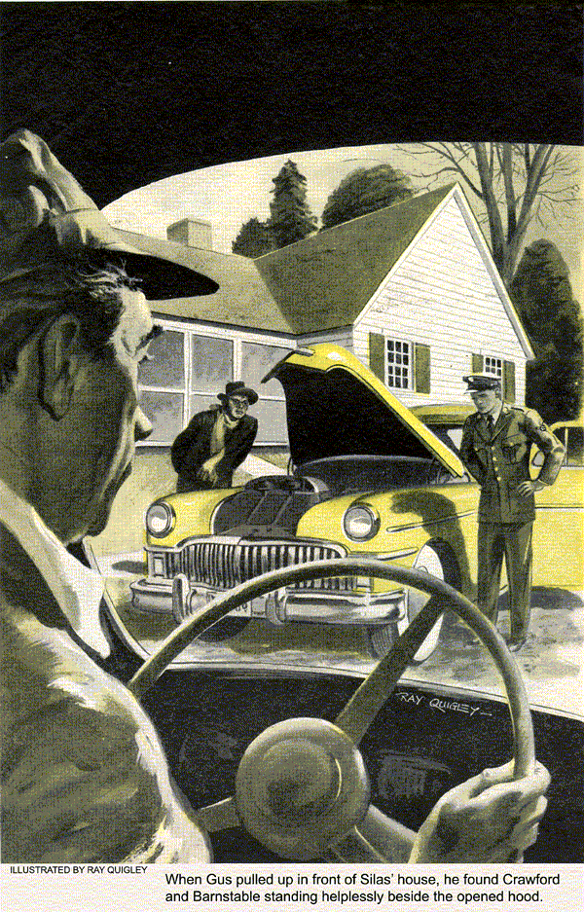
GUS WILSON had just finished with a gas customer and was hooking the hose nozzle back up on the pump when Stan Hicks, his young helper at the Model Garage, called to him.
"Hey, Gus, look what's coming."
Gus recognized the mile-weary old sedan that Silas Barnstable, our town's best-known penny pincher, called a car. Behind it, at the end of a frayed tow rope, was a maroon coupe.
"Going into the towing business, Silas?" Gus kidded as Barnstable brought his caravan to a stop in front of the repair shop.
"Now none of your sarcasm, Gus Wilson. Ain't it enough I'm bringing you a cash customer?
At this point, the door of the coupe popped open and a good-looking young man in the blue uniform of the Air Force slid out from behind the wheel. ,
"This here's my nephew, Dale Crawford. One of them Air Force fellers. Been visitin' over to my house for a spell."
Gus shook the boy's hand. "Glad to meet you, Crawford. Didn't know this dried-up old horse trader had any relatives that would admit they were kinfolk."
The Air Force Won't Wait
Silas ignored the remark.
"Got car troubles," he said, jerking his toward the coupe. "Ain't got much time either. Got to report or somethin' tonight. But mind you, we're not paying you any fancy bills for hurry-up repairs."
Gus grinned. He was used to haggling over prices with Silas. He'd been doing it for years. But he had an unexplainable liking for the old codger in spite of his miserly and cantankerous ways.
"You see, Mr. Wilson," young Crawford explained, "I just finished my basic training and stopped by to visit Uncle Silas for a few days on my way south - the base I'm assigned to is around 800 miles from here. I'm due there by midnight tomorrow and I'd expected to get an early start this morning but -"
"But your car wouldn't start," put in Gus.
"Oh, it started okay, but when I gave it the gas the engine rolled and vibrated like it was going to jump right out of the car."
"Shuddered like a sick cow," said Silas. "I made him shut it off."
No Trouble at All
When Gus arid Stan had pushed the ailing car into the shop, Gus lifted the hood and began checking the motor mounts. "Had some work done on it recently?"
"Yeah, had it tuned up just before I left. One of the grease monkeys at the field picks up a little spare change by making car repairs."
"Had any troubles?"
"Not a one. Driving down here to Uncle's she breezed along like a well groomed T-6. That's a training plane," he added in answer to Gus' puzzled look.
"Well, let's start her up," suggested Gus, standing beside the opened hood.
The engine caught immediately. "You see, Mr. Wilson, she idles fine. Now watch what happens when I rev her up."
As Dale pushed down on the accelerator the engine roared, but there wasn't a sign of roll, buck, miss or vibration.
"It's fixed," shouted Silas gleefully. "And Gus, don't you start figurin' on collectin' for work you didn't do."
"I can't understand it, Mr. Wilson," Dale Crawford said, as he let the engine idle again and then raced it just as he had before. "When I started to leave Uncle Silas' house this morning you'd have thought that engine was trying to shake itself loose from its moorings."
By this time, Silas had the repair shop doors swung wide and was shouting at his nephew to back the coupe out of the shop.
"What're you waitin' for, son? She runs fine, don't she? You can stop at the house to pick up that box lunch I packed for you and git along on your way."
Engine Refuses to Misbehave
Young Crawford hesitated for a moment, gunning his car's engine and looking quizzically at Gus. Then he slowly backed his car out of the shop.
"Well that's a hot one," said Stan as the two cars headed back down the road to town. "It's not like old Silas to imagine trouble, particularly when it might cost money. What do you suppose happened?"
Gus shrugged. "One of those on-again, off- again troubles, I guess. For the kid's sake, I wish I could've checked it a little more."
Half an hour later, the phone in the garage office rang.
"That was Silas," Stan called out. "His nephew's car is acting up again and he wants you to come right over. Said he's even afraid to tow it this time."
"If it weren't for young Crawford, I'd let the old goat stew in his own juice," grumbled Gus. "Where are they?"
"Parked over in front of Barnstable's house. Want me to go?"
"No, I'll go. You take care of things here." When Gus pulled up in front of Silas' house on the other side of town, he found Dale Crawford and Barnstable standing helplessly beside the opened hood. The engine was running.
Gus Gets His Wish
"She's acting up again," Dale said glumly as Gus walked up to the car. "We got back here fine - no trouble - but when I started her up again and fed her the gas to get going she began to vibrate and shake worse than she did before. Watch."
Sure enough, when Dale accelerated it the engine rolled and rocked so badly that it vibrated the whole car.
"Shut it off," called Gus. "No sense straining the mounts. I'll, tow you back to the garage."
"Gosh, now I'll never make the base on time."
"We'll try to get you on your way as fast as we can."
Stan Hicks had a wide grin on his face when Gus in the wrecker, with Silas bringing up the rear in his old rattletrap, towed young Crawford's car into the shop. "Well, you got your wish," he quipped.
Gus said nothing, but went right to work. His first hunch was that something had gone haywire either with the vibration dampener or the flywheel, but when both proved to be in order he turned his attention to the ignition. He checked spark plugs, ignition wiring, distributor and coil.
And Spots His First Clue
"See you've got a fairly new battery."
"Brand-new," replied Dale. "My old one was slowly pooping out so Uncle Silas took me to a cut-rate place down in the city yesterday and I bought that one."
Gus grunted. "Still trying to buy gold in bargain basements, aren't you, Silas?"
"There's no law against a man saving a little money, is there? Looks like any other battery to me."
Gus started to make some comment about how looks are only skin-deep. Instead he told Dale to start his-car. "She sure runs smoothly at idling," Gus thought to himself. "It must be a gallop that sets in only at high speeds."
The tester bore out Gus's analysis. Timing and spark were perfect at idling speeds.
"Okay, now give her the gas for a moment or two, Dale, and let's see what the tester shows. Be ready to shut her off if she starts to shake too badly."
Dale pressed the accelerator gingerly as Gus watched the tester, waiting for the vibrations to begin. But again, there wasn't the slightest sign of trouble.
"I'll be darned," said Stan.
"I'll be jiggered," echoed Silas.
"Gremlins," muttered Dale as he shut off the ignition at a signal from Gus.

Dale Gets the Third Degree
Gus said nothing. He just stood by the open hood thoughtfully. Then he walked around and looked at the starter.
"When did you say you had that new battery installed?"
"Late yesterday afternoon."
"Then what did you do?"
"Drove back here to town and had supper with Uncle Silas."
"Go out last night?"
"No," Dale replied, looking puzzled by Gus' questions.
"So the first time you used the car after driving to your uncle's with the new battery installed was this morning?"
"That's right."
"Okay, let's try her again. My hunch is that she'll vibrate again this time."
Sure enough, after Dale had started it again and began giving it the gas, the engine started to vibrate on its mounts all over again.
"Keep giving her the gas in spurts."

A Bit of Tape Turns the Trick
With the engine shuddering from side to side, Gus buried his head under the hood. Finally his head popped up into view again. "Shut her off."
Then Gus reached into the back pocket of his coveralls, pulled out a roll of tape, and began taping a section of a wire that led to the base of the distributor.
"Dale, I think your troubles are over. Start and stop her a half-dozen times or so and see if she acts up."
There was no doubt that whatever Gus had done he had fixed it. Dale stopped it, started it, accelerated it, idled it. It ran perfectly.
"Okay, take off, young man. Happy landings. Even with 10 hours out for shut-eye and chow you've still got about 26 hours to cover that 800 miles. And don't worry about the charges." Gus winked. "I know your uncle will be glad to take care of that."

Silas Wants His Money's Worth
Young Crawford thanked Gus, shook hands all around and took off in a hurry. He didn't even stop to ask what had caused his trouble.
But not so Silas. "Now look here, Gus Wilson," he said testily after they had waved young Crawford on his way, "if I'm gonna be stuck for this job I think I oughta be told what was wrong and how you fixed it."
"Seems fair enough," said Gus, smiling. "Well, the way I see it three things added up to make Dale's car act the way it did - soft-rubber engine mounts, the fact that that particular make and model of car has a polarity inverter mounted on the starter, and most of all the carelessness of the guy who installed the new battery."
"Humph," grunted Silas. "What's all that mean? And what in tarnation is a polarity inverter?"
"It's a gimmick like an automatic reversing switch. It reverses the flow of six-volt current to the distributor each time the starter works, so that the breaker points don't burn and pit quite so quickly."

Bare Wire Gets Pinched
"Oh. But how could that make an engine prance around like Dale's did?"
"It didn't, but it did account for the fact that the engine would run smoothly one time and not the next. What really caused the trouble was a chafed spot in the insulation on a low-voltage wire leading to the distributor."
"What chafed it?" Silas inquired, peering at Gus over his glasses.
"Well, that wire runs right up beside the battery, and unless I miss my guess the jerk who installed that battery pinched the wire between the battery and the metal battery case when he tightened the hold-down clamps. Then, to save time, he just yanked the wire loose, ripping off a hunk of the insulation."
Gus went on to explain how when the engine was idling everything was fine, but when it was speeded up the initial torque tilted the engine just enough on its rubber mounts to bring the bare wire in contact with the metal battery holder. That would short out the distributor, the engine would sputter, lose torque, return to its normal position, break the short and pick up again. Then the whole cycle would repeat itself, causing the engine to rock violently.
"Well, where does this here polarity reverser or whatever it is come in?" Silas wanted to know.

Gus Makes Everything Clear
"Here, I'll show you." Gus drew a couple of rough diagrams on a scrap of paper. "What I just described only happened every other start when the polarity inverting switch was in the position that made the wire with the bare spot the positive and live lead to the distributor.
"Naturally, when the switch made the wire the ground wire, the car ran okay even when the bare spot touched the battery holder. You can't short out a grounded wire."
"Now, about that damaged wire," said Silas, with a crafty gleam in his eye, "suppose you could prove the battery people caused all this trouble?"
"Sorry, Silas, but I'm not conniving with you in any schemes to get a rebate. Uh-uh. You bargained for a bargain and you got stuck with it."

Silas Gets a Bargain at Last
"How much you gonna soak the old tightwad?" asked Stan when Barnstable, grumbling as usual, had left.
"Oh, just the usual labor charge plus a tow. That ought to add up to enough to give young Crawford a nice Saturday night off the base."
"You mean you're going to send the money to him?"
"You guessed it," said Gus. "It'll be Silas' first contribution to the Armed Forces. I'll tell Crawford it was worth it to me to teach the old nickel-nurser a lesson." Gus grinned. "And for once Silas will really be getting his money's worth. Is there any better bargain today than American freedom?"
END

