May 1951

GUS TAMES A RUNAWAY
by Martin Bunn
With fishing on his mind,
the Model Garage owner takes a day off -
and runs into a busman's holiday.
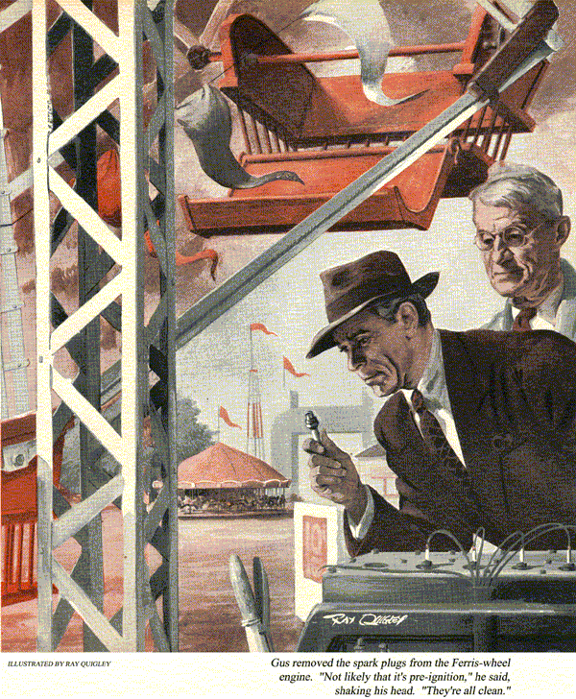
A few weeks ago, on his day off, Gus Wilson left Stan Hicks holding the fort at the Model Garage and drove up to Round Lake to see about getting his fishing skill in shape. One of the local boys always took care of the annual overhaul. After they'd talked the job over, Gus strolled over to the pint-size refreshment stand and bait store that old Tom Strong runs near the boat landing.
"Hi, Tom," Gus greeted the little old men behind the counter. "All set for a busy summer season?" he asked as he fished around in the cooler for a root beer.
"Can't rightly tell, Gus, what with all this war business stirrin' folks up."
Gus finally dredged up a bottle. As he stooped to open it the door slammed behind him. Looking up, he recognized Ken Peyton. Ken runs an amusement park down near the hotel at the other end of the lake.
"Saw your car outside, Gus," Peyton said as he pumped Gus's hand. "I need some advice."
"What's the matter, that one-horse Coney Island of yours falling apart?" Gus kidded.
"Not quite," Ken grinned, "but I've got the usual headaches that come along every year when I open up."
Gus drained the last of his drink and dropped the bottle into the case for the empties.
"It's that Ferris wheel I put in last year," Ken explained.
"Remember, I bought an old auto engine from a junk yard and hooked it up with a hand clutch?"
Gus nodded.
"Ran fine all last summer," Ken continued. "Well, this morning I decided to see how she'd got through the winter. I put in the battery, filled the radiator and the gas tank - she had oil - turned on the switch, and poked the starter button. Naturally, she didn't start right off, but after a little she caught and ran smoothly enough. I turned the ignition off, and you know what happened?"
Gus shook his head.
"That fool engine kept right on running. The only way I could stop her was to cut off the gas. Luckily, I've got a petcock in the fuel line."
"It's probably nothing more than a bum ignition switch," Gus said. "Want me to have a look?"
"Wish you would, Gus. I've got my car outside, and we can be over there in a jiffy."
"I'll follow you in my car," Gus put in as he followed Peyton through the door onto the landing. "Then I can leave for town right from your place."
"So long, Tom," Gus called back to old man Strong. "See you next week."
Less than 10 minutes later, Gus followed Ken's car through the newly painted wooden arch into Round Lake Park and parked in an open space behind the Ferris wheel.
"There's my runaway engine," Ken said, nodding toward the wheel. "I'll start her up and you can see what I mean."
Engine Won't Stop
The engine still warm from its earlier run, ticked off without a sputter. After about a minute of running, Ken reached over to the small control panel he'd rigged at the rear of the engine and turned the ignition key to the "off" position.
The engine kept right on running without so much as sputtering.
"See what I mean?" yelled Ken.
"Got a pair of pliers handy?" asked Gus.
Ken reached into a small tool box on the floor of the shed, rummaged around in it and finally handed Gus the pliers.
"I'll disconnect one of the wires at the rear of this switch," Gus explained as he went to work.
In a moment Gus loosened the small nut and pulled the wire loose. But it made no difference to the engine - it ran right along.
"Humph," grunted Gus. "Can't be the switch after all. Okay, shut off the gas. I want to try something else."
Ken complied, and, as the engine died, Gus reconnected the lead. "Now turn the gas back on and let's see if she'll start with the ignition off."
With the ignition key in its "off" position, Ken pushed the starter button again. The starter ground away without effect.
Now It Won't Start
"Are you sure that gas is turned on?" queried Gus.
"Wide open," Ken called over the whir of the starter motor. "And the hand throttle's cracked open too."
After a few more seconds with no results, Gus reached over and turned the ignition key to its "on" position. Almost instantly, the engine took hold. Then, when Gus turned the ignition key off, it continued to purr along.
"Now, how do you like that, Gus? She'll run with the ignition off, but won't start unless it's turned on."
Gus said nothing and began tracing and examining the wires leading to the switch.
"Been having any battery troubles?" he asked finally.
"Nope," replied Ken. "Took the battery out last fall and kept it up to charge over the winter. Just put her back in place this morning. Why?"
Even Runs Without Battery
"Just wondered," said Gus. Then, using a wrench, he began loosening the nut on the battery terminal lug that led to ground.
The clamp came off the post easily. And the engine never missed a beat as the cable popped loose.
"Say, what is this?" Ken hollered. "Ignition off, battery disconnected, and she still runs."
"Could be a bad case of pre-ignition," said Gus. "Let's shut her down and have a look at the plugs. Could be they're dirty."
Starting at the front end of the engine, Gus began removing the spark plugs. As he lifted out each one, he shook his head.
"Not likely that it's pre-ignition," he reported as he screwed them back into place and replaced the ignition wires. "All of 'em are clean. And from what I could see squinting through the spark plug holes, the piston heads aren't too fouled with carbon."
"Well, what now?" asked Ken.
Still Another Question
Gus scratched his head in thought.
"Look, Ken," he said, "what I'm going to do next may take some time, so if you have anything else to do go do it. No sense both of us sittin' here fuming."
About half an hour later, Ken was giving one of his workmen some instructions about minor repairs to be made on the merry-go-round when he heard the Ferris wheel engine start up. After a few seconds it stopped. Then it started up again. Ken made off in the direction of the wheel on the double. When he got there, Gus was standing beside the engine, grinning from ear to ear.
"Find the trouble?" asked Ken, puffing.
Gus nodded. "Yeah, finally. It was a short all right, not in the switch but in the wiring. It was a tough one to find, too."
Ken reached over and turned the ignition. The engine stopped just as promptly as any well-behaved engine should.
"Where'd you find it?"
Gus pointed down to the side of the engine. "I went over all the visible wiring without finding a thing. Then I just happened to examine those two wires there where they enter that metal conduit that leads them by the block."
One Question Answered
Ken looked at the two wires Gus had indicated. They now were protected with fresh tape.
The sharp edge on the hole in that conduit had cut through the insulation on both," Gus explained. "And if you'll follow them through, you'll find that one leads from the generator, the other to the coil.
As a result there was a direct connection from the generator to the coil. So no matter what position the ignition switch was in, the coil was always getting juice once the engine was started."
"Okay, but how come then she wouldn't start unless the switch was turned on?"
"With the engine dead, the coil could only get juice through the switch," Gus explained. "You see, the generator isn't even connected into the ignition circuit when you start an engine. The cutout - that's that gimmick mounted on top the generator housing - doesn't kick it in until the generator's turning fast enough to put out more juice than the battery does. Otherwise a battery would discharge back through the generator."
"I get it," said Ken. "So the short didn't feed the coil until the engine got up to speed."
"That's about it," agreed Gus. "And by the way, that tape will hold for now, but when you get a chance I'd put all new wiring in. Most of the insulation is brittle. You may want to replace the coil, too, though it seems all right. The generator may have kicked out enough juice to weaken the insulation on the primary."
"How much do I owe you, Gus?"
"Aw shucks," grinned Gus. "This is my day off. I'll take a raincheck on some rides this summer."
"Second childhood?" laughed Ken.
"Oh, not for me," replied Gus. "I've got a young niece coming to visit me in July and what kid doesn't like a Ferris wheel?"
END

