March 1951

GUS FINDS

TWO RIGHTS CAN MAKE A WRONG
by Martin Bunn
The Model Garage owner plays tricks
with a neighbor's ornery tractor and sets things right again.
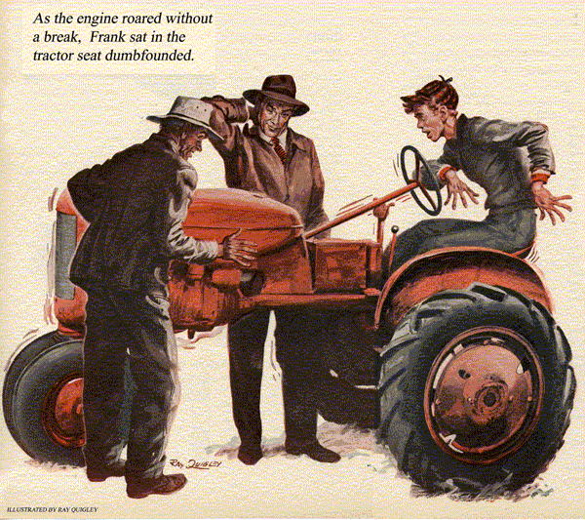
At about this time every year, Gus Wilson always gets a rash of S O S calls from the local farmers. Quite a few of them who think they are handy with tools spend part of the winter months trying to get their trucks and other farm gear in shape for the spring. Then, when they get into trouble - and they often do - they invariably call on good old Gus with a last minute fix it plea.
Most times Gus doesn't mind. February and March usually are slow months at the Model Garage. The big rush doesn't start until April when folks begin thinking about getting their cars ready for warmer weather.
This year, though, things got a little ahead of themselves. A few stretches of downright balmy weather had Gus Wilson's shop jammed to the doors with repair jobs and tune-ups by the end of February. As a result, the veteran mechanic had to stick pretty close to his bench.
There was one call for help, however, that Gus just couldn't bring himself to turn down. It was from his old and very good friend Mel Mowbray. Mel and his wife were two of Gus's favorite people.
It seems that Mel had a new hired hand who'd talked Mel into letting him overhaul the tractor. He'd evidently botched the job, because Mel had asked Gus to come to the rescue.
So one Sunday recently found Gus driving up the long lane that leads to Mowbray's farm. As he neared the house, Mel headed toward him from the barn.
"Sure swell of you to give up your Sunday and drive all the way out here to help us," Mel said appreciatively after Gus had parked his car.
"Can't let an old friend down," Gus replied with a smile. "Besides," he added with a wink, "I haven't had a piece of Mrs. Mowbray's deep-dish apple pie in ages."
"How about a cup of coffee right now, Gus?" he said ushering the mechanic into the big farm kitchen.
A few minutes later, after Mrs. Mowbray had brought them two steaming cups and a plate of hot buttered biscuits, Mel began telling Gus his troubles.
"I'm in a spot, Gus," he said. "This each spring has sort'uv caught me unprepared. I'll be needin' my tractor pretty soon now and it's in no shape to be of much use."
"What happened? Your new hired hand take it apart and forget how to put it back together again?"
"Not as bad as that. Last fall, when we put it up for the winter, I knew that she needed a general tune-up and probably new rings and a valve job. I made my mistake by letting Frank-that's my hired hand - talk me into letting him do the job. He meant well - wanted to save us the money."
Gus nodded, reaching for another one of Mrs. Mowbray's biscuits.
"Well," Mel continued, "he put in the new rings, ground the valves, and took care of a few other repairs. Finished the job last Friday. He was a proud youngster when he cranked her up and she took hold and purred like a well-fed kitten. That is, he was proud until he gave her the gas.
Then she began to sputter. Sounded like she was only hitting on three cylinders."
"Did he check the timing?"
"Gus, he's been checking everything ever since. The poor kid hasn't done anything else. He's out there in the barn right now going over that engine piece by piece."
"Let's amble on out," suggested Gus, gulping the last swallow of his coffee.
"Tractors aren't my meat, but maybe the three of us can gang up on the trouble."
As the two men walked into the barn they found Frank, grease-smeared and dejected, carefully checking the ignition wiring.
Gus Meets Susie the Tractor
"Frank," called Mel, "this is Gus Wilson.
He's come out from town to see if he can help us find out what's ailin' old Susie."
"Having troubles, Frank?" Gus grinned as he gripped the younger man's hand.
"Since I gather it's a she I wouldn't feel too bad. Females are always temperamental. Got any theories?"
"Gosh, Mr. Wilson, that's just it, I haven't got a one," Frank admitted. "Everything checks out as it should, yet she misses when you give her the gas."
"Let's hear her idle."
Just as Mel had said, Susie started without a falter and idled smoothly.
"Now give her the gas."
Frank complied and the tractor engine picked up from a pleasant purr to a stuttering roar. There was no doubt about it, Susie had a bad miss.
"It's the No. 2 cylinder, I'm sure," Frank said after he had shut off the ignition and climbed down from the tractor seat.
"No. 2 okay?" asked Gus, walking over to where Frank stood beside the tractor.
"Perfect, I even switched plugs to make doubly sure, and No. 2 still missed," answered Frank. "I've checked fuel, ignition, timing, and compression. They're all okay."
"In other words," said Gus scratching his chin, "everything about No. 2 is perfect except she won't perk at anything above idling."
"That's about it, Mr. Wilson."
"Susie ever give you any trouble before?"
Gus asked turning to Mel.
Mel was silent for a moment. "Well, come to think of it," he finally replied, "she did run kinda rough when I first bought her a few years back. The dealer worked on her a bit, but as I recall she finally smoothed down of her own accord. I dunno, guess she was a little stiff or somethin'."
"Mind if I check the valve clearances, Frank?" Gus asked, taking off his dress-up coat and slipping on Frank's discarded jacket.
Valve Clearances Are All Okay
"Sure thing," answered Frank, holding out a set of feeler gauges. "It's a cinch I've slipped up on something."
"What's the clearance?" asked Gus as he reached for the gauges.
"The manual says '.011' on both intake and exhaust."
Mel and Frank watched while Gus removed the valve cover and proceeded to check the valves for No. 2. Evidently satisfied that they were okay, he made a quick check of the others.
"No fault there," he announced. Then he hesitated for a moment and rubbed his finger over a spot on the engine block.
"Humph," he grunted. "Got the valve wrench handy, Frank?"
Somewhat puzzled, Frank found the wrench in his toolbox. Gus took it and turned back to the engine. When he finally straightened up, he said, "now give her a whirl, Frank, and let's hear how she sounds."
Frank climbed back up on the tractor seat and hit the starter switch. As usual, Susie started up with a pleasant purr.
"Now try the gas again," Gus called.
The three men made a composite picture of surprise. Frank just sat in the tractor seat dumbfounded. Mel stood looking slightly bewildered. Even Gus looked as if he couldn't quite believe his ears.
When Frank recovered, he began moving the throttle back and forth to make sure what he heard was true. Finally, convinced that the miss had disappeared completely, he shut off the ignition, slid off the seat, and stepped down to the barn floor.
"What the devil did you do to it? “asked Mel. "And whatever made you do it?"
Gus grinned. "I was a little lucky. I just happened to stumble onto two things and they happened to add up right," he replied, modestly. "First of all, since there didn't seem to be anything particularly the matter with cylinder No. 2, I figured that maybe some other cylinder was causing the trouble."
"But all the cylinders checked," put in Frank.
Luck and a Hunch Located the Trouble
"Okay," agreed Gus, but I had a hunch that maybe two rights were making a wrong. Now," he added, "the only connection between cylinders is through the intake and exhaust manifolds. Right?"
Both Frank and Mel nodded in agreement.
"Then, continued Gus, "the most likely cylinder that could have any possible effect on No. 2 is No. 1, because they both use the same halves of the manifolds. Since No. 2 for no good reason, was doing the missing, I figured that in some roundabout way No. 1 was starving No. 2 at speeds above idling.
"Also, since No. 1 was firing perfectly, it seemed most likely that if it was affecting No. 2 it was getting in its dirty work during the exhaust stroke.
"But how could that be?" interrupted Frank. "If the valve clearances were right, only the exhaust valve would be open on No. 1, and all the gasses would pass out through the exhaust manifold.
Gus nodded, "And according to this firing order," he added pointing to the numerals '1-3-4-2' cast into the engine block.
"No. 2's intake valve would be open at the same time. I had a hunch that something was preventing No. 2 from getting her full supply of fuel and air."
"But what could do that?" asked Mel.
"I didn't have the slightest idea, Mel. Until you happened to mention that Susie hadn't run too well when you first got her but that she'd settled down."
"I still don't get it," said Frank, puzzled.
"Well, I figured that the trouble must be connected with something that wasn't overhauled," explained Gus, "something that could open No. 1's intake valve when it shouldn't be open - like a little hump on the intake cam."
"A hump on the intake cam?" repeated Mel.
Gus Explains a Simple Fix
"Yes, if there was little hump on the intake cam at just the right point, it could nudge No. 1's intake valve open just a crack during its exhaust stroke. That could build up enough back pressure in the intake manifold to prevent the full mixture from ever getting to No. 2 on its intake stroke at anything above idling speed. ‘ Might be one of those manufacturing defects that sometimes - rarely - gets by the factory inspectors."
"But how did you fix it?" asked Frank.
"Simple enough. I just backed the No. 1 intake valve clearance off a bit so the bump couldn't raise the intake valve. It's only a makeshift. It'll hold for now, but when you have a lull in your plowing, I wish you'd bring it down to the shop so we can grind that high spot off and readjust the valve."
Frank had little to say during dinner that Sunday. Then, as Gus was scraping the last bit of Mrs. Mowbray's apple pie onto his fork, the young hired hand said, "Sometimes two rights can make a wrong. Before you fixed her, her valve clearances were off enough so that hump on the cam didn't matter. When you ground the valves and made the clearances right, it did."
END

