January 1951

GUS TAMES A RUNAWAY ENGINE
by Martin Bunn
First it wouldn't stop, then it wouldn't go, and
the contrary engine had to get Gus's friend home by New Year's.
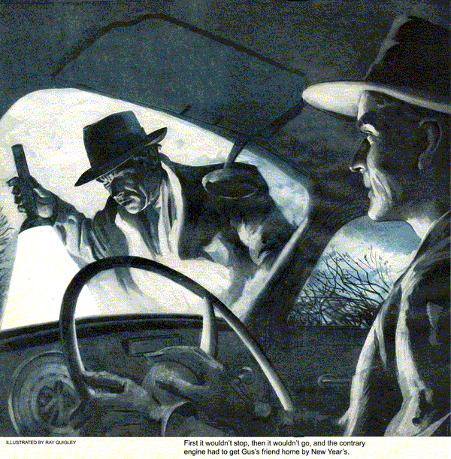
About ten months ago, one of the big electrical companies put up a branch plant and laboratory just outside our town. Part of that industrial decentralization program I've been hearing about, I guess. Anyhow, it brought quite an influx of new people into our community - most of them engineers and scientists.
One is a young fellow by the name of Jim Harrison. Jim, a veteran and unmarried, came from Indiana, where not too long ago he graduated from engineering school, thanks to the G.I. Bill. Right now, he's staying at Mrs. Paley's boarding house.
Everyone who knows Jim likes him, especially Gus Wilson whose Model Garage is one of Jim's favorite stopping-off places. Not long ago, Gus had helped Jim do a first-rate job of grinding his valves. Than back last summer, when Jim had just bought his second-hand car, Gus had shown him how to re-time the motor, adjust the carburetor and hook up a water injector, put in a new exhaust pipe and muffler, and replace a cracked windshield. Under Gus's direction, Jim had worked over the old car until he had practically rebuilt it.
Gus hadn't seen Jim for several weeks when one night recently Gus was strolling down our main street doing a little window-shopping. Suddenly he heard someone shouting his name. It was Jim and he was running across the street toward Gus.
"Gosh, am I glad to find you," Jim gasped. "Been looking all over town for you. Can you spare some time? I'm in a spot, and you can help out."
"Sure thing, Jim," Gus said. "But let's stop off here at Dan's Grille for coffee.
"Now, what's it all about?" Gus asked after they'd settled down on their stools and Dan had served up two steaming cups.
"Well," Jim began hesitatingly. "You may remember that I'd been hoping to take my two weeks vacation and drive along home to see my Mother and Dad at New Year's."
Gus nodded.
"I'd planned to start out tomorrow night right after work," he went on, "but I guess that's all off now."
"What's the matter?" Gus inquired. "Work at the plant too heavy and they've asked you to put off your vacation?"
"No, it's not that," Jim replied glumly. "I can still have my vacation. It's my car. Something's gone screwy with it and I'm blamed if I can spot it. It started acting up last night on my way back to town from the plant. I was breezing along the outer road at about forty and took my foot off the gas to slow down for an intersection. Instead of slowing down, the fool car just took the bit in her teeth and never slackened. Before I could throw out the clutch, I was through the intersection. Then all of a sudden, the engine began to spit and sputter and finally died."
"Would it start again?" put in Gus.
"Not right away," Jim replied. "So I got out and lifted the hood to take a look. As I started to poke my head in under the hood, I heard a distinct metallic click."
"A metallic click?" questioned Gus.
"Yeah, you know, like something snapping back into place," explained Jim. "I couldn't find anything that looked wrong, so I decided to try the starter again. She kicked right off."
"Did the motor run evenly?" Gus asked.
"Never ran smoother," Jim pointed out, "but about a half mile further down the road she took the bit in her teeth again and continued to roll along at forty, accelerator or no accelerator. Then, just like the first time, she gasped and died. She did that about four times before I got into town."
"Sounds like something's binding somewhere in your throttle linkage," Gus offered. "Probably sticks when you've pushed the gas pedal down far enough to hit forty, stays there for awhile, and then pops loose."
"That was my first guess, too," Jim confessed, "but no luck. Besides, that wouldn't account for the dying act."
"No, you're right, it probably wouldn't," admitted Gus. "How did she act today?"
"Same business all over again," Jim grumbled. "Took me an hour to get to the plant."
"Where's the car now?"
"Out in the garage in back of Mrs. Paley's," Jim said eagerly. "Will you come over and take a look at it?"
Ten minutes later, they were in Mrs. Paley's garage and Gus, hat on back of his head, was peering down at Jim's balky motor.
"The throttle linkage seems okay, just as you said," Gus muttered as he moved the throttle rod back and forth. "Doesn't bind at all. Have you looked to see if there's dirt or anything that might be jamming the throttle valve?"
But before Jim could answer, Gus had lifted off the air cleaner and was peering down into the carburetor's throat.
"Looks clean," Gus announced. "Let's take a little spin and see if she'll do a repeat performance for me. Got a flashlight?"
"She'll repeat all right. I'll guarantee that," Jim grumbled as he slid in behind the wheel, pulled a flashlight from the glove compartment, and handed it to Gus who had climbed in beside him. "I'll bet we don't get a quarter mile out on the state road before old Nellie here runs away and then dies gasping for breath."
Gus noticed that the car started easily enough, and, as Jim weaved his way through town, he marveled at how well the car ran in spite of its age.
Things happened just about as Jim had predicted they would. They'd no sooner hit the state road and gotten the car up to forty when, at a nudge from Jim, Gus looked down at the floor boards. Jim's foot wasn't on the accelerator, yet the car was rolling along at about forty-two miles an hour.
"Automatic pilot," Jim said with a chuckle, but his laugh was interrupted by sputterings from his motor. He maneuvered the coasting car to the shoulder of the road, and, almost before the car had come to a stop, Gus was out, had the hood up, and was directing the beam of the flashlight at the engine. Just as Jim had joined him, there was a click and Gus noticed that the throttle rod to the carburetor snapped back into what was evidently its idling position.
"Did you see that?" queried Gus.
Jim nodded.
"I think we're getting some place," Gus said hopefully. "Let's try her again."
After the two men had climbed back into the car, Jim pushed the starter and the motor caught without a falter.
"Now bring her up to forty again slowly," Gus instructed, "and the minute she runs away and then begins to sputter pull over to the side of the road."
They didn't have to wait long before things started to happen again, and when they did Jim followed his instructions. Gus jumped out of the car, flipped open the hood, which he'd left unlatched, pulled off the air cleaner, and aimed his flashlight into the carburetor's throat.
"Take a look down there," Gus said after a quick inspection. "Even a carburetor's throat can develop tonsils."
Jim looked. There was at least a half-inch of white ice blocking the throttle valve. As he watched, he could see the ice melting and suddenly there was that familiar metallic click he'd been hearing each time after his engine had died.
"There's your trouble," Gus said, tapping a metal tank mounted on the fire wall that held the water supply for Jim's water injector. "Your carburetor has been icing up because of the water you've been adding to your fuel."
"But Gus, the temperature hasn't dropped below freezing for weeks," Jim reminded him. "I know the manufacturer's instructions said not to use the injector when the weather dropped below thirty-two, and I haven't. As a matter of fact, when we left the house tonight it was a balmy forty-two." "Outside, yes," Gus corrected, "but not inside your carburetor."
"Well, what a dope I've been," Jim groaned as he thumped his forehead with his fist, "a fine budding engineer. Of course, the venturi effect in the carburetor acts like the expansion valve in a refrigerator - it lowers the temperature."
"Right, and the temperature in the throat of a carburetor can be quite a bit below freezing even if the outside temperature is above freezing," Gus explained. "What's been happening is that first just enough ice has been forming at forty miles an hour to hold your carburetor throttle valve open at that position. Then as more and more ice has formed it has choked off the carburetor throat and starved the engine. Finally, when she did stall, it didn't take long for the heat of the engine to melt the ice and you were all set to go again." "Live and learn," Jim grinned as he reached in under the hood and turned the petcock that shut off the water for the injector. "I guess about the only alibi I've got is that I'm an electrical engineer."
"Well, at least you were a dogface and not a fly-boy in the last war," Gus said as they started back to town. "If you'd been a pilot, you'd have known that airplane carburetors often ice up under certain damp weather conditions in the summer when the outside temperatures are soaring in the nineties. That's why they put heaters in 'em."
"Well, since I don't have a heater in mine," Jim replied, "I guess I'll just have to forget about my water injector until warmer weather sets in again."
"Not necessarily," Gus corrected. "You can always add enough alcohol to the water in the tank to prevent freezing. As a matter of fact, the alcohol will add to the pep of your engine. Some injectors are designed to operate only on an alcohol-and-water mixture."
"Thanks a million, Gus," Jim said as he slowed the car to a stop in front of Gus's house. "Now I can take off for home tomorrow night on schedule. Mom and Pop sure would have been disappointed if we hadn't been able to get together. Happy New Year, Gus."
"And a Happy New Year to you, Jim," Gus said shaking Jim's hand. "And while you're driving, look out for those holiday-happy goons who think they can mix alcohol and gasoline without an injector."
END

