August 1951

GUS ANSWERS A NIGHT CALL
by Martin Bunn
It was more than mechanical troubles that
brought Gus out to a dark, deserted street at two in the morning.
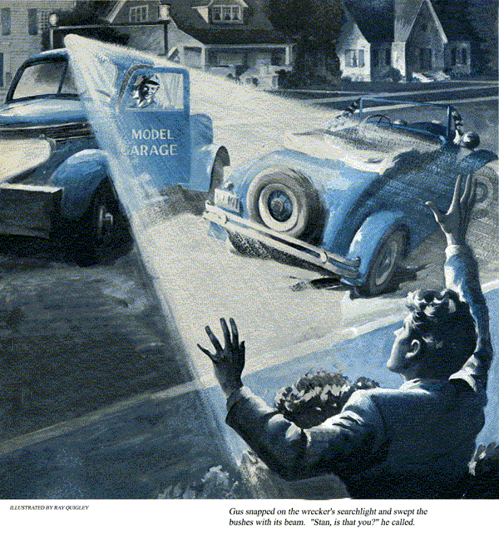
Gus Wilson wheeled the big wrecker down the dimly lighted streets as fast as a minimum of safety would permit.
It was two o'clock in the morning, and the veteran mechanic-owner of the Model Garage was worried.
Stan's frantic call for help hadn't been too coherent, and in his hurry to get started, Gus suddenly realized he had slammed down the receiver without giving his young assistant a chance to explain what the trouble was.
As Gus turned onto Maple Avenue, where Stan Hicks had said he would be waiting, he was surprised to find the houses dark and the street deserted. Then, half a block down, he spotted a familiar sight.
Stan's beloved old jalopy stood by the curb, one wheel nearly hubcap-deep in a hole.
As Gus cut the wrecker's engine, he heard a strange noise.
"Psst, Gus," whispered a voice from the bushes, "over here."
Gus tried to rub the sleep out of his eyes, "Stan, is that you?"
The voice from the bushes didn't answer.
Puzzled, Gus snapped on the wrecker's searchlight and swept the bushes with its beam. Suddenly the bushes parted and out burst Stan, waving wildly.
"The light," croaked Stan, "cut the light!"
Gus complied.
Stan's new white flannels were streaked with grease, and there was a jagged tear in the pocket of his sport coat.
"You look like something the cat left behind," Gus commented sarcastically.
"Gee, Boss, I didn't mean to get you out here, but I got a birdie in my car and Jane's father got mad and then I got stuck."
Gus tried to control himself. "Now what's a birdie got to do with--"
"Shhh," broke in Stan. "This is Jane's house, and if her father hears me again tonight, I'll really get it."
"All right," said Gus, lowering his voice, "what's wrong with your engine?"
"Nothing," explained Stan. "I just don't want to start it up because it'll make too much noise."
Gus glared.
"That's how I got into the hole," Stan continued. "Last night we got in a little late, and that noise in my car woke up Jane's father. He hit the roof. So tonight I figured I'd just cut the engine, coast up here, then roll her back down the hill when I left. Only I didn't see this hole and backed right into it."
Gus looked down at his feet that were still wearing bedroom slippers. "Okay," he said resignedly, "hook on the chain and I'll tow you out."
"No, no," yelped Stan, "that's worse. It'd be sure to wake up the old man. I was almost able to rock her out. Maybe the two of us--"
Gus started to say something, then thought the better of it and silently eased his big shoulder against the trapped jalopy. Together the two pushed and heaved until finally the car rolled out.
"Now back down easily," directed Gus, "and try not to hit any more holes. I'll coast down behind you."
At the bottom of the hill, Gus pulled up beside the roadster as Stan started the engine. Stan had a birdie all right. It was a high-pitched screech coming from under the hood that didn't sound quite like anything Gus had ever heard.
"Well," announced Gus, "we'll tackle that screech owl in the morning. I'm going back to bed."
Stan turned to offer his thanks, but the big wrecker was already rattling off.
Gus was a little late arriving at the Model Garage the next morning, and when he got there Stan was hard at work.
Stan looked up and greeted the master mechanic with an embarrassed grin. "Gee, Boss, I'm sure sorry about last night. I--"
"Forget it," cut in Gus. "But I think we'd better clip that birdie's wings before you lose Jane and I lose any more sleep. Why didn't you tell me about it sooner?"
Stan looked sheepish. "Well, Jane's been kidding me about a mechanic who can't even fix his own car, so I've been determined to find it myself."
"Well, two heads never hurt anybody," quipped Gus, "unless they're on the same shoulders. How long have you had it?"
"Several days now," replied Stan, "and it keeps getting worse all the time. Funny thing, though, instead of getting louder the faster you go, it quiets down. It's loudest when the engine's idling."
"Well, let's take a listen," said Gus, as he walked over to Stan's roadster and opened the hood. "Start her up."
Just as Stan said, the engine took hold to a shrill, high-pitched screech, then as Stan gunned the engine, the noise seemed to diminish rather than increase.
Gus motioned Stan to cut the engine. "What have you done so far?"
"Everything I could think of. I checked the fan belt, water-pump bearings, and generator bearings. All okay."
"How about the distributor?" asked Gus, remembering the squeaky cam they had found on Doc Rhodes' car a few years ago.
"Yup, checked that, too," said Stan wearily. "I just don't see what could--"
Stan was interrupted by the blast of a car horn outside.
"I'll get it," offered Gus. "You better look at the generator again and this time check the brushes."
A few minutes later, Gus returned grinning from ear to ear. "This seems to be our day for bird hunting.
Ted Trimble's outside with another canary."
"Oh, no," groaned Stan.
"We'd better give him a hand with his," advised Gus, "and maybe we'll learn something."
"Just listen to this," grumbled Ted, as the pair walked up to Ted's blue sedan.
As the engine idled, a rhythmic chirp, chirp, chirp came from the engine.
"Step on the gas a little," suggested Gus.
Ted complied, and the chirps speeded up, keeping time with the engine.
Methodically, Gus checked the tension of the fan belt and then began turning the fan by hand. Finally he reached into the side pocket of his coveralls, pulled out a screwdriver, and pointed to a dark spot on the inner groove of the fan pulley.
"I think just maybe that might be our trouble," he said, digging at the spot with the tip of the screwdriver.
"Feels like greasy dirt," he added, after he had scraped some off and rubbed between his fingers.
When Gus had cleaned the fan pulley, he told Ted to start the engine. Both men listened, but there wasn't a chirp.
"That's got it," grinned Gus. "Every time your fan belt hit that greasy spot, it slipped a bit and let out a squeak."
When Ted had driven off, Gus turned to Stan. "Well, one down, one to go. At least we're batting 500."
"I don't get it," said Stan. "I checked the generator brushes like you said, and they're all right, too.
What's left?"
Gus looked at his watch. "Well, it's getting on to noon and you probably have something better to do with your Saturday afternoon than chasing after noises. Why don't we give it up for now?"
"That's just it," said Stan glumly. "Jane and I were planning to go to the beach this afternoon, and she'll be here in a few minutes to ride out with me."
"I get it," winked Gus, "if you don't get rid of the noise, she'll get rid of you. Well, if we can't find out what it is, let's see if we can find out where it is."
As Stan started up the engine again, Gus cupped his hands around an ear, like a funnel, and began moving his head slowly along the side of the engine.
Intrigued by what Gus was doing, Stan began unconsciously to whistle a tune.
Gus's patience collapsed like a punctured tire. "For Pete's sake, Stan, how can I hear anything if you're going to--"
Suddenly Gus straightened up. "Hey, wait a minute. Stan, we've been a couple of chumps!"
Stan's expression had made a fast change from wounded vanity to abject apology to utter amazement and had now come to rest completely blank.
"No wonder we didn't recognize that noise," Gus went on. "It isn't a screech like two metallic surfaces rubbing together. It's a whistle, like air rushing through a hole."
Quickly, Gus checked the vacuum line to the windshield wipers, but the hose was sound and the connections tight. Then he reached for the air cleaner. It wobbled. As he held it, the whistle stopped, then when he let go, it started again.
"That's it," Stan shouted, "the air cleaner's loose."
"No," corrected Gus, "the whole carburetor's loose. Get me a wrench."
Stan brought the wrench and Gus fitted it to one of the studs that held the base of the carburetor to the intake manifold.
"This one's loose," said Gus, as he tightened it. And as he did so the whistle became fainter.
"Now let's try the one on the other side."
When he pulled that one up tight, too, the whistle disappeared completely.
"Well, that's one for the books," exclaimed Stan. "The looseness of those studs allowed air to be sucked in between the base of the carburetor and the intake manifold and caused a whistle."
Gus nodded.
"But how come the whistle was louder at low speeds?" asked Stan. "You'd think that when you opened her up more air would be pulled in through the leak and the whistle would get louder."
Gus rubbed his chin thoughtfully. "Probably what happened was that the bigger masses of air at high speeds were strong enough to seat the carburetor base a little better and cut down the leakage."
As Gus finished explaining, there was the sound of high heels outside the garage, and the two looked up to see the pretty young figure of Jane Stevens standing in the doorway. "Hi, Stan. Hello, Mr. Wilson. Am I too early?"
"Just in time," declared Gus. "I don't know about Stan, but this is the last time this thing will whistle at anybody!"
"We don't have to worry any more about waking up your father," put in Stan excitedly, "like we nearly did last night."
"Oh," exclaimed Jane, "I almost forgot to tell you. After we left for the dance last night, Dad drove over to Townsville to some business convention and stayed overnight. He wasn't home at all."
END

