April 1951

GUS TEAMS UP WITH THE DOCTOR
by Martin Bunn
A midnight encounter results in an appendix operation
for Doc Marvin and a ticklish engine diagnosis for Gus.
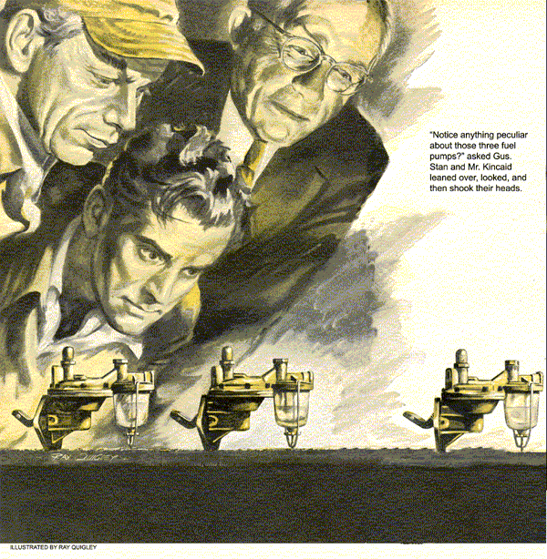
Doc Marvin was driving along at a fair clip. Gus Wilson, the owner of the Model Garage, was in the seat beside him. It was well past midnight and the two men were anxious to get home and into their beds. The two old cronies had spent the evening in the city at the fights.
Traffic was light - just an occasional car - so Doc was making good but cautious time. As he slowed for a curve, Gus noticed a car up ahead, parked off on the road's shoulder. Standing in the fan of light from the car's headlights was a man frantically waving his arms.
"Maybe we better stop and see what the trouble is," said Gus.
The Doc replied with pressure on the brakes that slowed his car to a stop less than a half-dozen yards beyond the man and the car.
"Need a hand?" Gus called as he opened the door and climbed out.
"Sure do," came the reply. "Been trying to flag down a car for a half hour, but you're the first folks who even as much as slowed."
By this time, both Doc Marvin and Gus Wilson were within a few feet of the man. He was elderly and his face was wreathed with anxiety.
"Trouble?" Gus asked.
"A heap. My wife and I have been touring. About three-quarters of an hour ago she was seized with violent cramps - just about doubled her up. I stepped on it to try to get to a doctor. Then my engine sputters and quits and won't start."
"Where is your wife?" Doc Marvin asked, striding toward the car.
"She's huddled on the back…" But before the man could finish, Doc had opened one of the rear doors and was climbing in.
"Who's he?" the man asked, bewildered.
"A doctor, fortunately," replied Gus.
A moment later, Doc Marvin poked his head out through the open door. "Gus," he called, "give me a hand, will you? We've got to get this woman to a hospital right away."
When Gus and the Doc had made the woman as comfortable as possible on the rear seat of the Doc's car, Gus turned to the man. "Lock up the car and give me the keys. I'm a garageman. I'll come back here in the morning with my tow car."
It was well past three by the time Gus had left Doc and the woman at our town's hospital and had found a room for the man. He'd learned that the man and wife were a Mr. and Mrs. Kinkaid from a small New England town, that the man had retired around the first of the year, and that they'd been off on a sight-seeing motor trip. However, it hadn't turned out to be a very pleasant one. Their 1942 car had plagued them with troubles almost from the start - and now Mrs. Kinkaid was ill. Well, thought Gus as he yawned and finally turned off his light, Doc Marvin will take good care of Mrs. Kinkaid.
In spite of his lack of sleep, Gus opened the Model Garage on time the next morning. When Stan Hicks, his helper, arrived about 10 minutes later, he said, "Let's get going, Stan. Get into your work clothes. We've got a car to pick up with the wrecker about eight miles south on the state road."
"Smash up?" asked Stan, pulling on his coveralls.
"Nope, just a stalled car," explained Gus as he climbed into the driver's seat. The wrecker's engine caught with a full-throated roar. "Luckily Doc Marvin and I happened by last night on our way home from the fights," he added as Stan climbed up beside him. "An elderly man with a sick wife and a stalled car. Doc took the wife right to the hospital."
When they reached the car, it didn't take Gus long to decide there was something wrong with the car's fuel system. Plenty of gas in the tank, but the carburetor wasn't getting any.
"No sense trying to troubleshoot it out here," he said as he closed the hood. "Rig up the tow gear and we'll haul her back to the shop."
"Might be a plugged gas line," offered Stan, as he fastened one end of the tow chain.
"Or a bum fuel pump," shrugged Gus, climbing back on the wrecker. "But let's not jump to conclusions."
When they got back to the garage with the car in tow, Mr. Kinkaid, looking a little less harassed and not quite so old as he had the night before, was waiting for them.
"Morning, Mr. Kinkaid," Gus called as he maneuvered the wrecker and the car into the shop. "How is Mrs. Kinkaid?"
"We sure were a couple of lucky people when you two fellows came along last night. Doctor Marvin operated just as soon as he could after he got her to the hospital. Acute appendicitis!"
"How is she now?"
"Doing fine. At least that's what the nurse at the hospital told me a short while ago. They're letting me see her this afternoon, so that sounds good."
"Great," grinned Gus. "Now, let's see what luck we can have with this ailing buggy. She been giving you a lot of trouble?"
"A heap of it," grumbled Kinkaid. "Over $100 worth in 500 miles, and she still won't perk as she should."
Gus let out a low whistle. "Well, at the moment," he said as he walked to the car and opened the hood, "I'd say she's got fuel problems - a fouled gas line or a bad fuel pump."
"Oh, don't say that, Mr. Wilson," groaned Kinkaid. "It just can't be. That's the third new fuel pump I've paid to have put on in the last five days. Maybe I'd best start at the beginning and tell you the whole story."
"Good," said Gus, thumbing shreds of tobacco into the bowl of his pipe.
"Well, the first three days of the trip went smoothly enough," Kinkaid explained. "Then the trouble started in Virginia. The motor suddenly quit dead. After a 16-mile tow to a small garage, the trouble finally was laid to a stripped camshaft timing gear. After a lot of trouble, they finally installed a new gear.
The car seemed to run fine, so we started off on our way again."
Gus nodded, puffing on his pipe.
"But we hadn't gone 10 miles," continued Kinkaid, "before she stalled again and wouldn't budge. Again a phone call and a tow back to the same garage. This time the verdict was a broken fuel pump."
"Did they test it?" put in Gus.
"They worked the little lever by hand, and it seemed to run all right to me, but the two mechanics said I needed a new one, so I let 'em go ahead."
"It could have had a broken diaphragm," said Gus.
"Well, anyway, when they were finished, the car purred as good as ever, so we started off once more.
But another 200 miles along the line she refused to start again. So, after another tow to another small-town garage the mechanic there felt sure it was sludge in the gas tank that was plugging the fuel lines."
"Did he blow out the line?"
"They blew the line and they drained the gas tank," grumbled Kinkaid, "without finding a bit of dirt. So, on went another fuel pump. Well, to make a long story short, mechanics at a garage about 70 miles down the road from here put on the third new fuel pump yesterday afternoon. And last night it happened again."
Gus rubbed his chin thoughtfully. "You just didn't happen to save that last fuel pump, did you?" he asked.
"Saved the last two," Kinkaid replied with an emphatic nod of his head. "They're in the trunk."
"Then let's have a look at 'em," said Gus walking around to the back of the car.
Kinkaid unlocked the trunk, reached in behind the neatly stacked luggage, and emerged with two fuel pumps.
Gus took one of the pumps, held his finger over the outlet hole, and began working the rocker arm up and down with his thumb. "This one seems okay," he said placing it on his bench. "Now, let's see the other one."
"Humph," he grunted as he repeated the test. Then he placed the two pumps side by side on the bench, turning over first one and then the other. Stan and Kinkaid watched as the veteran mechanic compared the two. Finally, with a shrug of his big shoulders, Gus reached up to a shelf on one side of his bench and took down a pressure gauge.
"Just to be sure," he said walking around to the side of the raised hood, "let's give your latest fuel pump a pressure test."
Disconnecting the outlet fuel line to the pump, he substituted the fitting on the pressure gauge. Then, calling to Stan, he said, "Give her a couple of dozen turns with the starter."
Gus watched the needle of the gauge as the starter churned. The needle didn't budge from zero. "Okay, that's enough," he called to Stan. Then, turning to Kinkaid, he said, "That fuel pump isn't even working."
"But it's brand-new," protested Kinkaid.
"I know," said Gus - "but now let's think back to that timing gear. That seemed to be the beginning of all your troubles. If I remember rightly, you said they had some sort of trouble installing the new one."
"Seemed to me it took 'em hours. I know next to nothing about cars, but I heard one of the mechanics say to the other something about a tight fit and then they began whamming away with a hammer and finally told me it was all fixed."
"Oh, no," groaned Gus. "But maybe we're getting some place. Stan, get that fuel pump off, will you?"
As Stan worked on Kinkaid's car, Gus went back to his bench and studied the two fuel pumps again.
When Stan brought over the third pump, Gus placed it beside the other two. "Notice anything peculiar about those pumps?"
Both Stan and Kinkaid looked and then shook their heads.
Gus picked up one of the pumps. "Look here," he said pointing to the head of the copper rivet that held the tip of the laminated rocker arm together. It was almost completely torn off. "And the rivets on those other are worn in just the same way."
Gus put the pump back on his bench. "I think, Mr. Kinkaid," he said, wiping his big hands on a scrap of waste, "we're on the trail of your troubles. If you'll drop back after you've been to the hospital this afternoon I've a hunch we'll be able to tell you what's wrong."
"Blamed if I follow you," Stan said after Kinkaid had left. "That rocker arm on the pump is supposed to ride on a cam on the camshaft, so how could that rivet head on the side of the arm get worn away?"
"That's just it," said Gus, "it is supposed to ride on the camshaft, but I'm willing to bet you a broken wrench that these haven't been. I've a feeling the whole trouble goes back to the monkeys who put on that new timing gear. A timing gear is supposed to be pressed on, not blacksmithed on, and if you do have to use a few taps to get it in place you're supposed to clamp the camshaft so it won't shift."
"Now I'm beginning to get it," grinned Stan. "When they belted the timing gear, the camshaft shifted to the rear just enough to about the only contact the rocker arm made with the cam was on the head of the rivet, and it wore away."
"Brilliant, Dr. Watson," Gus laughed. "Now let's get to work and see if I'm right."
Shortly before five that afternoon, Gus looked up to see Mr. Kinkaid coming through the repair-shop door.
"How's the patient?" asked Gus.
"Wonderful," smiled Kinkaid. "Came through it like a youngster. Doctor Marvin allows how she'll be getting up for a short time each day pretty soon." Then, jerking his thumb toward his car, "Any luck with the other invalid?"
"She'll be as good as new," Gus answered. Then he explained how the hammering on of the timing gear had caused the trouble, and how the worn rivets of the rocker arms had given him his clue.
"We'll have to install a new camshaft gear, replace a camshaft bearing, and put on one of those fuel pumps," he said. "But by this time tomorrow afternoon she should be ticking them off just about as well as she ever did."
Kinkaid looked at the three fuel pumps lined up on Gus' bench. "Know anyone who'd like to buy two slightly used fuel pumps?" he laughed. "Quite a town you've got here. My wife leaves her appendix and I leave fuel pumps."
END

